

Author: F.Bovendeert

Version: V1.0

Publication date: 25-07-2025

Work Instruction – Work (WBS)

|  |  |  |  |  |
| --- | --- | --- | --- | --- |
| Work Instruction – Work (WBS) | | | | Project: Master Template |
| Object | Doc No: | Doc sheet: | Doc Rev.: | Pages |
|  |  |  |  |  |
| Doc Class: | Created by: | Created on: | Changed by: | Changed Date: |
|  | Floris Bovendeert | 25-7-2025 |  |  |

In this document, you will find the basic work instructions for **Work.**

The document begins with general information about the module in Relatics, including an introduction, objective, and solution. Following this, the structure of the module as implemented in our master template is explained. The subchapters correspond to the tabs in Relatics. Whenever a relevant clickable element appears within a tab, its detail page is also described.

Content

1. General 3

1.1 Introduction 3

1.2 Objective 3

1.3 Solution 3

2. Module 4

2.1Activities 5

2.2 Overview WP 11

2.3 Hybrid 11

**Revision History**

|  |  |  |  |
| --- | --- | --- | --- |
| Revision | Date | By | Remarks |
|  |  |  |  |
|  |  |  |  |

# 1. General

## 1.1 Introduction

In this module, you can create and manage the Work Breakdown Structure (WBS) of your project by defining work packages, activity types, and activities. These elements represent the structured breakdown of project work, allowing you to plan, organize, and monitor tasks in a consistent way.

## 1.2 Objective

The goal is to establish a clear and traceable structure of all project work. Without a well-defined WBS, project planning can become fragmented, responsibilities may be unclear, and it becomes difficult to track progress or ensure that all necessary tasks are covered.

## 1.3 Solution

Relatics supports a structured WBS approach. By registering work packages, defining activity types, and creating activities within this module—and linking them to relevant elements—you create a clear and navigable representation of the project scope.

# 2. Module

Go to -> Product -> Work (WBS)

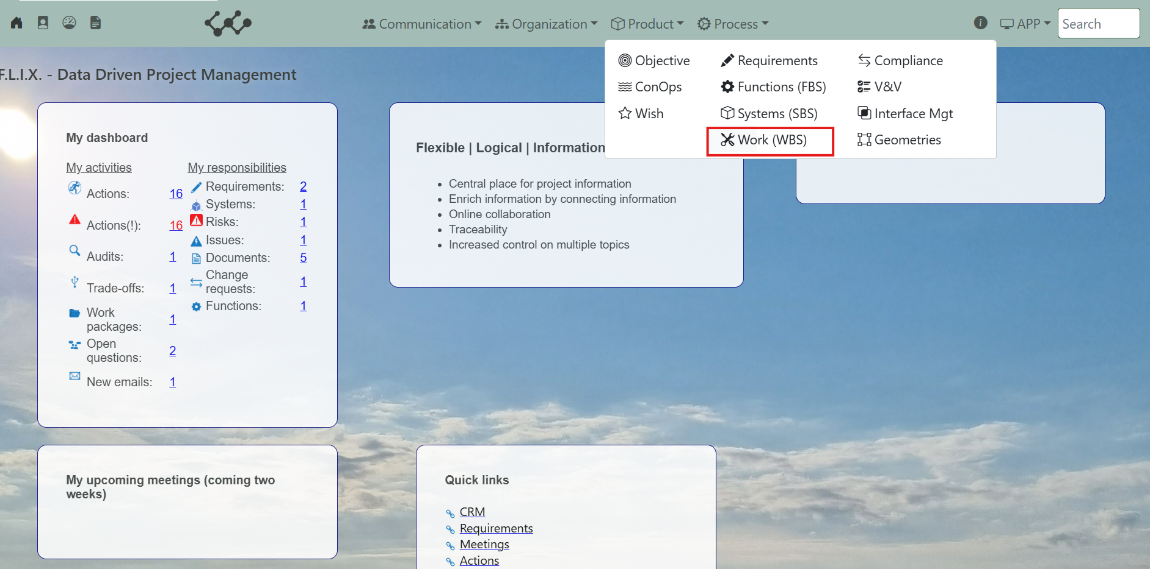

Click on Work (WBS) and you will see the following screen:

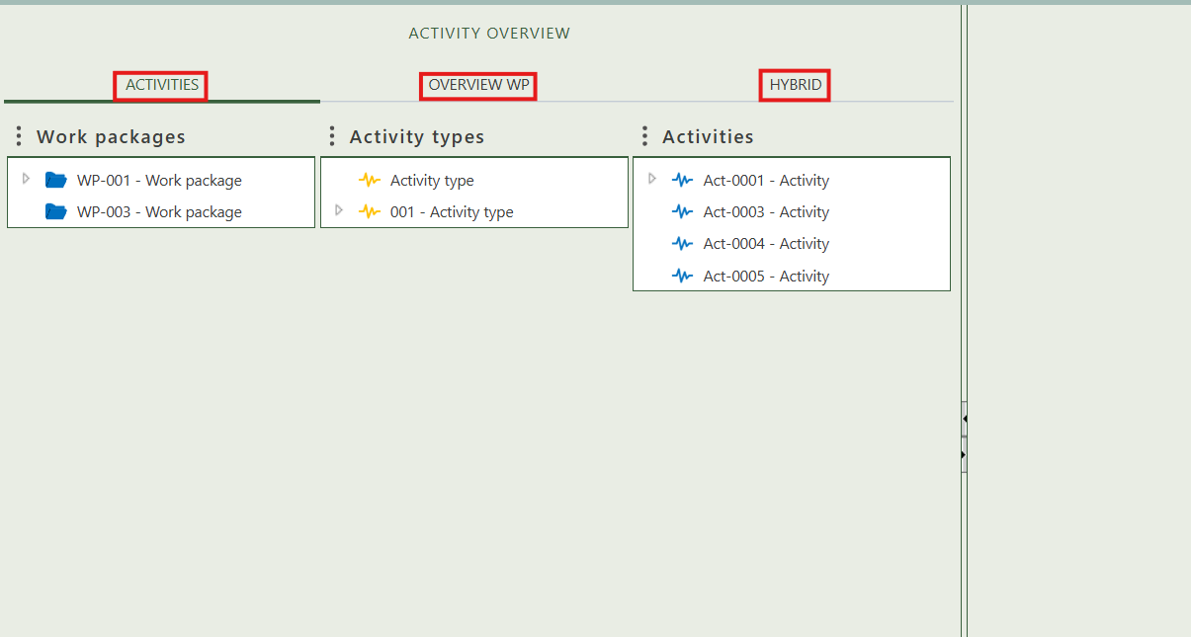

You will find three tabs in this module:

* Activities.
* Overview WP.
* Activities.

## 2.1 Activities

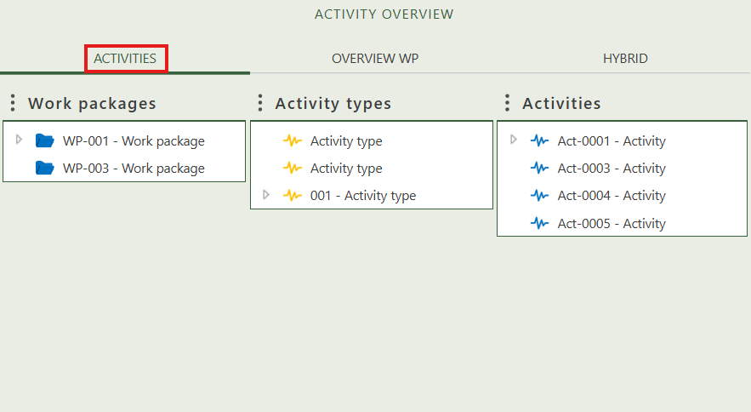This tab provides an hierarchical overview of all work packages, activity types, and activities within the workspace. You can also create new instances for these three elements within the tree by right-clicking on the white area. The tree structure allows you to build a hierarchy by dragging and dropping objects onto one another.

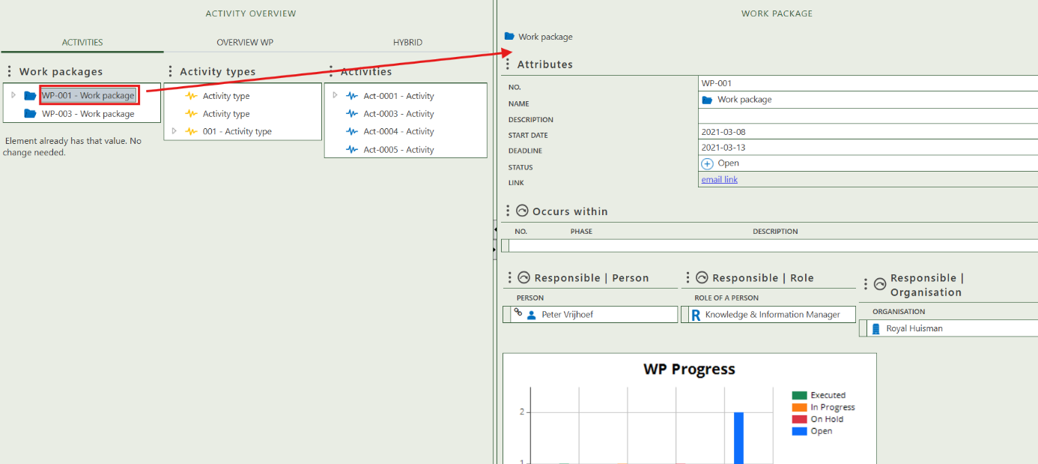When you click on a specific instance, its full details will appear on the right side of the screen, where you can review and update the information. Below, we’ll explain the detail pages for work packages, activity types, and activities.

(Example how to get to the detail page. Click on the instance and the right part of you screen will automatically open it).

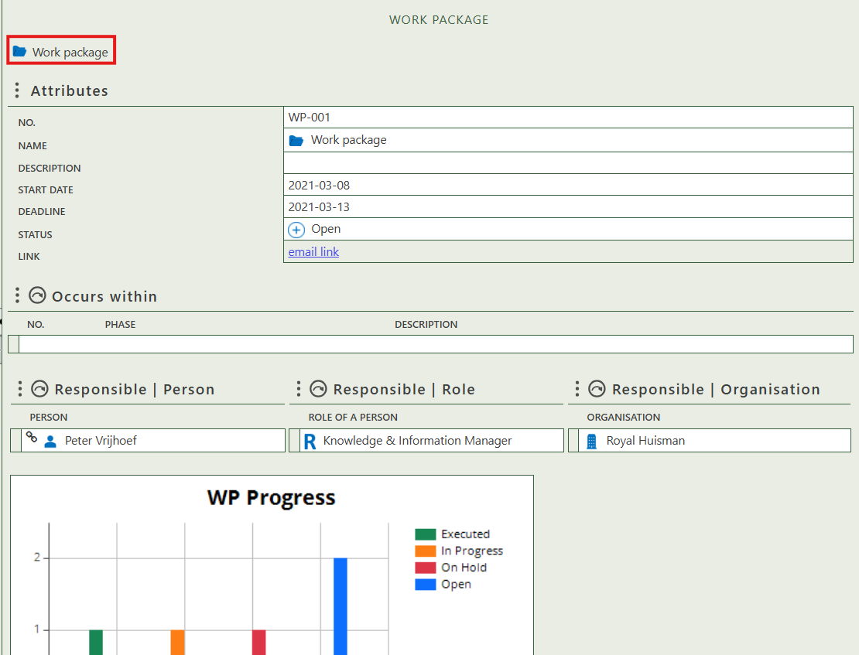

Fill in the general information of the work package.

Select in which phase(s) the work package occurs.

Select the responsible person, role and/or organization for the work package.

Visual graph of the number of work packages per status.

Select the activity types that the work packages contains.

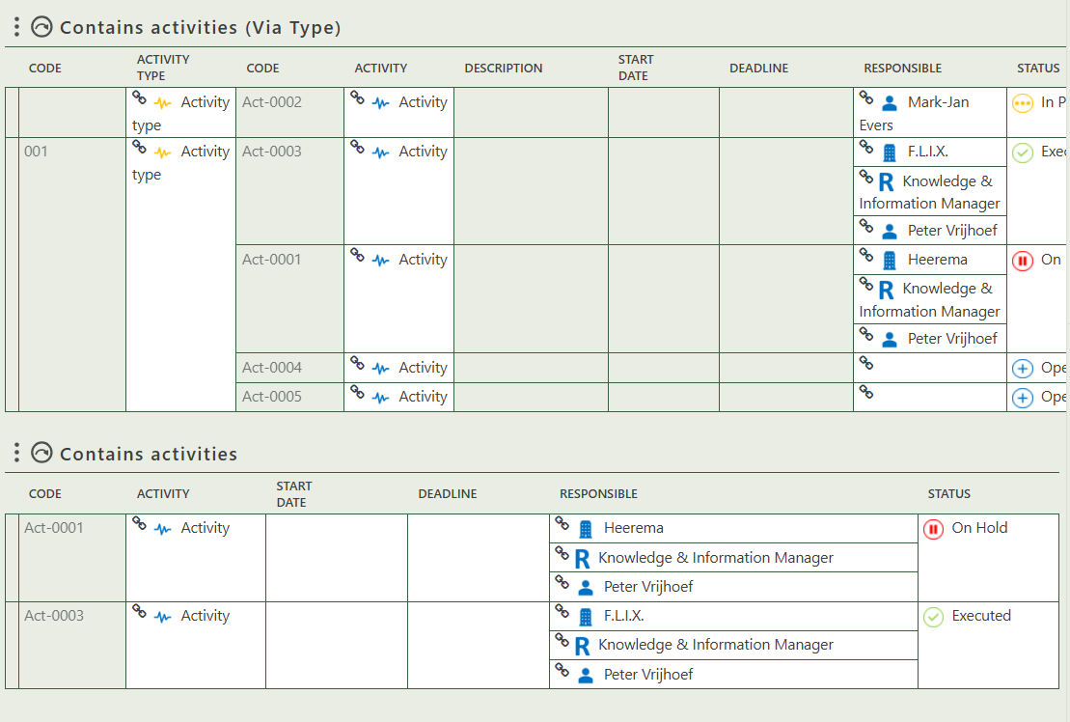

Select the activities that the work packages contains.

Fill in the general information of the activity type.

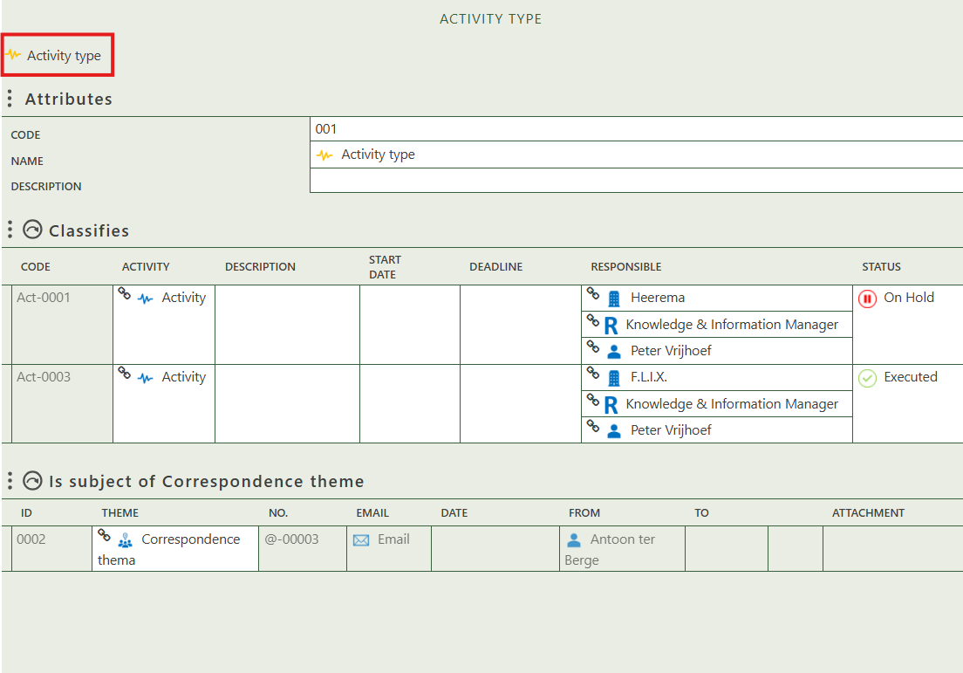

Allows you to select the activities this type classifies.

Allows you to assign this activity type as the subject of one or more correspondence themes.

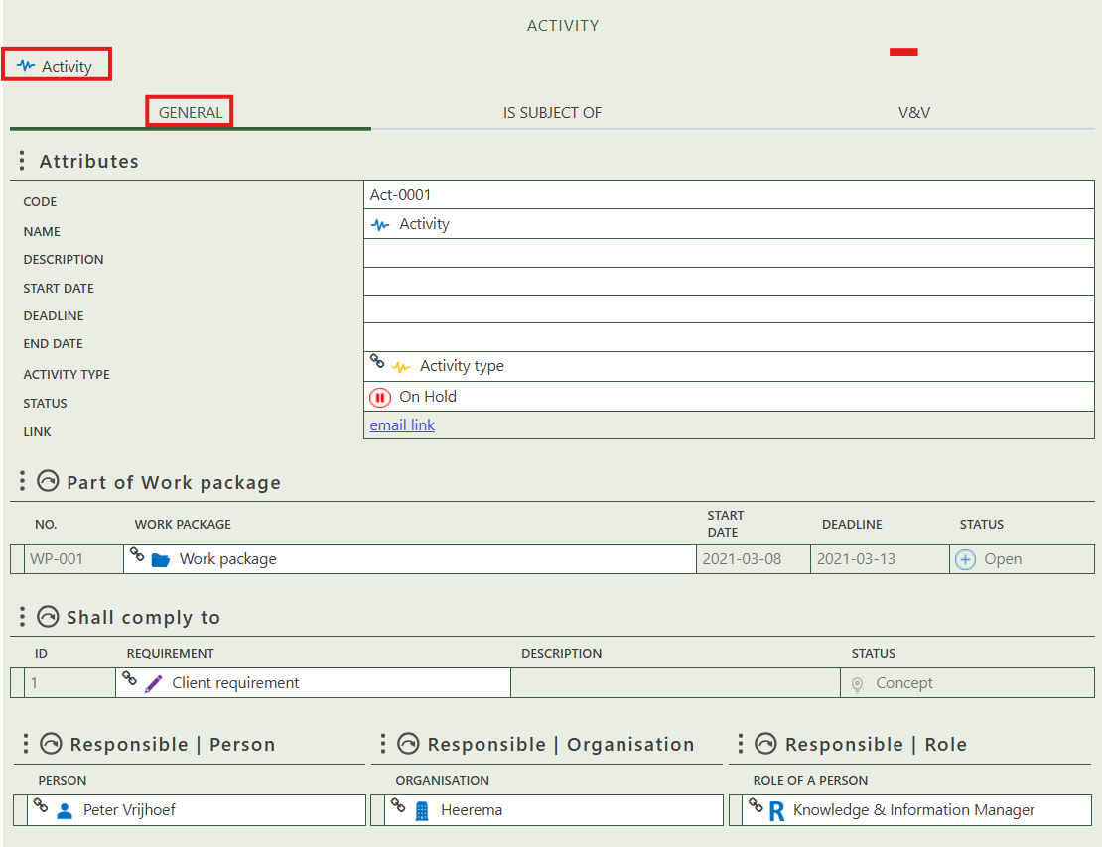

Fill in the general information of the activity.

Allows you to select the work package(s) that contains this activity.

Allows you to select requirements that this activity needs to comply to.

Select the responsible person, role and/or organization for the work package.

Shows you what change have this activity as subject.

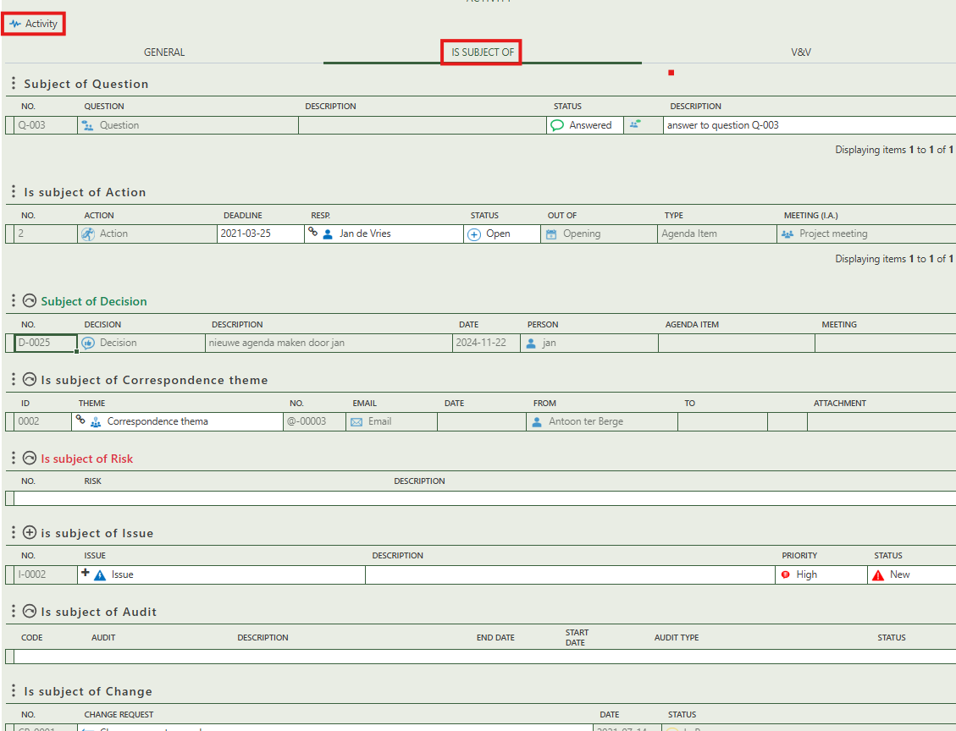

Allows you to assign this activity as the subject of one or more risk.

Allows you to create an issue that has this activity as subject.

Allows you to assign this activity as the subject of one or more audit.

Allows you to assign this activity as the subject of one or more correspondence themes.

Shows whether the activity is the subject of a question.

Allows you to assign this activity as the subject of one or more decision.

Shows whether the activity is the subject of an action.

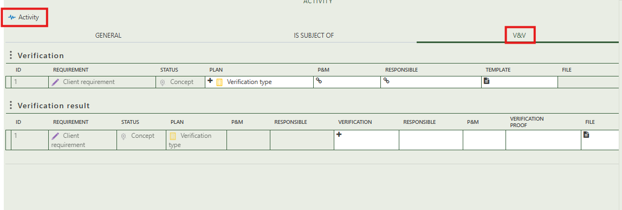

This section shows which requirements are planned for verification in relation to this activity. You can assign a verification type, responsible person, and supporting templates.

## 2.2 Overview WP

This tab provides an overview of all Work Packages and allows you to create new ones (+ sign above the table). When you click on a specific work packages type, its full details will appear on the right side of the screen, where you can review and update the information.

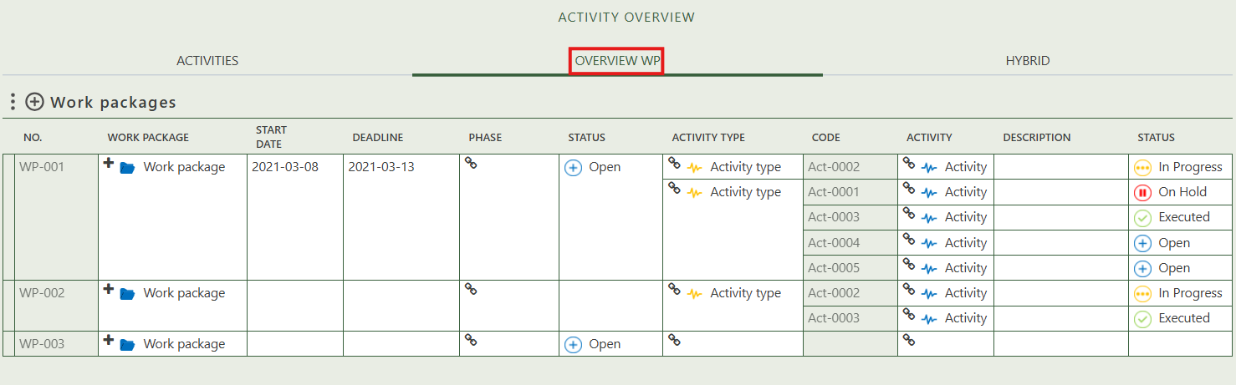

## 2.3 Hybrid

This tab displays a tree structure that allows you to build a hierarchy by dragging and dropping activity types onto one another. You can also create new activity types within the tree by right-clicking on the white area.

