

Author: F.Bovendeert

Version: V1.0

Publication date: 25-07-2025

Work Instruction - Wishes

|  |  |  |  |  |
| --- | --- | --- | --- | --- |
| Work Instruction - Wishes | | | | Project: Master Template |
| Function | Doc No: | Doc sheet: | Doc Rev.: | Pages |
|  |  |  |  |  |
| Doc Class: | Created by: | Created on: | Changed by: | Changed Date: |
|  | Floris Bovendeert | 25-7-2025 |  |  |

In this document, you will find the basic work instructions for **Wishes.**

The document begins with general information about the module in Relatics, including an introduction, objective, and solution. Following this, the structure of the module as implemented in our master template is explained. The subchapters correspond to the tabs in Relatics. Whenever a relevant clickable element appears within a tab, its detail page is also described.

Content

1. General 3

1.1 Introduction 3

1.2 Objective 3

1.3 Solution 3

2. Module 4

2.1Wishes 5

2.2 Wish approval 7

**Revision History**

|  |  |  |  |
| --- | --- | --- | --- |
| Revision | Date | By | Remarks |
|  |  |  |  |
|  |  |  |  |

# 1. General

## 1.1 Introduction

In this module, you can manage all project-related wishes. A wish represents a proposed idea, improvement, or need that may arise during project execution. Each wish includes an approval process and, if accepted, can be translated into one or more formal requirements. Relatics enables you to register and structure these wishes—capturing their motivation, context, related elements, and decisions—ensuring transparency and control throughout the process.

## 1.2 Objective

The goal is to create full traceability and structured decision-making around all project wishes. Without a clear process, ideas often remain informal, undocumented, or unresolved—making it difficult to assess their value, track approvals, or learn from past decisions. This module ensures that all wishes are considered consistently and documented thoroughly.

## 1.3 Solution

Relatics facilitates a clear and repeatable wish management process. By creating wishes in this module, tracking their approval status, and converting accepted wishes into requirements, you build a traceable and searchable history of ideas. This improves project adaptability, encourages innovation, and strengthens alignment with stakeholder needs.

# 2. Module

Go to -> Product -> Wishes.

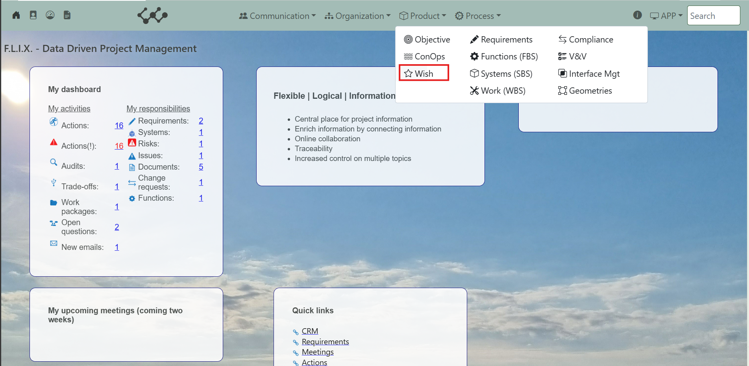

Click on Wishes and you will see the following screen:

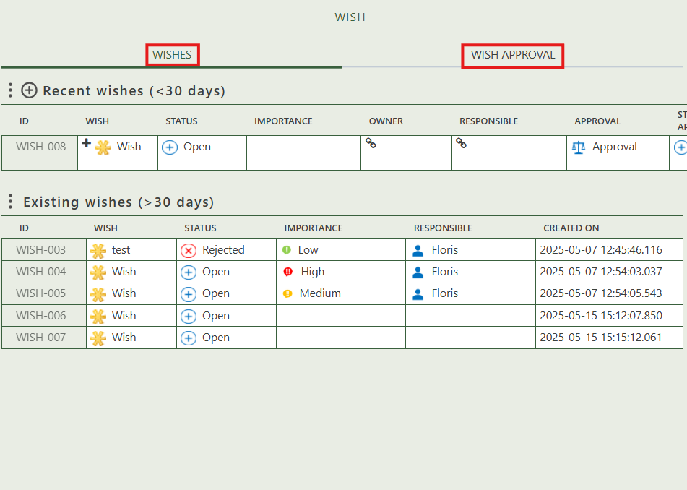

You will find three tabs in this module:

* Wishes.
* Wish approval.

## 2.1 Wishes

This tab contains an overview of all the wishes in this workspace. By pressing on the + sign next to Recent Wishes, you can create new wishes. The first table contains wishes that are created in the last 30 days. When a wish exists longer than 30 days, it will move to the second table.

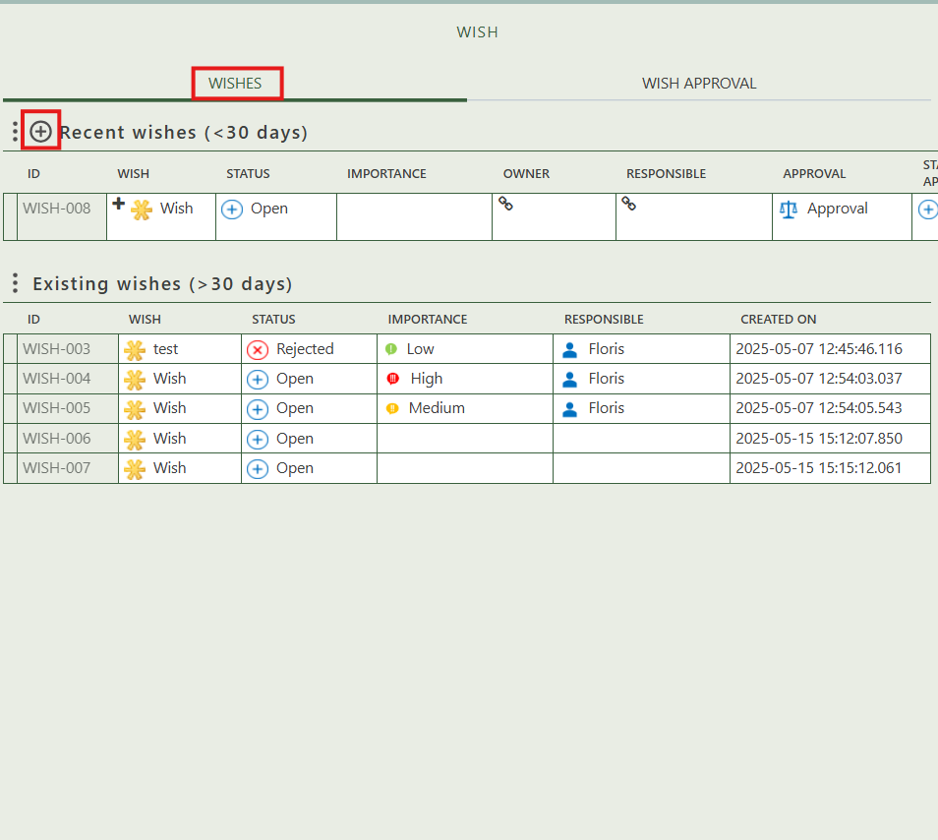

When you click on a specific wish, its full details will appear on the right side of the screen, where you can review and update the information.

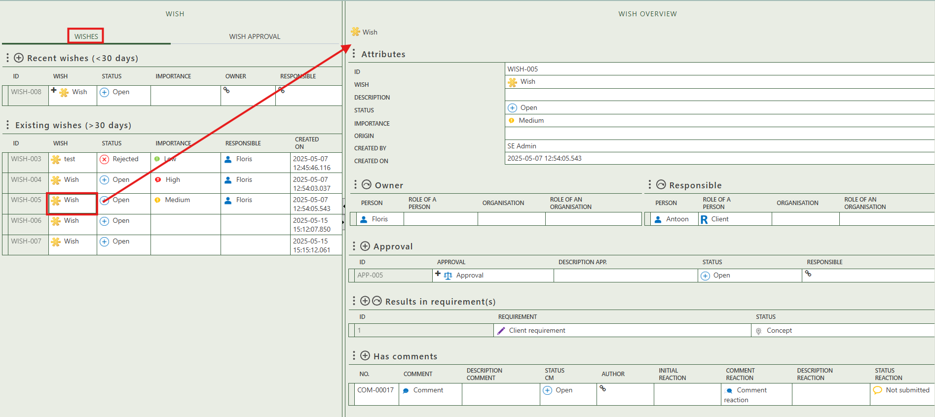

Fill in the general information of the wish.

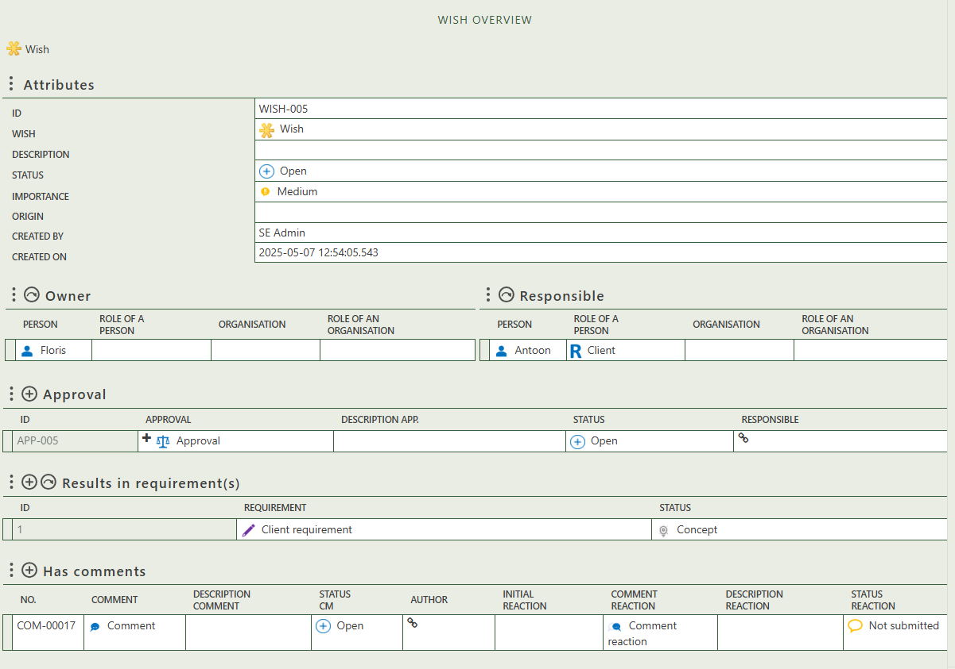

Allows you to select the owner of the wish.

Allows you to select a responsible person for the wish.

Allows you to create a maximum of 1 approval.

Allows you to create a requirement or select one.

Allows you to create comments that belong to the wish.

## 2.2 Wish approval

On the second tab, you can find all approvals associated with each wish. When a wish is created, an approval is automatically generated. Depending on their statuses, the wish and its approval move between different tables.

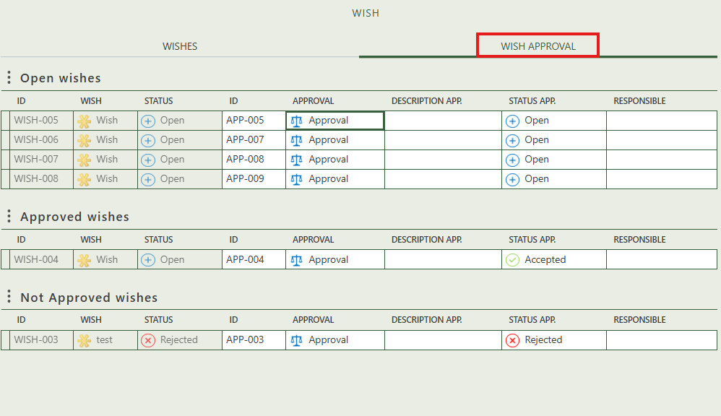

When you click on a specific approval, its full details will appear on the right side of the screen, where you can review and update the information.

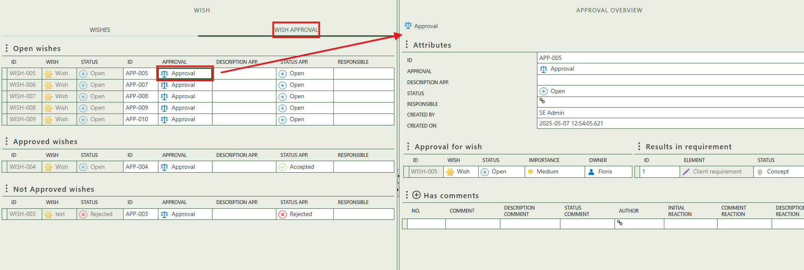

Fill in the general information of the wish.

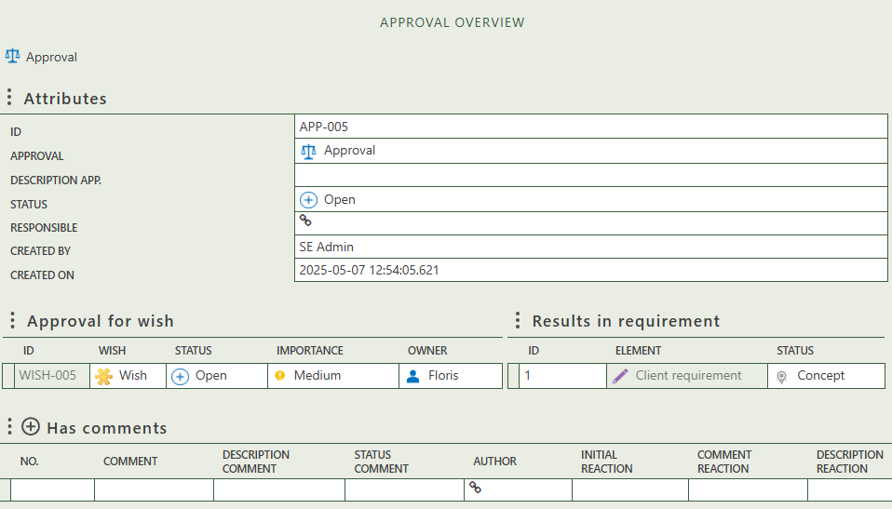

Allows you to create comments that belong to the approval.

Shows the wish that is being approved.

Shows the requirement as result of the wish.