

Author: F.Bovendeert

Version: V1.0

Publication date: 25-07-2025

Work Instruction – V&V

|  |  |  |  |  |
| --- | --- | --- | --- | --- |
| Work Instruction – V&V | | | | Project: Master Template |
| Object | Doc No: | Doc sheet: | Doc Rev.: | Pages |
|  |  |  |  |  |
| Doc Class: | Created by: | Created on: | Changed by: | Changed Date: |
|  | Floris Bovendeert | 25-7-2025 |  |  |

In this document, you will find the basic work instructions for **V&V.**

The document begins with general information about the module in Relatics, including an introduction, objective, and solution. Following this, the structure of the module as implemented in our master template is explained. The subchapters correspond to the tabs in Relatics. Whenever a relevant clickable element appears within a tab, its detail page is also described.

Content

1. General 3

1.1 Introduction 3

1.2 Objective 3

1.3 Solution 3

2. Module 4

2.1Verifications 5

2.2 Verifications results 6

**Revision History**

|  |  |  |  |
| --- | --- | --- | --- |
| Revision | Date | By | Remarks |
|  |  |  |  |
|  |  |  |  |

# 1. General

## 1.1 Introduction

In this module, you can create and manage verification and validation (V&V) plans for all relevant requirements within your project. These plans define how each requirement will be verified or validated, by whom, when, and with what evidence.

## 1.2 Objective

The goal is to ensure complete traceability and assurance that all requirements are properly verified and validated. Without a structured V&V process, requirements may be overlooked, inconsistently tested, or accepted without proper evidence.

## 

## 1.3 Solution

Relatics supports a structured V&V workflow. By registering verification and validation plans in this module, linking them to the appropriate requirements and subjects, and managing the associated results, you create a searchable and traceable verification record.

# 2. Module

Go to -> Product -> V&V

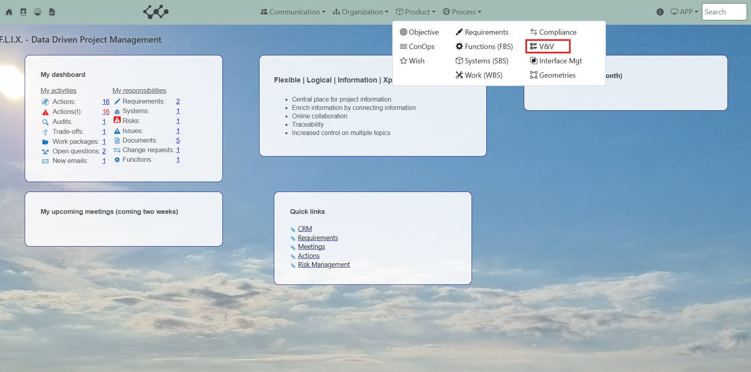

Click on V&V and you will see the following screen:

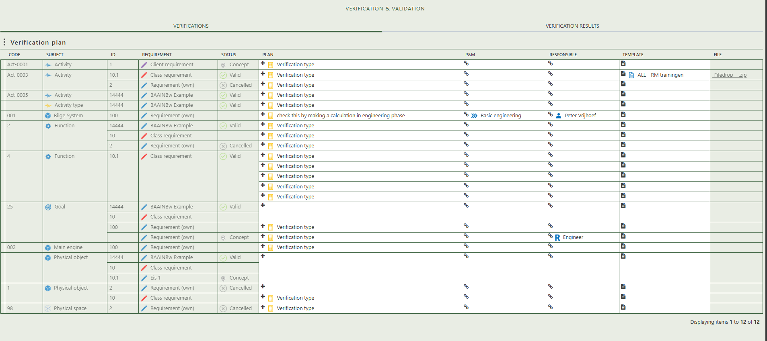

You will find two tabs in this module:

* Verifications.
* Verification results

## 2.1 Verifications

This tab provides an overview of all verifications plans within the workspace. Once a subject is linked to a requirement, it will automatically appear in this table. This gives you the opportunity to create a verification plan for that specific combination. In this plan, you define how the requirement will be verified, by whom, and using which tools or documentation. This structured approach supports traceability and ensures that all requirements are addressed clearly and consistently throughout the project.

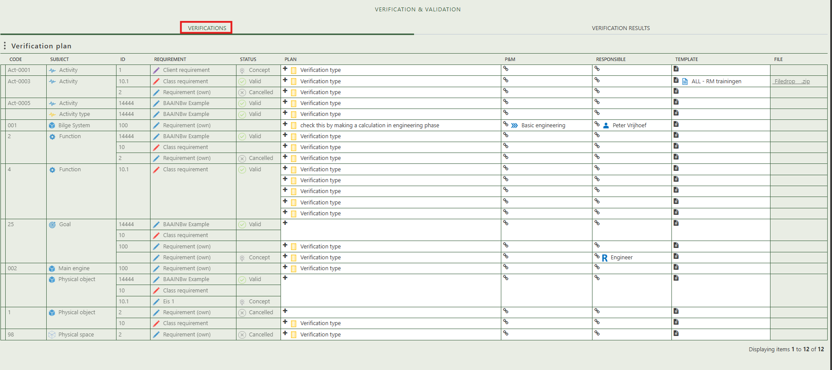

## 2.2 Verifications results

Once a verification plan has been created, the subject–requirement combination automatically appears in the Verification Results tab. Here, you can create and manage the actual verification, including defining the verification method, assigning responsibilities, linking planning and resources, adding proof or documentation, and updating the verification status. This ensures a structured and traceable verification process for each requirement.

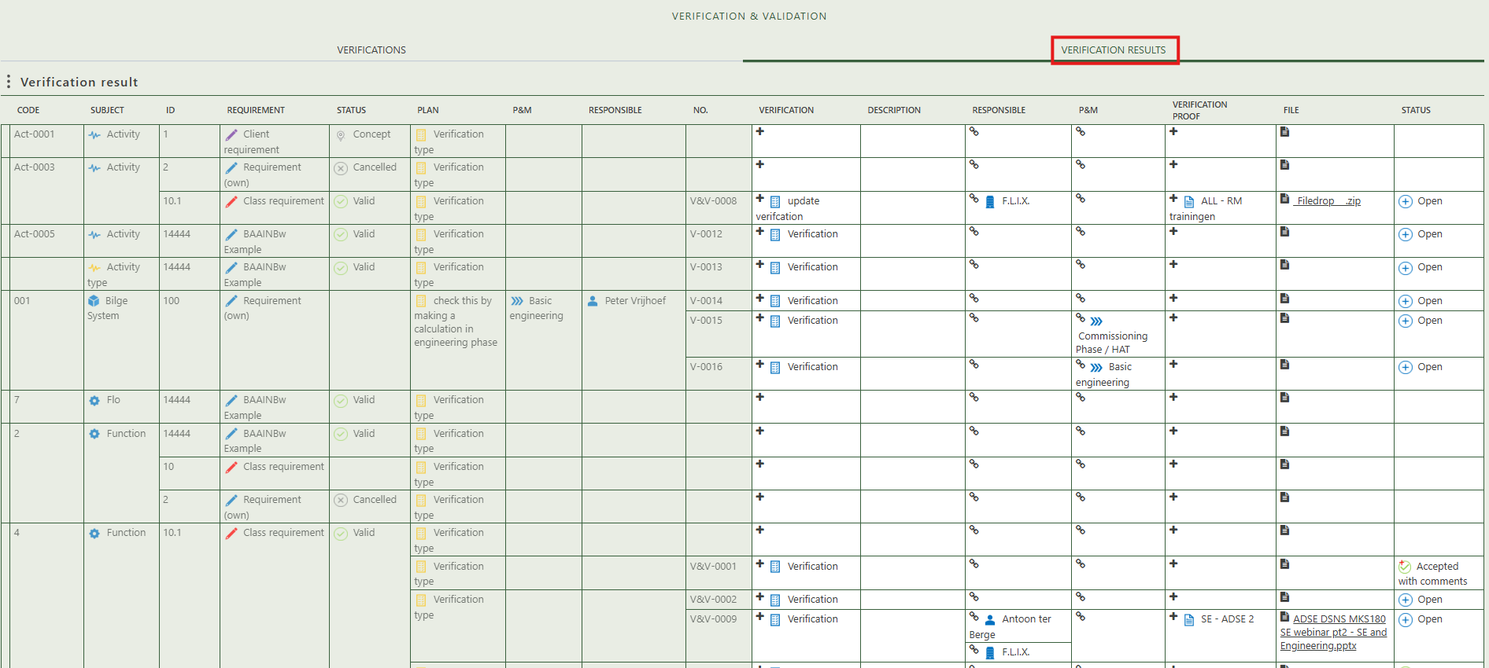

When you click on a specific verification, its full details will appear on the right side of the screen, where you can review and update the information.

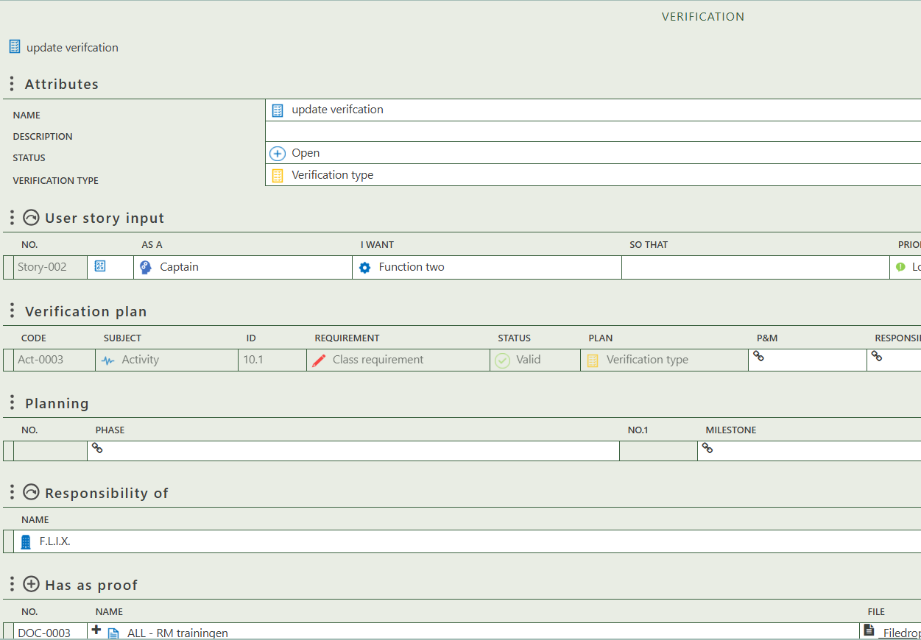

Fill in the general information of the physical object.

Allows you to select a user story as input for the verification.

Allows you to create proof for the verification and add a file to it.

Allows you to select persons (roles) and organizations that are responsible for the verification.

Allows you to select a phase and milestone for the verification.

Reflects the verification plan as shown in the table on the first tab