

Author: F.Bovendeert

Version: V1.0

Publication date: 25-07-2025

Work Instruction – Trade-Off

|  |  |  |  |  |
| --- | --- | --- | --- | --- |
| Work Instruction – Trade-Off | | | | Project: Master Template |
| Function | Doc No: | Doc sheet: | Doc Rev.: | Pages |
|  |  |  |  |  |
| Doc Class: | Created by: | Created on: | Changed by: | Changed Date: |
|  | Floris Bovendeert | 25-7-2025 |  |  |

In this document, you will find the basic work instructions for **Trade-Offs.**

The document begins with general information about the module in Relatics, including an introduction, objective, and solution. Following this, the structure of the module as implemented in our master template is explained. The subchapters correspond to the tabs in Relatics. Whenever a relevant clickable element appears within a tab, its detail page is also described.

Content

1. General 3

1.1 Introduction 3

1.2 Objective 3

1.3 Solution 3

2. Module 4

2.1 Overview 5

2.2Types 7

2.3 Criterion weights 7

**Revision History**

|  |  |  |  |
| --- | --- | --- | --- |
| Revision | Date | By | Remarks |
|  |  |  |  |
|  |  |  |  |

# 1. General

## 1.1 Introduction

In this module, you can manage all project-related **trade-offs**. Trade-offs often arise when making decisions between conflicting requirements, functions, object, or activities. Relatics enables you to capture, structure, and evaluate these trade-offs in a transparent and consistent way—supporting well-founded decision-making throughout the project lifecycle.

## 1.2 Objective

The goal is to ensure traceability and clarity around all significant project trade-offs. In complex projects, choices are often made based on discussions or implicit reasoning, which can lead to confusion or repeated debates later on. Imagine needing to explain why a technical solution was chosen over a cheaper alternative—without a record of the rationale, that’s a challenge.

## 1.3 Solution

Relatics helps formalize this process. By documenting trade-offs in this module—including the options considered, evaluation criteria, motivations, and the final decision—you create a well-structured record that supports transparency and accountability. This enables your project team to reflect on past decisions, align stakeholders, and make future trade-offs more efficiently.

# 2. Module

Go to -> Process -> Trade-Offs-> Trade-Offs

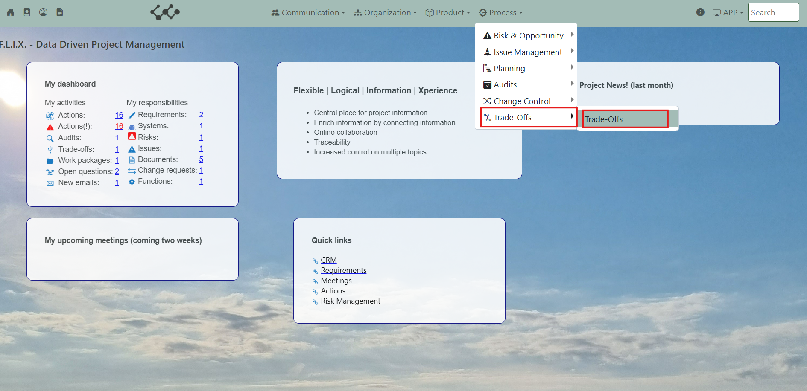

Click on Trade-Offs and you will see the following screen:

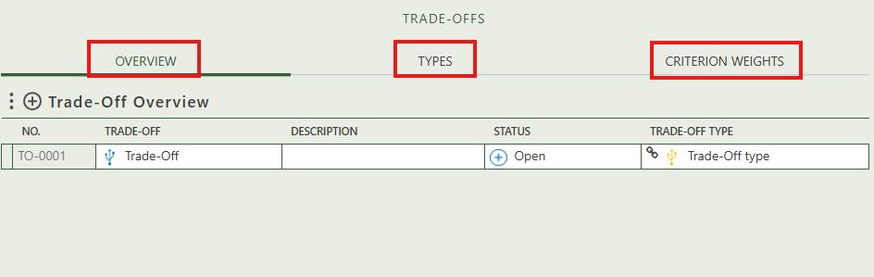

You will find three tabs in this module:

* Overview.
* Types.
* Criterion weights.

## 2.1 Overview

This tab contains an overview of all the trade-offs in the workspace. By pressing on the + sign next to Trade-Off Overview, you can create new trade-offs.

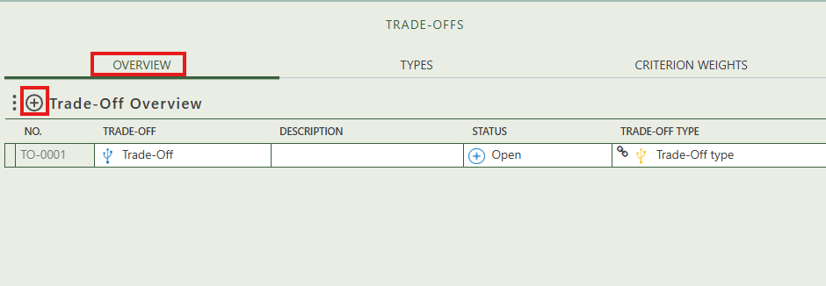

When you click on a specific trade-off, its full details will appear on the right side of the screen, where you can review and update the information.

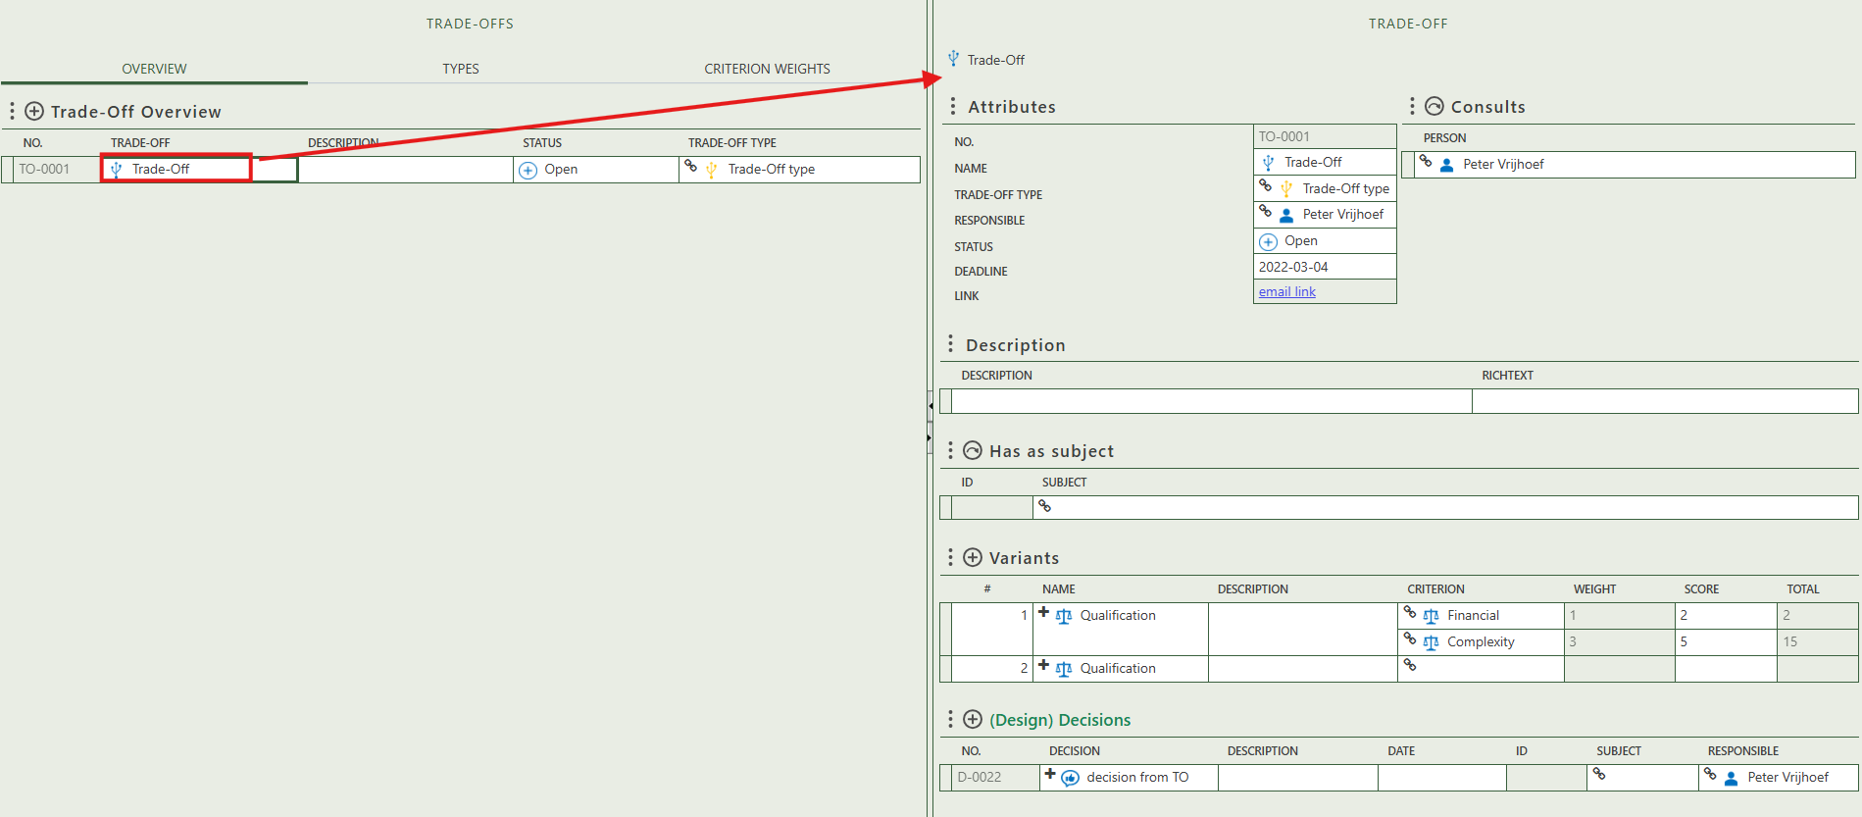

Fill in the general information of the specific trade-off.

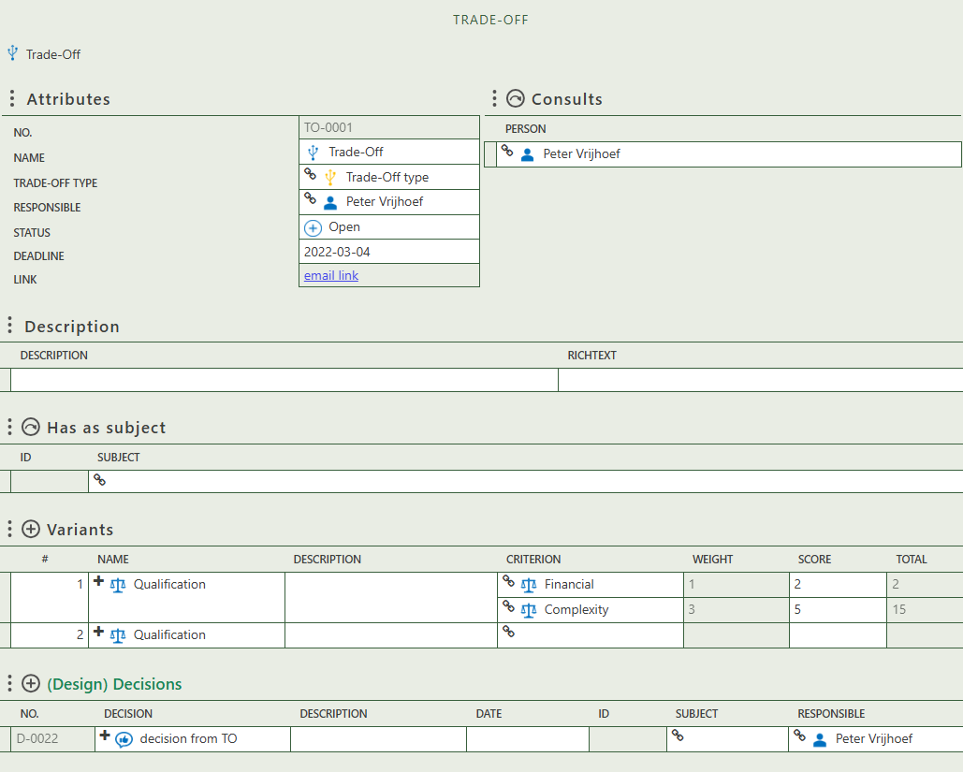

Select the persons that need to be consult.

Allows you to write a description and richtext regarding the trade-off.

Allows you to create a variant, which is a qualification where you select one or more criteria and assign them a score.

Allows you to create (design) decision(s) as a result of the trade-off.

Allows you to select a subject relevant to the trade-off.

## 2.2 Types

This tab provides an overview of all trade-off types and allows you to create new ones. When you click on a specific trade-off type, its full details will appear on the right side of the screen, where you can review and update the information. You can also see which trade-offs this type is used to classify.

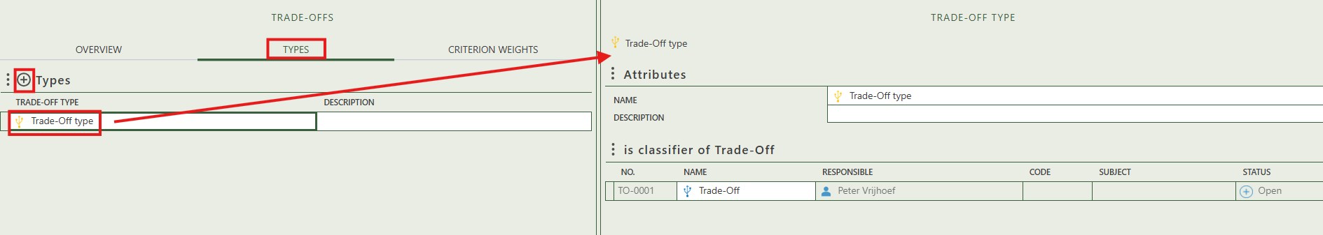

## 2.3 Criterion weights

This tab contains the criterion weights that are used in the qualification of a trade-off. You can create and adjust information regarding the weight and criterion.

