

Author: F.Bovendeert

Version: V1.0

Publication date: 25-07-2025

Work Instruction - Systems

|  |  |  |  |  |
| --- | --- | --- | --- | --- |
| Work Instruction - Systems | | | | Project: Master Template |
| Object | Doc No: | Doc sheet: | Doc Rev.: | Pages |
|  |  |  |  |  |
| Doc Class: | Created by: | Created on: | Changed by: | Changed Date: |
|  | Floris Bovendeert | 25-7-2025 |  |  |

In this document, you will find the basic work instructions for **Systems.**

The document begins with general information about the module in Relatics, including an introduction, objective, and solution. Following this, the structure of the module as implemented in our master template is explained. The subchapters correspond to the tabs in Relatics. Whenever a relevant clickable element appears within a tab, its detail page is also described.

Content

1. General 3

1.1 Introduction 3

1.2 Objective 3

1.3 Solution 3

2. Module 4

2.1Object 5

2.2 Hybrid 9

2.3 Object types 10

**Revision History**

|  |  |  |  |
| --- | --- | --- | --- |
| Revision | Date | By | Remarks |
|  |  |  |  |
|  |  |  |  |

# 1. General

## 1.1 Introduction

In this module, you can define and manage all physical objects relevant to the project. These objects represent the tangible components of the system and often serve as the foundation for structuring requirements, defining functions, and understanding the system's architecture. Relatics enables you to document each object in a structured way—capturing its identity, hierarchy, type, and relationships with other elements—ensuring clarity and consistency throughout the project.

## 1.2 Objective

The aim is to ensure complete traceability and a clear understanding of all physical objects within the project or system. Without a structured breakdown and proper relationship mapping, it becomes difficult to manage complexity, align system design with functional needs, or verify whether all stakeholder requirements are addressed. Well-defined objects improve integration between design, requirements, and system behavior.

## 1.3 Solution

Relatics supports a structured approach to managing physical objects. By registering objects in this module, assigning types, organizing them hierarchically, and linking them to related elements—such as functions, actions, and requirements—you create a transparent and verifiable object model. This strengthens system understanding, enhances traceability, and supports a controlled and well-aligned system development process.

# 2. Module

Go to -> Product -> Systems (SBS)

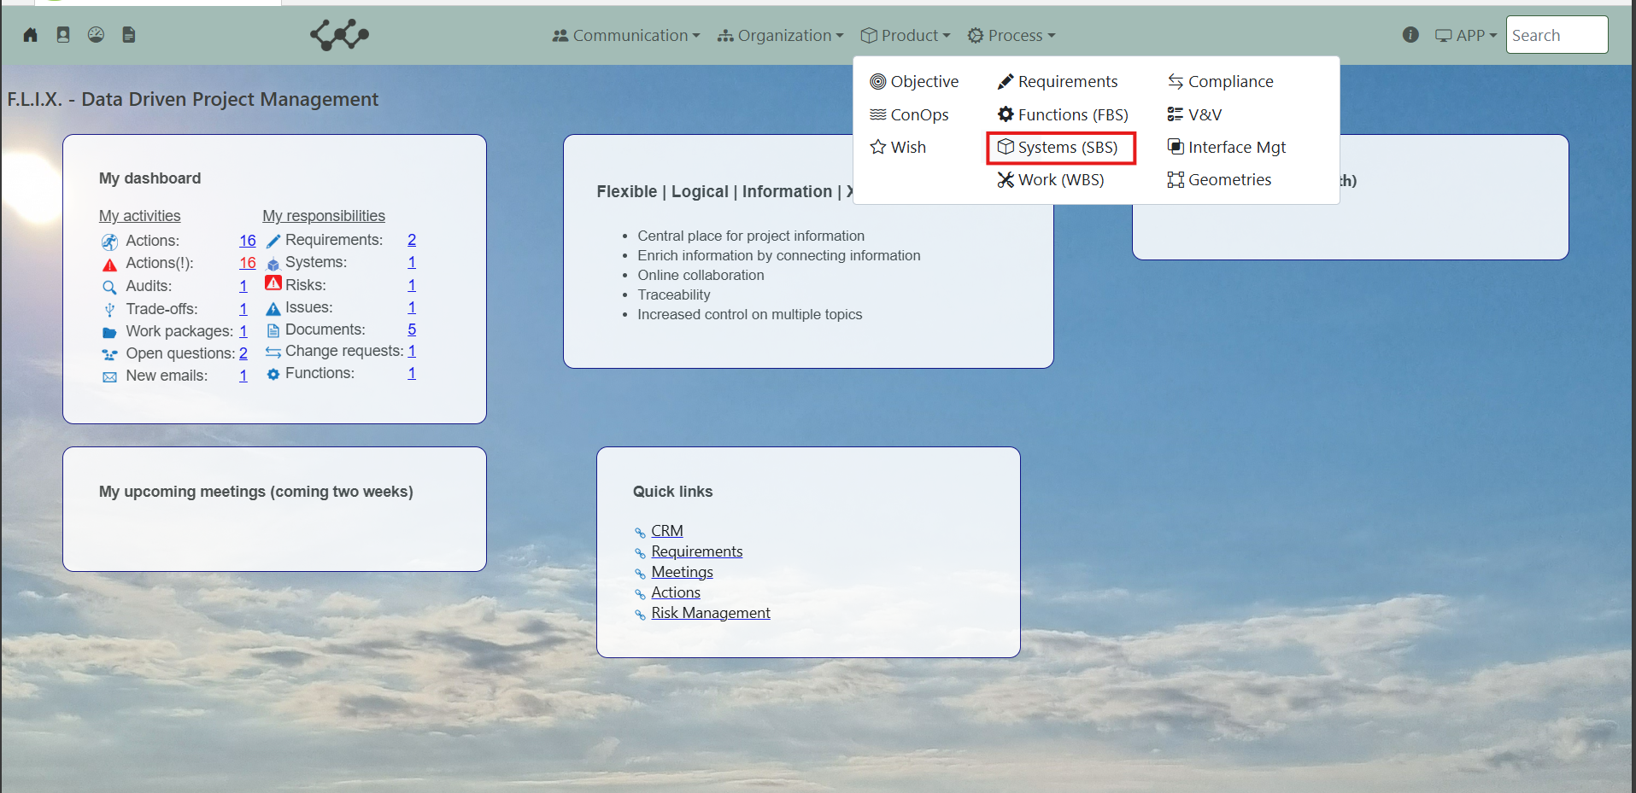

Click on Systems (SBS) and you will see the following screen:

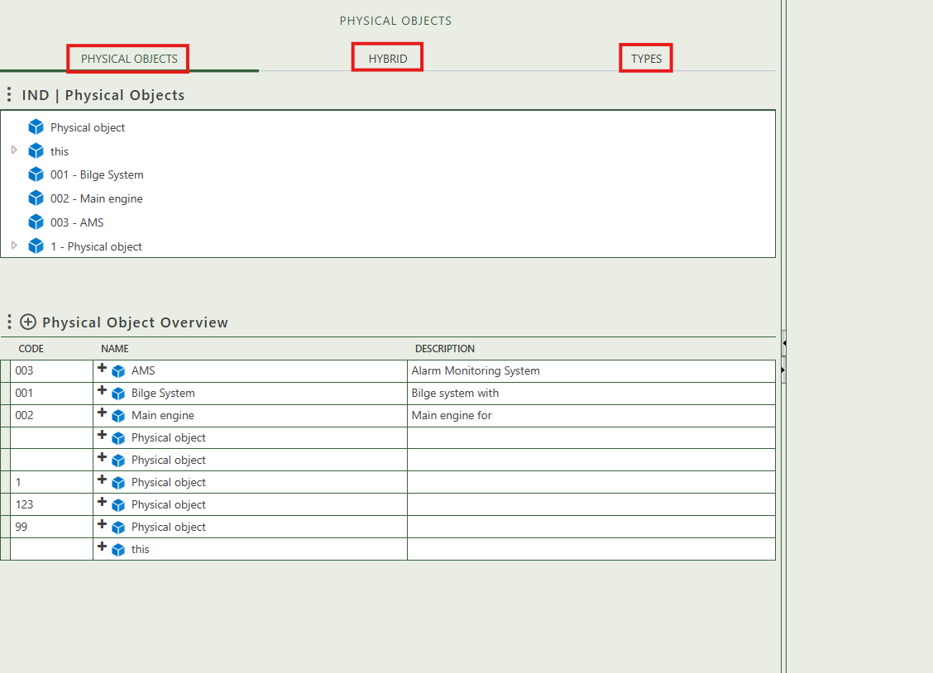

You will find three tabs in this module:

* Physical objects.
* Hybrid.
* Types.

## 2.1 Object

This tab provides an overview of all physical objects within the workspace. By clicking the **+** sign next to *Physical Object Overview*, you can create new objects. Once a object is added to the table, it will appear in the Physical Objects Breakdown after refreshing the tree view. The tree structure allows you to build a hierarchy by dragging and dropping objects onto one another.

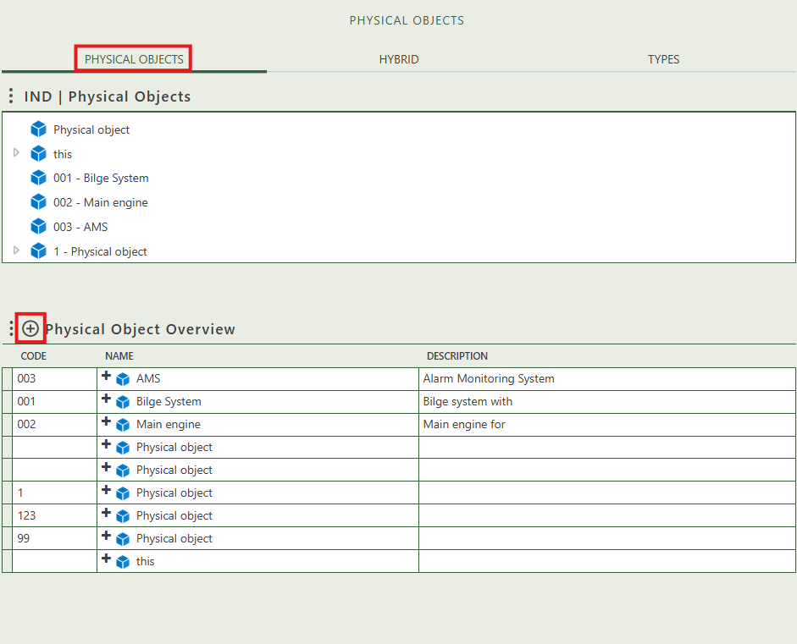

When you click on a specific object, its full details will appear on the right side of the screen, where you can review and update the information.

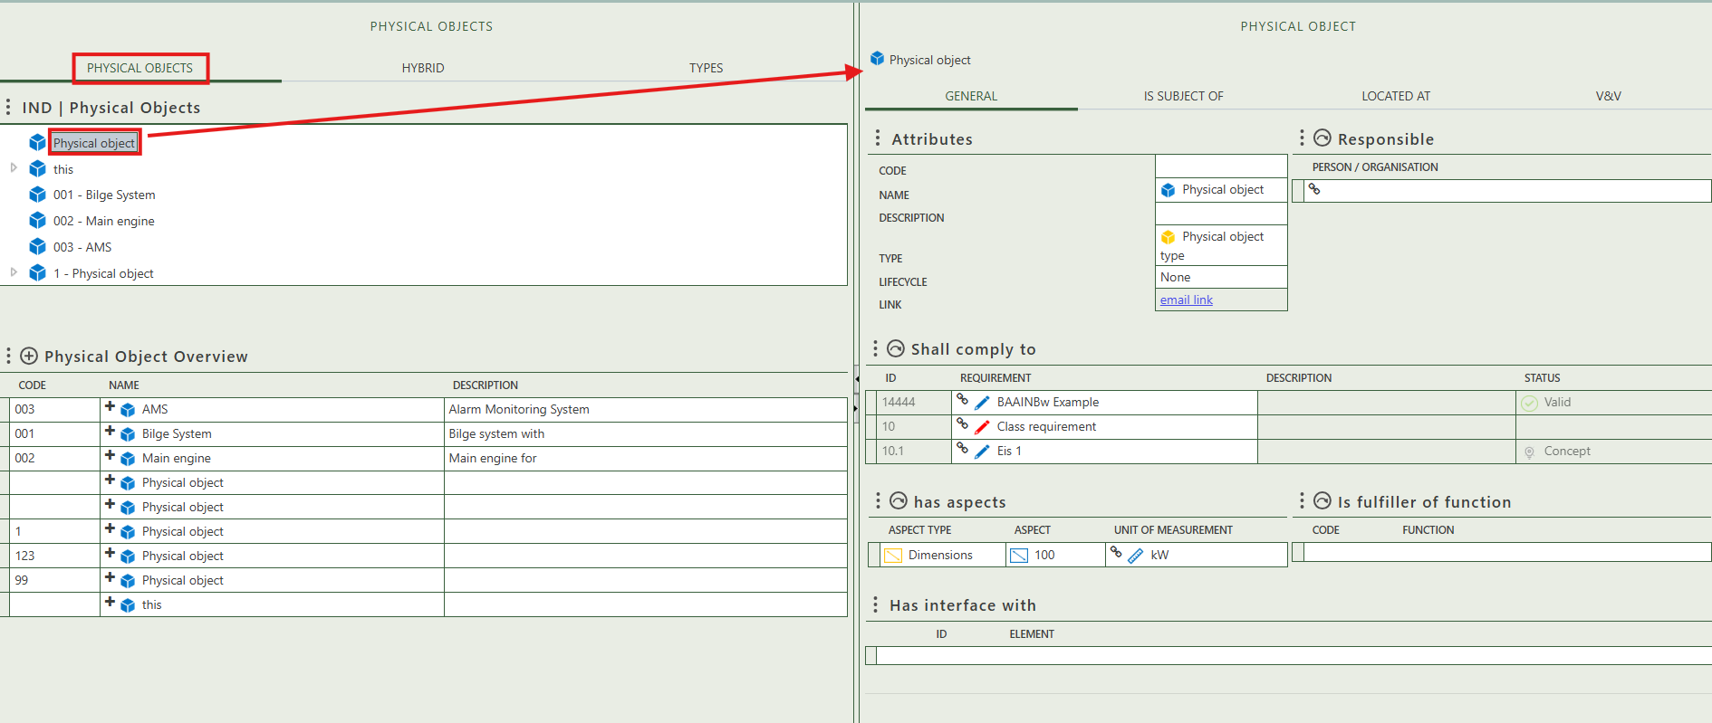

Fill in the general information of the physical object.

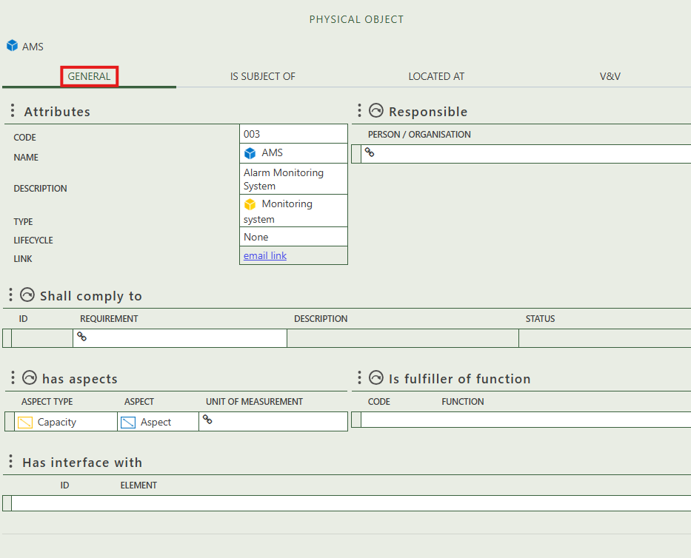

Allows you to select person(s) and/or organization(s) that are responsible for the physical object.

Allows you to select requirements that this object needs to comply to.

Allows you to select aspects that belong to this object.

Allows you to select object(s) that the object fulfills.

Is automatically filled in if the object has an interface.

Shows whether the object is the subject of a question.

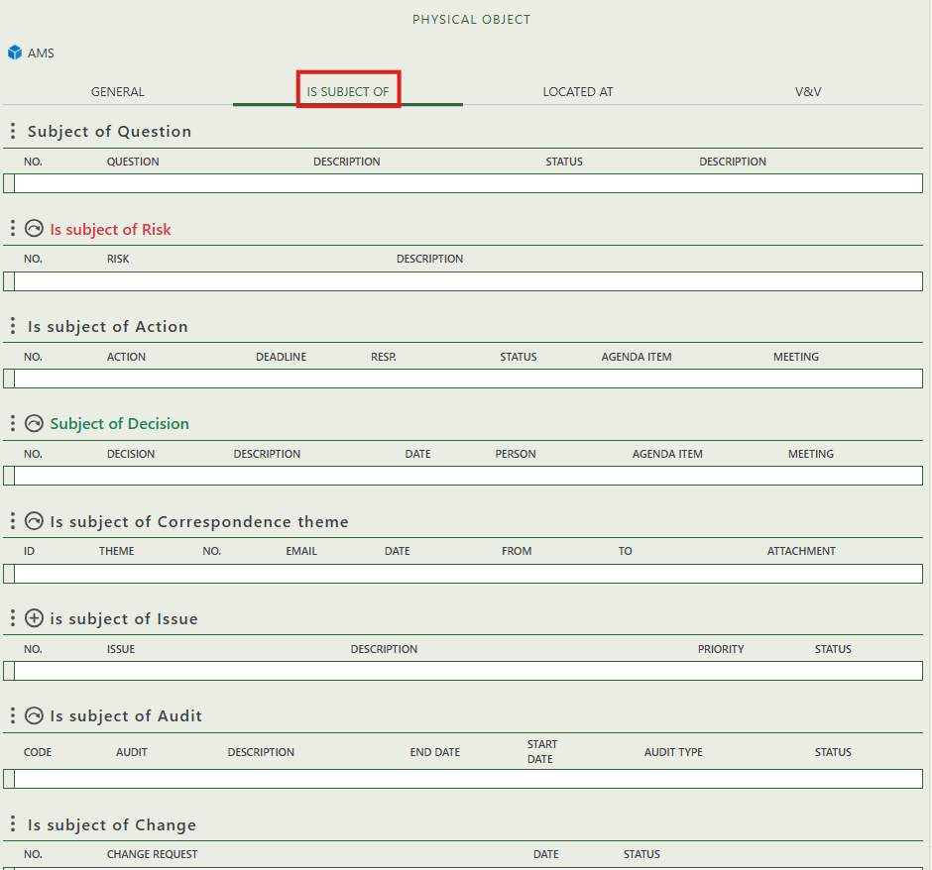

Allows you to create an issue that has this object as subject.

Allows you to assign this object as the subject of one or more audit.

Allows you to assign this object as the subject of one or more risk.

Shows you what change have this object as subject.

Allows you to assign this object as the subject of one or more decision.

Allows you to assign this object as the subject of one or more correspondence themes.

Shows whether the object is the subject of an action.

Allows you to select the ship geometry that is applicable for this object.

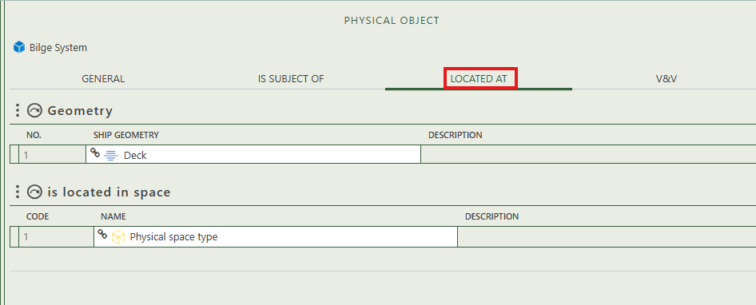

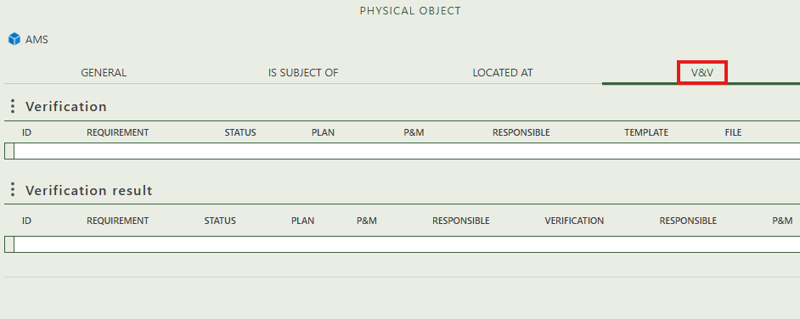

Allows you to select the space where this object is located.

This section shows which requirements are planned for verification in relation to this object. You can assign a verification, responsible person, and supporting templates.

## 2.2 Hybrid

This tab displays a tree structure that lets you create a hierarchy by dragging and dropping physical object (types) onto each other.

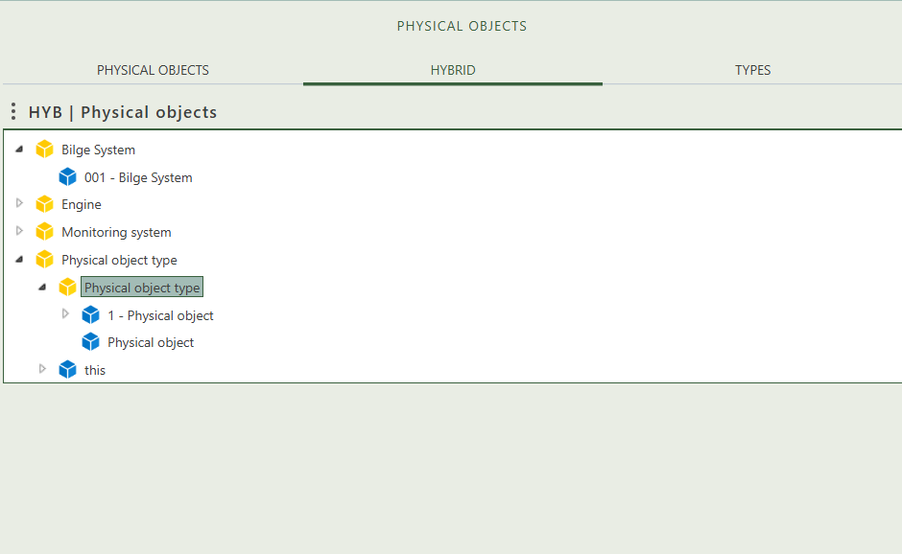

## 2.3 Object types

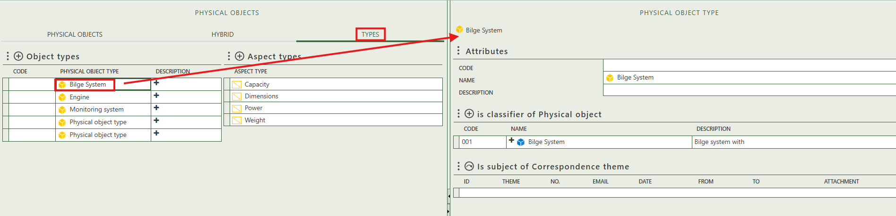This tab provides an overview of all object and aspect types and allows you to create new ones (+ sign above the table). When you click on a specific object type, its full details will appear on the right side of the screen, where you can review and update the information. The aspect type does not have a detail page, which is why it is not shown or explained.

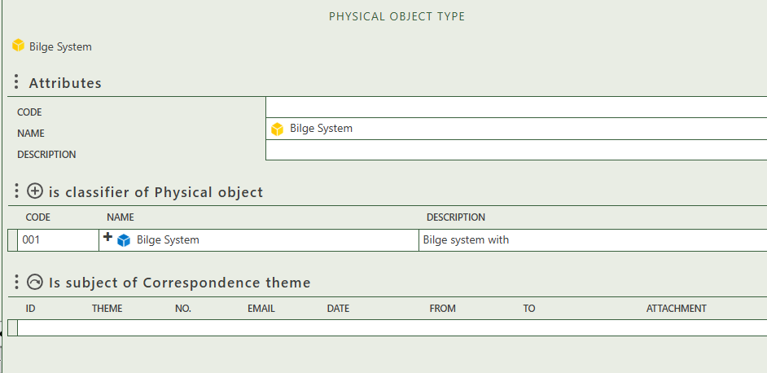

Allows you to assign this physical object as the subject of one or more correspondence theme.

Allows you to select the opbject(s) this type classifies.

Fill in the general information of the physical object type.