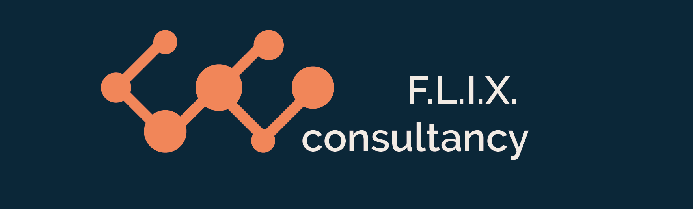

Author: F.Bovendeert

Version: V1.0

Publication date: 25-7-2025

Work Instruction –Stakeholder Mgt

|  |  |  |  |  |
| --- | --- | --- | --- | --- |
| Work Instruction – Stakeholder Mgt | | | | Project: Master Template |
| Function | Doc No: | Doc sheet: | Doc Rev.: | Pages |
|  |  |  |  |  |
| Doc Class: | Created by: | Created on: | Changed by: | Changed Date: |
|  | Floris Bovendeert | 25-7-2025 |  |  |

In this document, you will find the basic work instructions for **Stakeholder management.**

The document begins with general information about the module in Relatics, including an introduction, objective, and solution. Following this, the structure of the module as implemented in our master template is explained. The subchapters correspond to the tabs in Relatics. Whenever a relevant clickable element appears within a tab, its detail page is also described.

Content

1. General 3

1.1 Introduction 3

1.2 Objective 3

1.3 Solution 3

2. Module 4

2.1 Stakeholders 5

2.2 Log 5

**Revision History**

|  |  |  |  |
| --- | --- | --- | --- |
| Revision | Date | By | Remarks |
|  |  |  |  |
|  |  |  |  |

# 1. General

## 1.1 Introduction

This module provides a structured overview of all stakeholders involved in the project. Organizations and their affiliated persons are assigned specific project roles. In addition, individuals can be assigned a stakeholder role, in which their influence and interest are assessed. This generates an automatic stakeholder profile in text form, supporting targeted stakeholder management.

## 1.2 Objective

The aim is to clearly identify and understand key stakeholders and their potential impact on the project. Without proper documentation and evaluation, stakeholders may be overlooked or mismanaged, increasing project risk and communication breakdowns.

## 1.3 Solution

Relatics enables a structured approach by linking stakeholders to both their organization and specific roles, and by assessing each stakeholder’s level of influence and interest. The module also includes a Stakeholder Issue Log, where you can register and track concerns or issues tied to specific stakeholder roles. When used consistently, this module supports effective engagement, risk management, and proactive stakeholder communication.

# 2. Module

Go to -> Organization -> Stakeholder Mgt

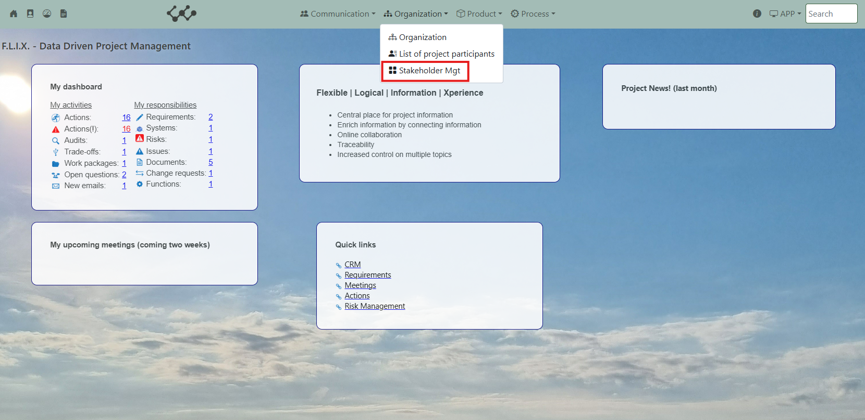

Click and you will see the following screen:

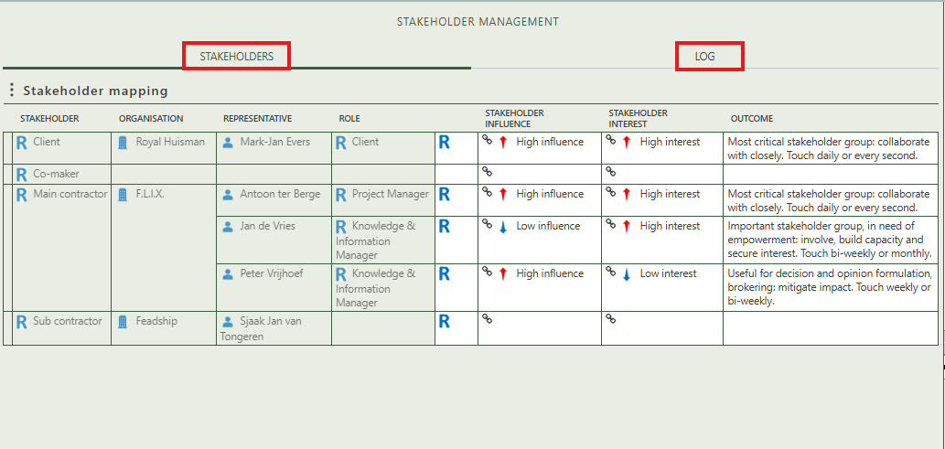

You will find two tabs in this module:

* Stakeholder
* Log

## 2.1 Stakeholders

On the first tab of the Stakeholder Management module, you can assess and manage the influence and interest levels of each stakeholder. By assigning scores to both parameters, the system automatically generates a stakeholder profile in text form. This helps to categorize stakeholders based on their potential impact and level of involvement, allowing for targeted communication and engagement strategies.

The stakeholders listed in the first column are determined by the number of roles assigned to organizations and the specific organizations selected. You can manage and adjust this configuration in the Organizations module under the Organizations tab.

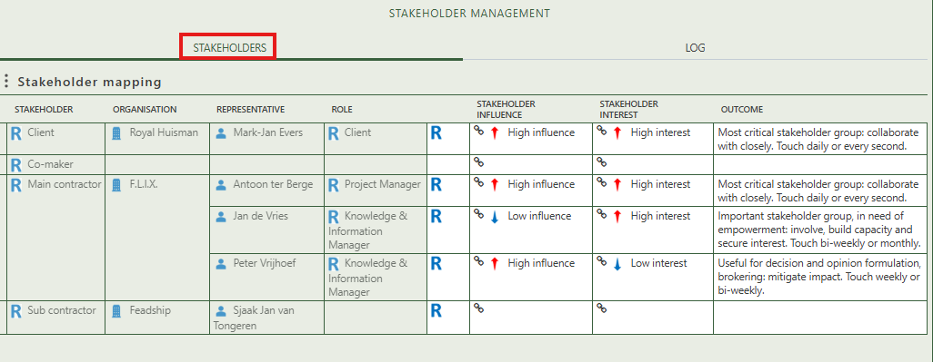

## 2.2 Log

The second tab, LOG, allows you to log and manage issues related to stakeholders. These issues are always linked to a specific stakeholder role, which is tied to a person within an organization.

On the detail page of a stakeholder issue, you can enter general information about the issue. The "Origin from" field is automatically populated based on the representative of the associated organization. Additionally, you have the option to create and manage issue-related actions to track follow-up steps or resolutions.

