
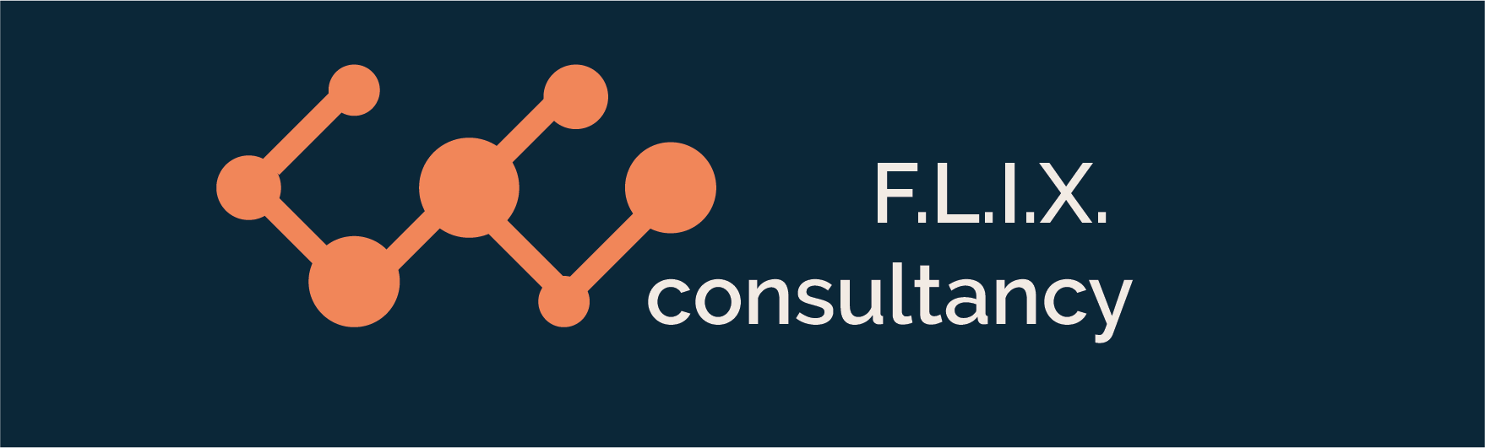
Author: F.Bovendeert
Version: V1.0
Publication date: 25-07-2025

Work Instruction - Risk

Work Instruction - Risk |  |  |  | Project: Master Template
Function | Doc No: | Doc sheet: | Doc Rev.: | Pages
Doc Class: | Created by: | Created on: | Changed by: | Changed Date:
 | Floris Bovendeert | 25-7-2025

In this document, you will find the basic work instructions for Risk.

The document begins with general information about the module in Relatics, including an introduction, objective, and solution. Following this, the structure of the module as implemented in our master template is explained. The subchapters correspond to the tabs in Relatics. Whenever a relevant clickable element appears within a tab, its detail page is also described.

Content
1. General 3
1.1 Introduction 3
1.2 Objective 3
1.3 Solution 3
2. Module 4
2.1 Risk 5
2.2 Risk types 8
2.3 Risk settomgs 8
3. Risk overview 9
3.1 Risk overview 9
3.2 Priority 9

Revision History
Revision | Date | By | Remarks

1. General

1.1 Introduction
In this module, you can manage all project-related risks. Risks may arise from project assessments, stakeholder input, or unforeseen developments. Relatics enables you to identify, assess, mitigate, and track these risks in a structured and transparent way—helping you stay in control throughout the project lifecycle.

1.2 Objective
The goal is to ensure full traceability and clarity around all project risks. In many projects, risks are only informally discussed or inconsistently documented, which can lead to missed threats, unmanaged exposures, or repeated mistakes. Imagine trying to explain how a residual risk was accepted without having a clear record of the assessment and mitigation steps taken.

1.3 Solution
Relatics supports a consistent risk management process—if used correctly. By registering risks, assessments, mitigation measures, and any resulting residual risks in this module, you build a clear and up-to-date risk overview. This improves project decision-making, accountability, and enables proactive management of potential issues.

2. Module

Go to -> Process -> Risk & Opportunity -> Risks and Risks overview
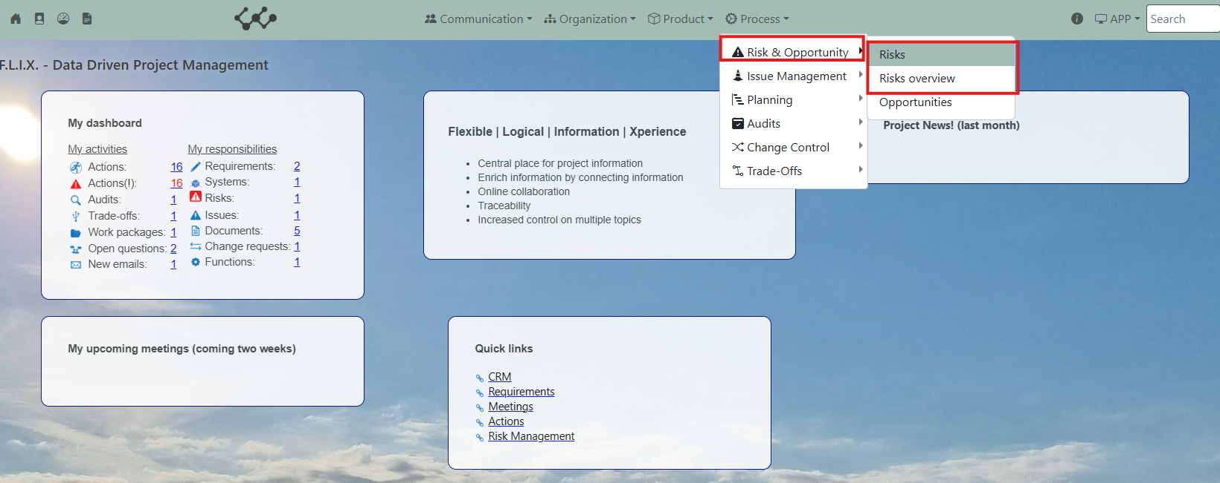

Click on Risks and you will see the following screen:
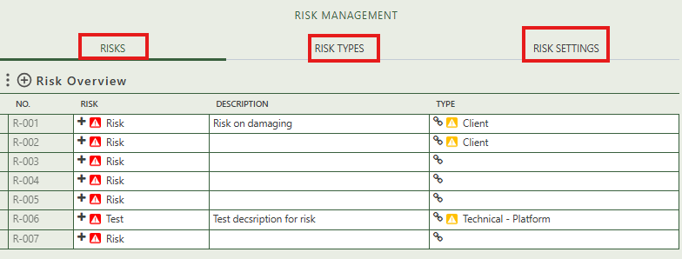
You will find three tabs in this module:
- Risks.
- Risks types.
- Risks settings.

2.1 Risk
This tab contains an overview of all the risks in this workspace. By pressing on the + sign next to Risk overview, you can create new actions.

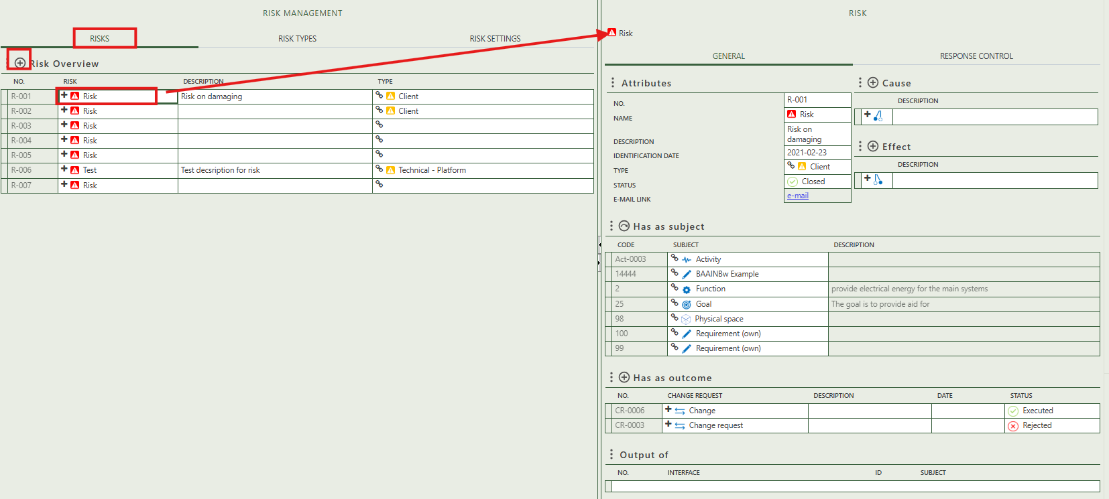

When you click on a specific risk, its full details will appear on the right side of the screen, where you can review and update the information.

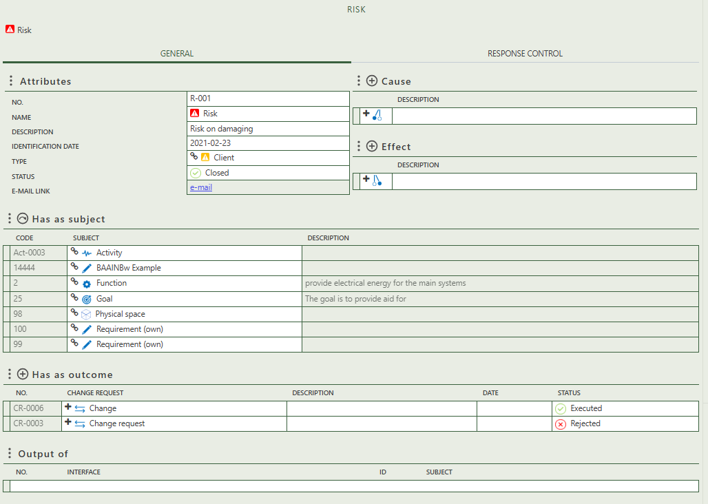

Fill in the general information of the specific risk.

A risk must have at least one cause and effect

Allows you to select a subject(s) to which the risk applies.

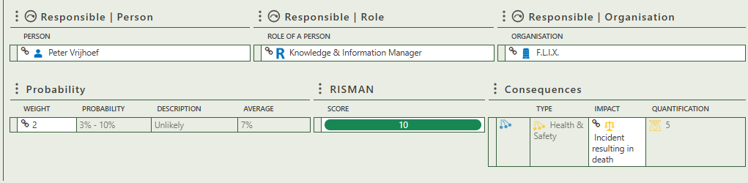
Select the impact of the consequence the risk has.
Select the weight or probability that the risk has.
Select the person, role, and/or organization that is responsible for the risk.
Shows the interface from which the risk originates.
Allows to create a change as outcome of the risk.

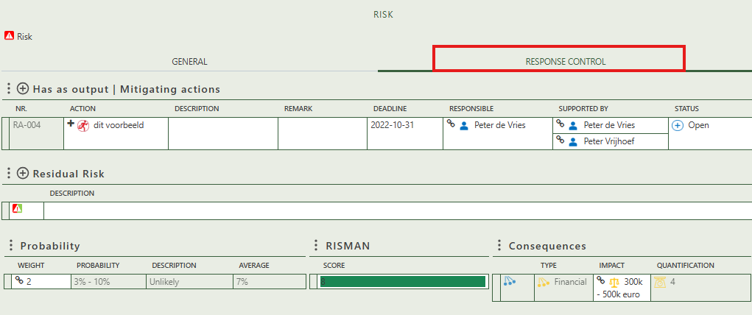
Select the impact of the consequence the residual risk has.
Select the weight or probability that the residual risk has.
Allows you to a residual risk (risk after mitigating action).
Allows you to create a mitigating action.

2.2 Risk types
This tab provides an overview of all risk types and allows you to create some new ones. When you click on a specific risk type, its full details will appear on the right side of the screen, where you can review and update the information.
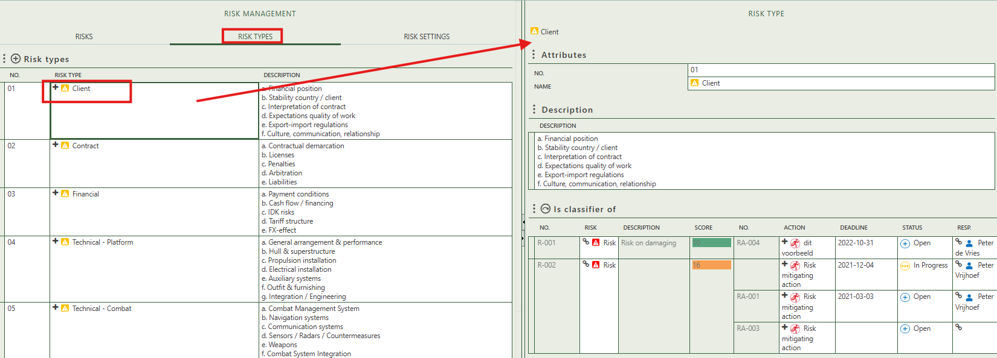

2.3 Risk settings
This tab displays multiple risk settings where you can create and adjust information regarding the probability, impact type, consequence, and the weights used to assess a risk and calculate the Risman score.
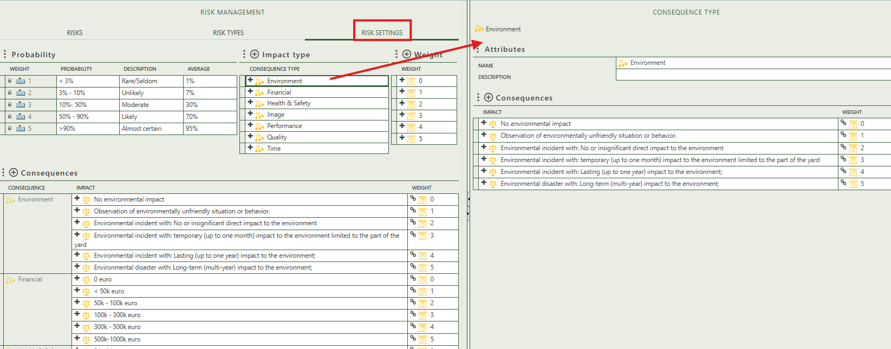

3. Risk overview
The Risk Overview module provides a clear, centralized overview of all registered project risks. It consists of two tabs:

- General Overview: This tab displays all risks in a single table, including key details such as probability, impact, mitigation status, and responsible owner. It offers a complete view of the current risk landscape.

- Prioritized Overview: This tab shows the same information but is automatically sorted from highest to lowest priority, based on the calculated risk score. This helps you focus on the most critical risks first and supports effective risk-based decision-making.

3.1 Risk overview
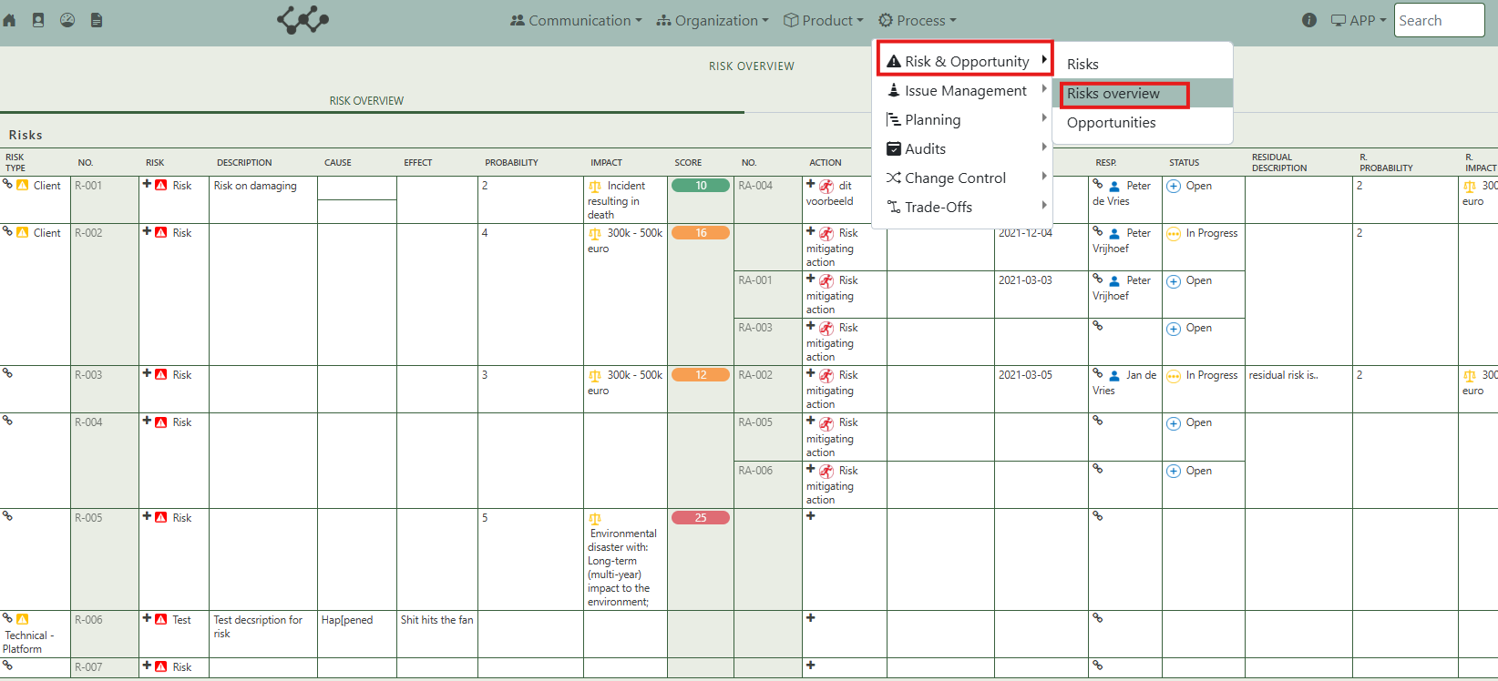

3.2 Priority
