

Author: F.Bovendeert
Version: V1.0
Publication date: 25-07-2025

Work Instruction - Opportunity

Work Instruction - Opportunity |  |  |  | Project: Master Template
Function | Doc No: | Doc sheet: | Doc Rev.: | Pages
Doc Class: | Created by: | Created on: | Changed by: | Changed Date:
 | Floris Bovendeert | 25-7-2025

In this document, you will find the basic work instructions for Opportunity.

The document begins with general information about the module in Relatics, including an introduction, objective, and solution. Following this, the structure of the module as implemented in our master template is explained. The subchapters correspond to the tabs in Relatics. Whenever a relevant clickable element appears within a tab, its detail page is also described.

Content
1. General 3
1.1 Introduction 3
1.2 Objective 3
1.3 Solution 3
2. Module 4
2.1 Opportunities 5
2.2 Opportunity types 6

Revision History
Revision | Date | By | Remarks

1. General

1.1 Introduction
In this module, you can manage all project-related opportunities. Opportunities may arise from creative insights, stakeholder input, process improvements, or changes in external conditions. Relatics enables you to identify, categorize, and track these opportunities in a structured and transparent way—so you can actively capitalize on potential benefits throughout the project lifecycle.

1.2 Objective
The goal is to ensure full traceability and clarity around all project opportunities. In many projects, valuable ideas or chances for improvement are lost because they are discussed informally or not followed up on. Imagine missing out on a cost-saving or efficiency gain simply because no one documented it properly.

1.3 Solution
Relatics supports a consistent opportunity management process—if used correctly. By registering opportunities and their types in this module, you can keep track of all the opportunities that arise during the project.

2. Module

Go to -> Process -> Risk & Opportunity -> Opportunities.
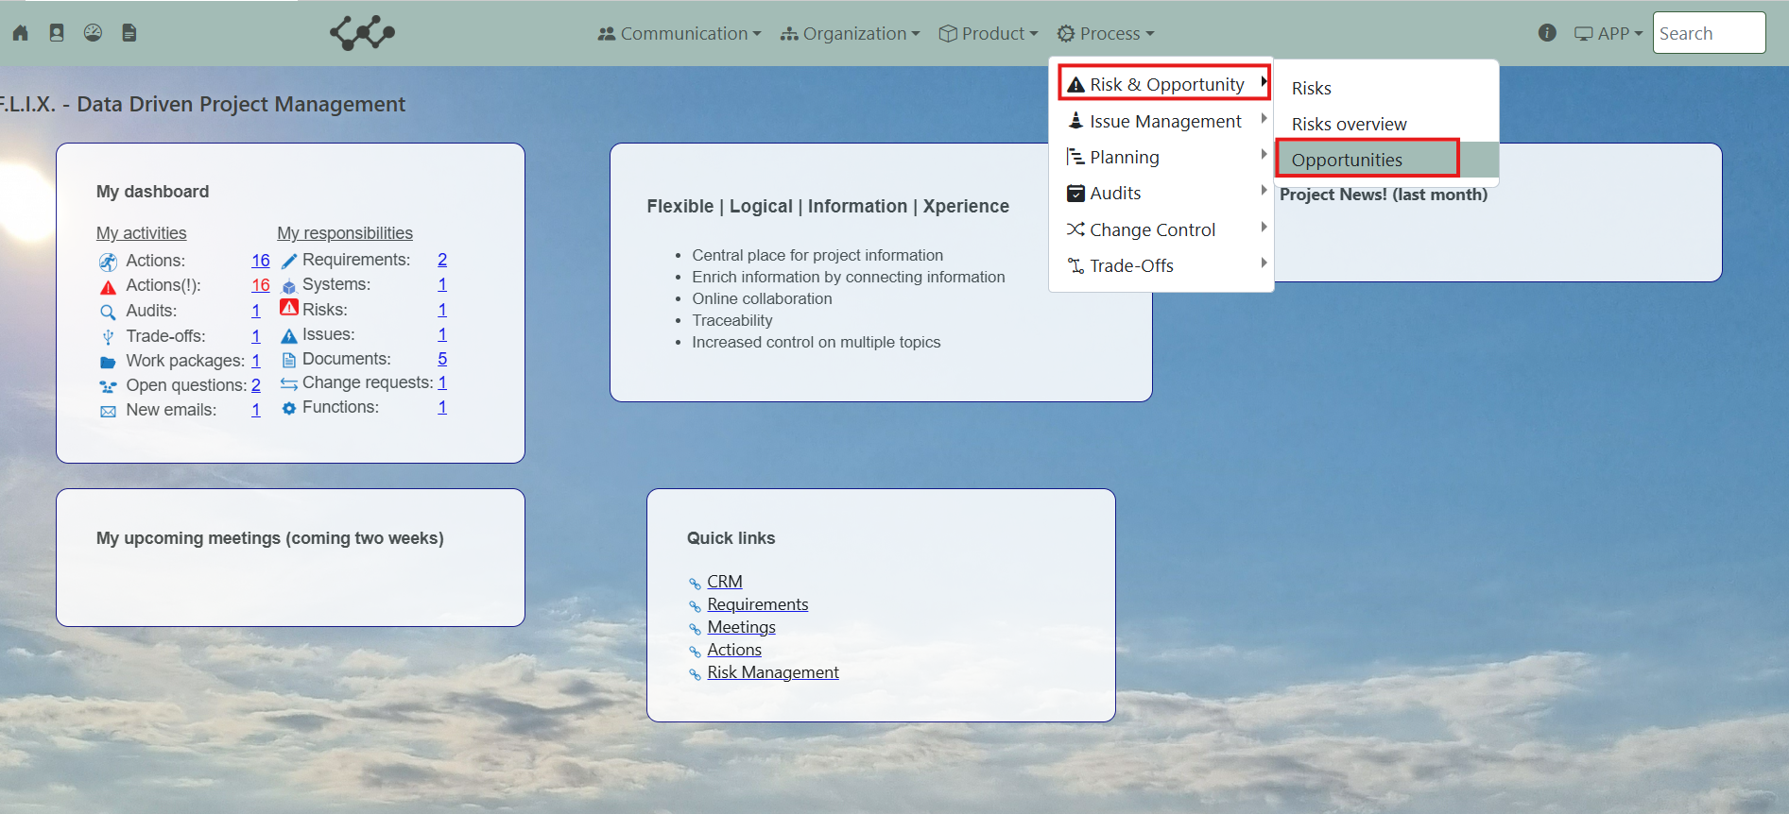

Click on opportunity and you will see the following screen:
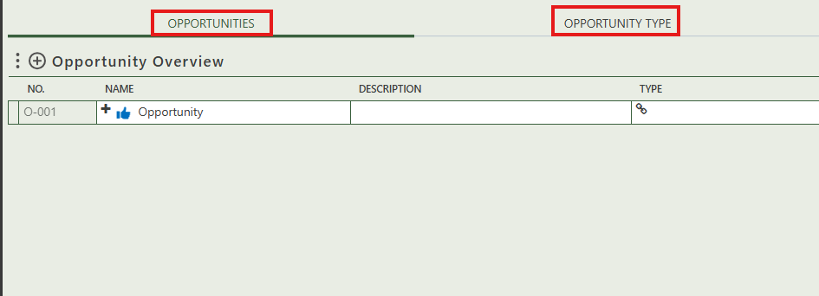
You will find three tabs in this module:
- Opportunities.
- Opportunity type.

2.1 Opportunities
This tab contains an overview of all the opportunity in this workspace. By pressing on the + sign next to Opportunity overview, you can create new opportunities.

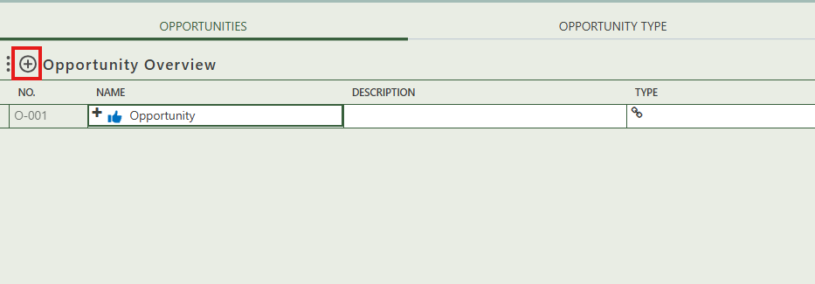

When you click on a specific opportunity, its full details will appear on the right side of the screen, where you can review and update the information.

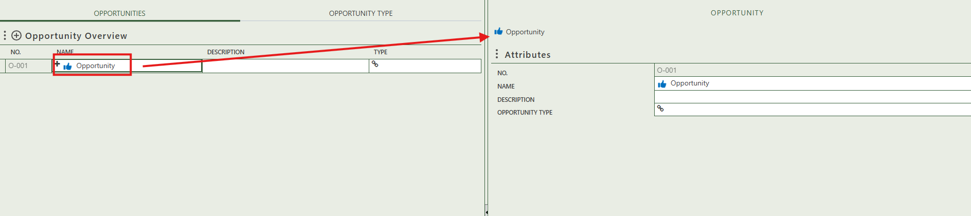

Fill in the general information of the specific opportunity.
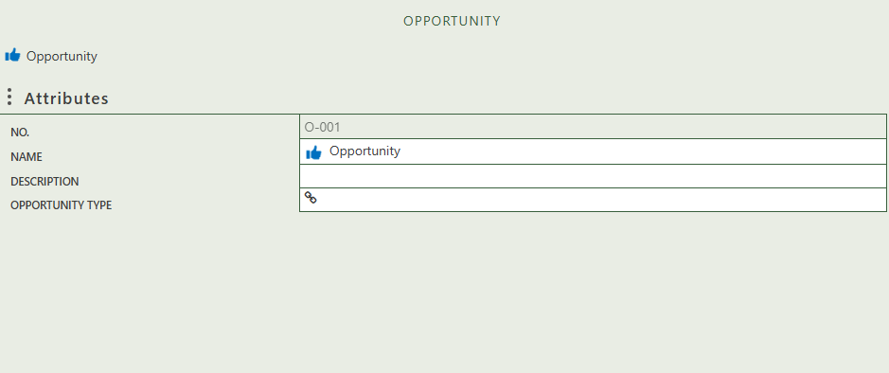

Select the opportunity type.

2.2 Opportunity types
This tab provides an overview of all opportunities types and allows you to create new ones by clicking on the + sign above the table.. When you click on a specific opportunity type, its full details will appear on the right side of the screen, where you can review and update the information.
