

Author: F.Bovendeert

Version: V1.0

Publication date: 25-07-2025

Work Instruction - Requirements

|  |  |  |  |  |
| --- | --- | --- | --- | --- |
| Work Instruction - Requirements | | | | Project: Master Template |
| Object | Doc No: | Doc sheet: | Doc Rev.: | Pages |
|  |  |  |  |  |
| Doc Class: | Created by: | Created on: | Changed by: | Changed Date: |
|  | Floris Bovendeert | 25-7-2025 |  |  |

In this document, you will find the basic work instructions for **Requirements.**

The document begins with general information about the module in Relatics, including an introduction, objective, and solution. Following this, the structure of the module as implemented in our master template is explained. The subchapters correspond to the tabs in Relatics. Whenever a relevant clickable element appears within a tab, its detail page is also described.

Content

1. General 3

1.1 Introduction 3

1.2 Objective 3

1.3 Solution 3

2. Module 4

2.1Requirements breakdown 5

2.1.1 Own requirement 6

2.1.2 Class requirement 9

2.1.3 Client requirement 11

2.2 Hybrid 15

2.3 Requirements document 16

2.4 Requirements demarcation 17

2.5 Requirements types 18

**Revision History**

|  |  |  |  |
| --- | --- | --- | --- |
| Revision | Date | By | Remarks |
|  |  |  |  |
|  |  |  |  |

# 

# 1. General

## 1.1 Introduction

In this module, you can define and manage all requirements relevant to the project. These include own (project-specific) requirements, client requirements, and class requirements. Relatics enables you to document each requirement in a structured way—capturing its type, hierarchy, and relationships to other elements such as functions, objects, and documents—ensuring traceability and consistency throughout the project lifecycle.

## 1.2 Objective

The goal is to ensure full traceability, clarity, and control over all requirements across different levels and types. Without a clear structure and links between related elements, it's difficult to manage requirements changes and verify compliance.

## 1.3 Solution

Relatics supports a structured and integrated requirement management process. By registering and organizing own, client, and class requirements in this module, linking them hierarchically, and connecting them to relevant objects, functions, activities, and requirement documents, you build a transparent and auditable requirements framework.

# 2. Module

Go to -> Product -> Requirements

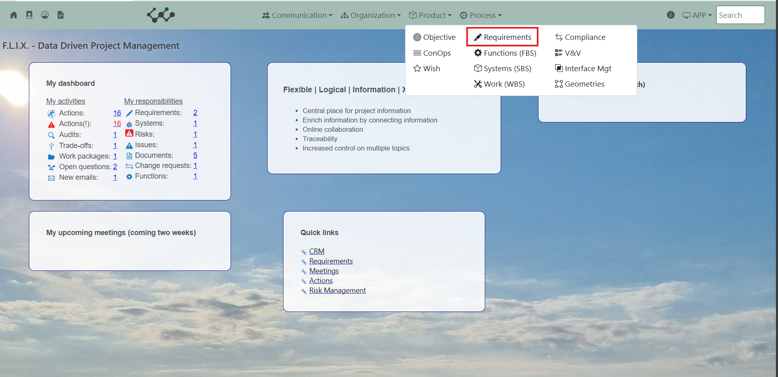

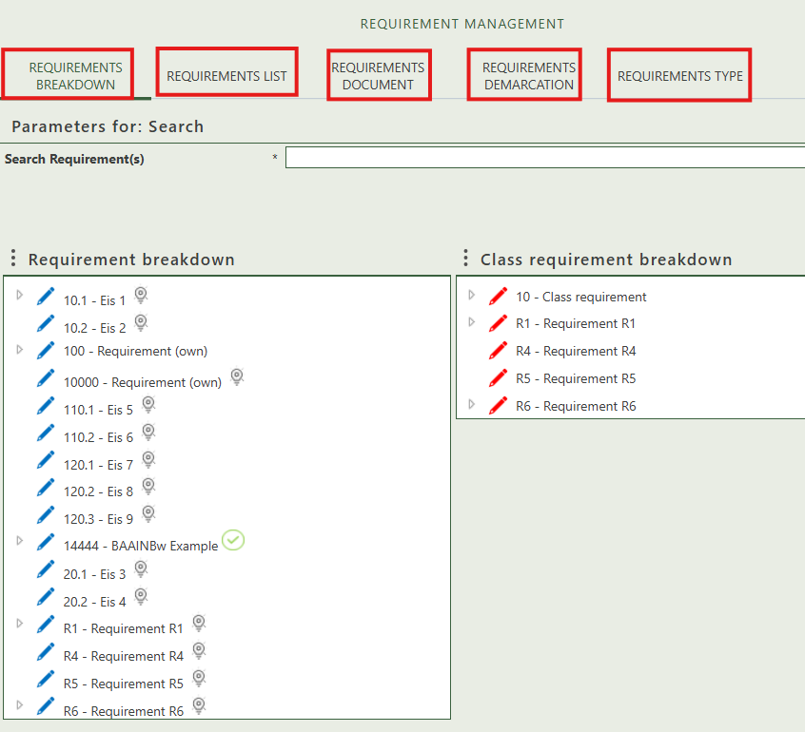Click on Systems (SBS) and you will see the following screen:

You will find five tabs in this module:

* Requirements breakdown.
* Requirements list.
* Requirements document.
* Requirements demarcation.
* Requirements type.

## 2.1 Requirements breakdown

This tab provides two separate trees: the Requirement Breakdown and the Class Requirement Breakdown. In both trees, you can create new requirements (by right-clicking on the white surface) and build a hierarchy by dragging and dropping items onto each other. This allows you to organize and structure both standard and class-specific requirements within the workspace.

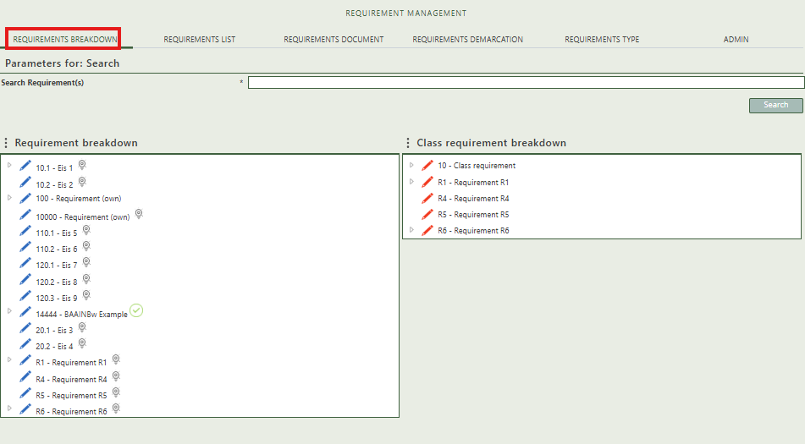

When you click on a specific object, its full details will appear on the right side of the screen, where you can review and update the information.

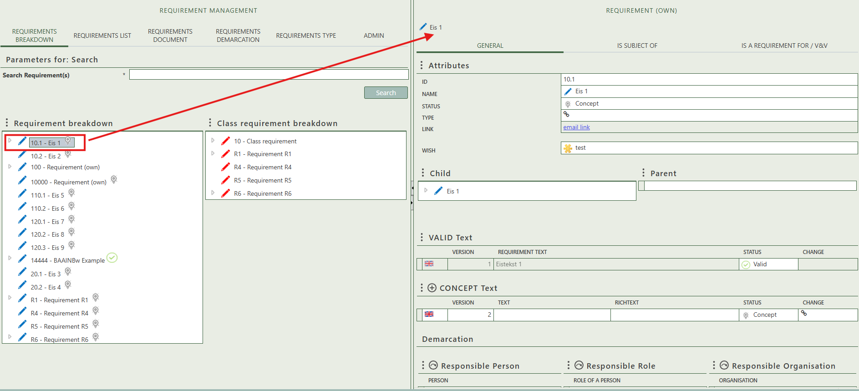

### 2.1.1 Own requirement

Fill in the general information of the physical object.

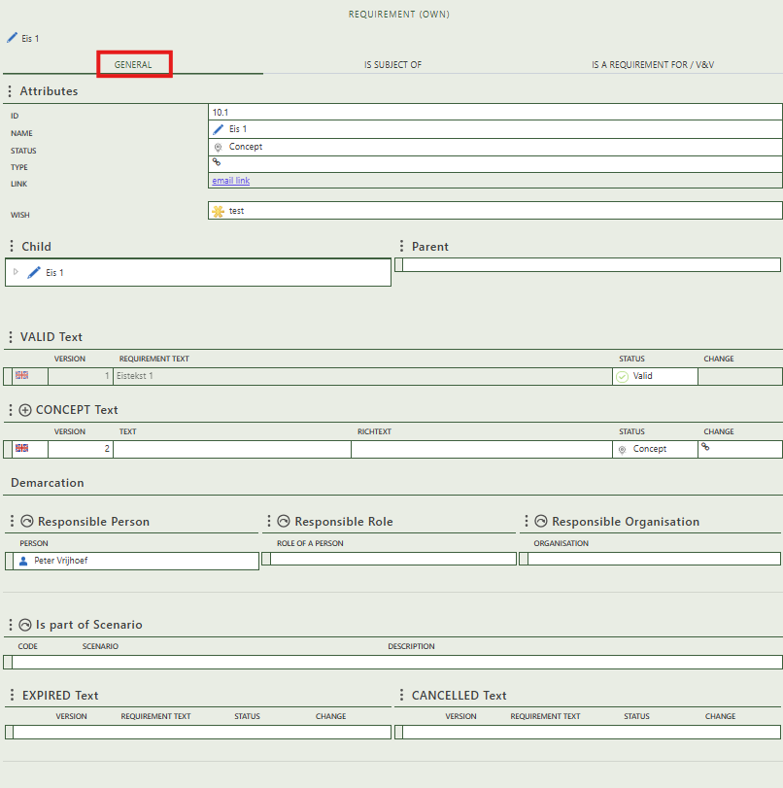

Shows if the requirement has any child/parent requirements.

Shows if the status of the requirement text is changed to expired or cancelled.

Allows you to select a scenario of which the requirement is a part.

Allows you to select the responsible persons, organizations, or role of a person.

Allows you to create concept text for the requirement. If you change the status to valid it will shift to the valid text table.

Shows whether the requirement is the subject of a question.

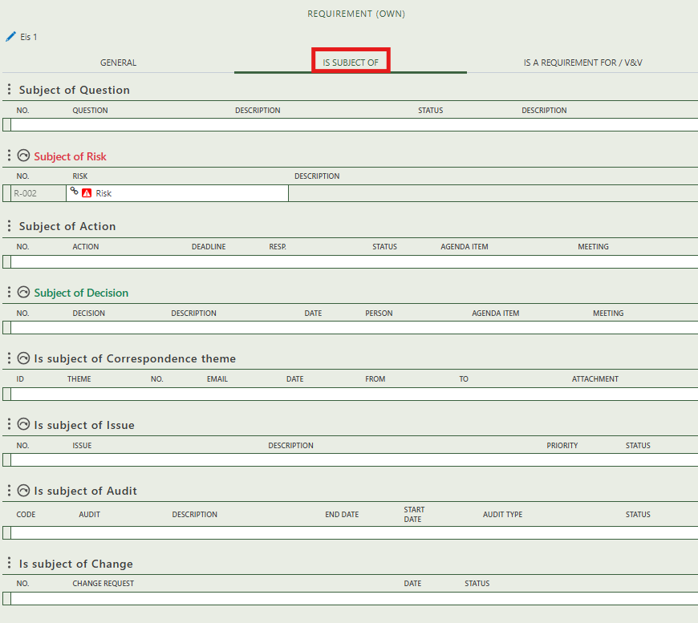

Allows you to assign this requirement as the subject of one or more risk.

Allows you to assign this requirement as the subject of one or more audit.

Shows you what change have this requirement as subject.

Allows you to create an issue that has this requirement as subject.

Allows you to assign this requirement as the subject of one or more decision.

Allows you to assign this requirement as the subject of one or more correspondence themes.

Shows whether the requirement is the subject of an action.

Allows you to select an activity for which this requirement applies.

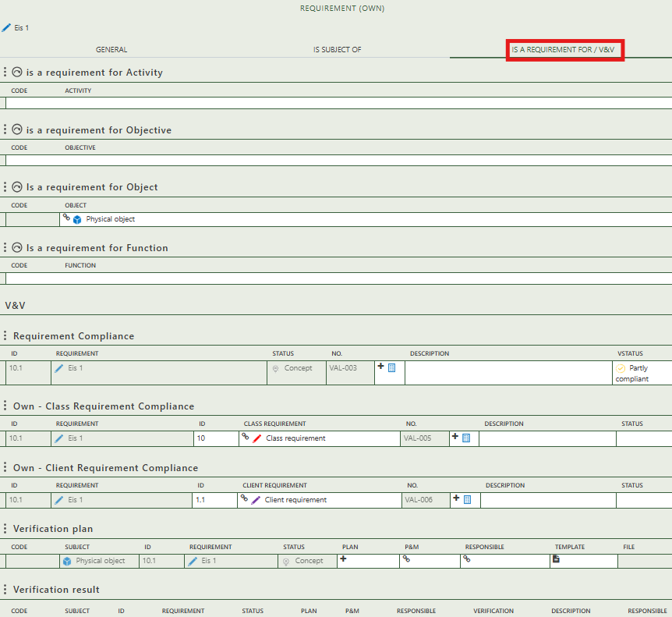

Allows you to select a client and/or class requirement and create compliances for them.

Allows you to create a verification for this requirement and the selected subject.

Allows you to create a compliance for this requirement.

Allows you to select an function for which this requirement applies.

Allows you to select an object for which this requirement applies.

Allows you to select an objective for which this requirement applies.

Shows you the verification results for this requirement.

### 2.1.2 Class requirement

Fill in the general information of the physical object.

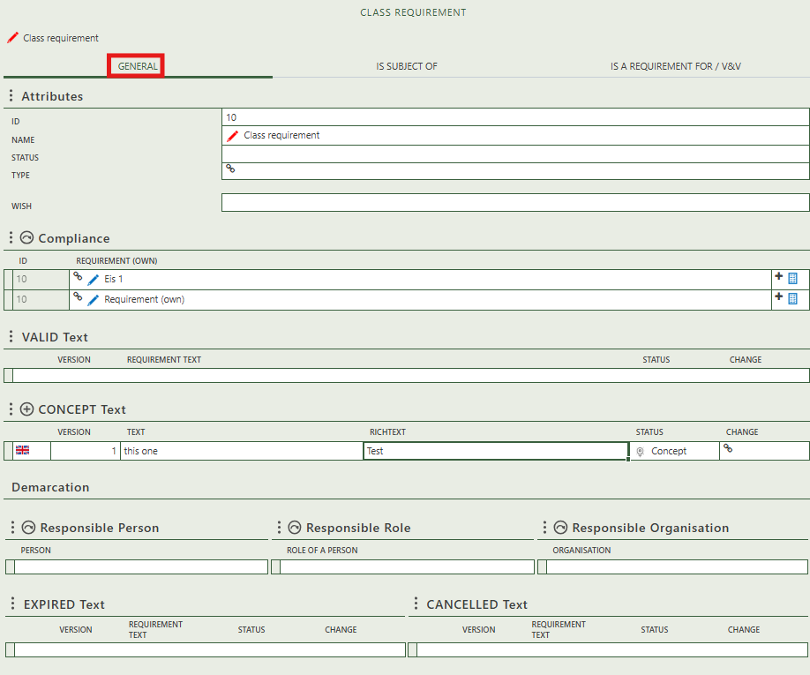

Create compliances by selecting own requirement(s).

Shows if the status of the requirement text is changed to expired or cancelled.

Allows you to select the responsible persons, organizations, or role of a person.

Allows you to create concept text for the class requirement. If you change the status to valid it will shift to the valid text table.

Shows whether the class requirement is the subject of a question.

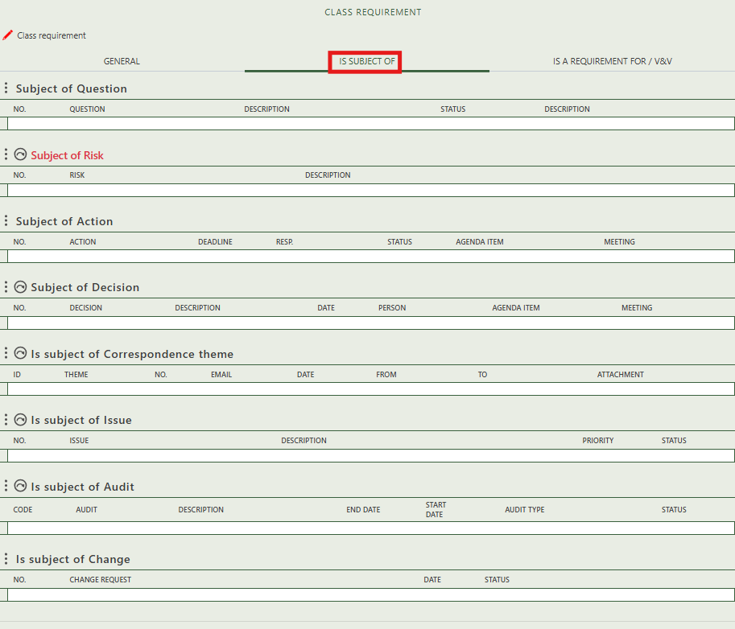

Allows you to assign this class requirement as the subject of one or more risk.

Shows you what change have this class requirement as subject.

Allows you to assign this class requirement as the subject of one or more audit.

Allows you to create an issue that has this class requirement as subject.

Allows you to assign this class requirement as the subject of one or more decision.

Allows you to assign this class requirement as the subject of one or more correspondence themes.

Shows whether the class requirement is the subject of an action.

Allows you to select an activity for which this class requirement applies.

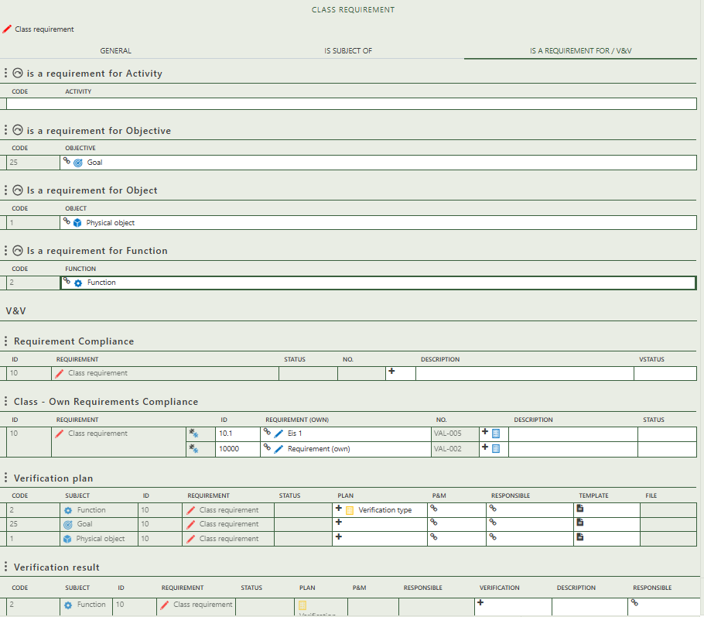

### 2.1.3 Client requirement

Allows you to select an object for which this class requirement applies.

Allows you to select a own requirement(s) and create compliances for them.

Allows you to create a verification for this class requirement and the selected subject.

Allows you to create a compliance for this class requirement.

Allows you to select an function for which this class requirement applies.

Allows you to select an objective for which this class requirement applies.

Shows you the verification results for this class requirement.

Fill in the general information of the physical object.

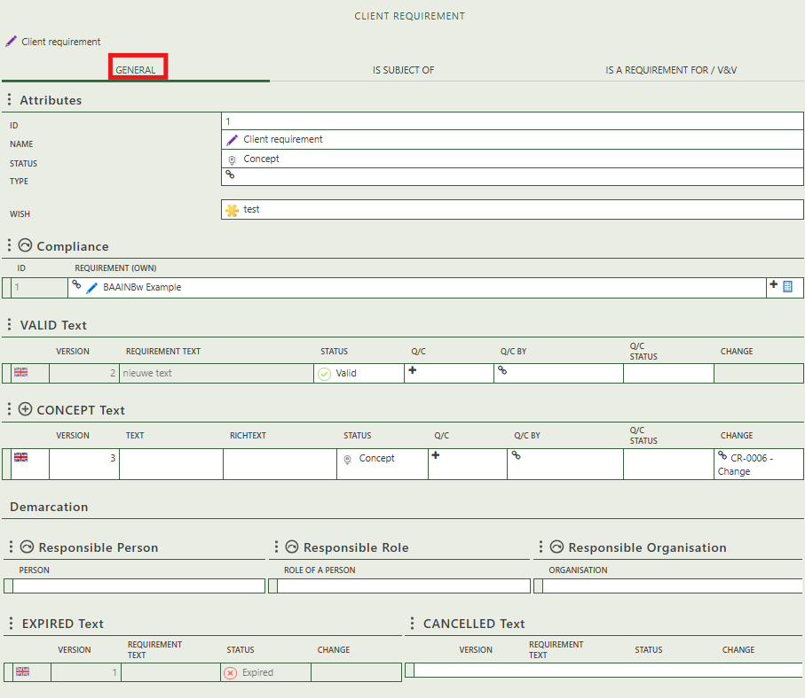

Create compliances by selecting own requirement(s).

Shows if the status of the requirement text is changed to expired or cancelled.

Allows you to select the responsible persons, organizations, or role of a person.

Allows you to create concept text for the client requirement. If you change the status to valid it will shift to the valid text table.

Shows whether the client requirement is the subject of a question.

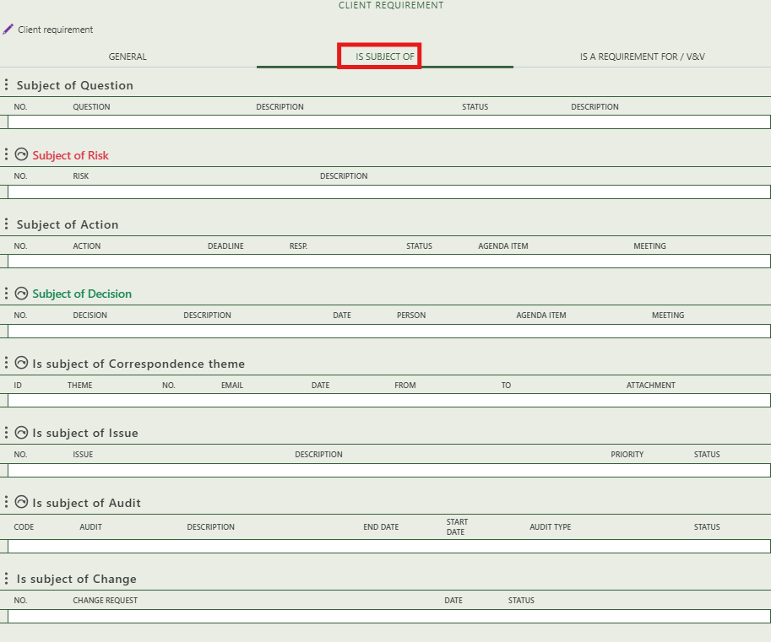

Allows you to assign this client requirement as the subject of one or more risk.

Allows you to create an issue that has this client requirement as subject.

Shows whether the client requirement is the subject of an action.

Shows you what change have this client requirement as subject.

Allows you to assign this client requirement as the subject of one or more audit.

Allows you to assign this client requirement as the subject of one or more decision.

Allows you to assign this client requirement as the subject of one or more correspondence themes.

Allows you to select an activity for which this client requirement applies.

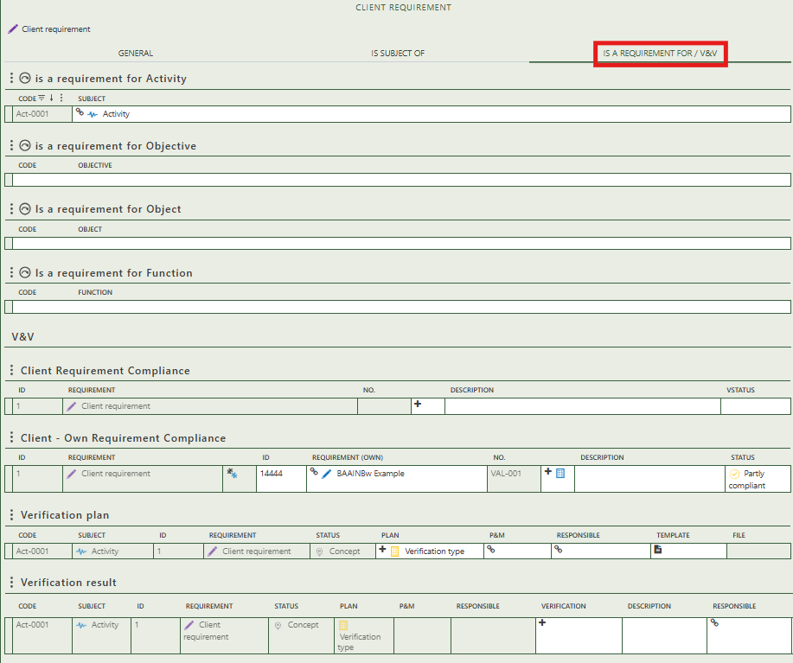

Shows you the verification results for this client requirement.

Allows you to select an objective for which this client requirement applies.

Allows you to select an object for which this client requirement applies.

Allows you to select a own requirement(s) and create compliances for them.

Allows you to create a verification for this client requirement and the selected subject.

Allows you to create a compliance for this client requirement.

Allows you to select a function for which this client requirement applies.

## 2.2 Hybrid

This tab provides an overview of all requirements within the workspace. By right-clicking on the white cells in the Requirements column, you can create three types of requirements:

• Own requirements

• Class requirements

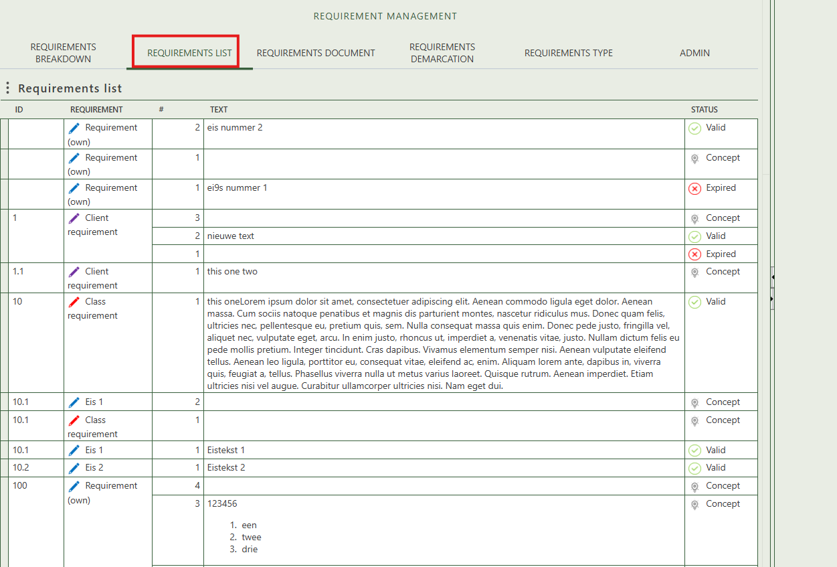• Client requirements

## 2.3 Requirements document

This tab allows you to create and manage requirement documents. To add a new requirement document, right-click on the white space within the “Requirement Documents” tree on the left side of your screen. The tree structure supports a hierarchy, which you can build by dragging and dropping items onto one another.

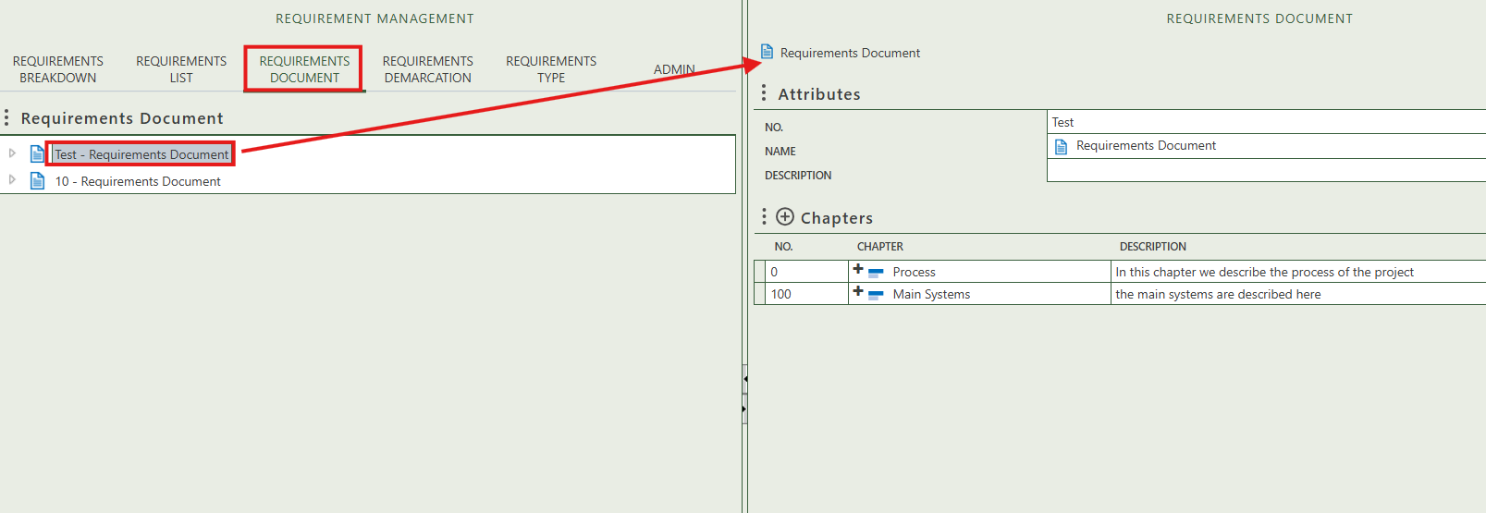

When you click on a specific requirement document, its full details will appear on the right side of the screen, where you can review and update the information. Here, you can enter general information about the requirement document and create chapters. The chapters are clickable and allow you to add general information as well as create paragraphs. When you click on a paragraph, you can enter its general information, create sub-paragraphs, and add own requirements that belong to that paragraph.

## 2.4 Requirements demarcation

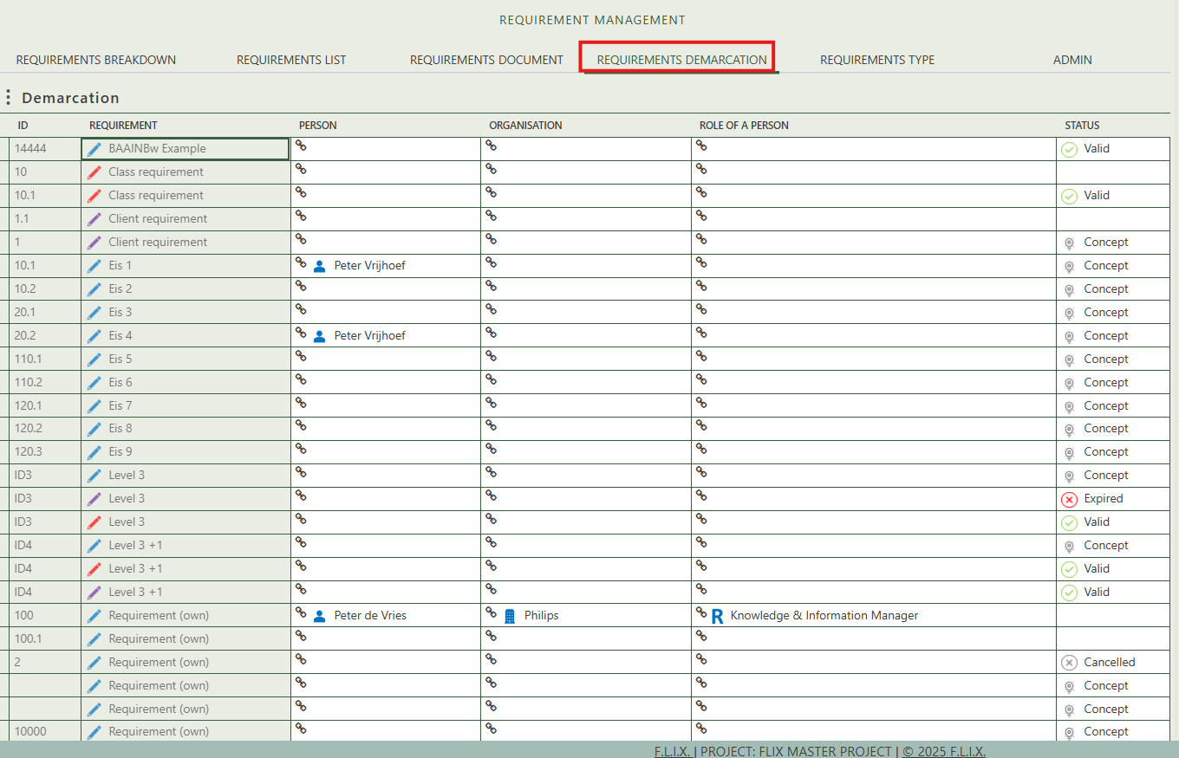This tab provides an overview of all requirements within the workspace. The demarcation allows you to easily see which person, organization, and/or role is responsible for each requirement, as well as the current status of the requirement.

## 2.5 Requirements types

This tab provides an overview of all requirements types and allows you to create new ones (+ sign above the table). The requirement type does not have a detail page, which is why it is not shown or explained.

