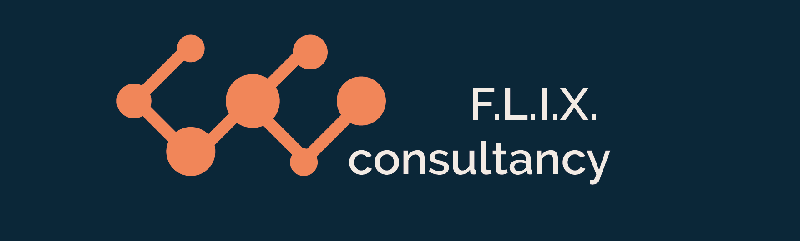

Author: F.Bovendeert

Version: V1.0

Publication date: 25-07-2025

Work Instruction – Q&A

|  |  |  |  |  |
| --- | --- | --- | --- | --- |
| Work Instruction – Q&A | | | | Project: Master Template |
| Function | Doc No: | Doc sheet: | Doc Rev.: | Pages |
|  |  |  |  |  |
| Doc Class: | Created by: | Created on: | Changed by: | Changed Date: |
|  | Floris Bovendeert | 25-7-2025 |  |  |

In this document, you will find the basic work instructions for **Q&A.**

The document begins with general information about the module in Relatics, including an introduction, objective, and solution. Following this, the structure of the module as implemented in our master template is explained. The subchapters correspond to the tabs in Relatics. Whenever a relevant clickable element appears within a tab, its detail page is also described.

Content

1. General 3

1.1 Introduction 3

1.2 Objective 3

1.3 Solution 3

2. Module 4

2.1 Questions 5

2.2Q&A overview 7

**Revision History**

|  |  |  |  |
| --- | --- | --- | --- |
| Revision | Date | By | Remarks |
|  |  |  |  |
|  |  |  |  |

# 1. General

## 1.1 Introduction

In this module, you can manage all project-related questions and answers. Questions often arise during meetings, discussions, or project activities, and answers provide the necessary clarification or solutions. Relatics enables you to record, track, and maintain a clear history of these Q&As in a structured and transparent way.

## 1.2 Objective

The goal is to ensure full traceability and accessibility of all project questions and their corresponding answers. In many projects, questions and answers are shared informally or scattered across emails and notes, which can lead to misunderstandings or lost information.

## 1.3 Solution

Relatics addresses this problem—if used correctly and consistently. By registering questions and answers in this module, you create a shared and searchable record that enhances communication, accountability, and knowledge sharing throughout the project.

# 2. Module

Go to -> Communication -> Q&A.

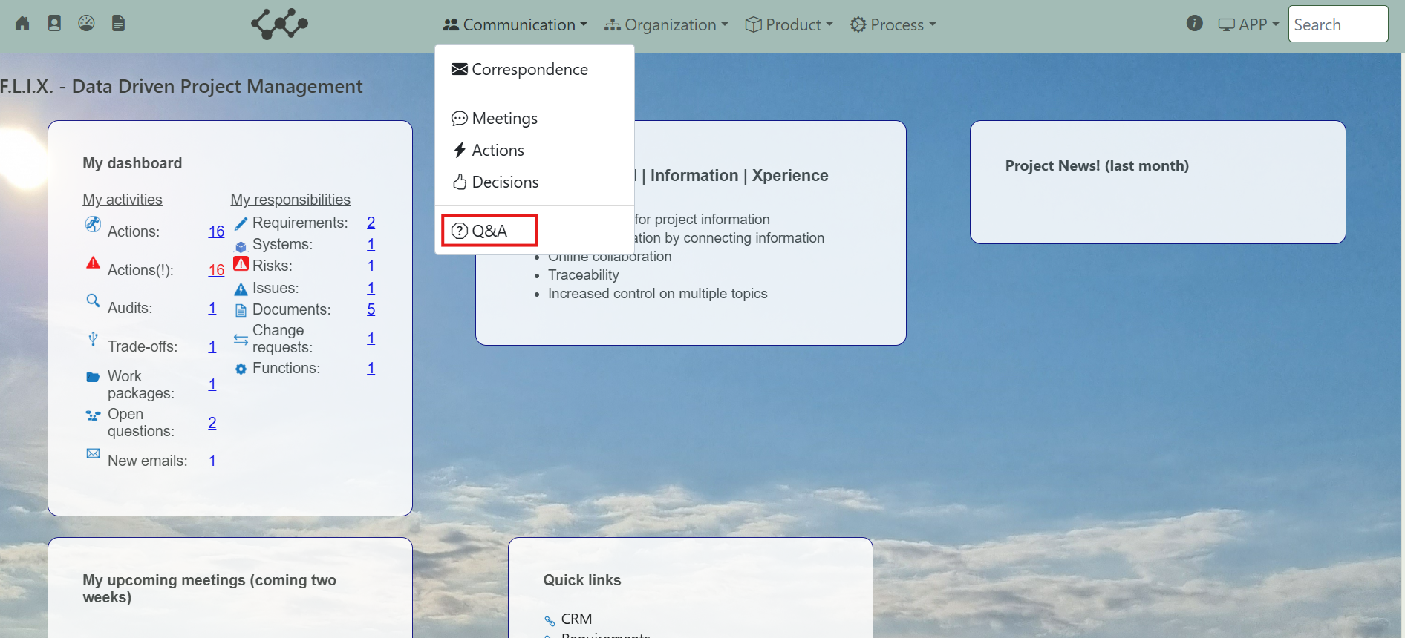

Click and you will see the following screen:

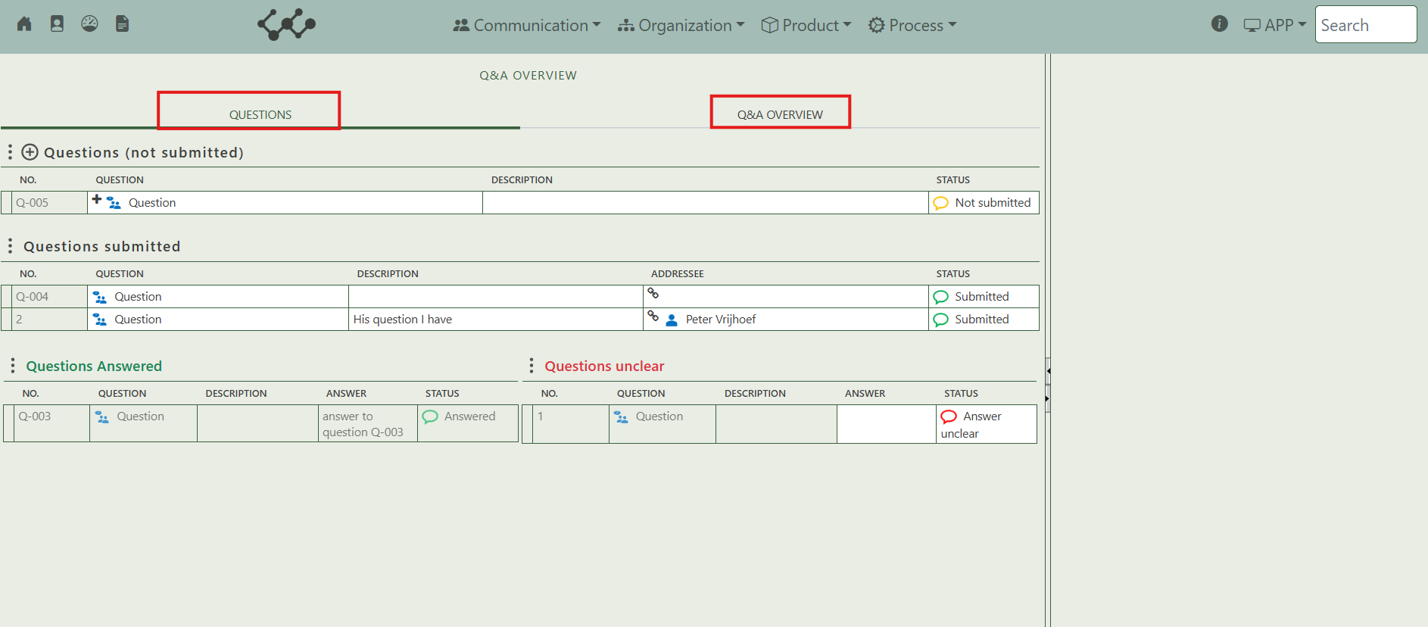

You will find two tabs in this module:

* Questions.
* Q&A overview

## 2.1 Questions

This tab contains an overview of all the questions that are created in this workspace. Based on their status they are divided in four tables:

* Questions (not submitted).
* Questions submitted.
* Questions answered.
* Questions unclear.

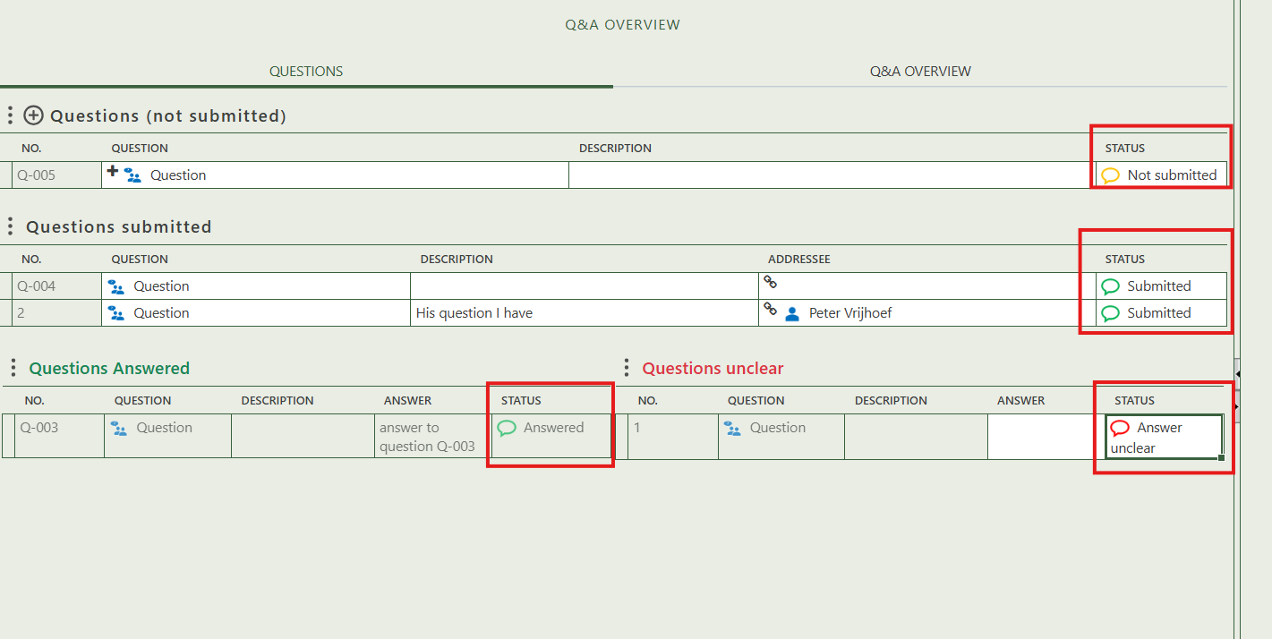

By pressing on the + sign next to question, you can create new questions.

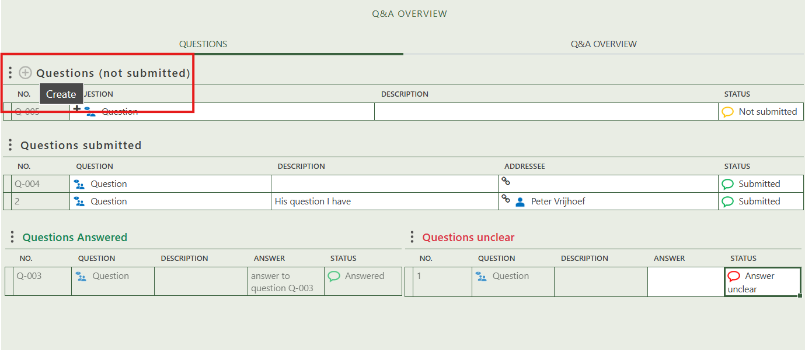

When you click on a specific decision, its full details will appear on the right side of the screen, where you can review and update the information.

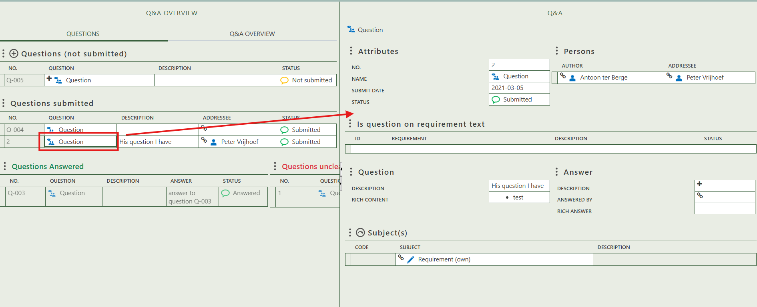

Select the person who is the author of the question. decision.

Fill in the general information of the specific question.

Select the person to whom the question is directed.

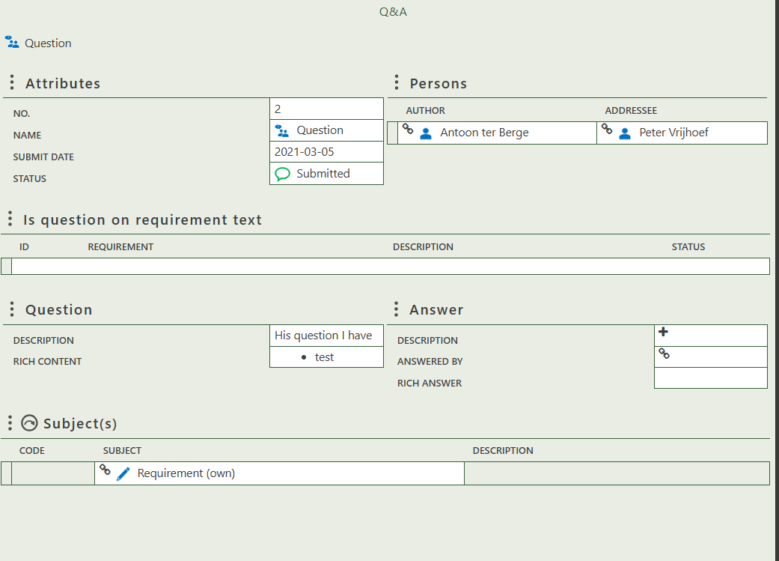

Shows requirement text from which the question originates.

Allows you to create an answer, specify who provided it, and include rich content.

Allows you fill in the description and perhaps rich content of the question.

Allows you to select a subject to which the question applies.

## 2.2 Q&A overview

This tab contains one table that shows a big overview of all the questions and their answers.

