

Author: F.Bovendeert

Version: V1.0

Publication date: 25-07-2025

Work Instruction - Planning

|  |  |  |  |  |
| --- | --- | --- | --- | --- |
| Work Instruction - Planning | | | | Project: Master Template |
| Function | Doc No: | Doc sheet: | Doc Rev.: | Pages |
|  |  |  |  |  |
| Doc Class: | Created by: | Created on: | Changed by: | Changed Date: |
|  | Floris Bovendeert | 25-7-2025 |  |  |

In this document, you will find the basic work instructions for **Planning.**

The document begins with general information about the module in Relatics, including an introduction, objective, and solution. Following this, the structure of the module as implemented in our master template is explained. The subchapters correspond to the tabs in Relatics. Whenever a relevant clickable element appears within a tab, its detail page is also described.

Content

1. General 3

1.1 Introduction 3

1.2 Objective 3

1.3 Solution 3

2. Module 4

2.1 Phases & Milestones 5

2.2Types 8

3. Planning overview 8

**Revision History**

|  |  |  |  |
| --- | --- | --- | --- |
| Revision | Date | By | Remarks |
|  |  |  |  |
|  |  |  |  |

# 1. General

## 1.1 Introduction

In this module, you can manage all project-related planning elements. Projects typically progress through defined phases, each marked by key milestones. Relatics enables you to create, edit, and structure these phases and milestones in a clear and consistent way—helping you maintain oversight and coordination throughout the project lifecycle.

## 1.2 Objective

The goal is to ensure full traceability and structure in the project planning. In many cases, phases and milestones are loosely defined or scattered across different documents, which can lead to misalignment and unclear expectations. Imagine trying to determine when a milestone was achieved or what phase it belonged to—without a centralized and structured overview, this becomes difficult.

## 1.3 Solution

Relatics supports a structured planning process—if used consistently. By defining phases and milestones in this module, and linking milestones to the relevant phases in a hierarchical structure, you create a clear and navigable project timeline. This enhances transparency, supports progress monitoring, and aligns all stakeholders around key project moments.

# 2. Module

Go to -> Process -> Planning-> Phases & Milestones and Planning overview.

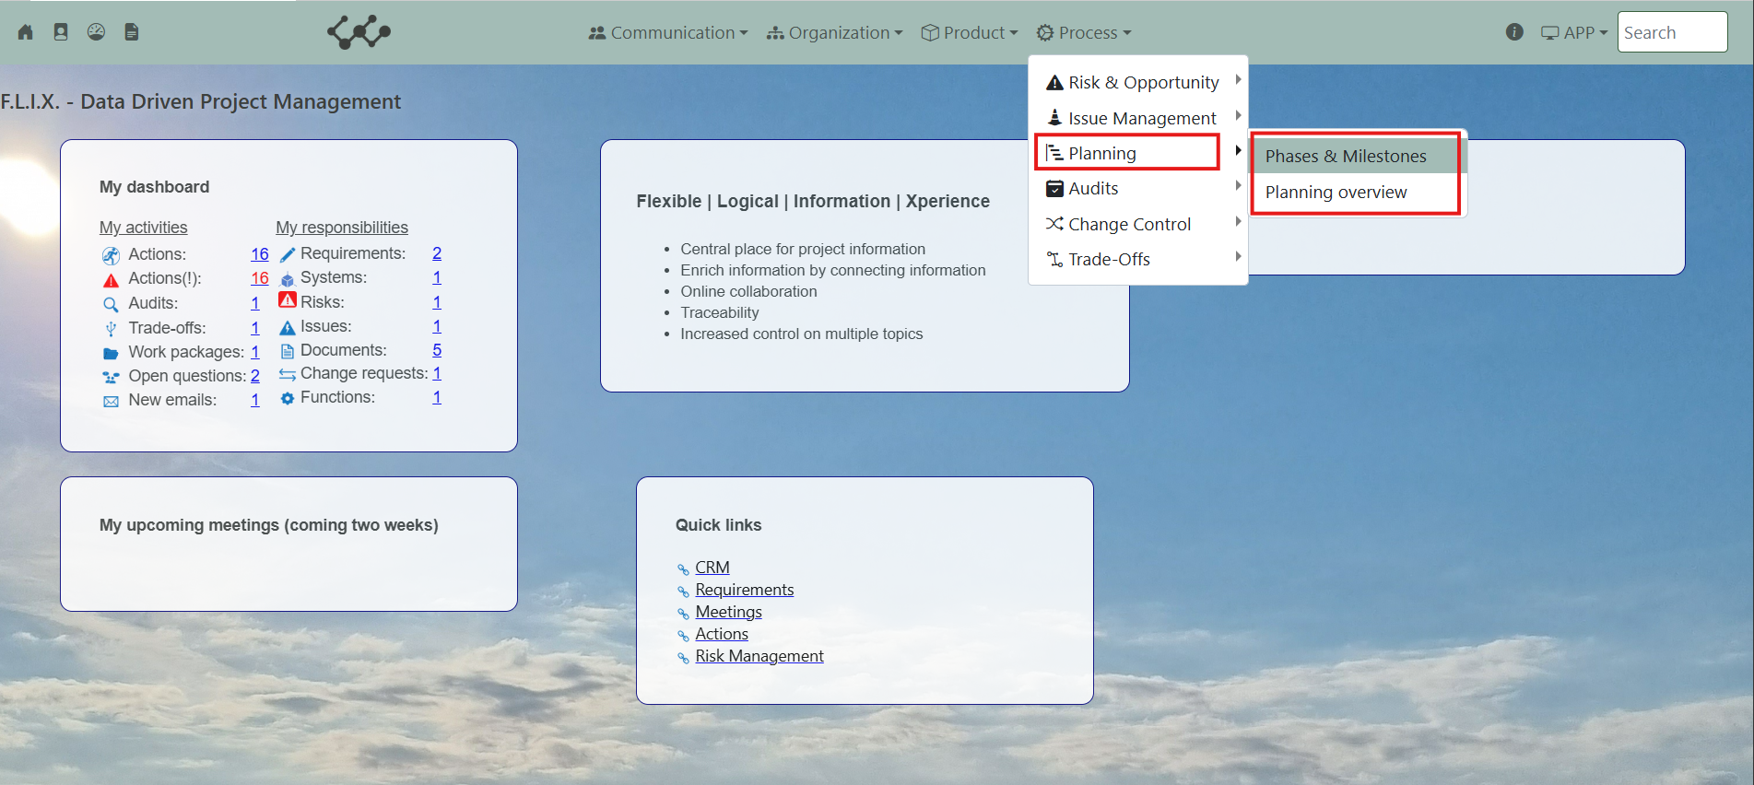

Click on Phases & Milestones and you will see the following screen:

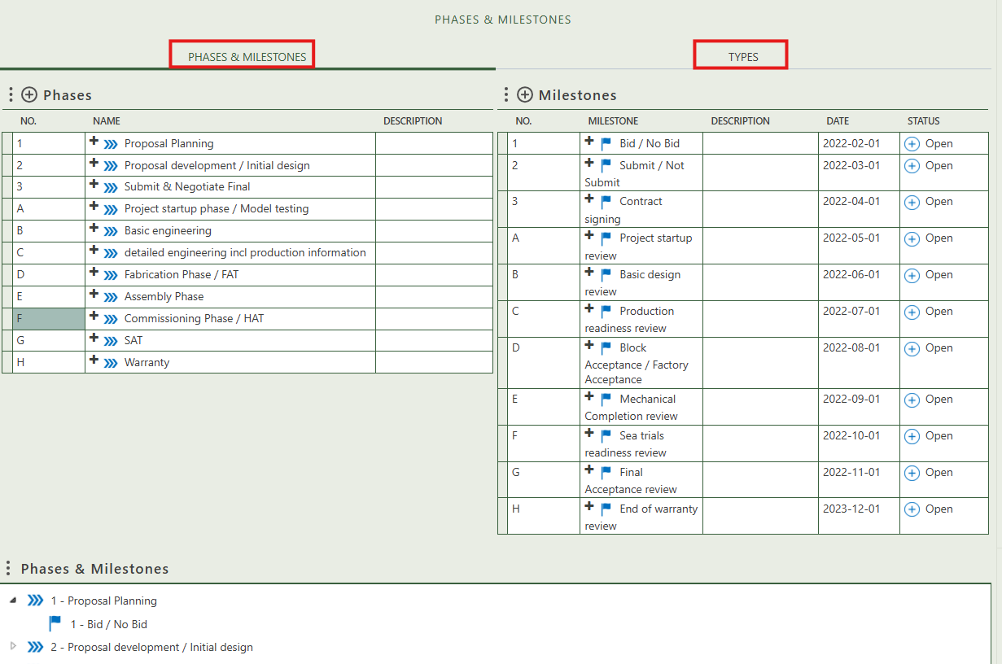

You will find two tabs in this module:

* Phases & Milestones.
* Types.

## 2.1 Phases & Milestones

This tab provides an overview of all phases and milestones within the workspace. You can create new entries by clicking the "+" icon above each table. Below the tables, a tree structure is displayed, allowing you to view, create, and modify the hierarchical relationship between phases and milestones.

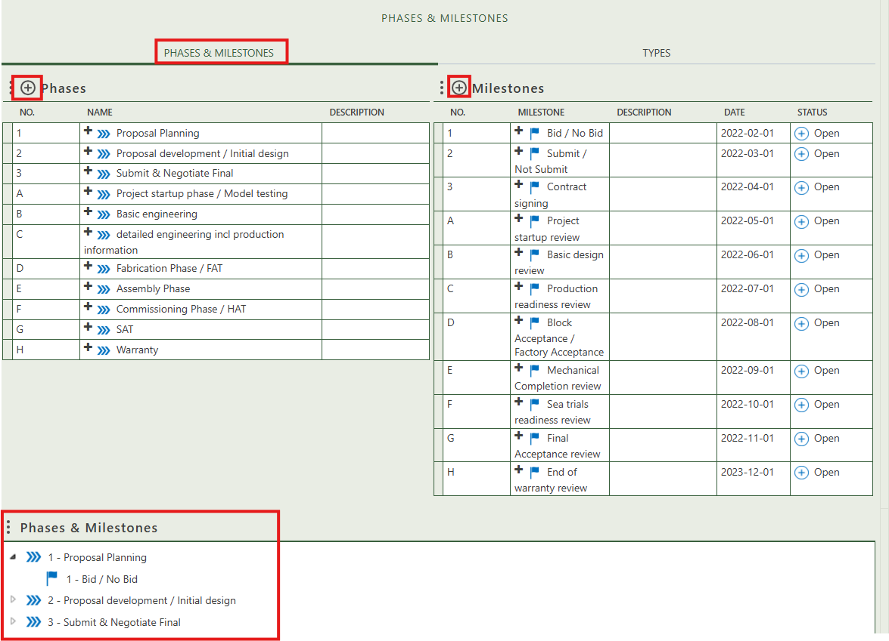

When you click on a specific phase, its full details will appear on the right side of the screen, where you can review and update the information.

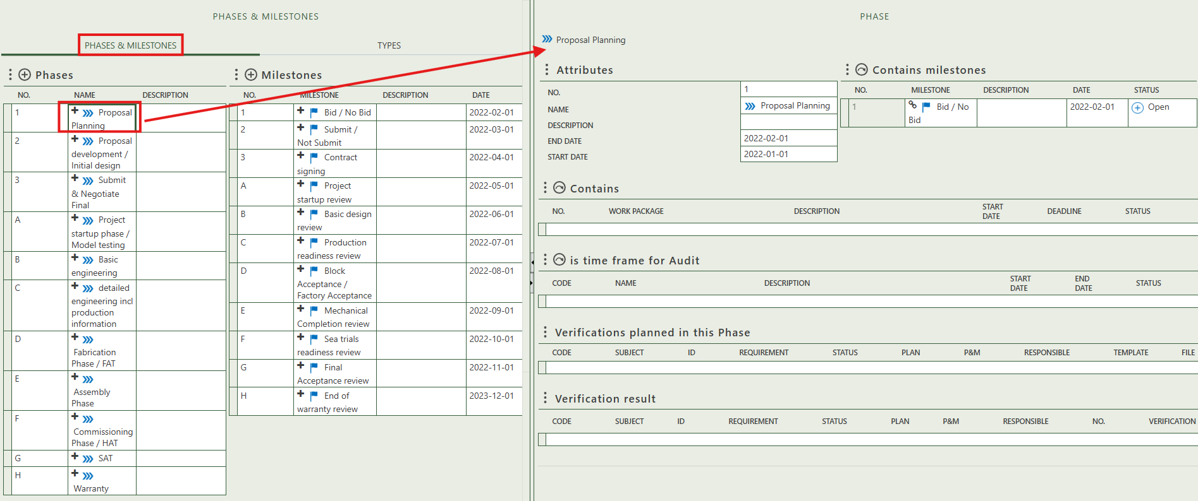

Fill in the general information of the specific phase.

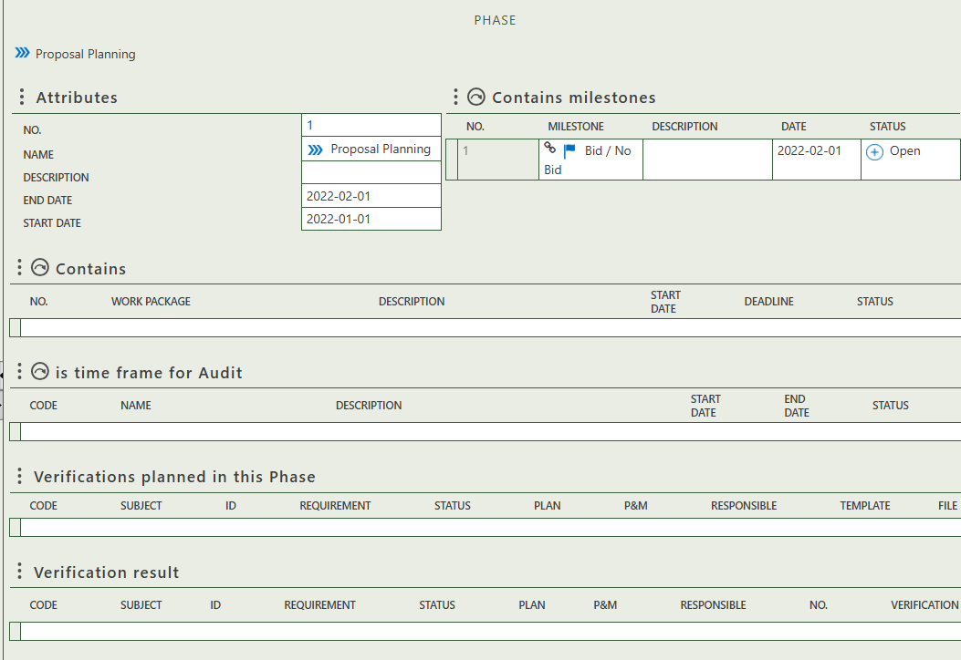

Select the milestone(s) included in this phase.

Select the work package(s) included in this phase.

Select the audit(s) included in this phase.

Shows the verification(s) results that are planned in this phase.

Shows the verification(s) that are planned in this phase.

When you click on a specific milestone, its full details will appear on the right side of the screen, where you can review and update the information.

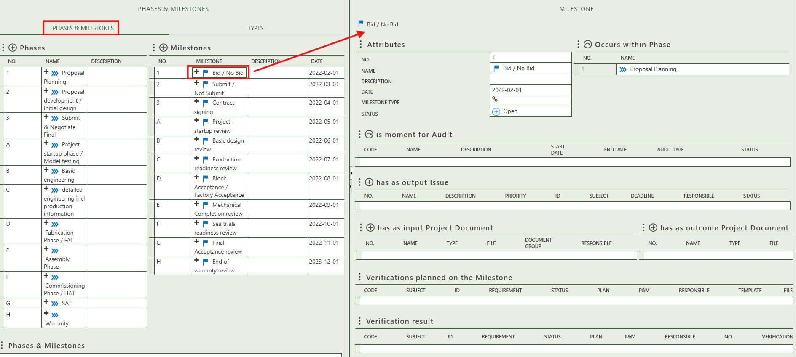

Fill in the general information of the specific milestone.

Select the phase(s) in which the milestone belongs.

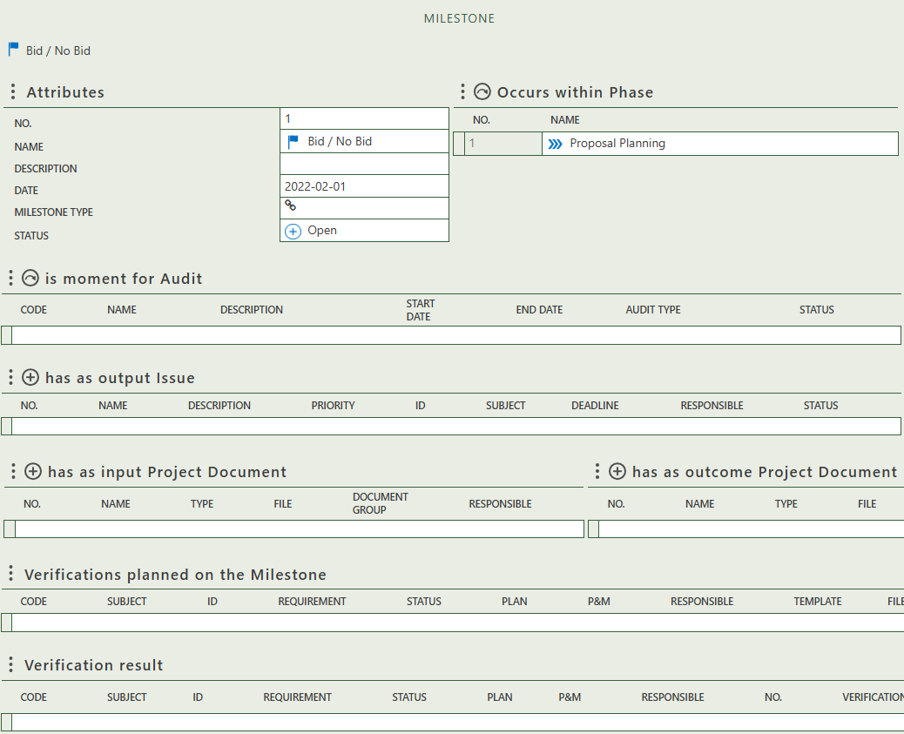

Select the audit(s) that take place at this milestone.

Allows you to create issue(s) as output of the milestone.

Allows you to create project documents as outcome of this milestone.

Allows you to create project documents as input for this milestone.

Shows the verification(s) results of this milestone.

Shows the verification(s) that are planned in on this milestone.

## 2.2 Types

This tab provides an overview of all milestones and phase types and allows you to create new ones. When you click on a specific milestone or phase type, its full details will appear on the right side of the screen, where you can review and update the information.

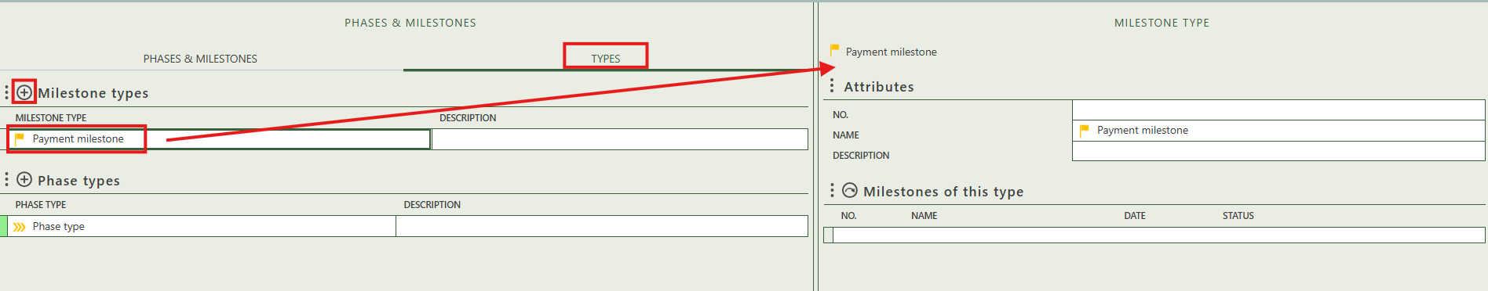

# 3. Planning overview

The planning overview is currently empty and leaves room for project specific request(s).

