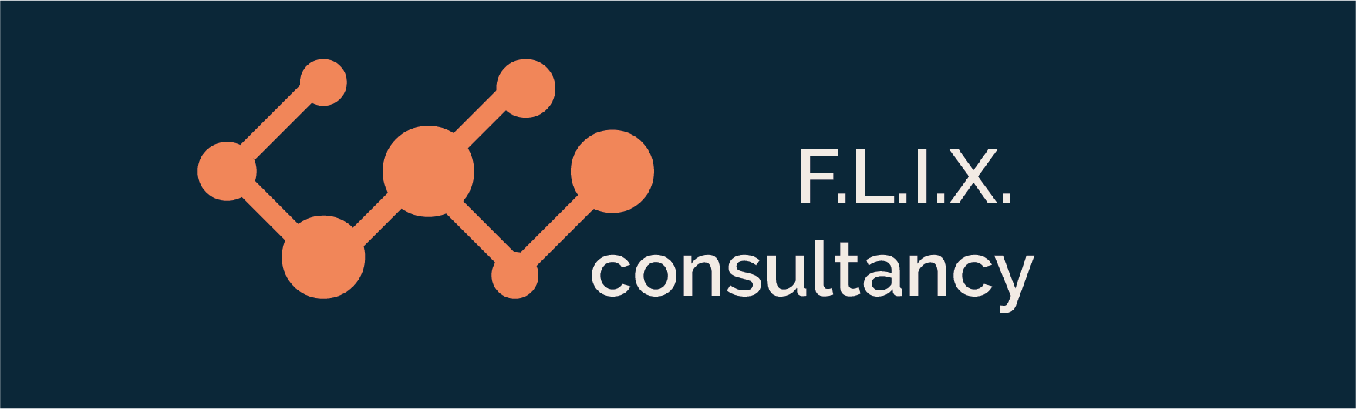

Author: F.Bovendeert

Version: V1.0

Publication date: 25-07-2025

Work Instruction - Organization

|  |  |  |  |  |
| --- | --- | --- | --- | --- |
| Work Instruction - Organization | | | | Project: Master Template |
| Function | Doc No: | Doc sheet: | Doc Rev.: | Pages |
|  |  |  |  |  |
| Doc Class: | Created by: | Created on: | Changed by: | Changed Date: |
|  | Floris Bovendeert | 25-7-2025 |  |  |

In this document, you will find the basic work instructions for **Organization.**

The document begins with general information about the module in Relatics, including an introduction, objective, and solution. Following this, the structure of the module as implemented in our master template is explained. The subchapters correspond to the tabs in Relatics. Whenever a relevant clickable element appears within a tab, its detail page is also described.

Content

1. General 3

1.1 Introduction 3

1.2 Objective 3

1.3 Solution 3

2. Module 4

2.1 Project organisation 5

2.2Teams 7

2.3 Departments & types 8

2.4 List of all addresses 9

2.5 Checks 9

**Revision History**

|  |  |  |  |
| --- | --- | --- | --- |
| Revision | Date | By | Remarks |
|  |  |  |  |
|  |  |  |  |

# 1. General

## 1.1 Introduction

In this module, you manage all organization-related information within your project. This includes organizations, persons, roles, teams, departments, addresses, and their classifications. Relatics allows you to record and maintain this data in a structured way, ensuring clarity and consistency across the project organization

## 1.2 Objective

The aim is to ensure full traceability and transparency of who is involved in the project, in which role, from which organization, and at which location. In many projects, this information becomes fragmented or outdated, leading to miscommunication and inefficiencies. A centralized and structured approach prevents this.

## 1.3 Solution

Relatics addresses this issue by helping you manage all relevant organizational data in one place. When used consistently, this module provides insight into the organizational structure, responsibilities, and communication lines. It supports effective collaboration, avoids duplication, and enables smooth project execution.

# 2. Module

Go to -> Organization -> Organization.

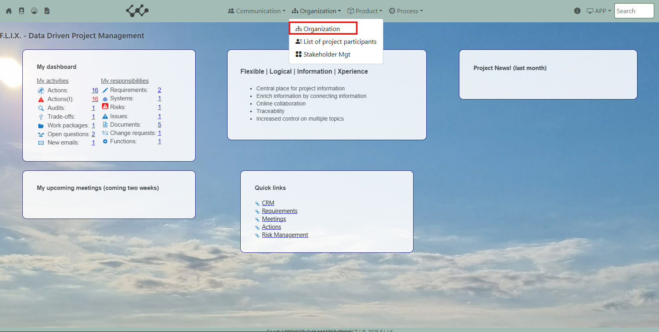

Click and you will see the following screen:

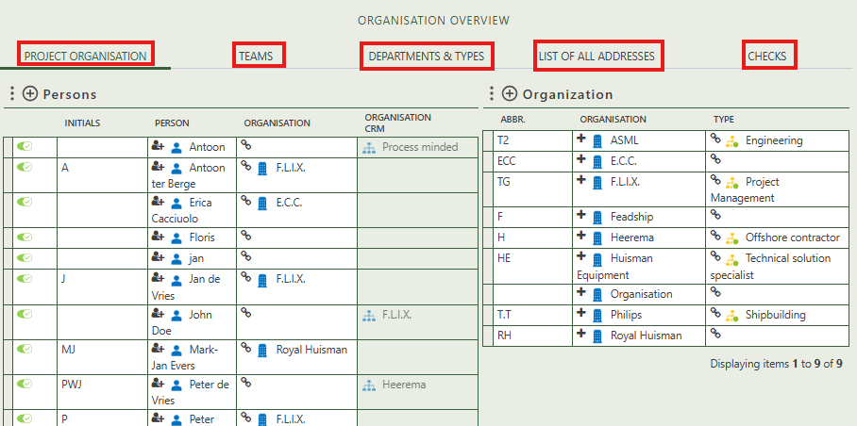

You will find three tabs in this module:

* Project organisation.
* Teams.
* Departments & Types
* List of all addresses.
* Checks.

## 2.1 Project organisation

This tab contains an overview of all persons, organizations, roles of persons, and roles of organizations.

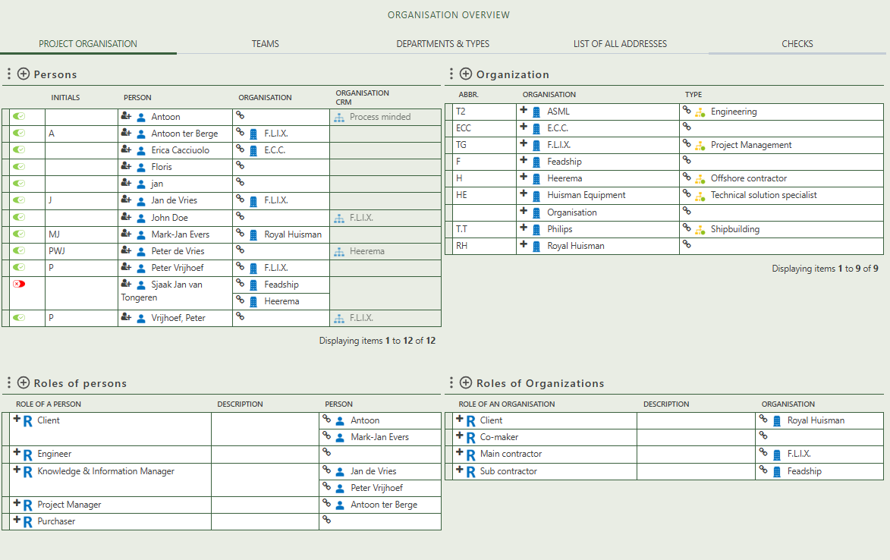

By pressing on the + sign next to decision, you can create new instances of the specific element.

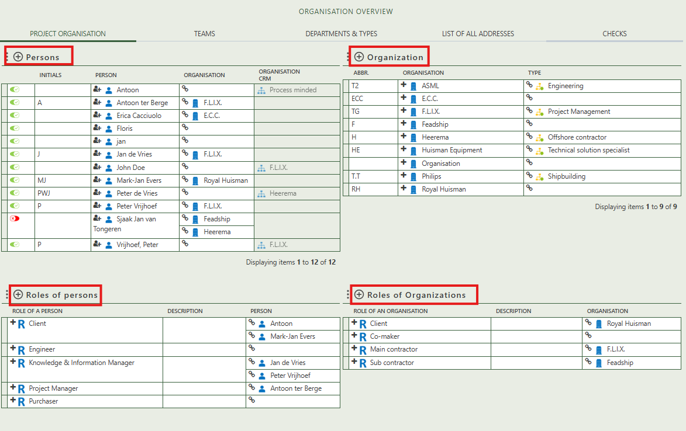

When you click on a person, its full details will appear on the right side of the screen, where you can review and update the information.

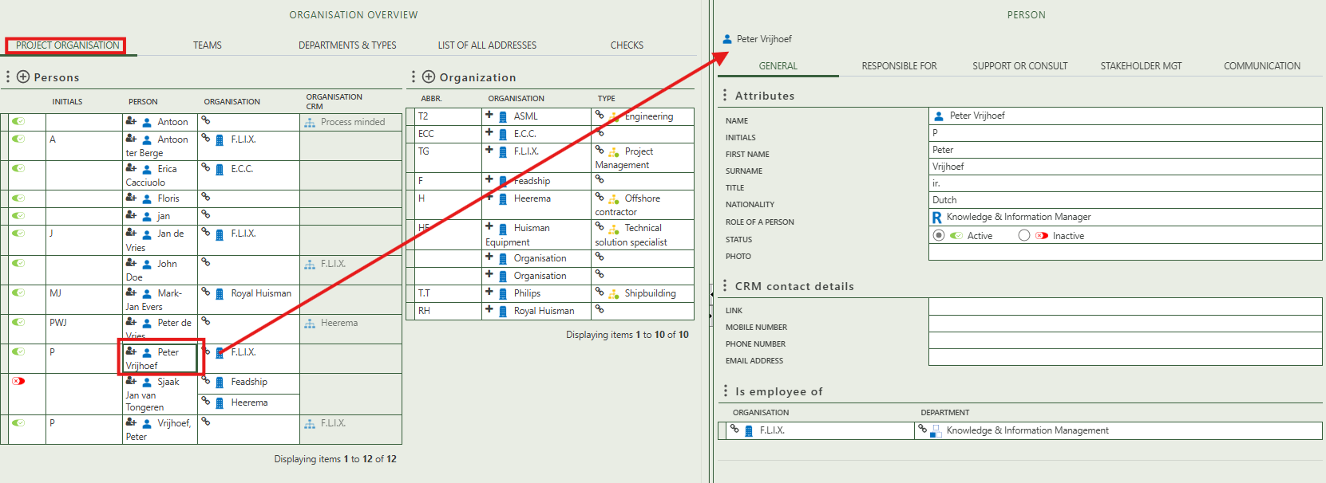

By clicking on a specific tab on the person’s detail page, you can access, review, and update targeted information about that individual. Each tab provides a different category of personal data:

* **General** – Displays general information about the person.
* **Responsible** **for** – Lists all instances where the person is marked as responsible.
* **Support** **or** **consult** – Shows where the person is selected as a support or consultation contact.
* **Stakeholder** **mgt** – Allows you to describe the person as a stakeholder and assess their influence and interest.
* **Communication** – Displays emails sent and received by the person, as well as questions submitted or answered.

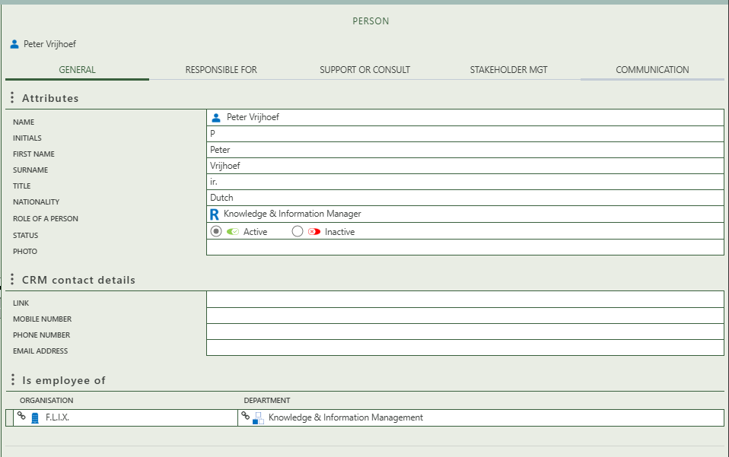

General information about the person is automatically updated if it has been filled in within the CRM and the person is correctly linked to their corresponding CRM entry.

Fill in the general information of the specific decision.

Option tot select an organization and department that applies for the person.

By clicking on a specific tab on the organization detail page, you can access, review, and update targeted information about that organization. Each tab provides a different category of organizations data:

* **General =** Displays general information about the organization.
* **Stakeholder mgt** = Allows you to describe the person as a stakeholder and assess their influence and interest.
* **Correspondence** = Displays all the emails the organization has sent or received

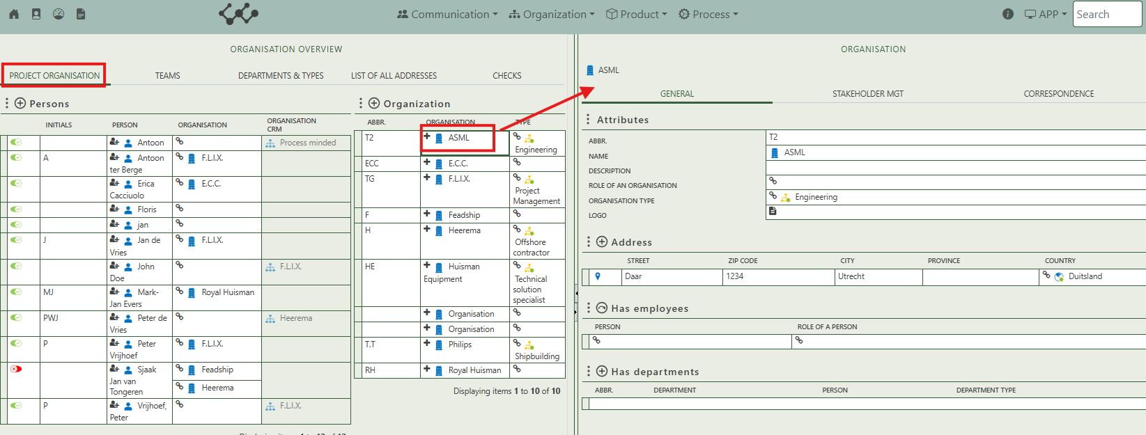

## 2.2 Teams

This tab allows you to create teams by right-clicking in the white area and arranging them hierarchically. By selecting a specific team, a detail page opens on the right side of the screen. Here, you can enter general information about the team, define sub-teams, link recurring meetings, assign a meeting template, and specify which people belong to the team.

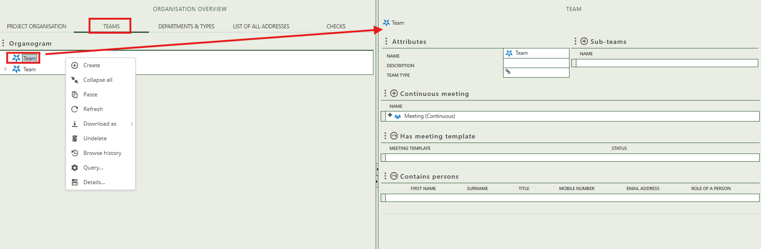

## 2.3 Departments & types

This tab provides an overview of departments, organization types, and team types. Users can add new entries by clicking the + sign above each table. Selecting a specific entry opens its detail page on the right side of the screen, where you can view and edit all related information.

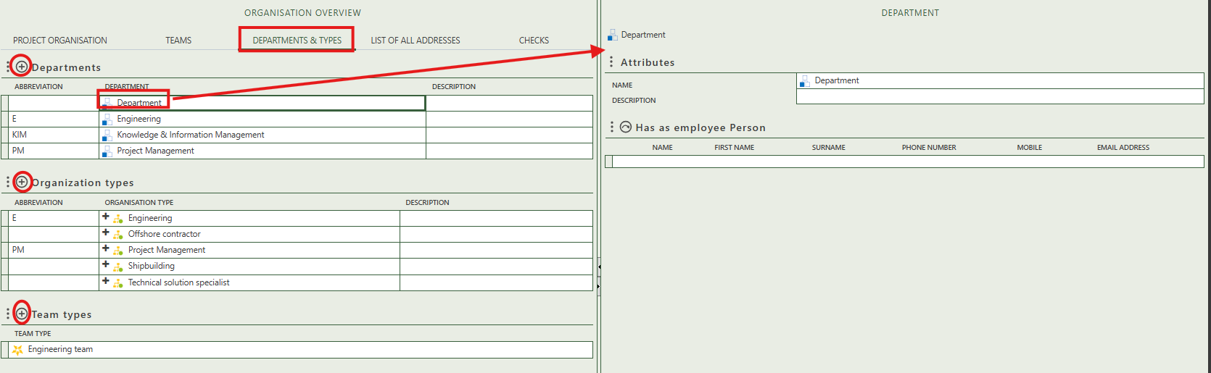

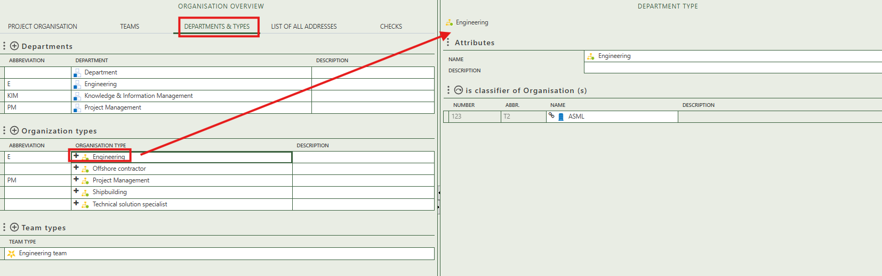 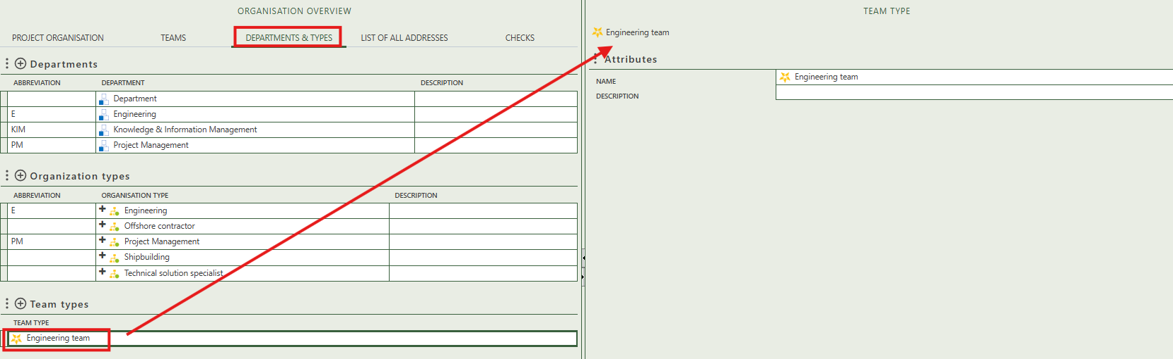

## 2.4 List of all addresses

This tab allows users to create geographical or digital addresses for organizations.

To register a geographical address, you must first link it to an existing organization from the CRM or create a new one. The first table shows that multiple addresses can be added to a single organization. To create a new address, right-click the marker icon with the + sign and select Create.

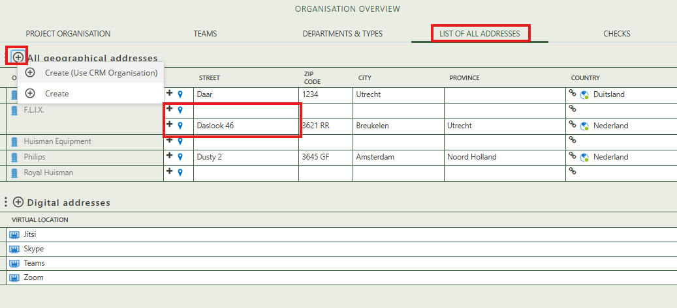

## 2.5 Checks

This final tab displays all individuals with an active status who are not currently linked to any organization.

