

Author: F.Bovendeert

Version: V1.0

Publication date: 25-07-2025

Work Instruction - Objective

|  |  |  |  |  |
| --- | --- | --- | --- | --- |
| Work Instruction - Objective | | | | Project: Master Template |
| Function | Doc No: | Doc sheet: | Doc Rev.: | Pages |
|  |  |  |  |  |
| Doc Class: | Created by: | Created on: | Changed by: | Changed Date: |
|  | Floris Bovendeert | 25-7-2025 |  |  |

In this document, you will find the basic work instructions for **Objectives.**

The document begins with general information about the module in Relatics, including an introduction, objective, and solution. Following this, the structure of the module as implemented in our master template is explained. The subchapters correspond to the tabs in Relatics. Whenever a relevant clickable element appears within a tab, its detail page is also described.

Content

1. General 3

1.1 Introduction 3

1.2 Objective 3

1.3 Solution 3

2. Module 4

2.1Objective 5

**Revision History**

|  |  |  |  |
| --- | --- | --- | --- |
| Revision | Date | By | Remarks |
|  |  |  |  |
|  |  |  |  |

# 1. General

## 1.1 Introduction

In this module, you can manage all project-related objectives. Objectives represent the goals or intentions that the project aims to achieve and often serve as a foundation for defining requirements and verifying success. Relatics enables you to document each objective in a structured way—capturing its context, related requirements, and validation path—ensuring transparency and alignment throughout the project.

## 1.2 Objective

The aim is to provide full traceability and clarity regarding the objectives of the project. Without a central place to define and structure objectives, it becomes difficult to monitor progress, ensure alignment with stakeholder goals, or verify that project outcomes meet expectations. Clear documentation of objectives supports better planning, decision-making, and quality assurance.

## 1.3 Solution

Relatics supports a consistent objective management process. By registering objectives in this module, linking them to requirements and verification, you build a clear and auditable goal structure. This improves traceability, strengthens project control, and ensures that the project delivers what it set out to achieve.

# 2. Module

Go to -> Product -> Objective

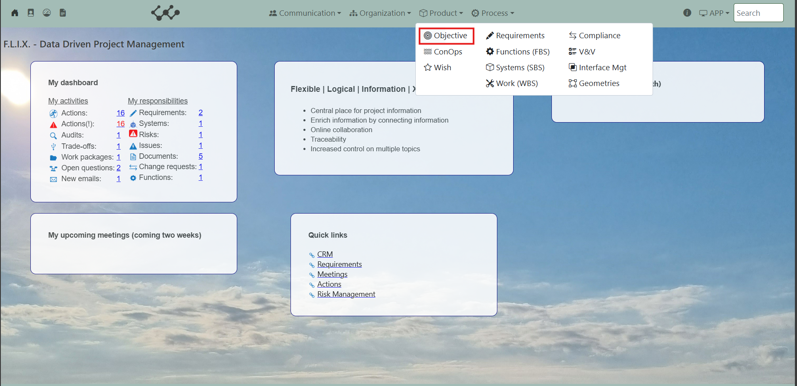

Click on Objective and you will see the following screen:

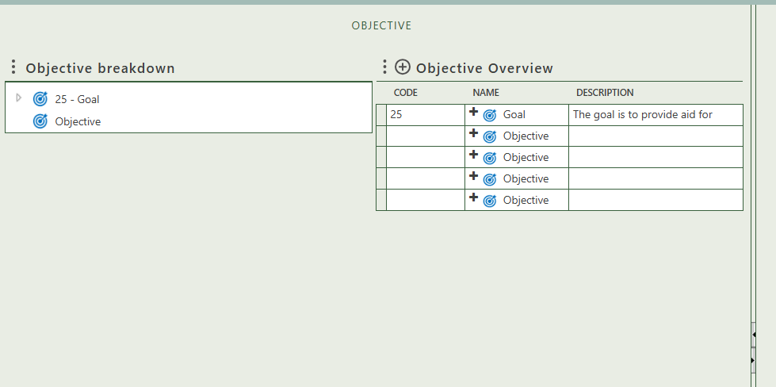

You will find zero tabs in this module

## 2.1 Objective

This tab provides an overview of all objectives within the workspace. By clicking the **+** sign next to *Objective Overview*, you can create new objectives. Once an objective is added to the table, it will appear in the Objective Breakdown after refreshing the tree view. The tree structure allows you to build a hierarchy by dragging and dropping objectives onto one another.

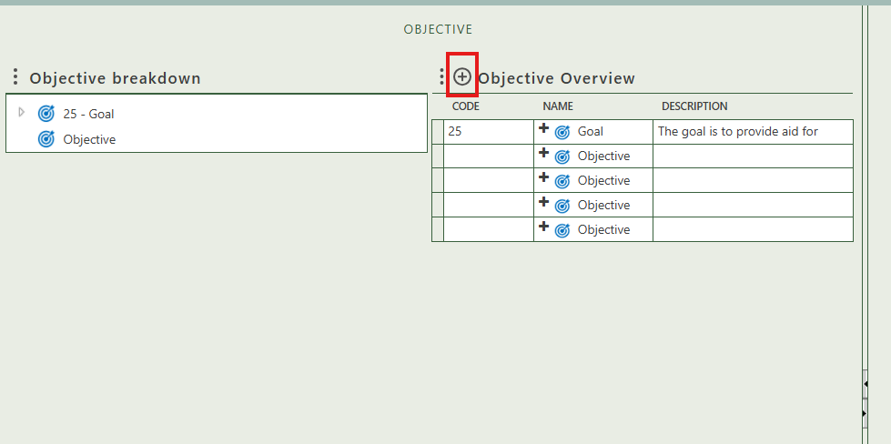

When you click on a specific objective, its full details will appear on the right side of the screen, where you can review and update the information.

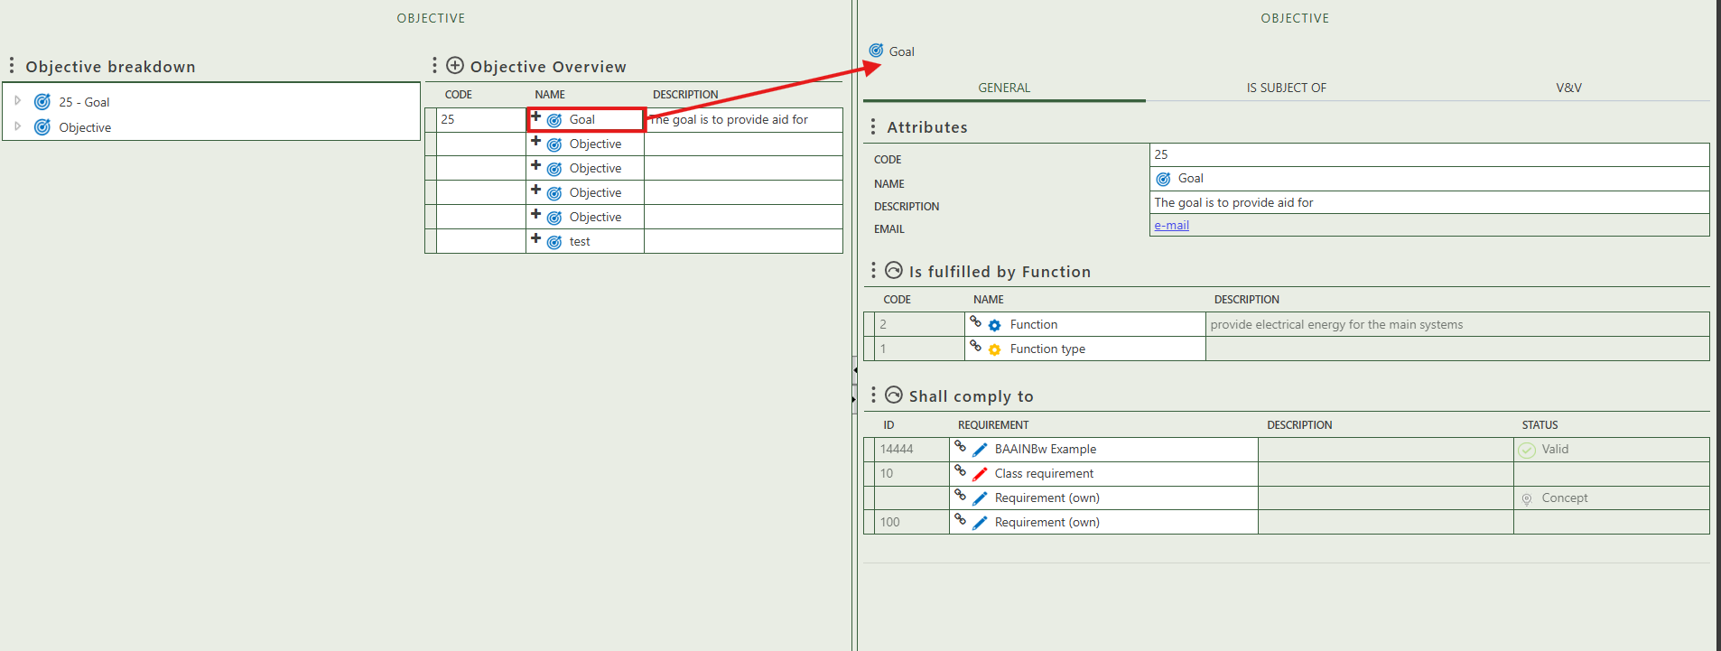

Fill in the general information of the objective.

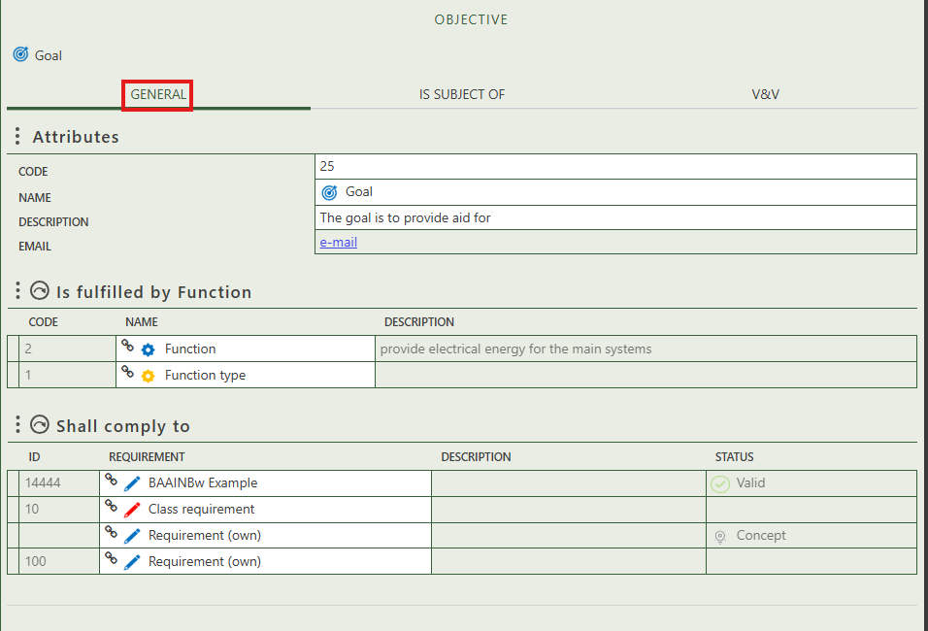

Allows you to select what function (type) the objective fulfills.

Allows you to select own and class requirements that the objective needs to comply to.

Shows you what question have this objective as subject.

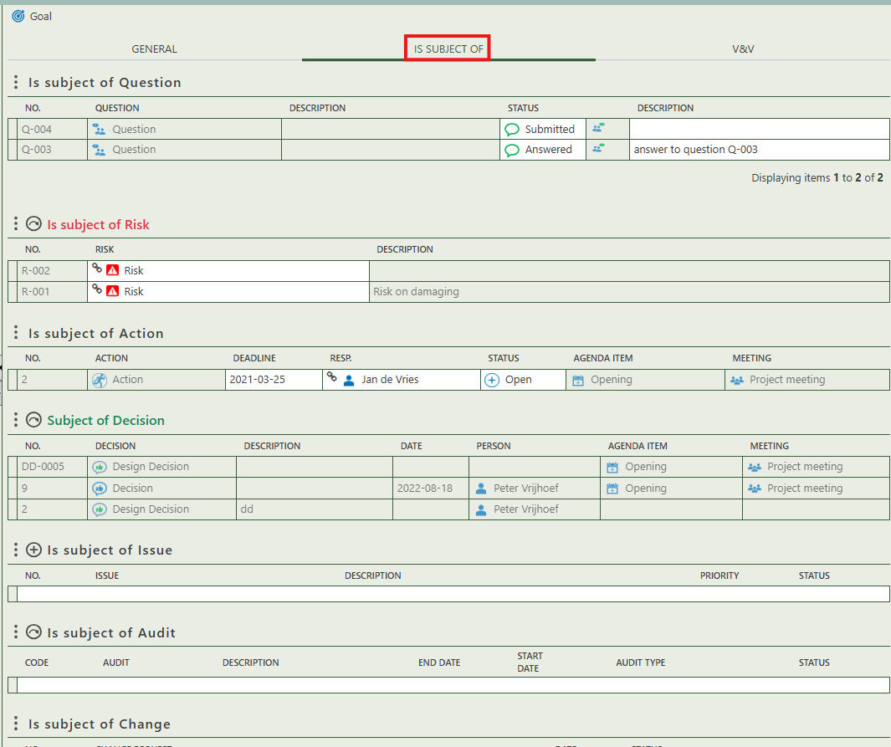

Allows you to create an audit that has this objective as subject.

Shows you what action have this objective as subject.

Shows you what change have this objective as subject.

Allows you to assign this objective as the subject of one or more audit.

Allows you to assign this objective as the subject of one or more decision.

Allows you to assign this objective as the subject of one or more risk.

This section shows which requirements are planned for verification in relation to this objective. You can assign a verification type, responsible person, and supporting templates.

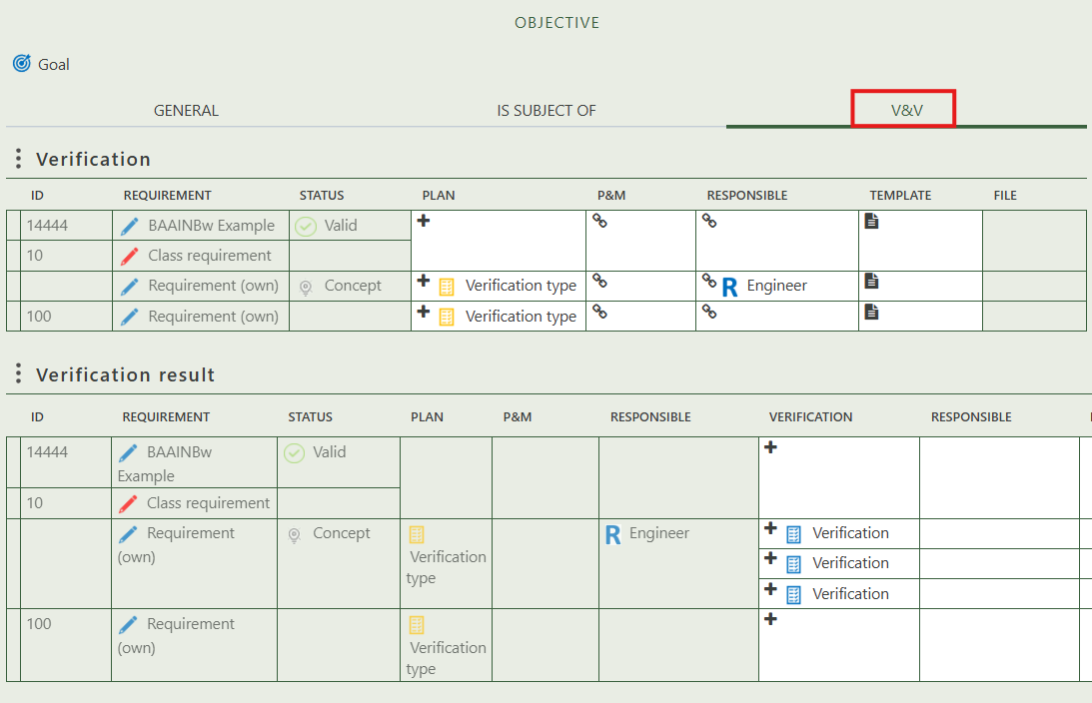

This section displays the outcomes of the verification activities, including who performed them and which verification documents or methods were used.