

Author: F.Bovendeert
Version: V1.0
Publication date: 25-07-2025

Work Instruction – Minutes of Meeting

Work Instruction – Minutes of Meeting |  |  |  | Project: Master Template
Function | Doc No: | Doc sheet: | Doc Rev.: | Pages
Doc Class: | Created by: | Created on: | Changed by: | Changed Date:
 | Floris Bovendeert | 25-7-2025

In this document, you will find the basic work instructions for Meetings.

The document begins with general information about the module in Relatics, including an introduction, objective, and solution. Following this, the structure of the module as implemented in our master template is explained. The subchapters correspond to the tabs in Relatics. Whenever a relevant clickable element appears within a tab, its detail page is also described.

Content
1. General 3
1.1 Introduction 3
1.2 Objective 3
1.3 Solution 3
2. Module 4
2.1 Meeting 5
2.2 Continuous meeting 9
2.3 Actions overview 9
2.4 Decisions overview 10
2.5 Standard 11

Revision History
Revision | Date | By | Remarks

1. General

1.1 Introduction
In this module, you can manage all meeting-related information. Meetings often generate important discussions, decisions, and actions. Relatics allows you to register and track these outcomes in a clear and structured way, ensuring consistency and accessibility across the project.

1.2 Objective
The goal is to maintain full traceability and clarity of what was discussed and agreed during meetings. Without proper documentation, key points can easily be lost or misunderstood—especially over time. This module helps you avoid confusion or disputes by capturing all essential meeting outcomes in one place.

1.3 Solution
Relatics offers a reliable solution—when used consistently. By documenting minutes of meetings in this module, including agenda items, decisions, and follow-up actions, you create a shared source of truth that enhances communication, accountability, and alignment across your project team.

2. Module

Go to -> Communication -> Meetings.
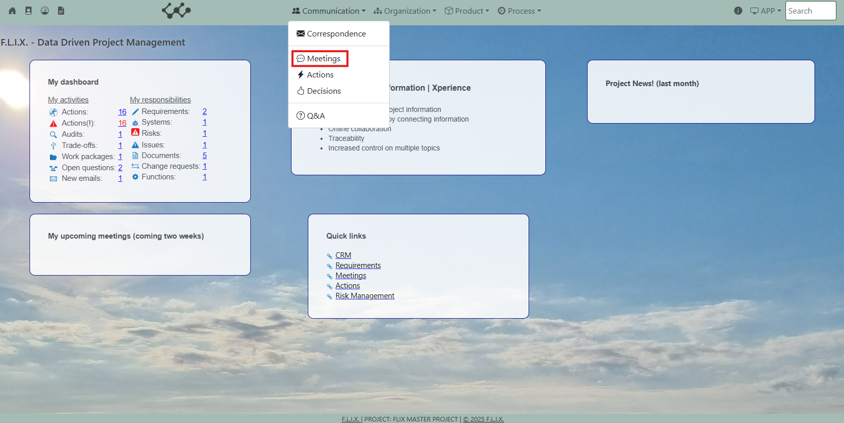

Click and you will see the following screen:
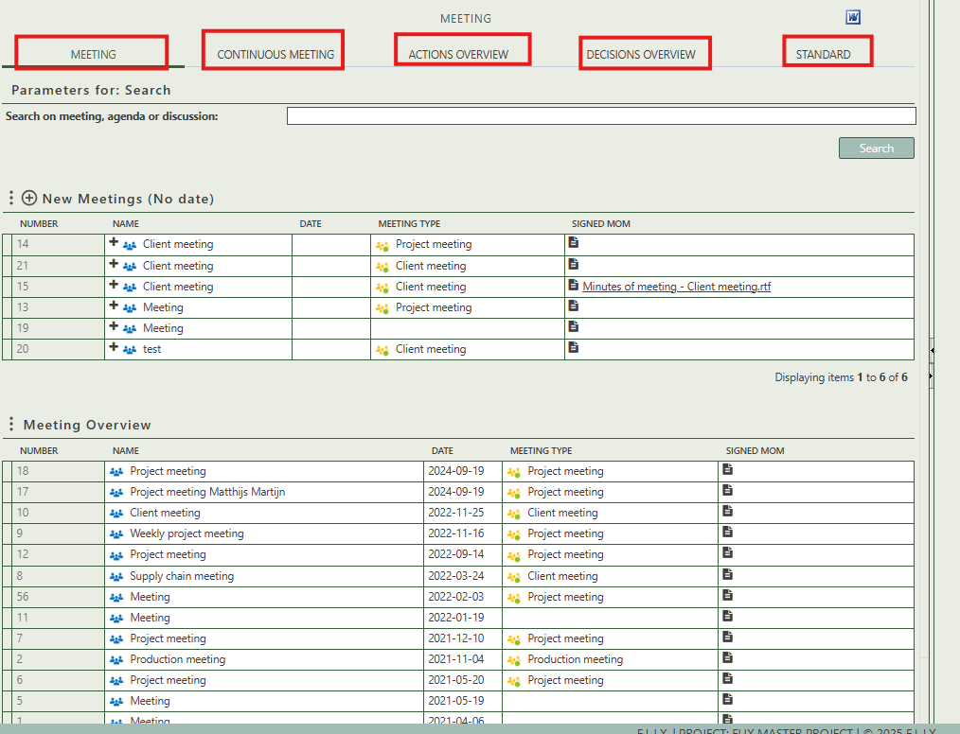
You will find five tabs in this module:
- Meeting.
- Continuous meeting.
- Actions overview.
- Decisions overview
- Standard

2.1 Meeting
The top table allows users to create new meetings using the + Create button, which includes options for:
- Create (=empty meeting, not based on a template)
- All standard meetings (= all template meetings)
- My standard meetings (=all templates that apply to me as a person)
- My team meetings (=all templates that apply to my team(s))

The bottom table is a broader overview of all registered meetings, showing:
- Meeting number
- Name
- Date
- Type
- Signed MoM

It provides a searchable, scrollable summary of historical meetings across the project, allowing users to review and reference past records easily.
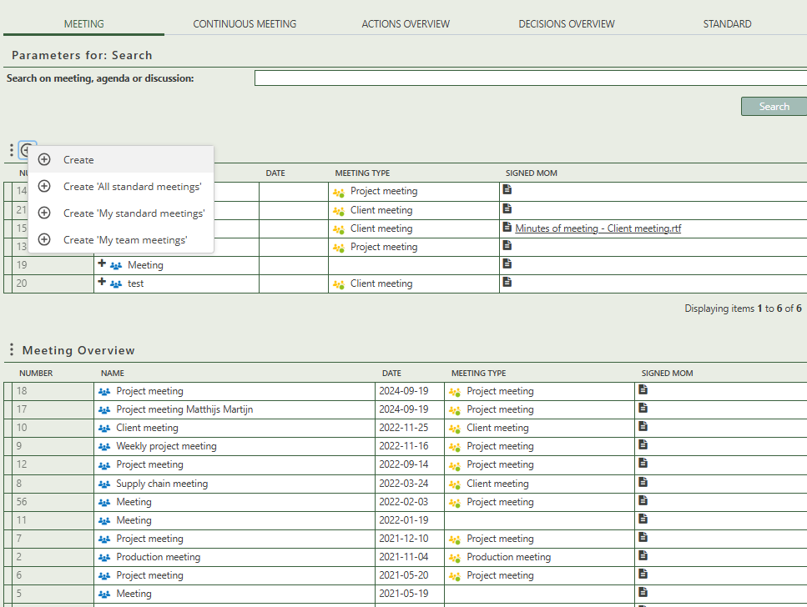

To create a meeting, it is best practice to first create a template. You can create different kinds of Templates, according to your needs. E.g. Weekly Project Team meeting, monthly board meeting, engineering meeting, General meeting, etc. The template can consist of all recurring information (attendees, location, agenda, etc.) But all the information can be changed to the need of the moment. For accidental meetings (one-time meetings), there is no need to assign it to a template.

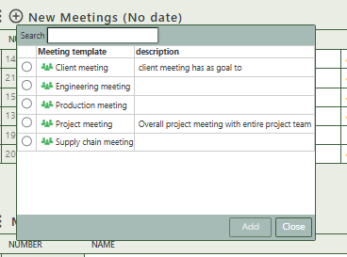

Find your template and click

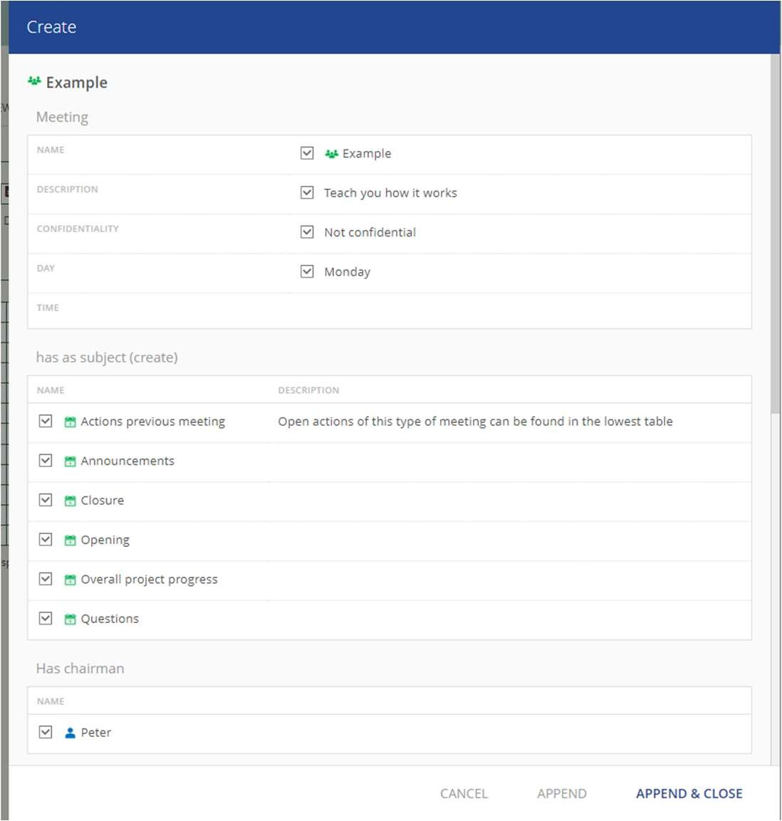
Here you can already make changes to your template (it will not change the original template, but sometimes one-time changes can occur. E.g. someone won’t be attending or agenda items are postponed, etc.). In that case, you can make some changes in this window already, but you can also make the changes later in the process. Then click Append & Close to create your meeting.

When you click on a specific meeting, its full details will appear on the right side of the screen, where you can review and update the information. On the top right corner you can click on the word icon to create a output report of the meeting.
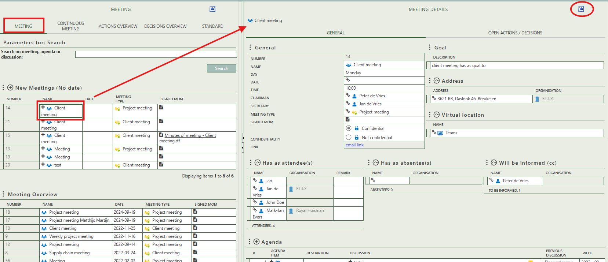

Fill in the general information of the specific decision.
Describe the goal of the meeting.

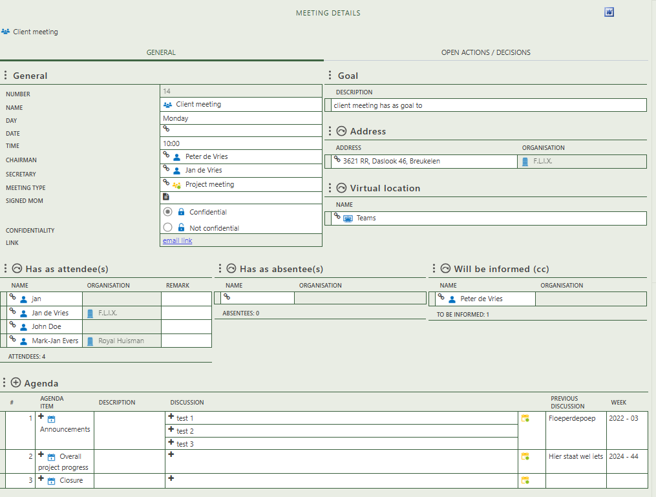

Select an address or an virtual location where the meeting is being held.

Select which persons are attendees, absentees, or being informed.

Allows you to create new agenda items. IF

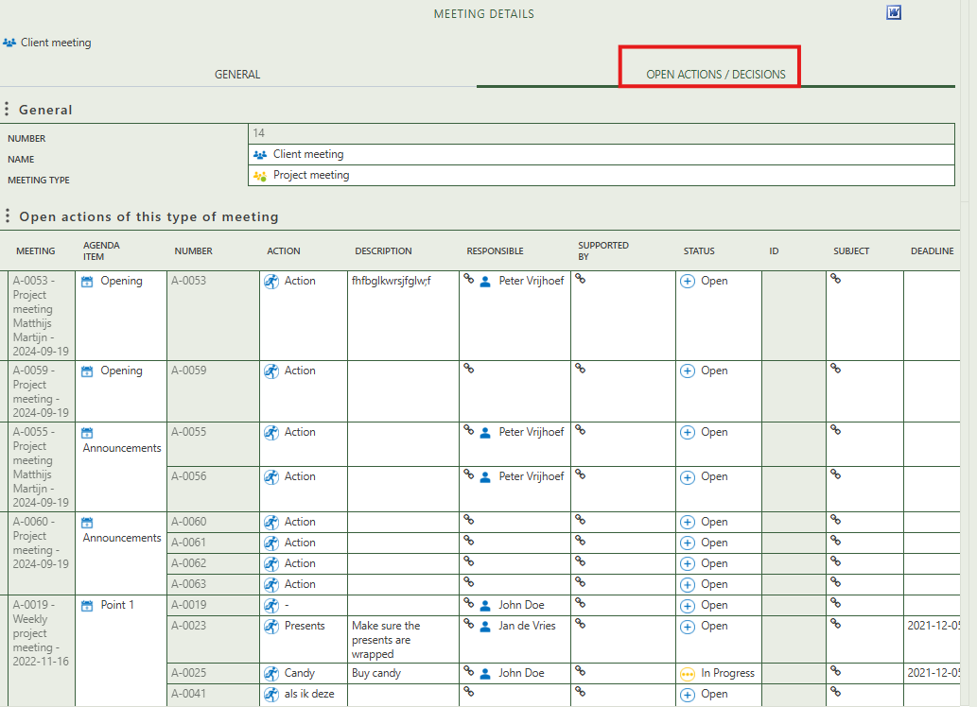
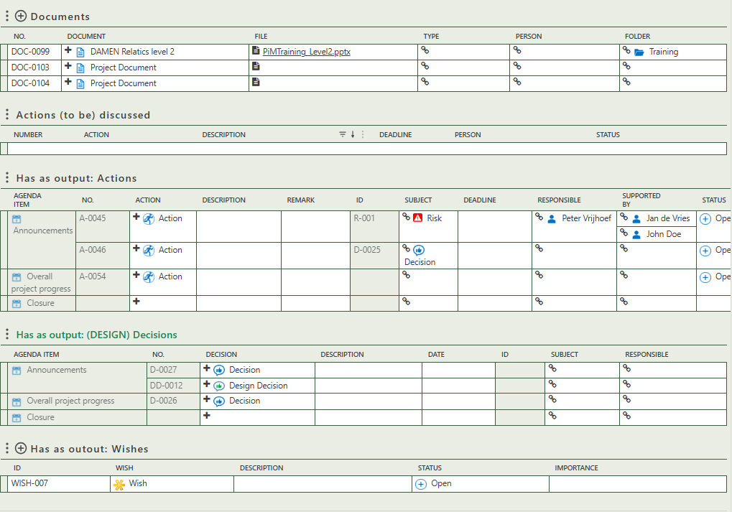
This tab on the meeting’s detail page displays all open actions related to this specific meeting type, as well as all decisions made during such meetings.
Allows you to create wishes as output of the meeting.
Allows you to create decisions as output of agenda items
Allows you to create actions as output of agenda items
Allows you to create documents.

2.2 Continuous meeting
The "Continuous Meeting" tab allows you to manage recurring meetings linked to specific teams. On the left, you see a list of teams, each of which can be connected to a continuous meeting via the plus (+) button. When a team is selected, its detail page opens on the right side of the screen. Here, you can view and edit team attributes, add a continuous meeting, assign a standard meeting template for consistency, and manage the team members involved, including their roles and contact details.

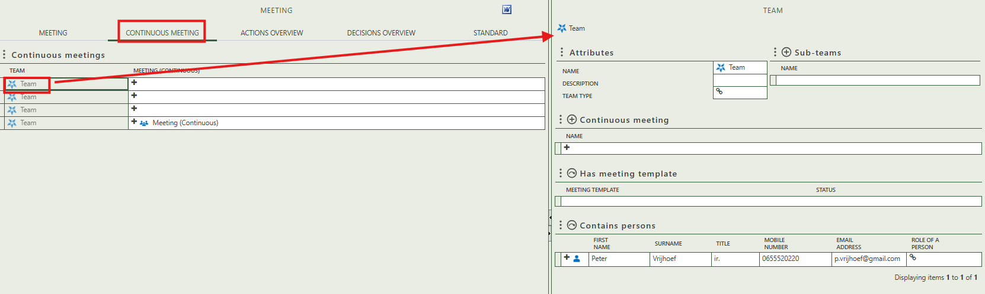

2.3 Actions overview
This tab contains one table that provides an overview of all actions made per agenda type.
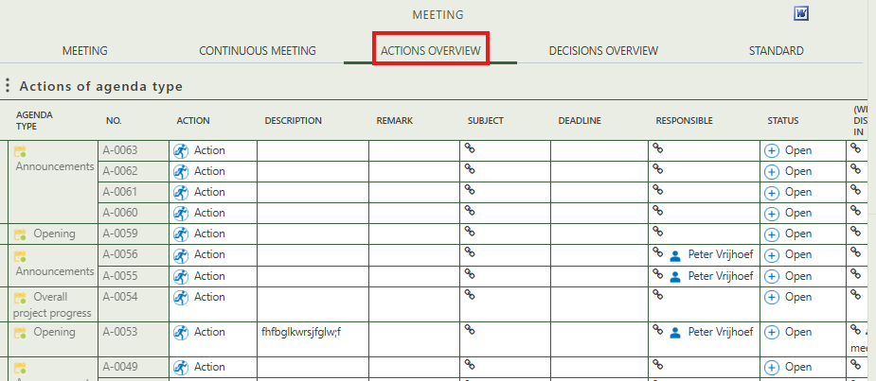

2.4 Decisions overview
This tab contains one table that provides an overview of all decisions made per agenda type.
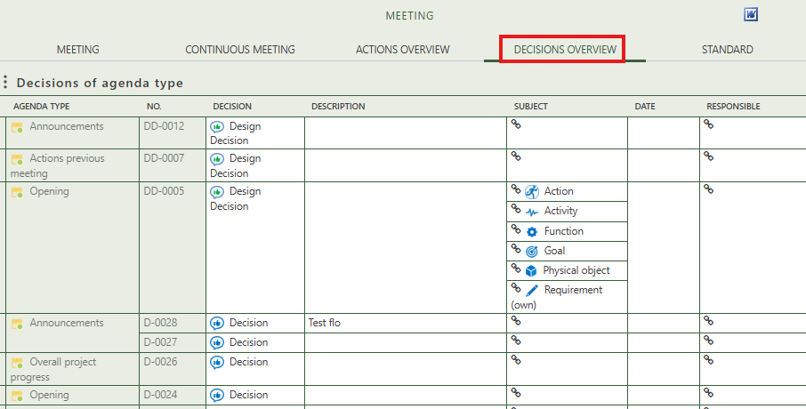

2.5 Standard
This tab allows you to create unique meeting templates, agenda templates, and meeting types.
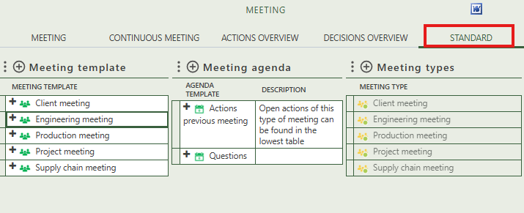

After creating a meeting template, you can select it to open its detail page on the right side of your screen. Here, you can standardize specific details for recurring meetings. On this detail page, you can also select newly created meeting agenda items. These agenda items can be filled with specific information by clicking on them.
If you are listed as a standard attendee in a meeting template, that template will appear as an option when you click on: 'Create My Standard Meetings'
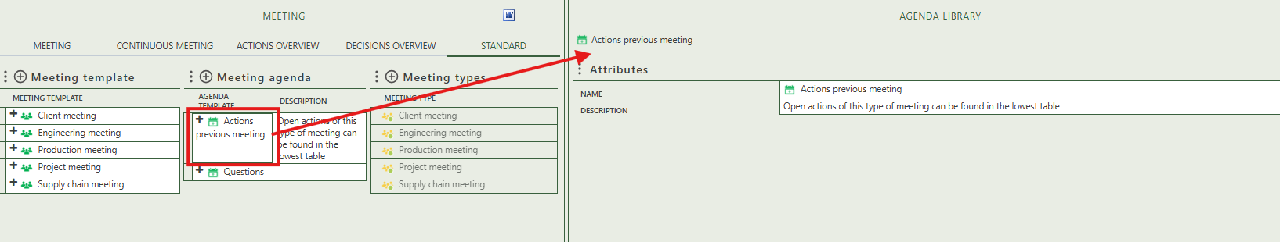
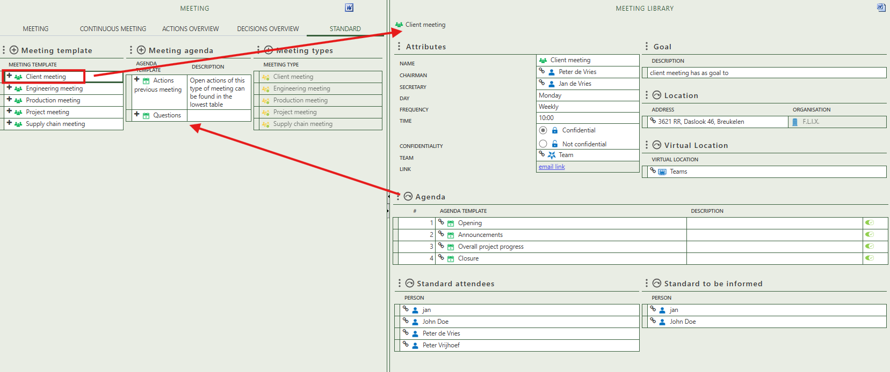

To create a new meeting type, click the plus sign above the table. Selecting a specific meeting type opens its detail page, where you can enter general information, link it to a meeting template, and view a table listing all meetings that use this type.
