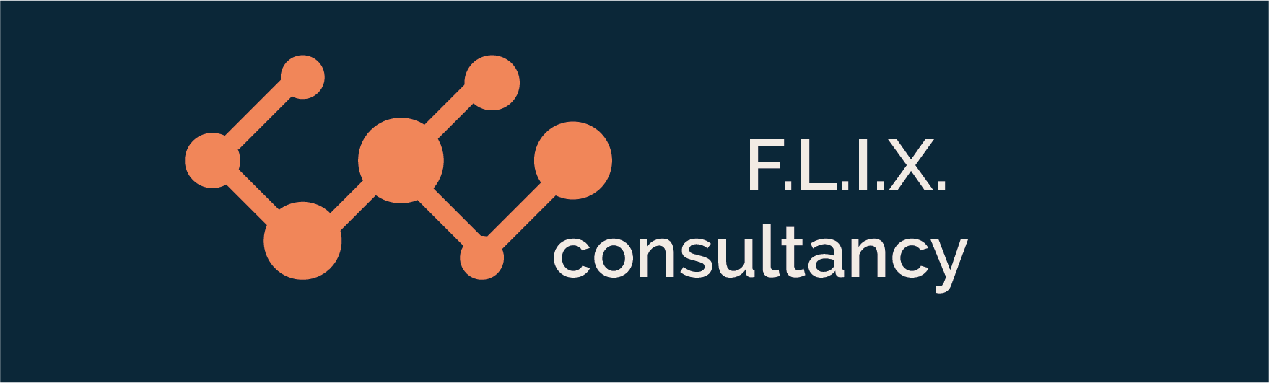

Author: F.Bovendeert

Version: V1.0

Publication date: 25-07-2025

Work Instruction – List of project participants

|  |  |  |  |  |
| --- | --- | --- | --- | --- |
| Work Instruction – List of project participants | | | | Project: Master Template |
| Function | Doc No: | Doc sheet: | Doc Rev.: | Pages |
|  |  |  |  |  |
| Doc Class: | Created by: | Created on: | Changed by: | Changed Date: |
|  | Floris Bovendeert | 25-7-2025 |  |  |

In this document, you will find the basic work instructions for **Project participants.**

The document begins with general information about the module in Relatics, including an introduction, objective, and solution. Following this, the structure of the module as implemented in our master template is explained. The subchapters correspond to the tabs in Relatics. Whenever a relevant clickable element appears within a tab, its detail page is also described.

Content

1. General 3

1.1 Introduction 3

1.2 Objective 3

1.3 Solution 3

2. Module 4

**Revision History**

|  |  |  |  |
| --- | --- | --- | --- |
| Revision | Date | By | Remarks |
|  |  |  |  |
|  |  |  |  |

# 1. General

## 1.1 Introduction

This module provides a complete overview of all project participants within your workspace. It consists of two views—one for active and one for inactive participants—offering a clear and organized list of everyone involved in the project.

## 1.2 Objective

The goal is to maintain full visibility into who is participating in the project, including their status, roles, and associated organizations. Without a centralized overview, this information can become fragmented, outdated, or unclear—resulting in confusion and inefficiencies.

## 1.3 Solution

Relatics ensures that participant information is structured, accessible, and always up to date. By consistently using this module, you gain insight into the people involved, their roles, and their organizational ties. This enhances collaboration, streamlines communication, and supports smooth project execution.

# 2. Module

Go to -> Organization -> List of project participants

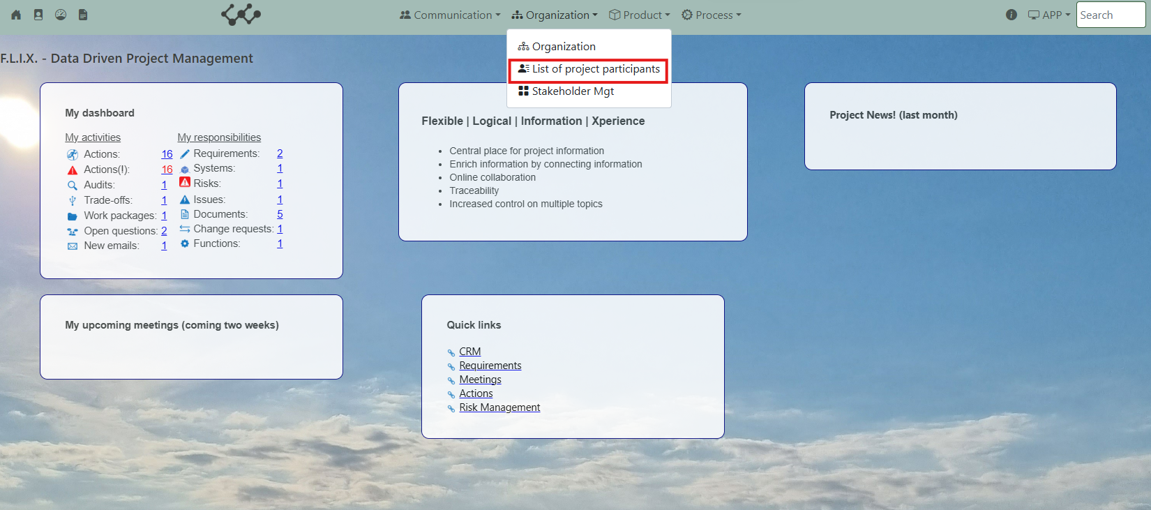

Click and you will see the following screen:

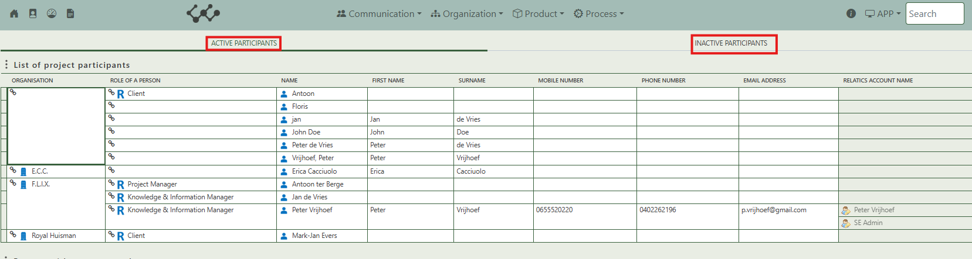

You will find two tabs in this module:

* Active participants
* Inactive participants.

The tables on both tabs are identical in structure; the only difference is the participant status they display. The first tab shows all active project participants, while the second tab lists those marked as inactive. This module provides a clear, centralized overview of who is currently involved in the project and who is not. Additionally, the table is editable, allowing users to directly update relevant details for each participant within the overview.