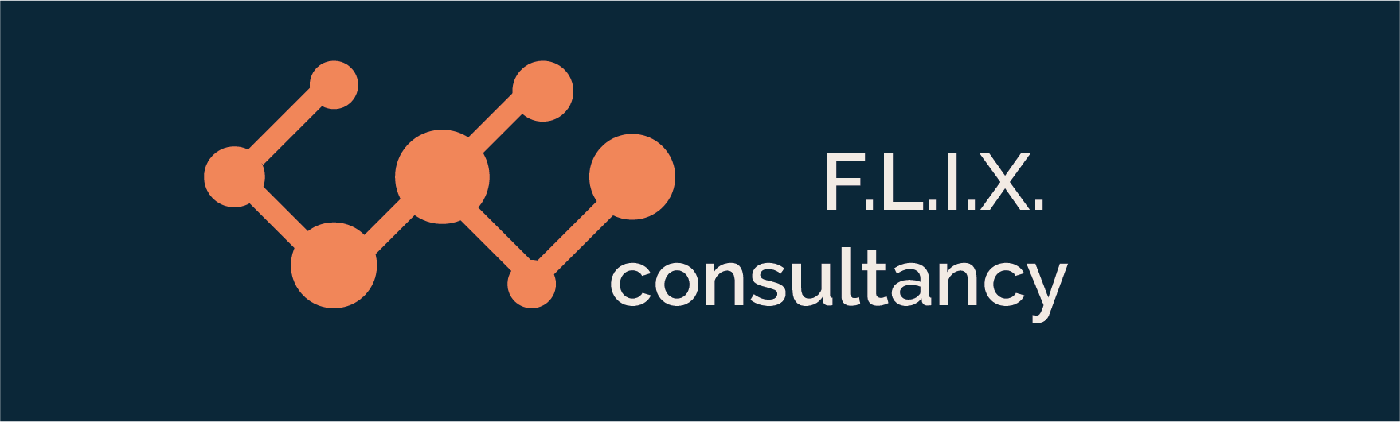

Author: F.Bovendeert

Version: V1.0

Publication date: 25-07-2025

Work Instruction - Issue

|  |  |  |  |  |
| --- | --- | --- | --- | --- |
| Work Instruction - Issue | | | | Project: Master Template |
| Function | Doc No: | Doc sheet: | Doc Rev.: | Pages |
|  |  |  |  |  |
| Doc Class: | Created by: | Created on: | Changed by: | Changed Date: |
|  | Floris Bovendeert | 25-7-2025 |  |  |

In this document, you will find the basic work instructions for **Issue.**

The document begins with general information about the module in Relatics, including an introduction, objective, and solution. Following this, the structure of the module as implemented in our master template is explained. The subchapters correspond to the tabs in Relatics. Whenever a relevant clickable element appears within a tab, its detail page is also described.

Content

1. General 3

1.1 Introduction 3

1.2 Objective 3

1.3 Solution 3

2. Module 4

2.1 Dashboard 5

2.2Overview 6

2.3 Issue types 8

3. Issue overview 8

**Revision History**

|  |  |  |  |
| --- | --- | --- | --- |
| Revision | Date | By | Remarks |
|  |  |  |  |
|  |  |  |  |

# 1. General

## 1.1 Introduction

In this module, you can manage all project-related issues. Issues can arise unexpectedly during project execution and often require quick analysis and resolution. Relatics enables you to document each issue in a structured way—capturing its cause, effect, related subjects, and the chosen resolution—ensuring clarity and control throughout the process.

## 1.2 Objective

The goal is to ensure full traceability and understanding of all issues that impact the project. In many cases, issues are discussed ad hoc and not formally documented, which makes it difficult to track recurring problems, assess their impact, or evaluate how they were resolved. Without clear documentation, valuable insights and lessons may be lost.

## 1.3 Solution

Relatics supports a consistent issue management process—if used effectively. By registering issues in this module, describing their cause and effect, linking them to relevant topics, and documenting the outcomes, you create a transparent and searchable issue history. This helps teams to learn from past problems, reduce repetition, and strengthen project resilience.

# 2. Module

Go to -> Process -> Issue Management -> Issues and Issue overview.

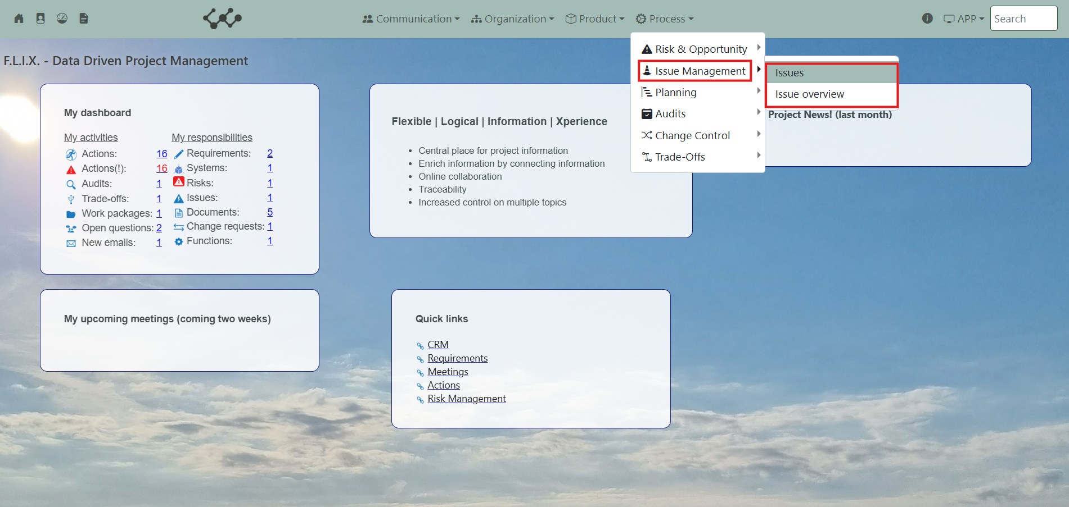

Click on Issues and you will see the following screen:

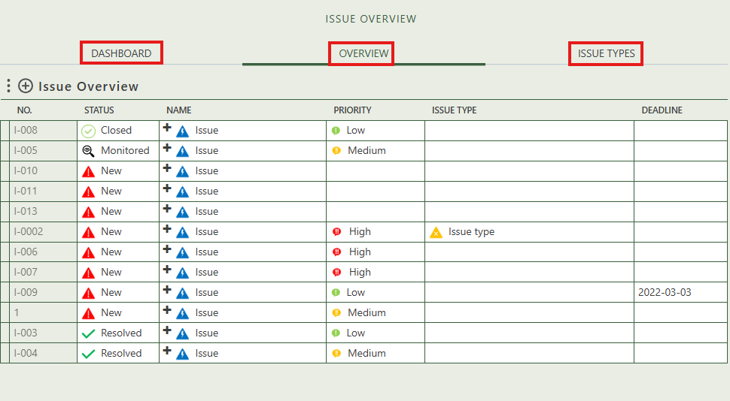

You will find three tabs in this module:

* Dashboard.
* Overview.
* Issue types.

## 2.1 Dashboard

This tab serves as a dashboard, offering both visual and tabular overviews of all project-related issues, including their statuses, priorities, and related actions. It helps users quickly identify active and urgent issues and includes a clickable pivot table for easy navigation and follow-up.

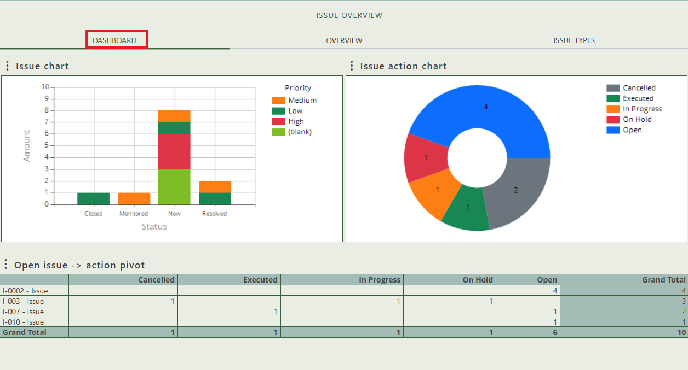

## 2.2 Overview

This tab contains an overview of all the issues in this workspace. By pressing on the + sign next to Issue Overview, you can create new issues.

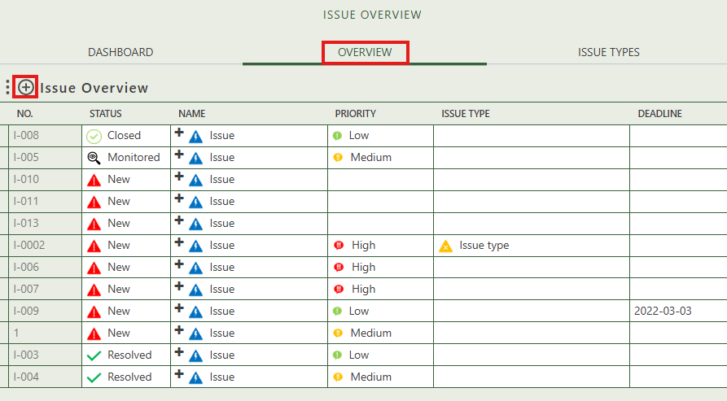

When you click on a specific issue, its full details will appear on the right side of the screen, where you can review and update the information.

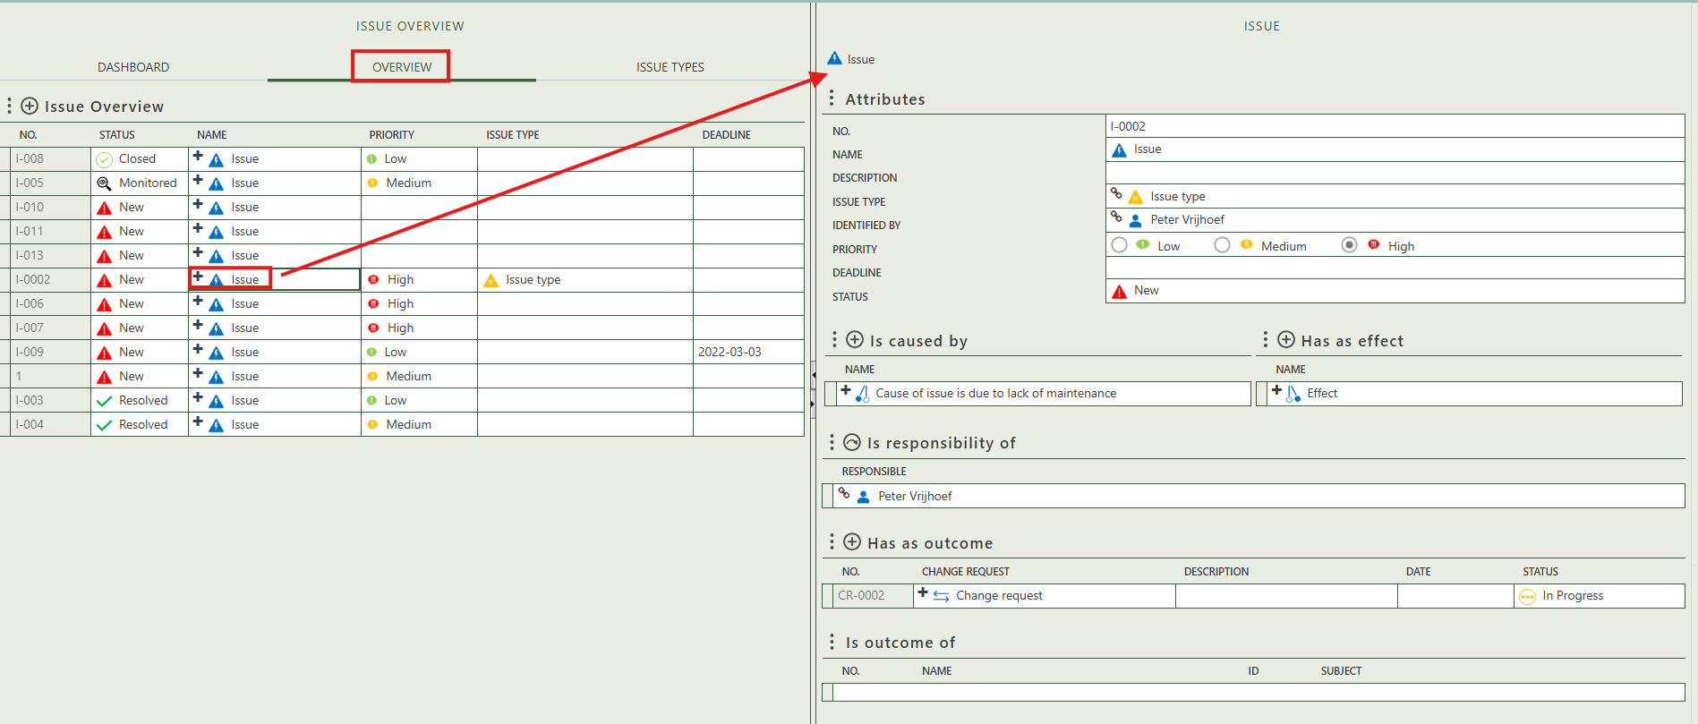

Fill in the general information of the issue.

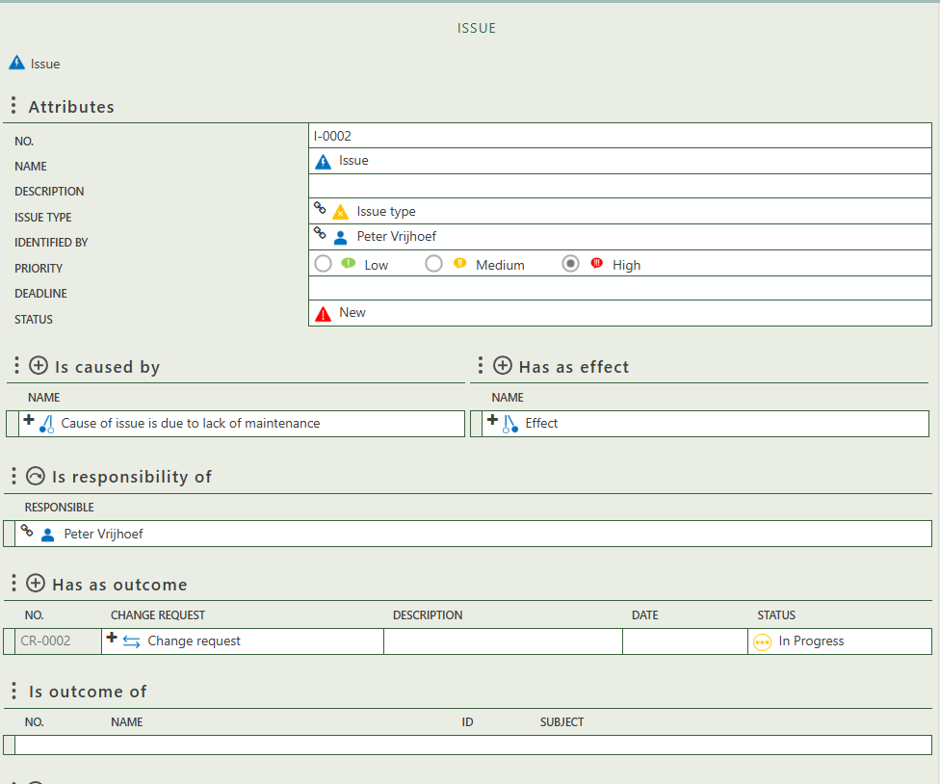

The option to get an audit output report.

Allows you to create the cause(s) of the issue.

Allows you to create the effect(s) of the issue.

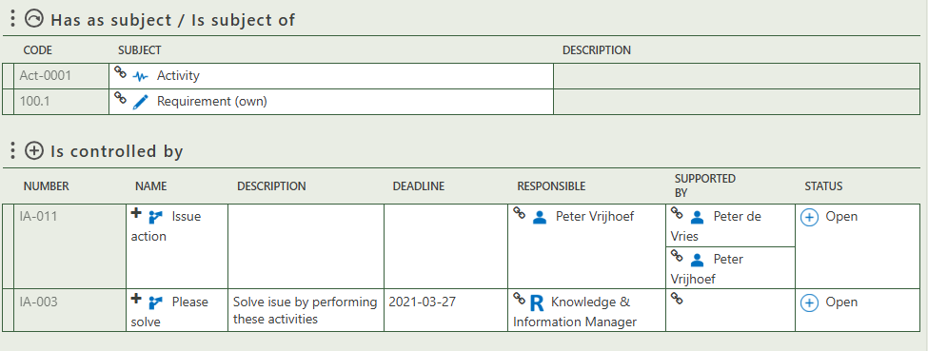

Allows you to create issue action(s) as control on the issue.

Is automatically filled in when an instance of the element results in an issue being created.

Allows you to select subject(s) of the issue.

Allows you to create change(s) as outcome of the issue.

Allows you to select a responsible person, organization or role of a person.

## 2.3 Issue types

This tab provides an overview of all issue types and allows you to create new ones. When you click on a specific issue type, its full details will appear on the right side of the screen, where you can review and update the information. You can also see which issues this type is used to classify.

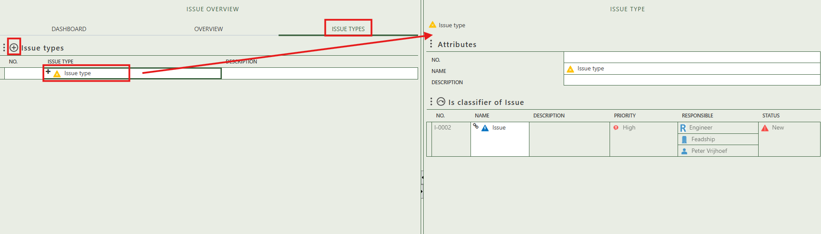

# 3. Issue overview

The Issue Overview offers a clear, centralized view of all registered issues. It also allows you to create new issues by clicking the "+" icon above the table.

