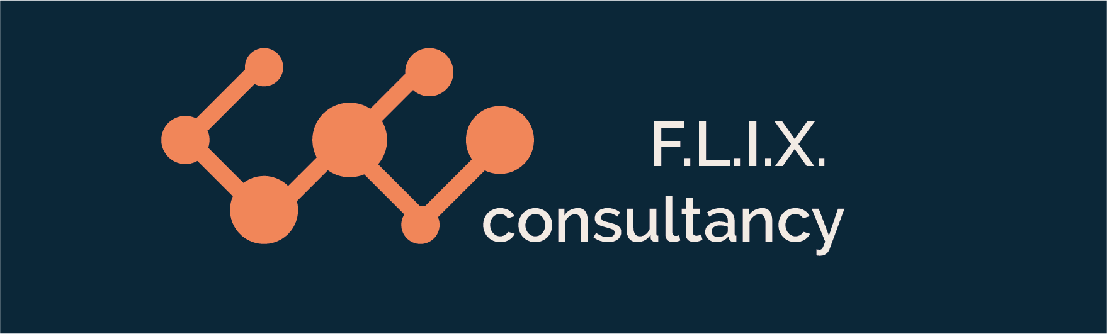

Author: F.Bovendeert

Version: V1.0

Publication date: 25-07-2025

Work Instruction - Interface

|  |  |  |  |  |
| --- | --- | --- | --- | --- |
| Work Instruction - Interface | | | | Project: Master Template |
| Function | Doc No: | Doc sheet: | Doc Rev.: | Pages |
|  |  |  |  |  |
| Doc Class: | Created by: | Created on: | Changed by: | Changed Date: |
|  | Floris Bovendeert | 25-7-2025 |  |  |

In this document, you will find the basic work instructions for **Interface.**

The document begins with general information about the module in Relatics, including an introduction, objective, and solution. Following this, the structure of the module as implemented in our master template is explained. The subchapters correspond to the tabs in Relatics. Whenever a relevant clickable element appears within a tab, its detail page is also described.

Content

1. General 3

1.1 Introduction 3

1.2 Objective 3

1.3 Solution 3

2. Module 4

2.1 Interfaces 5

2.2 Types 7

**Revision History**

|  |  |  |  |
| --- | --- | --- | --- |
| Revision | Date | By | Remarks |
|  |  |  |  |
|  |  |  |  |

# 1. General

## 1.1 Introduction

The Interface module allows you to manage all project-related interface issues. Interfaces—connections between activities, functions, physical objects, and requirements—are critical and can become sources of conflict or misalignment if not properly managed. This module helps you register each interface issue in a structured manner, ensuring transparency and control across the interfaces in your project.

## 1.2 Objective

The objective is to maintain full traceability and understanding of all interface-related issues that affect the project. These issues are often addressed informally, making it difficult to identify patterns, assess risks, or evaluate resolution strategies. Without structured documentation, recurring interface problems may go unnoticed, leading to inefficiencies or rework.

## 1.3 Solution

Relatics facilitates a consistent approach to interface management. By using this module to document interfaces and relate them to subjects, teams build a reliable knowledge base. This promotes proactive coordination, helps prevent repeated interface conflicts, and enhances overall project integration and performance.

# 2. Module

Go to -> Product -> Interface Mgt

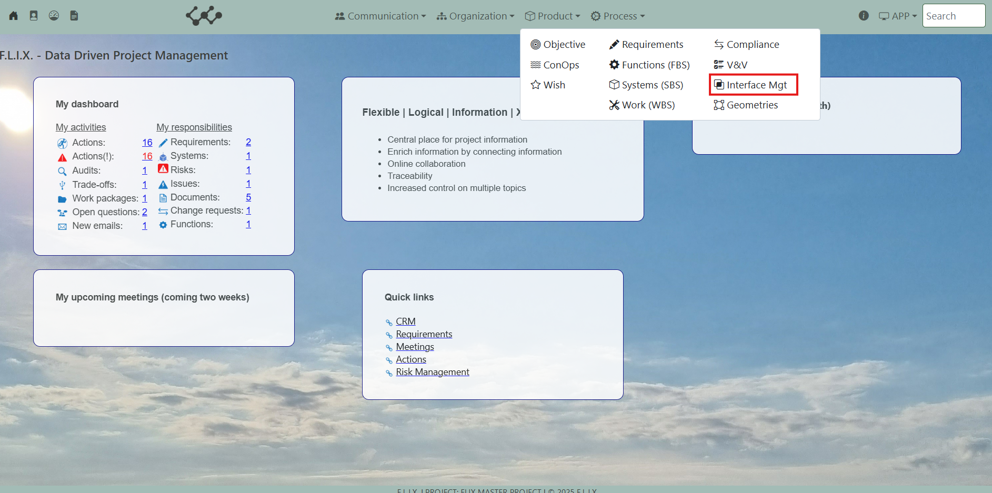

Click on Interface Mgt and you will see the following screen:

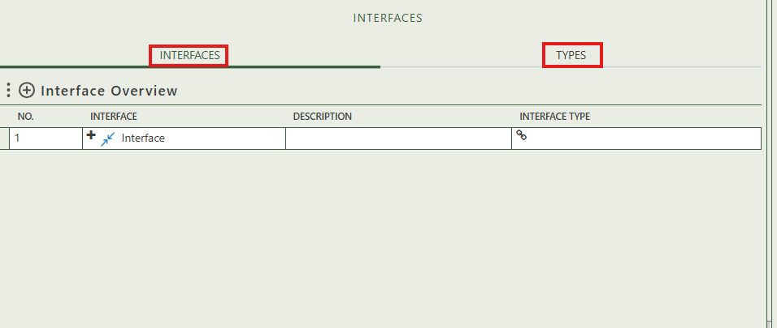

You will find two tabs in this module:

* Interfaces
* Types.

## 2.1 Interfaces

This tab contains an overview of all the interfaces in this workspace. By pressing on the + sign next to Interface Overview, you can create new interfaces.

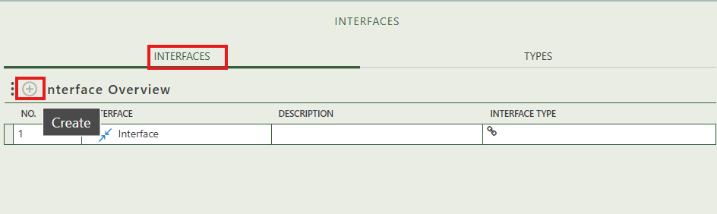

When you click on a specific interface, its full details will appear on the right side of the screen, where you can review and update the information.

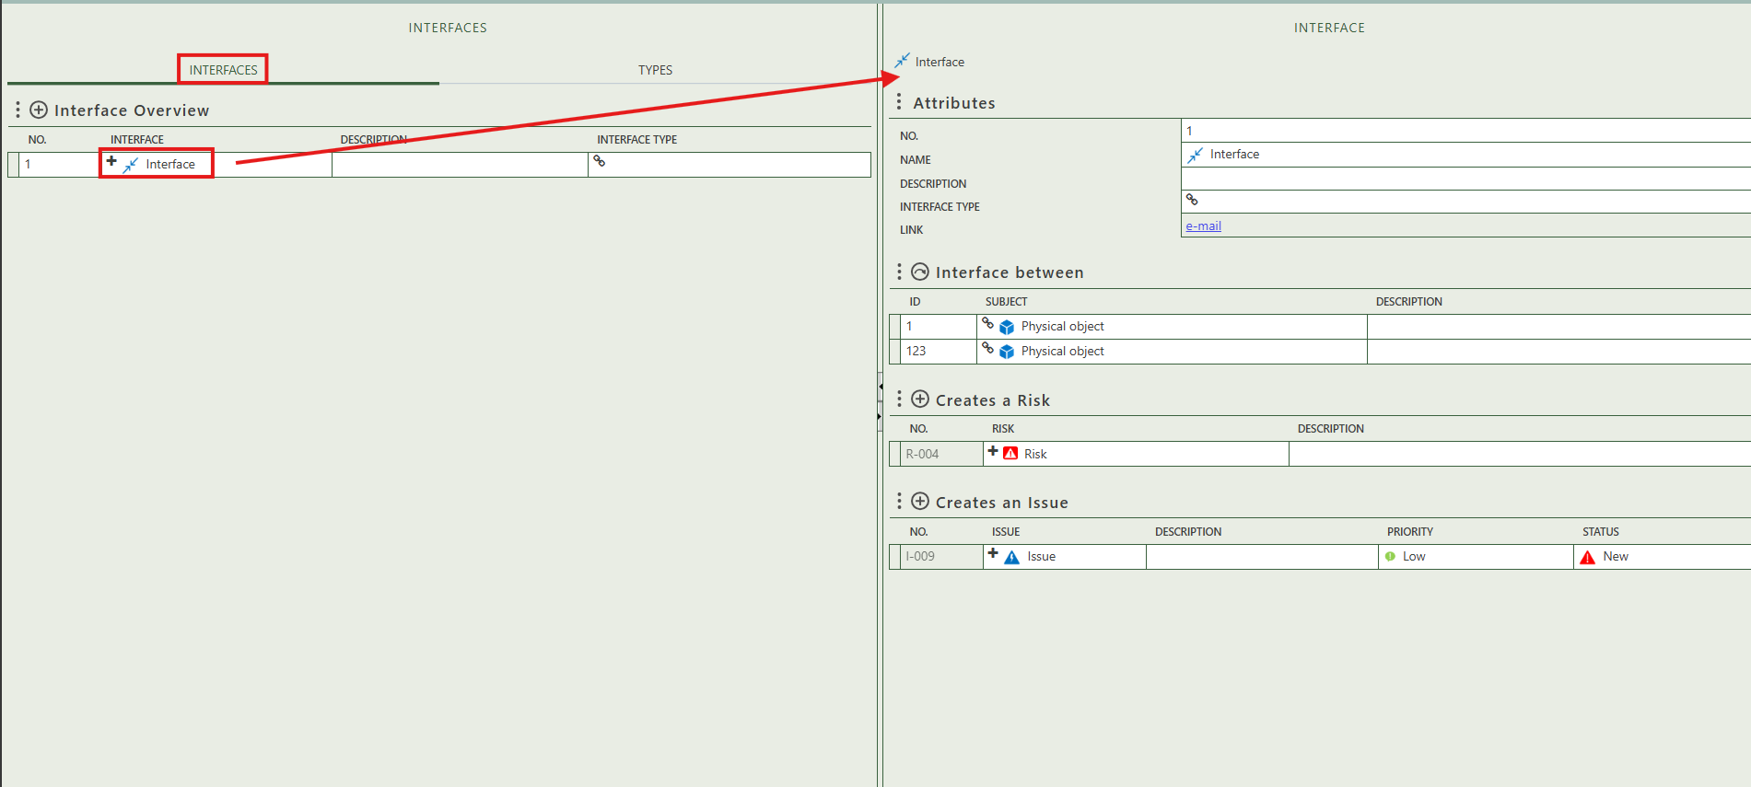

Fill in the general information of the interface.

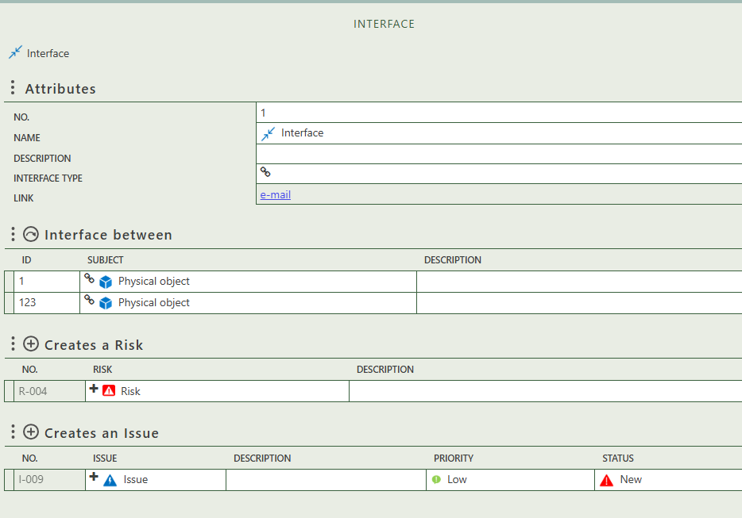

Allows you to select the interface between activities, functions, physical objects, and requirements.

Allows you to create issue(s) that belong to the interface.

Allows you to create risk(s) that belong to the interface.

## 2.2 Types

This tab provides an overview of all interface types and allows you to create new ones. When you click on a specific interface type, its full details will appear on the right side of the screen, where you can review and update the information. You can also see which interfaces, risks, and issues this type is used to classify.

