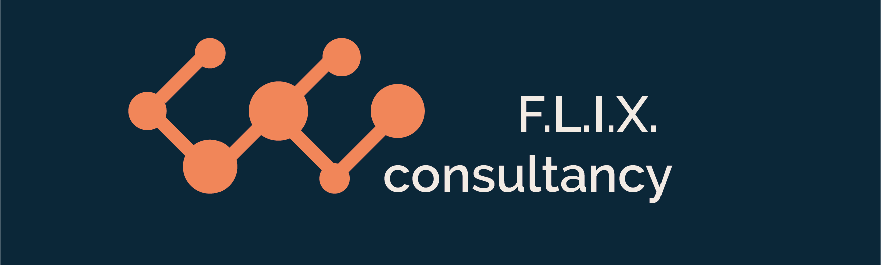

Author: F.Bovendeert

Version: V1.0

Publication date: 25-07-2025

Work Instruction - Geometries

|  |  |  |  |  |
| --- | --- | --- | --- | --- |
| Work Instruction - Geometries | | | | Project: Master Template |
| Function | Doc No: | Doc sheet: | Doc Rev.: | Pages |
|  |  |  |  |  |
| Doc Class: | Created by: | Created on: | Changed by: | Changed Date: |
|  | Floris Bovendeert | 25-7-2025 |  |  |

In this document, you will find the basic work instructions for **Geometries.**

The document begins with general information about the module in Relatics, including an introduction, objective, and solution. Following this, the structure of the module as implemented in our master template is explained. The subchapters correspond to the tabs in Relatics. Whenever a relevant clickable element appears within a tab, its detail page is also described.

Content

1. General 3

1.1 Introduction 3

1.2 Objective 3

1.3 Solution 3

2. Module 4

2.1Geometry 5

2.2 Types 8

**Revision History**

|  |  |  |  |
| --- | --- | --- | --- |
| Revision | Date | By | Remarks |
|  |  |  |  |
|  |  |  |  |

# 1. General

## 1.1 Introduction

In this module, you can create, manage, and structure all physical spaces within a project—such as blocks, decks and, sections. The Geometry module in Relatics enables you to define each physical element and establish clear hierarchical relationships between them, ensuring a consistent and navigable project structure.

## 1.2 Objective

The goal is to create a coherent and traceable geometric model of the project environment. Without a clear spatial structure, it becomes difficult to align design data, project deliverables, and responsibilities. Misunderstandings about physical locations or their interdependencies can lead to inefficiencies, delays, or even design conflicts.

## 1.3 Solution

Relatics offers a structured way to build and manage the physical breakdown of a project. By clearly defining all relevant spaces and their relationships—from general areas to specific sections—you enable consistency across disciplines. This approach supports better coordination, accurate linking of requirements and activities to locations, and improved change management throughout the project lifecycle.

# 2. Module

Go to -> Product -> Geometries

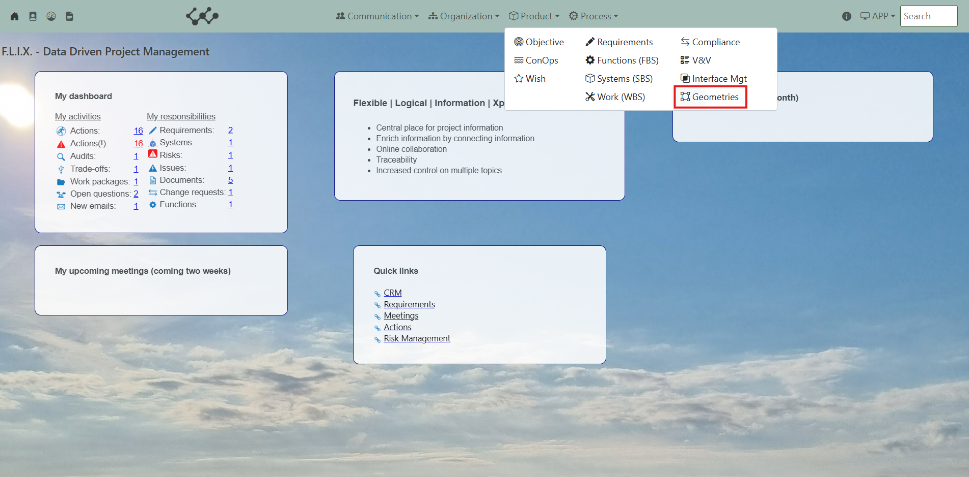

Click on Geometries and you will see the following screen:

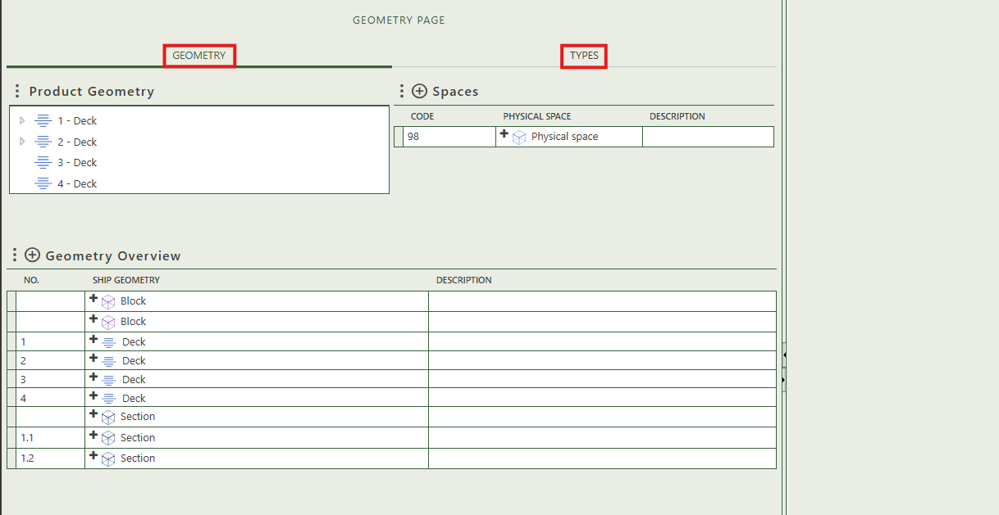

You will find three tabs in this module:

* Geometry.
* Types.

## 2.1 Geometry

This tab provides an overview of all physical spaces, blocks, decks, and sections within the workspace. By clicking the + sign next to Spaces and Geometry Overview, you can create new instances. The hierarchical relationships between these elements can be managed in the product geometry tree.

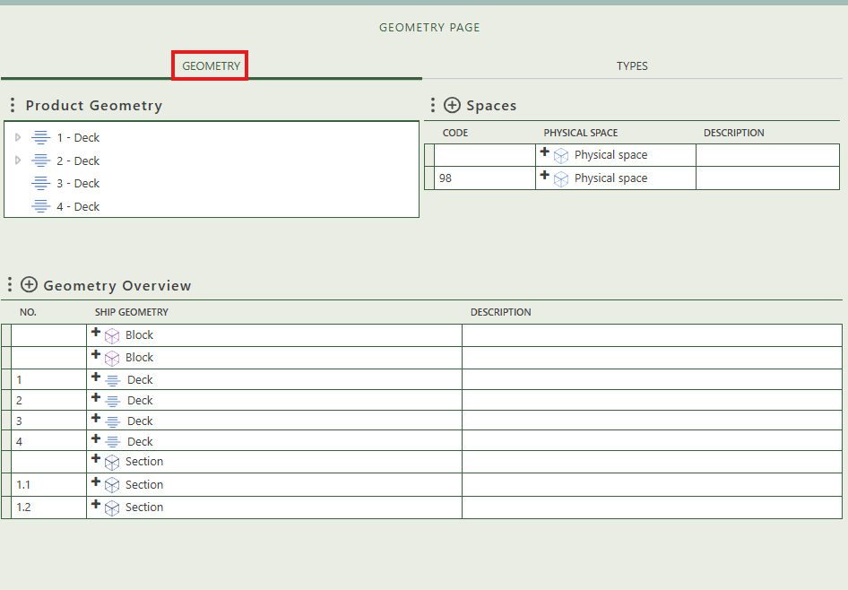

Allows you to create the physical spaces.

Allows you to create hierarchy between physical spaces, blocks, decks, and sections.

Allows you to create:

* Block
* Deck
* Section

When you click on a specific physical space, its full details will appear on the right side of the screen, where you can review and update the information.

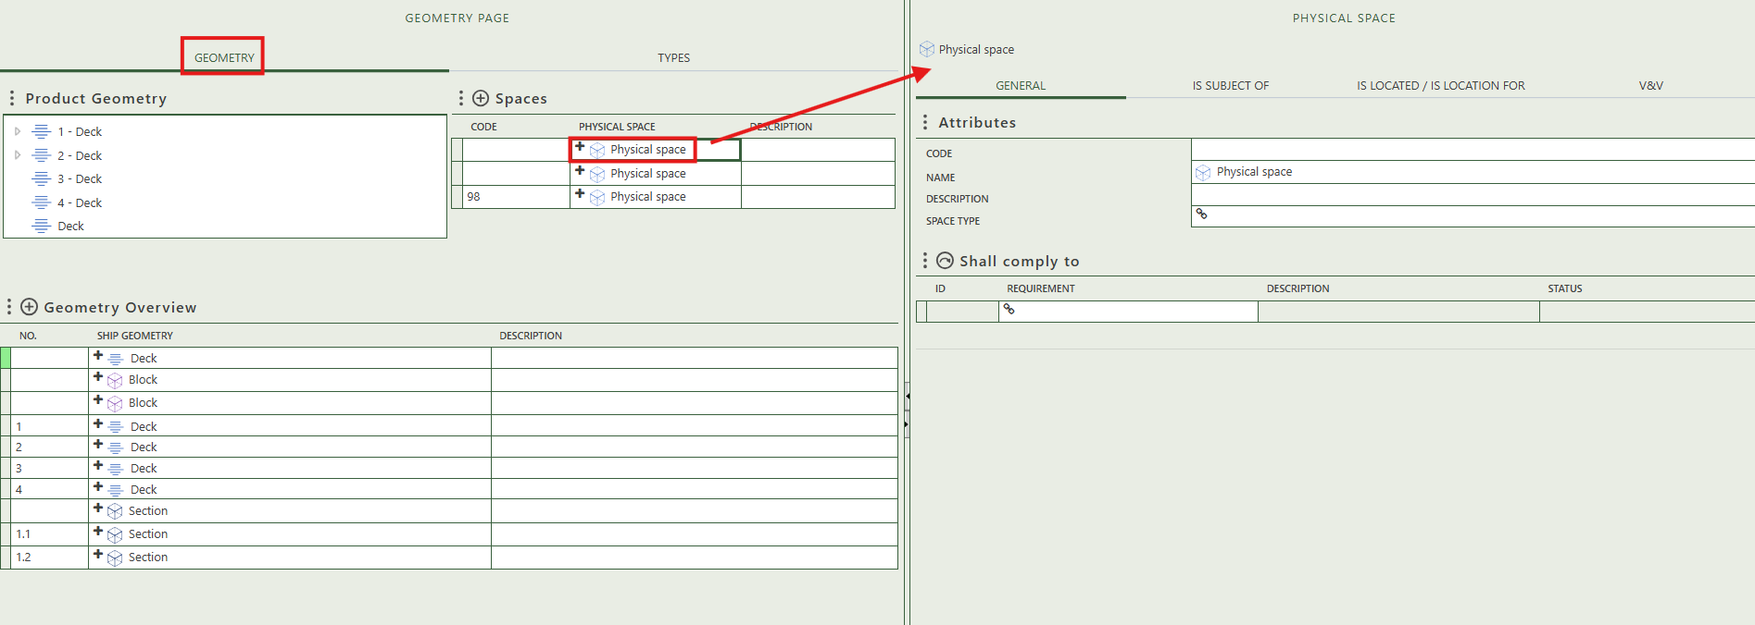

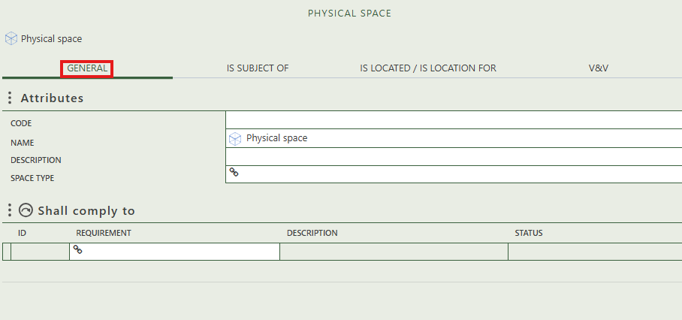

Fill in the general information of the physical space type.

Allows you to select requirements that this physical space needs to comply to.

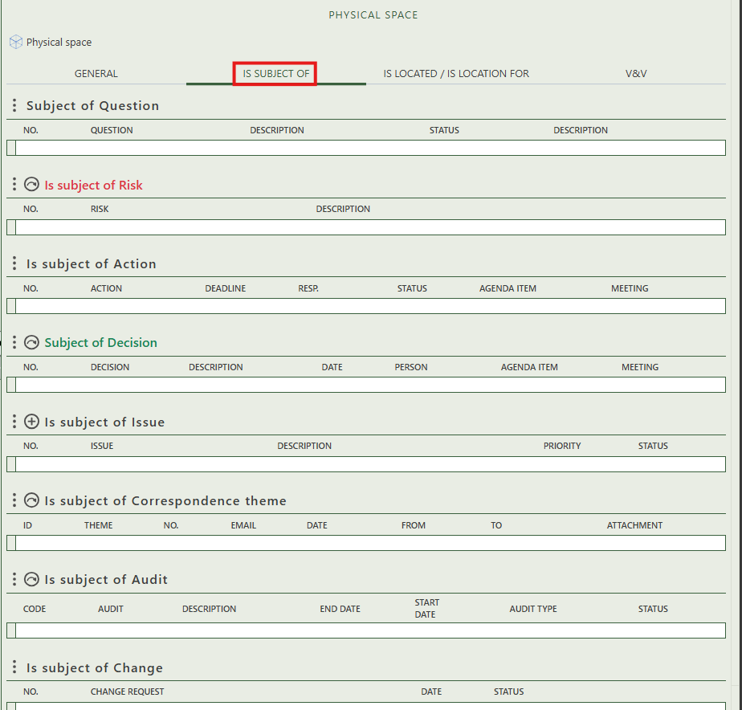

Allows you to assign this physical space as the subject of one or more risk.

Shows whether the physical space is the subject of a question.

Allows you to create an issue that has this physical space as subject.

Allows you to assign this physical space as the subject of one or more audit.

Allows you to assign this physical space as the subject of one or more correspondence themes.

Shows you what change have this object as subject.

Allows you to assign this physical space as the subject of one or more decision.

Shows whether the physical space is the subject of an action.

The elements: Deck, Block, and Section all three have content wise the same detail page. That’s why we only show it once.

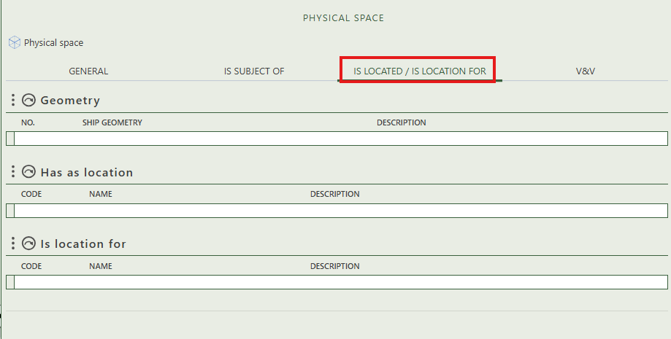

Allows you to select the geometry that is applicable on the physical space.

Allows you to select the physical space for which this space serves as the location.

Allows you to select the physical space type as location.

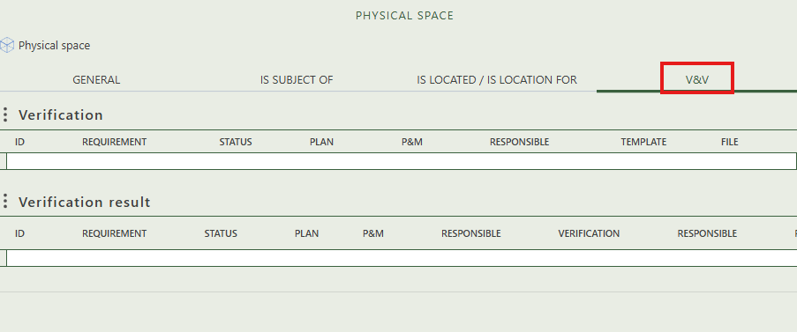

This section shows which requirements are planned for verification in relation to this object. You can assign a verification, responsible person, and supporting templates.

## 2.2 Types

This tab provides an overview of all physical space types and allows you to create new ones. When you click on a specific physical space type, its full details will appear on the right side of the screen, where you can review and update the information.

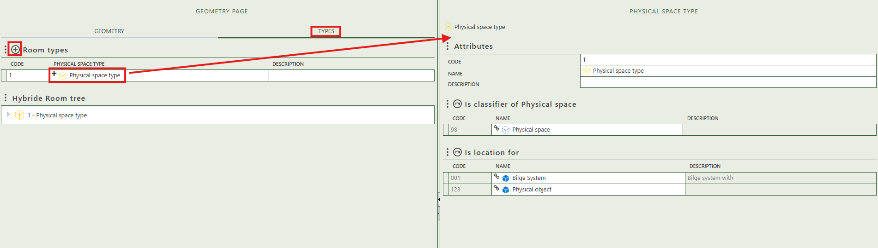

Fill in the general information of the physical space type.

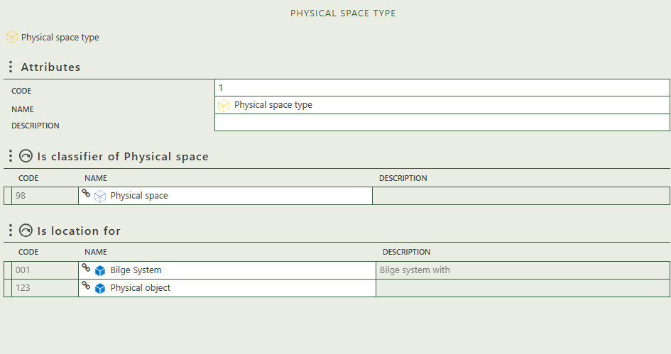

Allows you to select the physical space(s) this type classifies.

Allows you to select the physical object for which this type serves as the location.