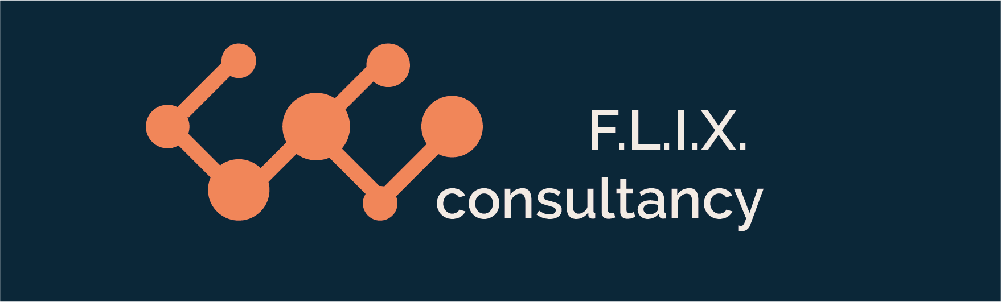

Author: F.Bovendeert

Version: V1.0

Publication date: 25-07-2025

Work Instruction - Function

|  |  |  |  |  |
| --- | --- | --- | --- | --- |
| Work Instruction - Function | | | | Project: Master Template |
| Function | Doc No: | Doc sheet: | Doc Rev.: | Pages |
|  |  |  |  |  |
| Doc Class: | Created by: | Created on: | Changed by: | Changed Date: |
|  | Floris Bovendeert | 25-7-2025 |  |  |

In this document, you will find the basic work instructions for **Function.**

The document begins with general information about the module in Relatics, including an introduction, objective, and solution. Following this, the structure of the module as implemented in our master template is explained. The subchapters correspond to the tabs in Relatics. Whenever a relevant clickable element appears within a tab, its detail page is also described.

Content

1. General 3

1.1 Introduction 3

1.2 Objective 3

1.3 Solution 3

2. Module 4

2.1Function 5

2.2 Function types 9

**Revision History**

|  |  |  |  |
| --- | --- | --- | --- |
| Revision | Date | By | Remarks |
|  |  |  |  |
|  |  |  |  |

# 1. General

## 1.1 Introduction

In this module, you can define and manage all functions related to the project. Functions describe what the system or project must do and often form the basis for structuring requirements and understanding system behavior. Relatics enables you to document each function in a structured way—capturing its purpose, hierarchy, type classification, and relationships with other elements—ensuring consistency and functional clarity throughout the project.

## 1.2 Objective

The aim is to ensure full traceability and understanding of all functions within the system or project. Without a clear functional breakdown and relationship mapping, it becomes difficult to manage complexity, trace requirements back to purpose, or ensure that all stakeholder needs are addressed. Properly structured functions improve alignment between design, requirements, and execution.

## 1.3 Solution

Relatics supports a consistent function management process. By registering functions in this module, organizing them hierarchically, assigning types, and linking them to related elements such as objects, actions, and requirements, you build a transparent and auditable functional model. This strengthens system understanding, supports validation, and ensures alignment between what the system should do and how it is realized.

# 2. Module

Go to -> Product -> Function

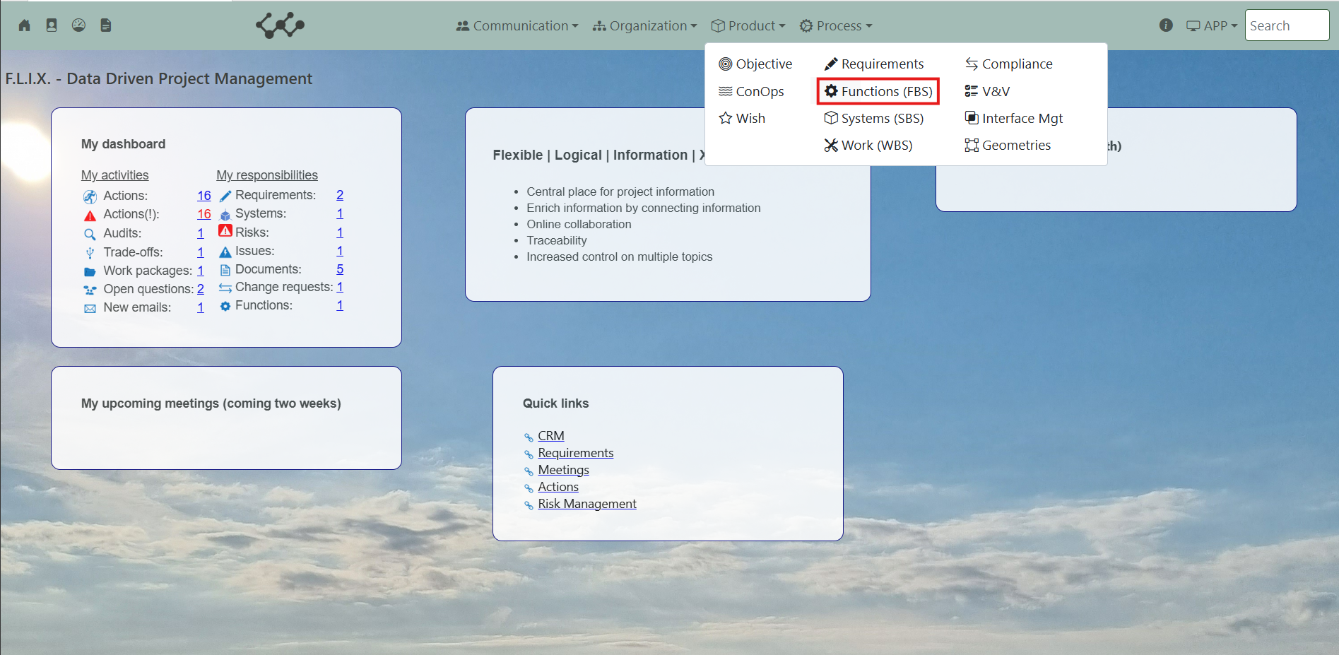

Click on Functions (FBS) and you will see the following screen:

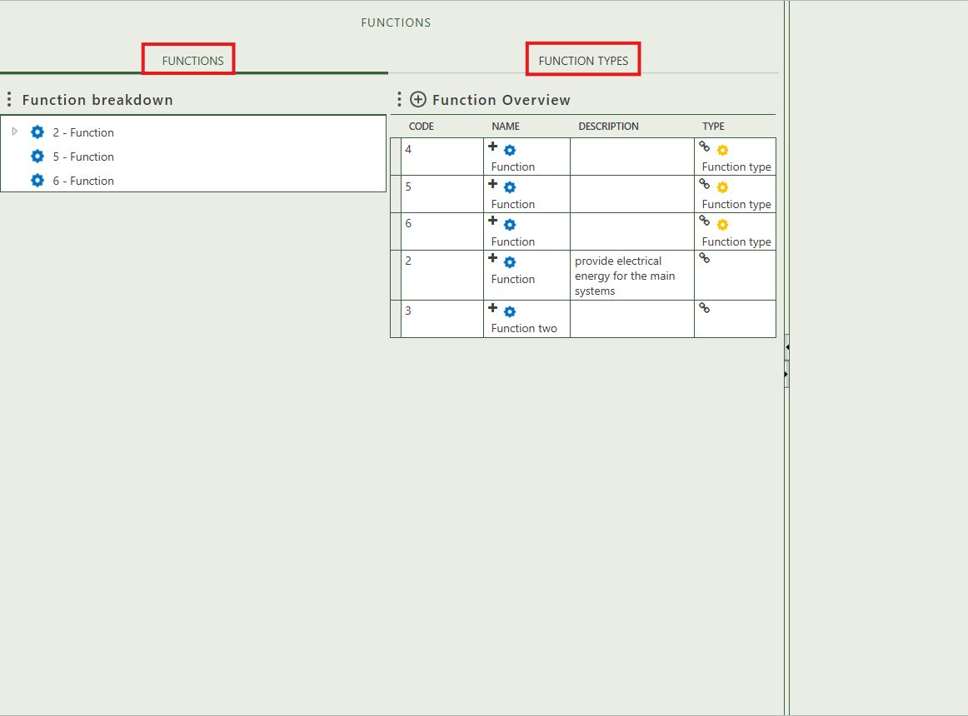

You will find two tabs in this module:

* Functions.
* Function types.

## 2.1 Function

This tab provides an overview of all functions within the workspace. By clicking the **+** sign next to *function Overview*, you can create new functions. Once a function is added to the table, it will appear in the Function Breakdown after refreshing the tree view. The tree structure allows you to build a hierarchy by dragging and dropping funnction onto one another.

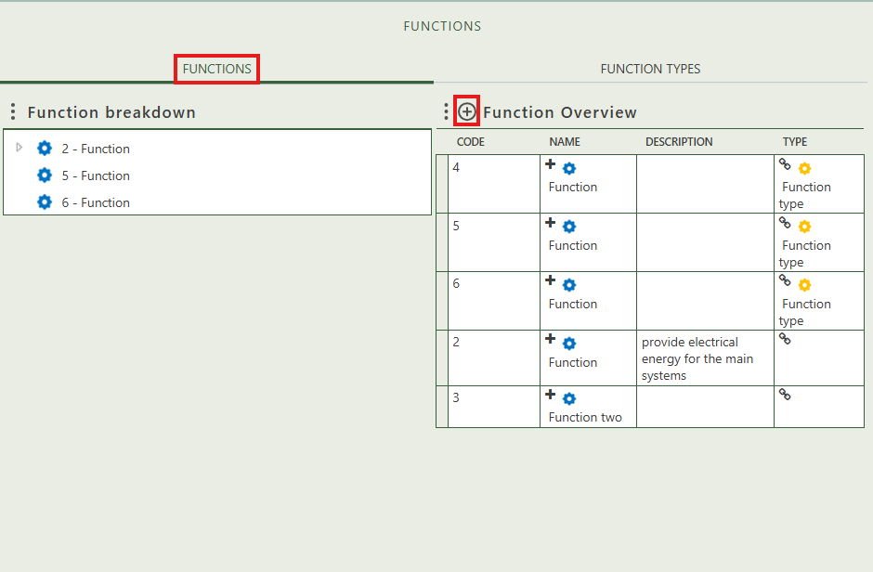

When you click on a specific function, its full details will appear on the right side of the screen, where you can review and update the information.

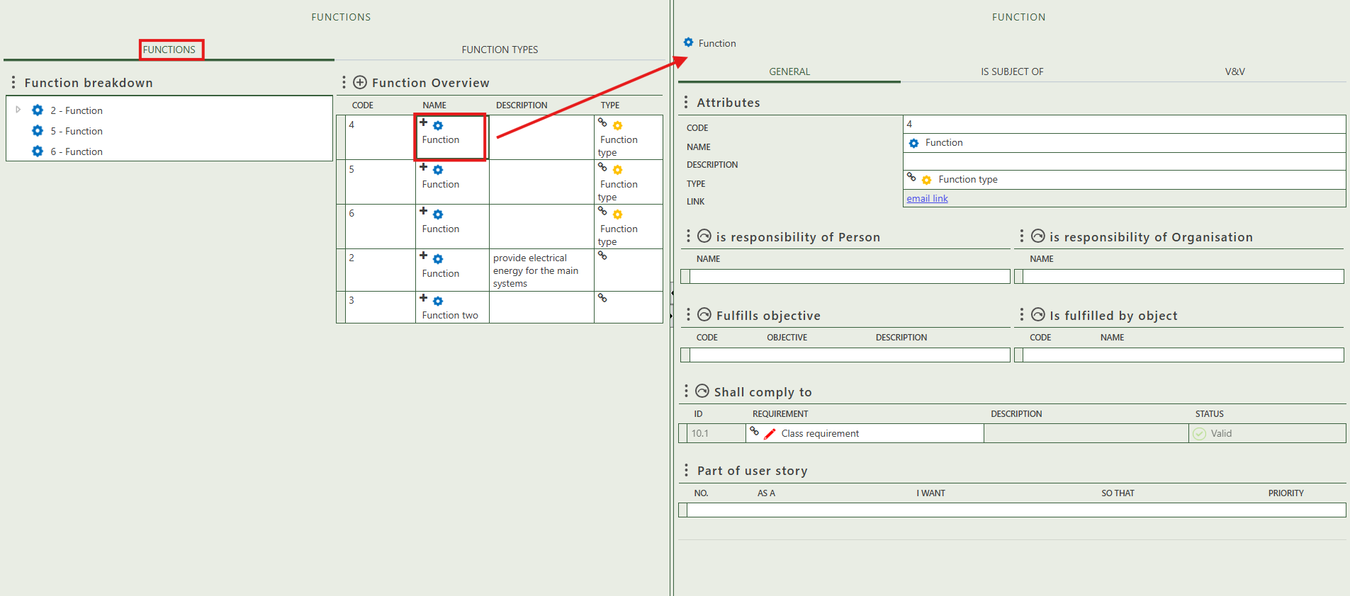

Fill in the general information of the function.

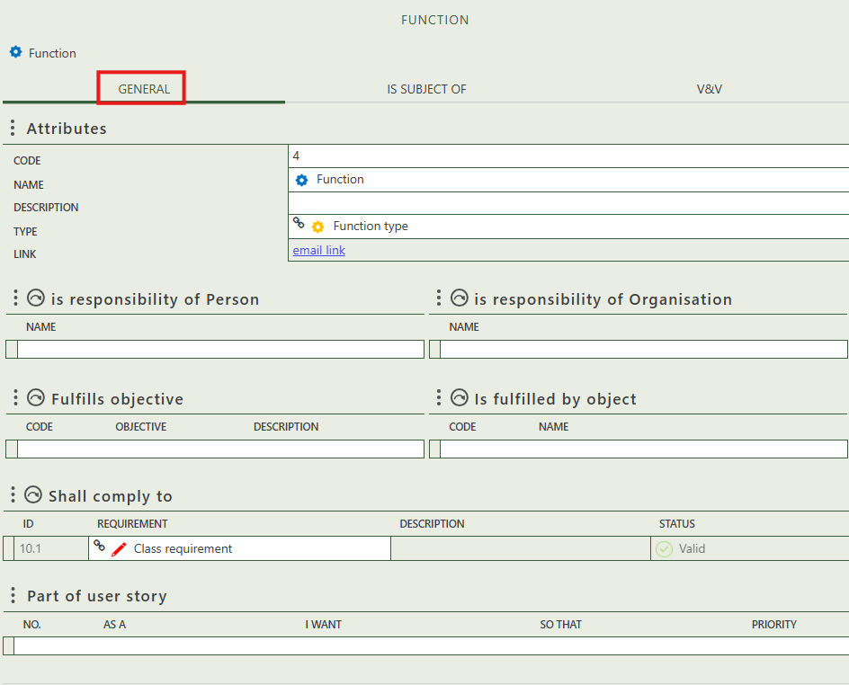

Allows you to select the person(s) and/or organization(s) that are responsible for the function.

Allows you to select objects that are fulfilled by this function.

Allows you to select objects that are fulfilled by this function.

Is automatically filled in if the function is part of a user story.

Allows you to select requirements that this function needs to comply to.

Shows whether the function is the subject of a question.

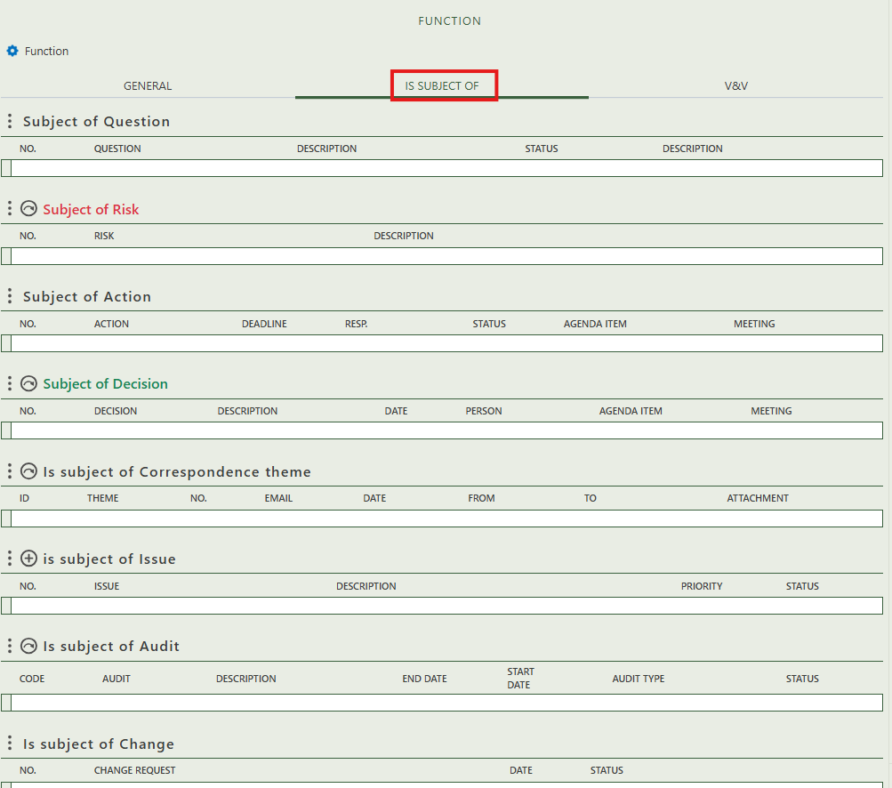

Allows you to create an issue that has this function as subject.

Allows you to assign this function as the subject of one or more audit.

Allows you to assign this function as the subject of one or more risk.

Shows you what change have this function as subject.

Allows you to assign this function as the subject of one or more decision.

Allows you to assign this function as the subject of one or more correspondence themes.

Shows whether the function is the subject of an action.

This section shows which requirements are planned for verification in relation to this function. You can assign a verification type, responsible person, and supporting templates.

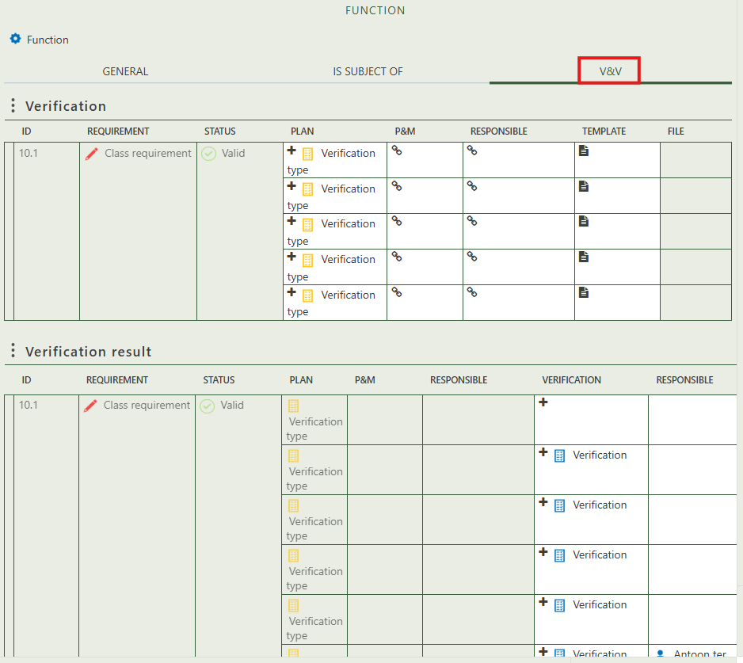

## 2.2 Function types

This tab provides an overview of all function types and allows you to create new ones (+ sign above the table). When you click on a specific function type, its full details will appear on the right side of the screen, where you can review and update the information. You can also see which issues this type is used to classify.

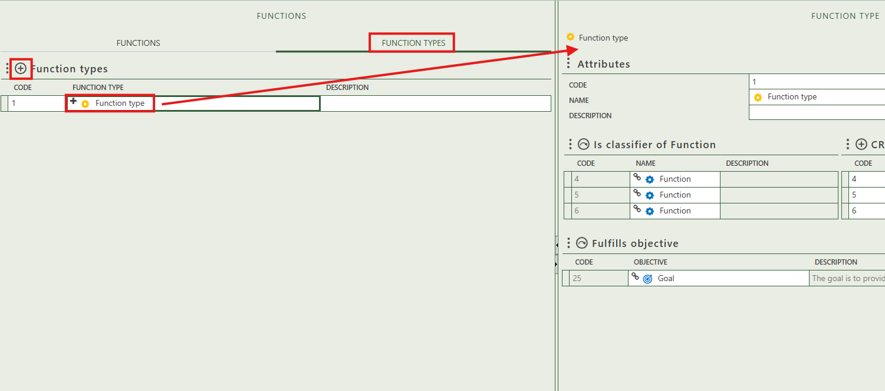

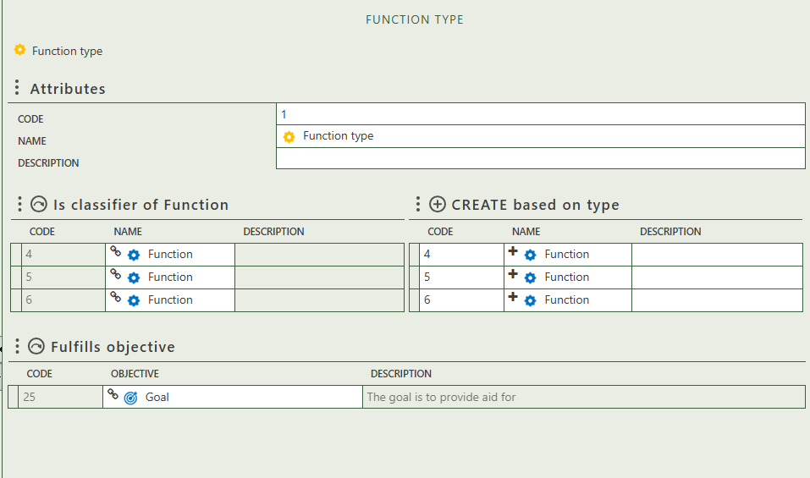

Allows you to select objective(s) that this type fulfills.

Allows you to create functions this type classifies.

Allows you to select the function(s) this type classifies.

Fill in the general information of the function.