

Author: F.Bovendeert

Version: V1.0

Publication date: 25-07-2025

Work Instruction – Documents

|  |  |  |  |  |
| --- | --- | --- | --- | --- |
| Work Instruction - Documents | | | | Project: Master Template |
| Function | Doc No: | Doc sheet: | Doc Rev.: | Pages |
|  |  |  |  |  |
| Doc Class: | Created by: | Created on: | Changed by: | Changed Date: |
|  | Floris Bovendeert | 25-7-2025 |  |  |

In this document, you will find the basic work instructions for **Documents.**

The document begins with general information about the module in Relatics, including an introduction, objective, and solution. Following this, the structure of the module as implemented in our master template is explained. The subchapters correspond to the tabs in Relatics. Whenever a relevant clickable element appears within a tab, its detail page is also described.

Content

1. General 3

1.1 Introduction 3

1.2 Objective 3

1.3 Solution 3

2. Module 4

2.1 Folders 5

2.2Documents 8

2.3 Document reviews 9

2.4 Types 9

**Revision History**

|  |  |  |  |
| --- | --- | --- | --- |
| Revision | Date | By | Remarks |
|  |  |  |  |
|  |  |  |  |

# 1. General

## 1.1 Introduction

In this module, you can manage all project-related documents. Documents often form the foundation for meetings, decisions, and key project milestones. Relatics allows you to register, link, and maintain a clear structure and version history of all relevant documentation in a transparent and consistent way.

## 1.2 Objective

The goal is to ensure that all project documents are easily accessible, traceable, and up-to-date. In many projects, information gets lost in emails or shared drives. Imagine searching for the latest version of a contract or report without knowing who edited it last or where it’s stored—that’s both inefficient and risky.

## 1.3 Solution

Relatics offers a central environment where documents can be registered, linked to project elements, and version-controlled. By using this module consistently, teams ensure that everyone works with the right information, avoid duplication or outdated versions, and support reliable project execution.

# 2. Module

Go to -> Communication -> Documents.

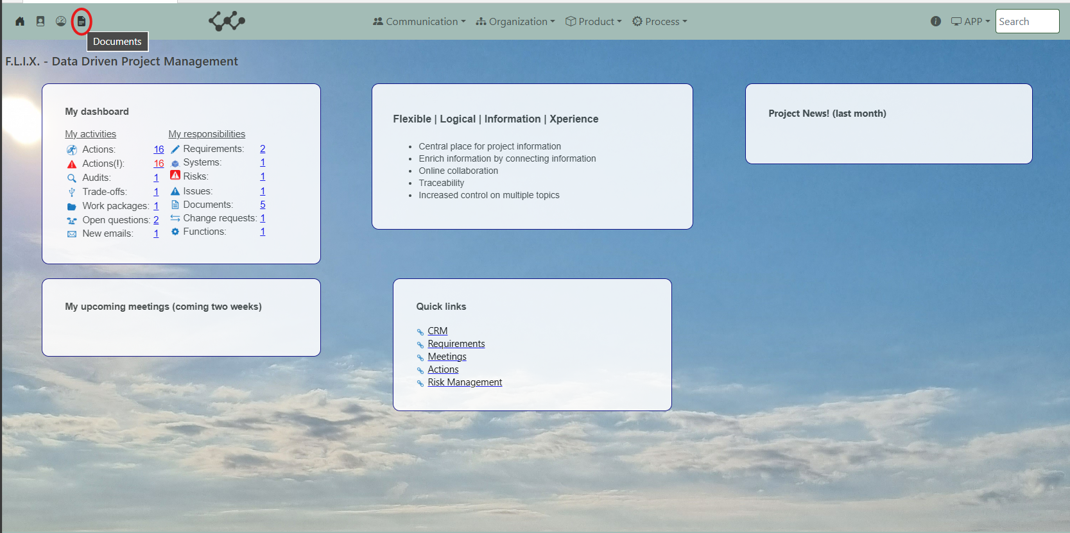

Click and you will see the following screen:

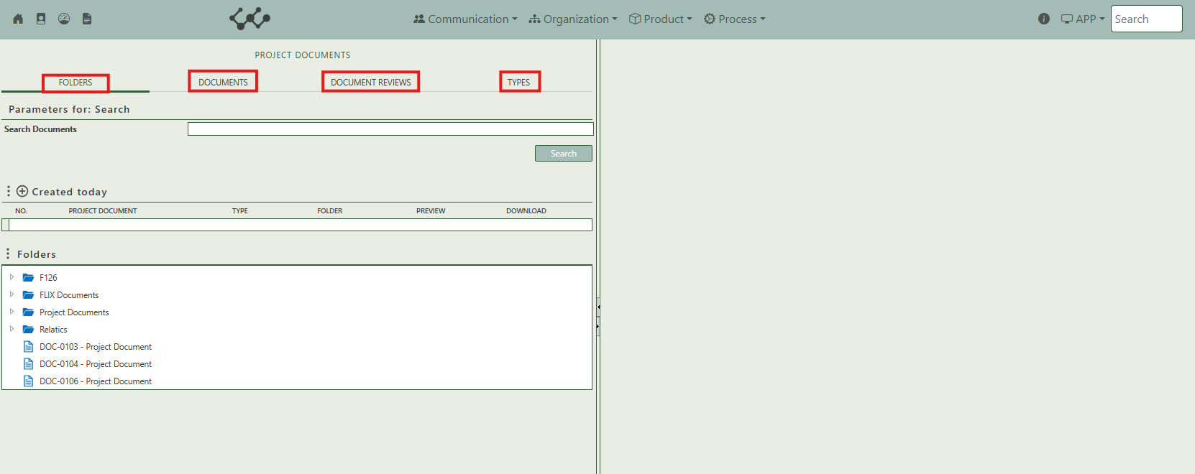

You will find three tabs in this module:

* Folders.
* Documents.
* Document review.
* Types.

## 2.1 Folders

This tab allows you to search for documents using various parameters. Additionally, it displays the folder structure used to organize documents and includes the upload section for adding new files.

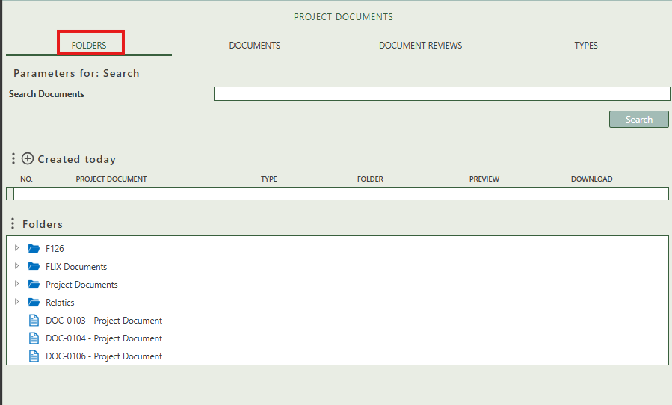

By pressing on the + sign next to Created today, you can create new documents.

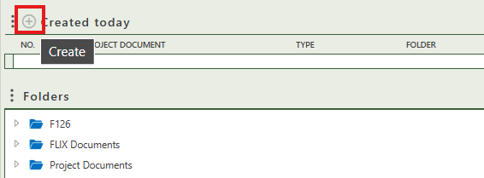

When you click on a specific folder, its full details will appear on the right side of the screen, where you can review and update the information, see what child/parent folder it has, and what documents it contains.

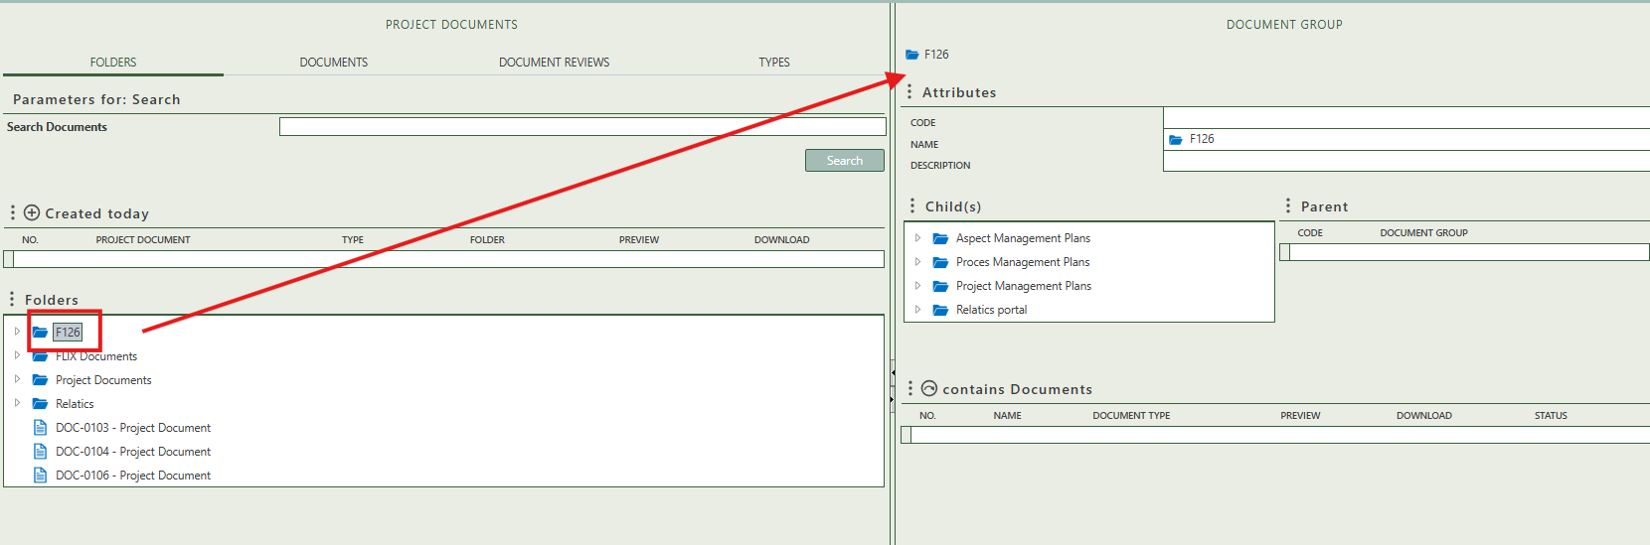

When you click on a specific document, its full details will appear on the right side of the screen, where you can review and update the information.

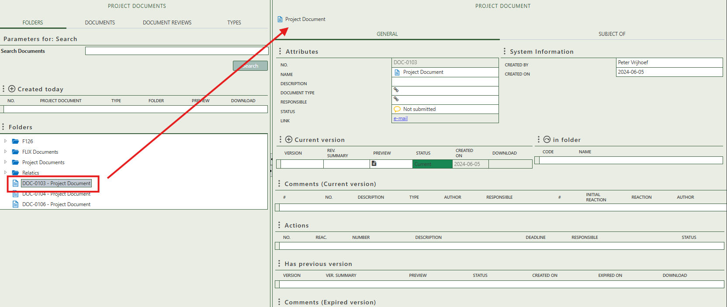

Fill in the general information of the document.

Is automatically filled in on the moment a user creates the document.

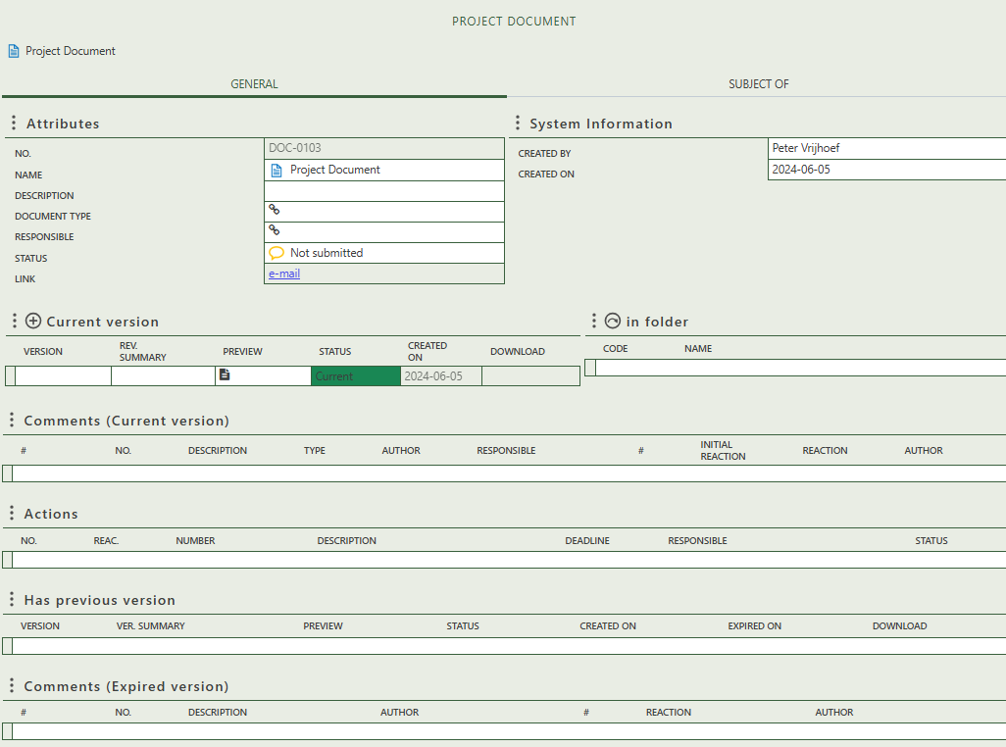

Allows you to create and control the version info of the document. When the status is changed to Expired, the document will move to the has previous version table.

Select in what folder you want the document to be stored.

If a document has been created as a result of a comment, that comment will be displayed here. Depending on the status, the comment is either the current or expired version.

If a document has been created as a result of an action, that action will be displayed here.

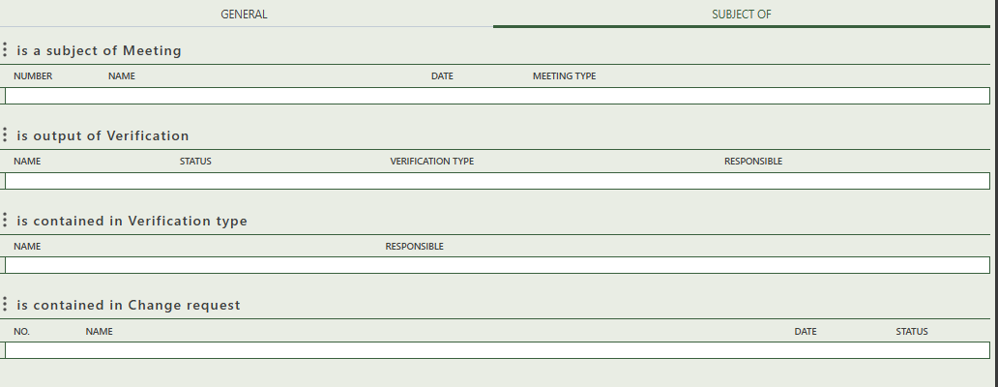This is the second tab on your detail page. This tab is solely for reference purpose. Here you can see if your document has been linked to a meeting, verification or change request. If you want to add a document to these modules, you will need to go to those modules themselves to link them. You can also upload a document via those modules, but make sure you fill in as much information as possible and also the folder you want them in order to be able to find those documents via the document module.

## 2.2 Documents

This tab displays all documents available in the workspace and allows you to create new project documents. On the left-hand side, a side panel enables you to quickly filter the table by document type, responsible person, or status.

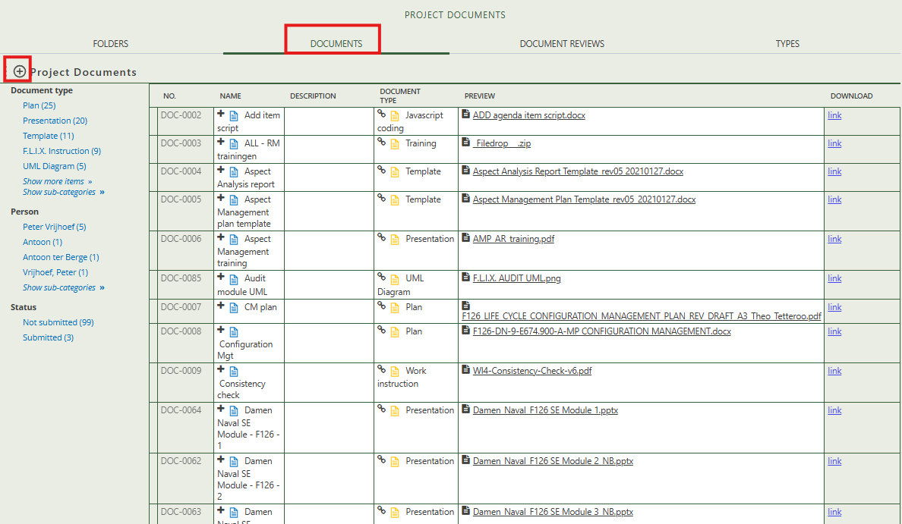

## 2.3 Document reviews

You’ll see the status of the review, the documents themselves and the folder they are stored in.

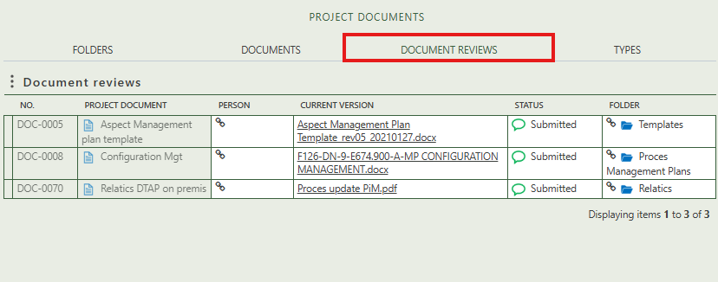

## 2.4 Types

All document types used in this module are listed here. If a required type is missing, you can easily create a new one by clicking the + sign above the table. Selecting a specific document type opens its detail page on the right side of the screen. On this page, you can fill in general information about the document type and view a list of all documents that are classified under it.

