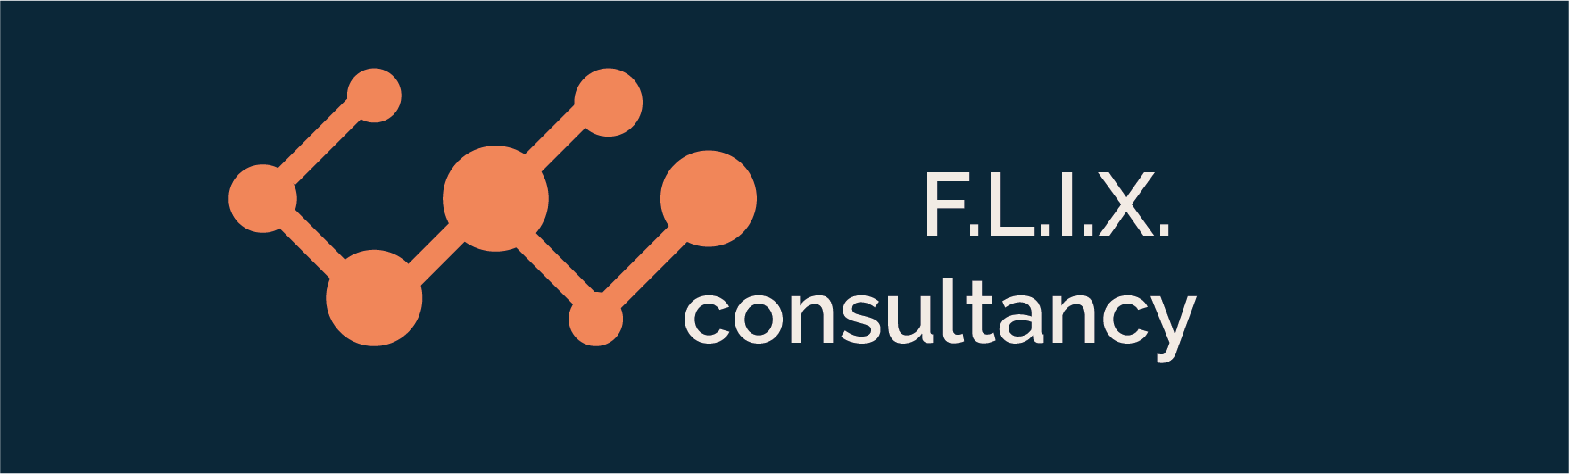

Author: F.Bovendeert

Version: V1.0

Publication date: 25-07-2025

Work Instruction - Decision

|  |  |  |  |  |
| --- | --- | --- | --- | --- |
| Work Instruction - Decision | | | | Project: Master Template |
| Function | Doc No: | Doc sheet: | Doc Rev.: | Pages |
|  |  |  |  |  |
| Doc Class: | Created by: | Created on: | Changed by: | Changed Date: |
|  | Floris Bovendeert | 25-7-2025 |  |  |

In this document, you will find the basic work instructions for **Decision.**

The document begins with general information about the module in Relatics, including an introduction, objective, and solution. Following this, the structure of the module as implemented in our master template is explained. The subchapters correspond to the tabs in Relatics. Whenever a relevant clickable element appears within a tab, its detail page is also described.

Content

1. General 3

1.1 Introduction 3

1.2 Objective 3

1.3 Solution 3

2. Module 4

2.1 Decisions 5

2.2Design decisions 7

2.3 Decision created last week 7

**Revision History**

|  |  |  |  |
| --- | --- | --- | --- |
| Revision | Date | By | Remarks |
|  |  |  |  |
|  |  |  |  |

# 1. General

## 1.1 Introduction

In this module, you can manage all project-related decisions. Decisions often arise from meetings, discussions, or project documentation. Relatics enables you to record, track, and maintain a clear history of these decisions in a structured and transparent manner.

## 1.2 Objective

The goal is to ensure full traceability and clarity of all project decisions. In many projects, decisions are made verbally or documented informally, which can cause confusion or disputes later on. Imagine needing to understand why a key decision was made two years ago—without a centralized record, this can be very difficult.

## 1.3 Solution

Relatics helps solve this issue—if used consistently and correctly. By registering decisions in this module, you create a transparent overview of what was decided, by whom, and when. This supports better communication, accountability, and informed project progress.

# 2. Module

Go to -> Communication -> Decision.

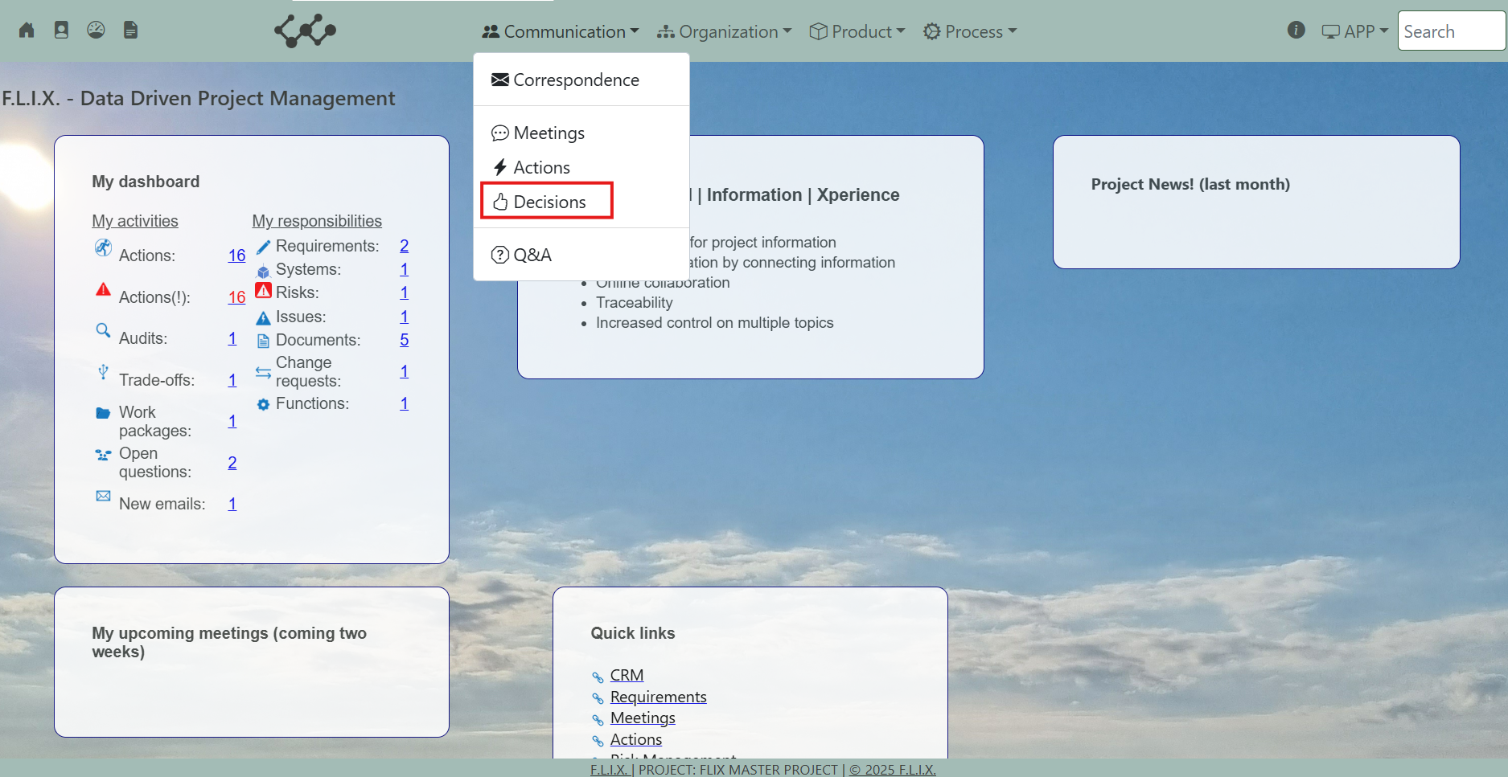

Click and you will see the following screen:

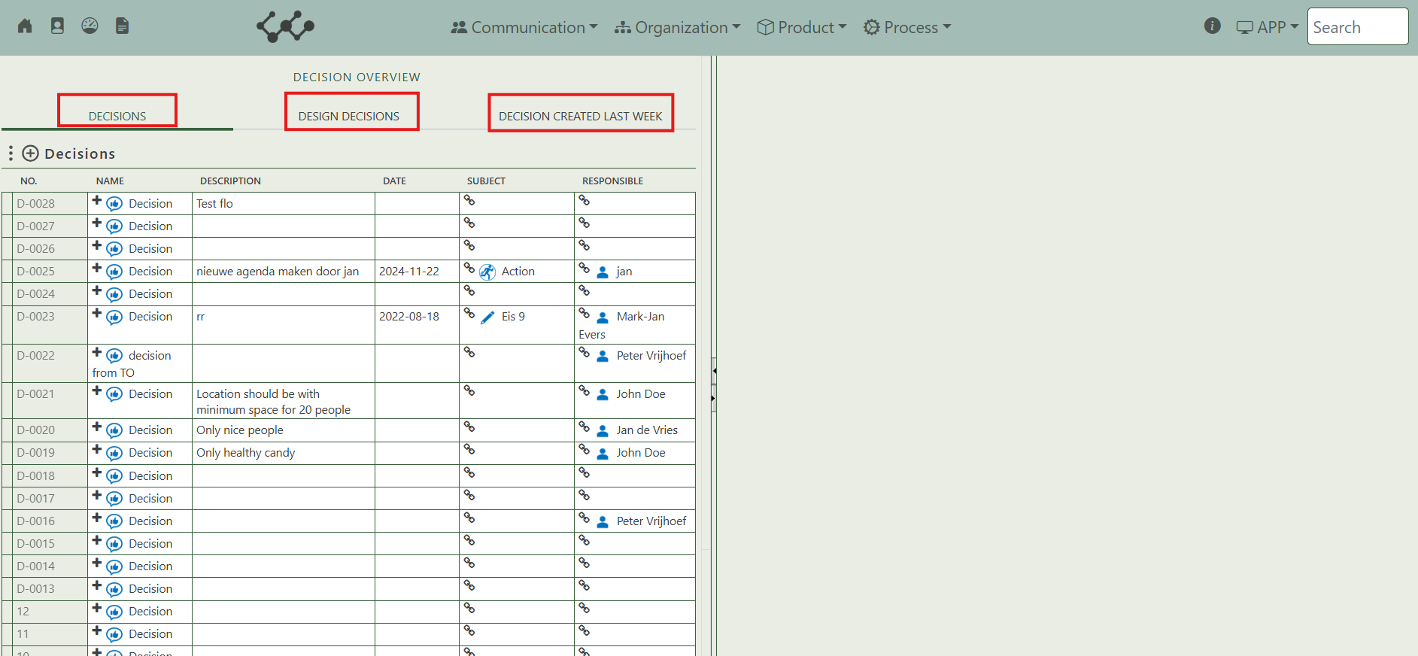

You will find three tabs in this module:

* Decisions.
* Design decisions.
* Decisions created last week.

## 2.1 Decisions

This tab contains an overview of all the decisions that are created in this workspace.

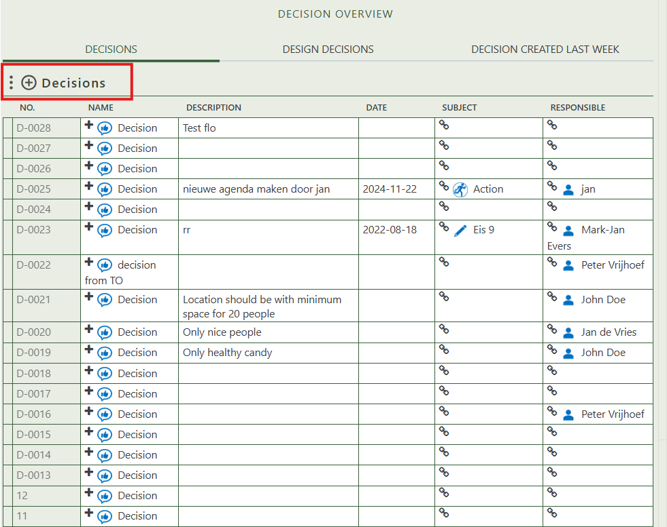

By pressing on the + sign next to decision, you can create new decisions.

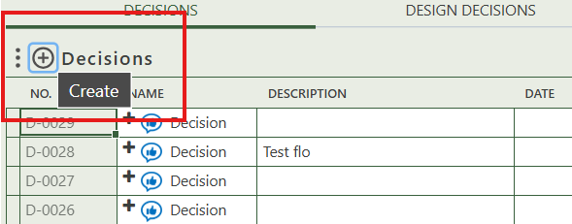

When you click on a specific decision, its full details will appear on the right side of the screen, where you can review and update the information.

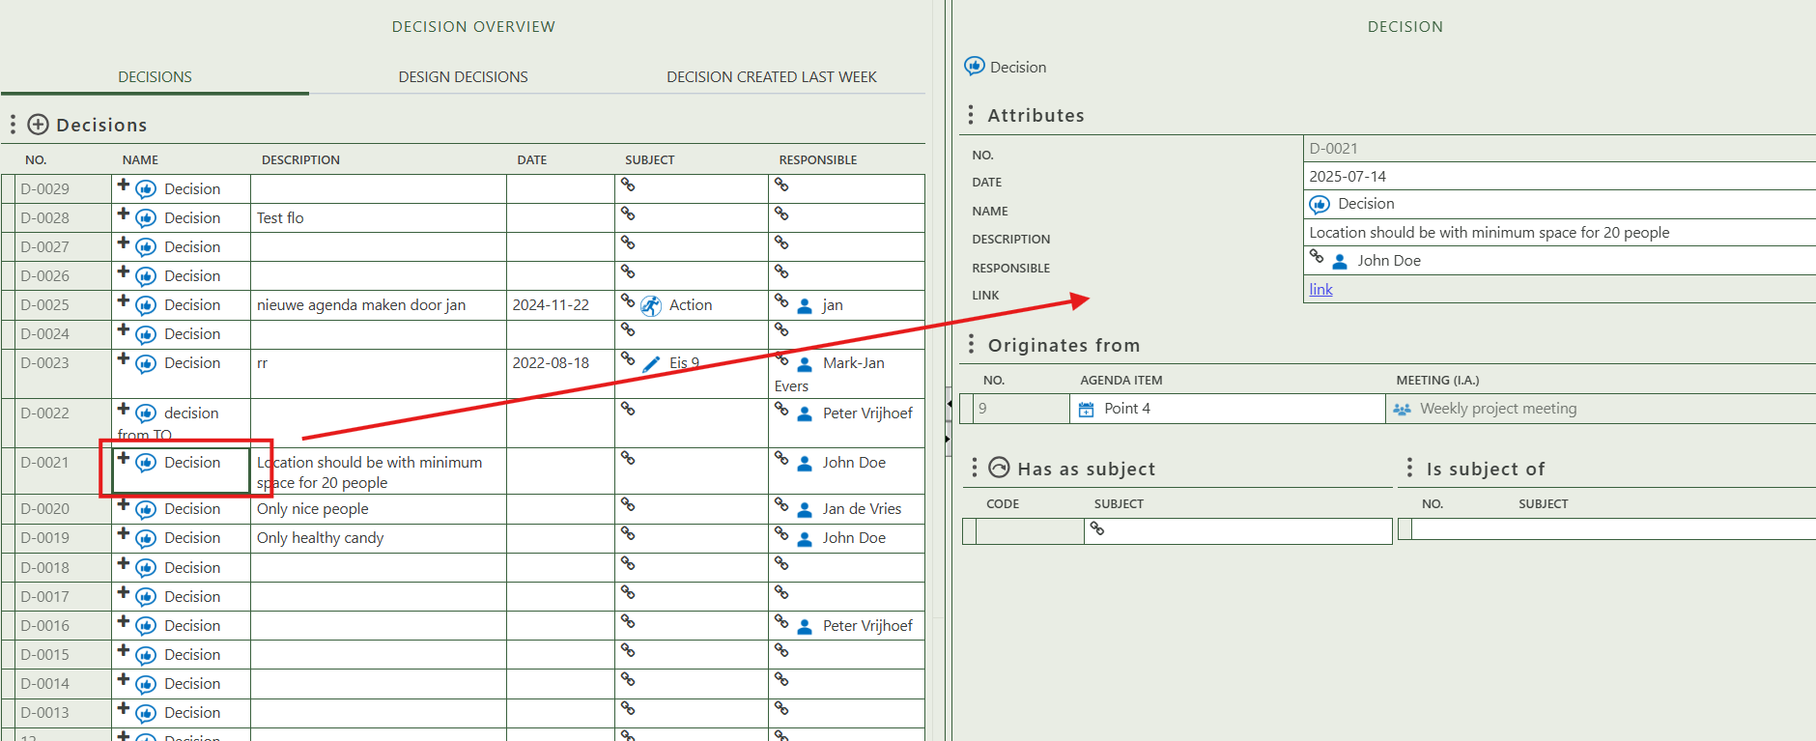

Fill in the general information of the specific decision.

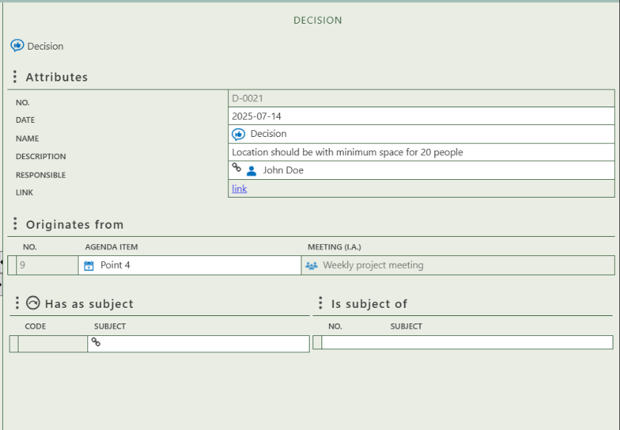

Select the person who is responsible for the decision.

Shows the agenda item and meeting from which the decision originates.

Shows where this decision is the subject of.

Allows you to select a subject to which the decision applies.

## 2.2 Design decisions

This tab is configured identically to the Decisions tab, but it is dedicated to Design Decisions rather than standard Decisions.

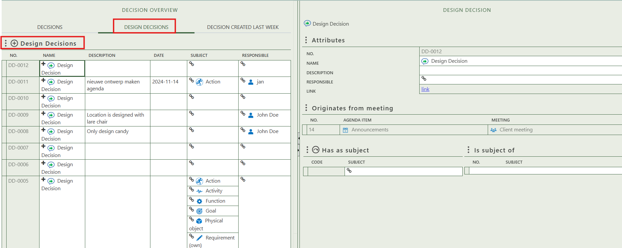

## 2.3 Decision created last week

This tab displays a single table showing decisions created within the last 7 days. As you can see, I created a decision just a few minutes before taking this screenshot, which is why it appears here.

