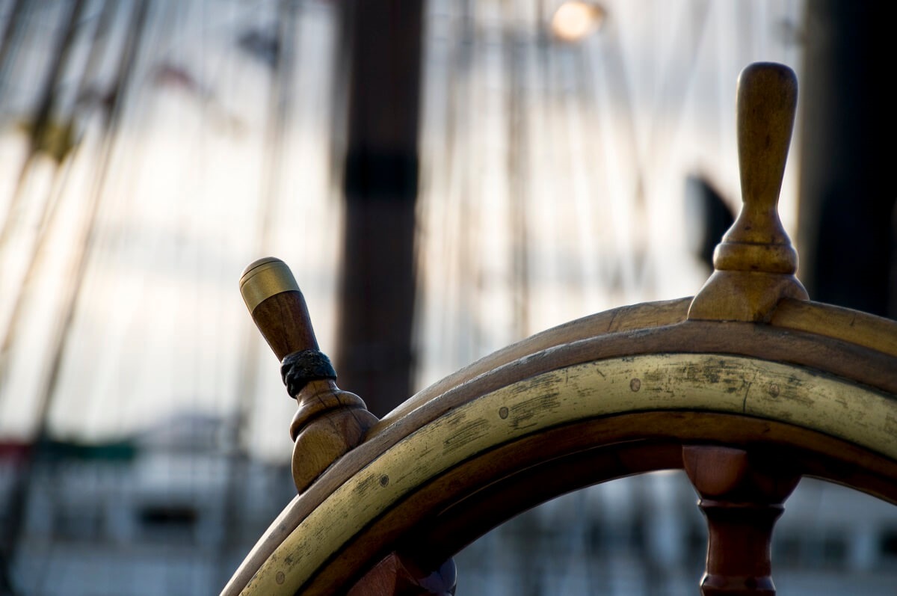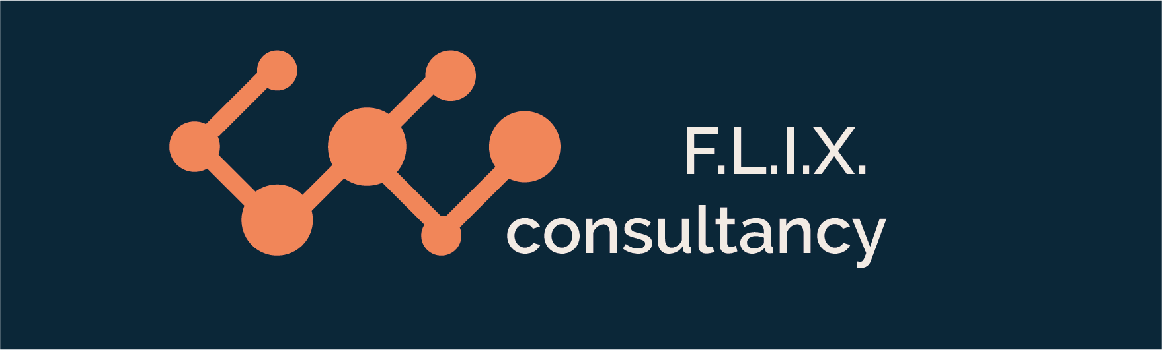

Author: F.Bovendeert

Version: V1.0

Publication date: 25-07-2025

Work Instruction - Correspondece

|  |  |  |  |  |
| --- | --- | --- | --- | --- |
| Work Instruction - Correspondence | | | | Project: Master Template |
| Function | Doc No: | Doc sheet: | Doc Rev.: | Pages |
|  |  |  |  |  |
| Doc Class: | Created by: | Created on: | Changed by: | Changed Date: |
|  | Floris Bovendeert | 25-7-2025 |  |  |

In this document, you will find the basic work instructions for **Correspondence**.

The document begins with general information about the module in Relatics, including an introduction, objective, and solution. Following this, the structure of the module as implemented in our master template is explained. The subchapters correspond to the tabs in Relatics. Whenever a relevant clickable element appears within a tab, its detail page is also described.

Content

1. General 3

1.1 Introduction 3

1.2 Objective 3

1.3 Solution 3

2. Module 4

2.1 Correspondence 5

2.2Transmittals 8

2.3 Email types 8

**Revision History**

|  |  |  |  |
| --- | --- | --- | --- |
| Revision | Date | By | Remarks |
|  |  |  |  |
|  |  |  |  |

# 1. General

## 1.1 Introduction

In this module you can administrate all correspondence of a project. You can’t send emails via Relatics. You still need to send your email via your own email browser, but you can administrate all the correspondence in Relatics.

## 1.2 Objective

You do this to have complete traceability on your project mail flow. Often mail is kept in individual email browsers. This can eventually become a problem. Let’s say you need information that was sent in an email 3 years ago to someone that is no longer working for the company, How would you find the email?

## 1.3 Solution

Relatics reduces the problem, if used correctly and consistently.

# 2. Module

Go to -> Communication -> Correspondence

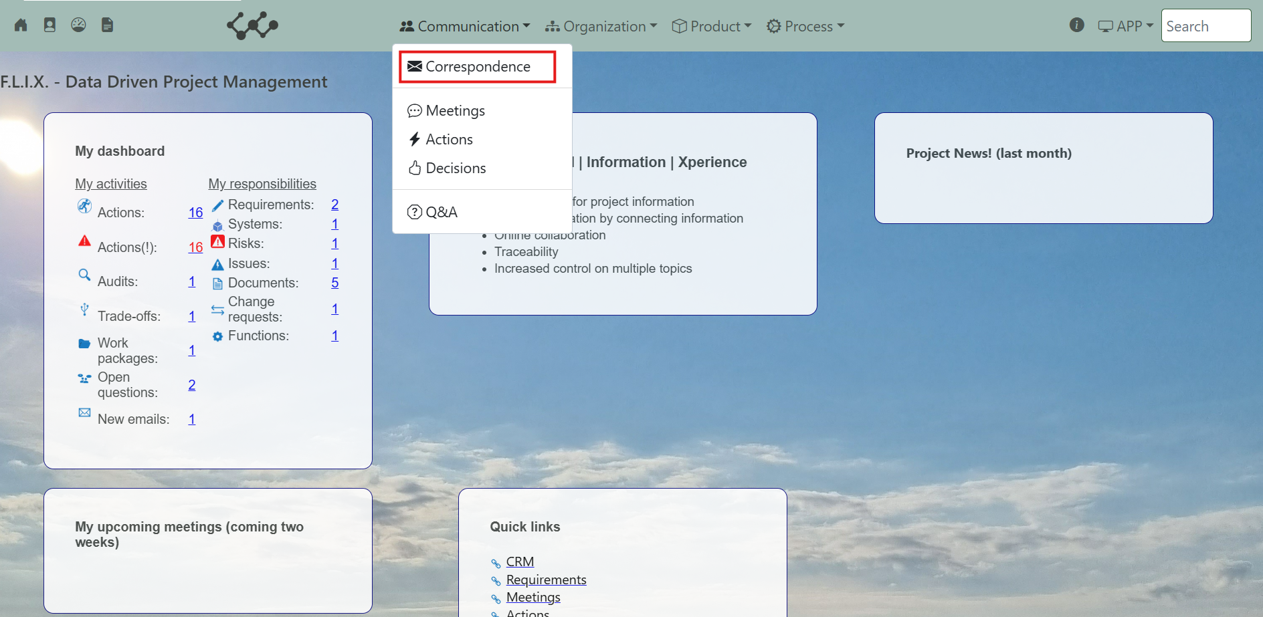

Click and you will see the following screen:

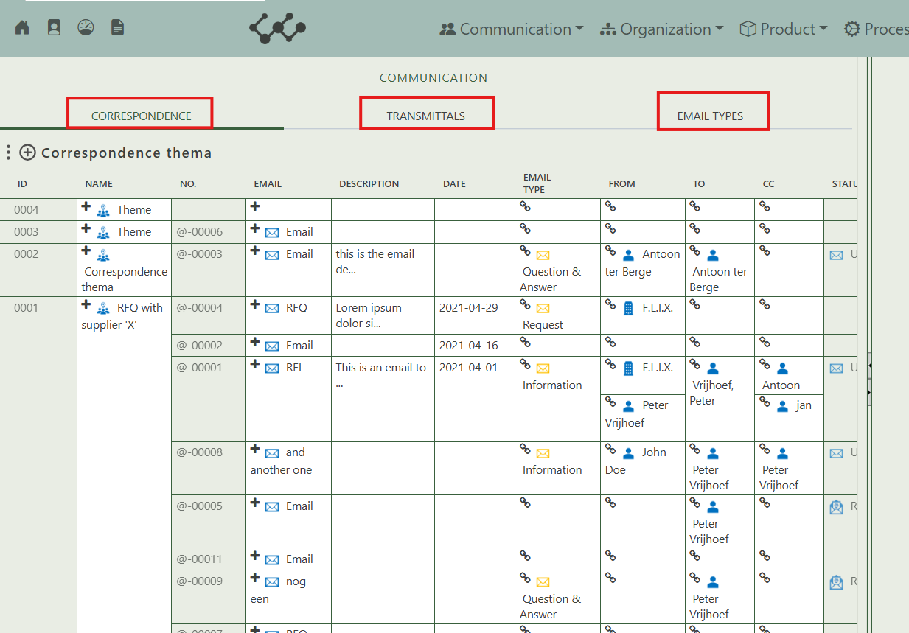

You will find three tabs in this module:

* Correspondence
* Transmittals.
* Email types.

## 2.1 Correspondence

This tab contains an overview of all the Correspondence that belong in this workspace. This is also the place where you can create a new correspondence.

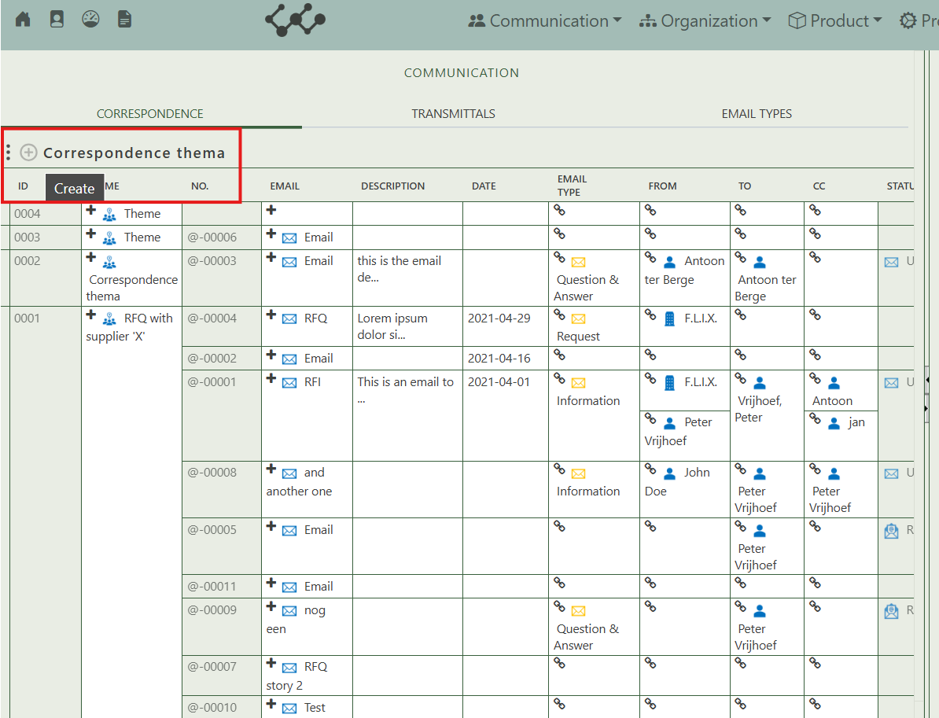

By pressing on the + sign next to actions, you can create new correspondence.



When you click on a specific correspondence, its full details will appear on the right side of the screen, where you can review and update the information.

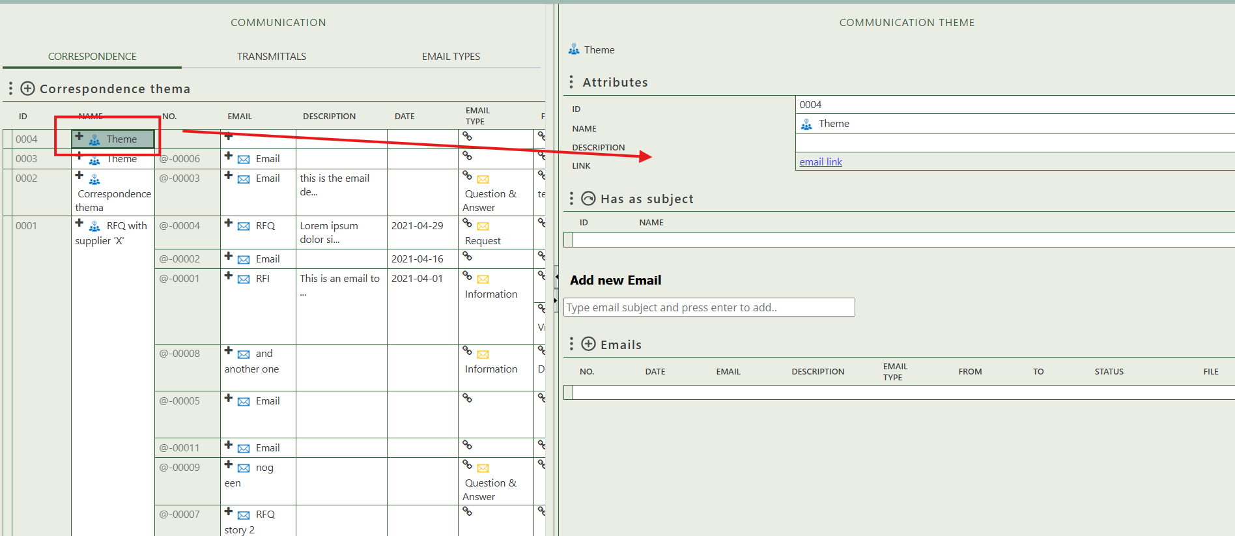

Fill in the general information of the specific correspondence = theme.

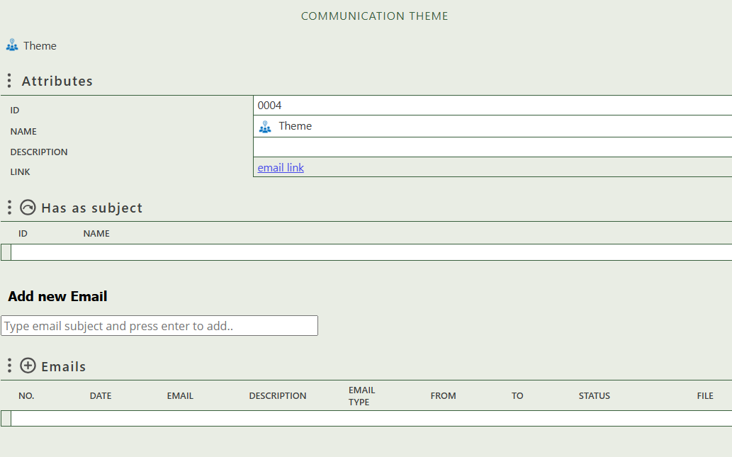

Select the subject to which the correspondence applies.

Here you can create an email, and use the table to edit or manage its content.

Click to add an email.

When you click on a specific Email, its full details will appear on the right side of the screen, where you can review and update the information.

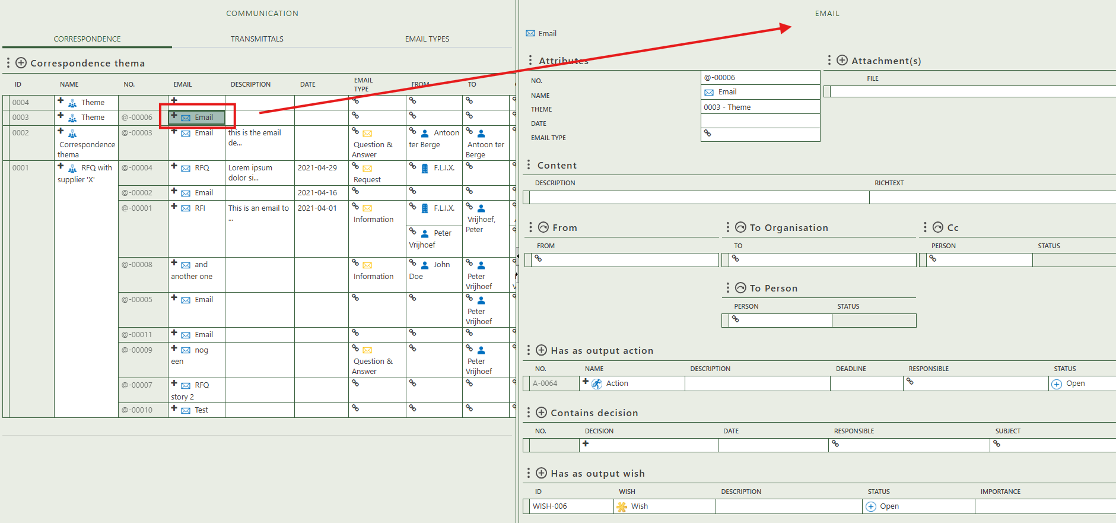

Add attachment to the email.

Fill in the general information of the specific email

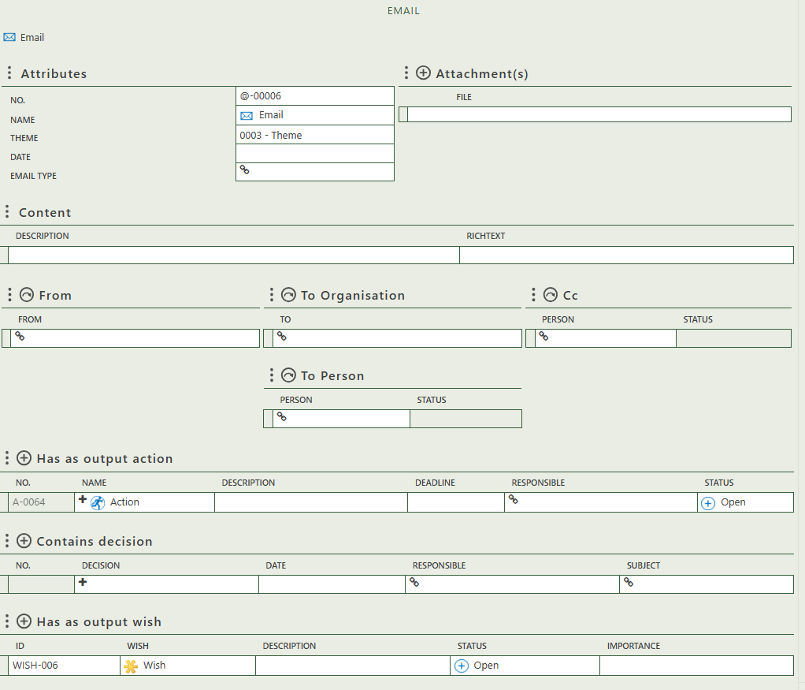

Allows you to fill in a description and richtext of the email.

Allows you to select:

* The person the email is from.
* The persons included in CC.
* The persons or organizations the email is addressed to.

Allows you to create actions as result of the email.

Allows you to create decisions as result of the email.

Allows you to create wishes as result of the email.

## 2.2 Transmittals

This tab contains nothing.

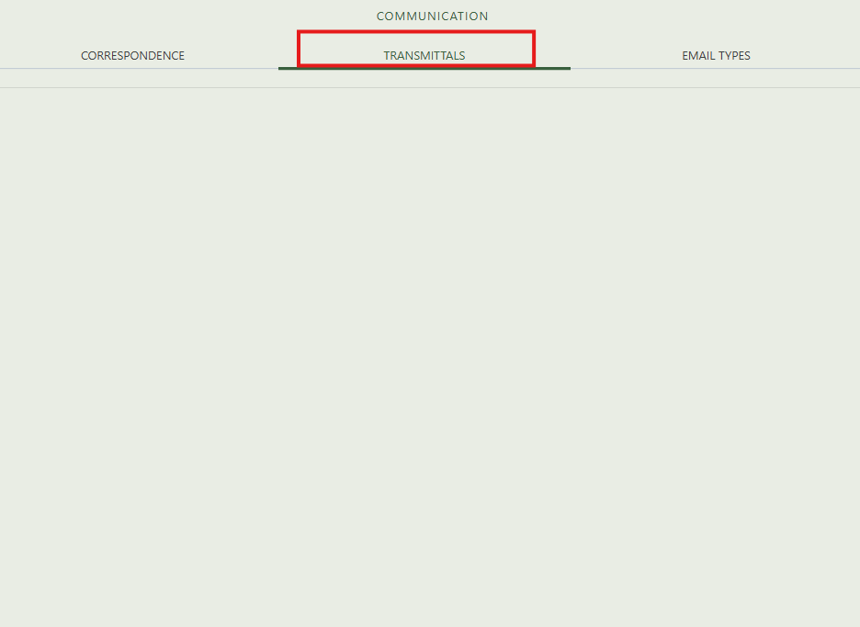

## 2.3 Email types

Click on the tab “email types” and you will see the following screen: 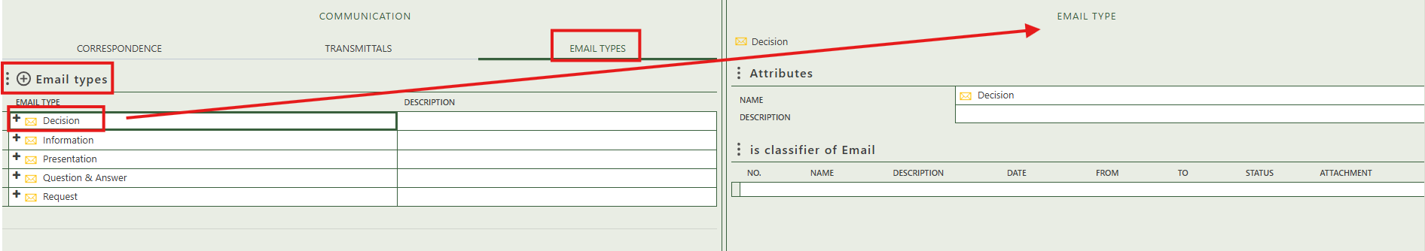

On the left side, you can create a new email type by clicking the "+" icon above the table.

By selecting an existing email type, its detail screen appears on the right, where you can enter general information. The second table displays all emails that are classified under the selected email type.