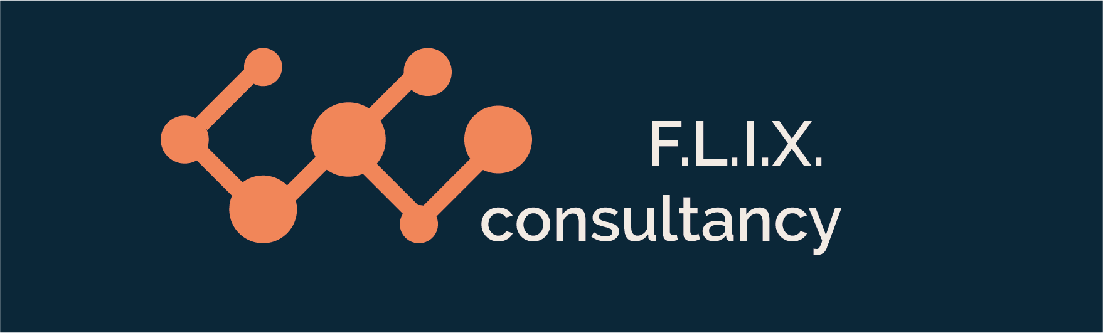

Author: F.Bovendeert

Version: V1.0

Publication date: 25-07-2025

Work Instruction - Conops

|  |  |  |  |  |
| --- | --- | --- | --- | --- |
| Work Instruction - Conops | | | | Project: Master Template |
| Function | Doc No: | Doc sheet: | Doc Rev.: | Pages |
|  |  |  |  |  |
| Doc Class: | Created by: | Created on: | Changed by: | Changed Date: |
|  | Floris Bovendeert | 25-7-2025 |  |  |

In this document, you will find the basic work instructions for **Conops.**

The document begins with general information about the module in Relatics, including an introduction, objective, and solution. Following this, the structure of the module as implemented in our master template is explained. The subchapters correspond to the tabs in Relatics. Whenever a relevant clickable element appears within a tab, its detail page is also described.

Content

1. General 3

1.1 Introduction 3

1.2 Objective 3

1.3 Solution 3

2. Module 4

2.1Processes 5

2.2 User stories 7

2.3 Types 8

**Revision History**

|  |  |  |  |
| --- | --- | --- | --- |
| Revision | Date | By | Remarks |
|  |  |  |  |
|  |  |  |  |

# 1. General

## 1.1 Introduction

In this module, you can define and manage all operational aspects of system use, including user processes, (end) users, user stories, and usage scenarios. These elements help to clarify how the system will be used in practice. Relatics enables you to document this information in a structured way—capturing user needs, roles, goals, and interactions—providing a clear and shared understanding of system usage from a user perspective.

## 1.2 Objective

The goal is to ensure traceability and alignment between system design and actual user needs. Without a structured approach, user expectations often remain implicit or are only discussed informally, making it harder to validate whether the final system meets real-world demands. Proper documentation supports communication, validation, and alignment with stakeholders.

## 1.3 Solution

Relatics supports a structured ConOps (Concept of Operations) process. By registering user processes, defining roles and responsibilities, and linking user stories and scenarios, you create a clear operational context for system development. This helps bridge the gap between users and technical teams, ensures functional relevance, and supports verification and validation throughout the project lifecycle.

# 2. Module

Go to -> Product -> Conops

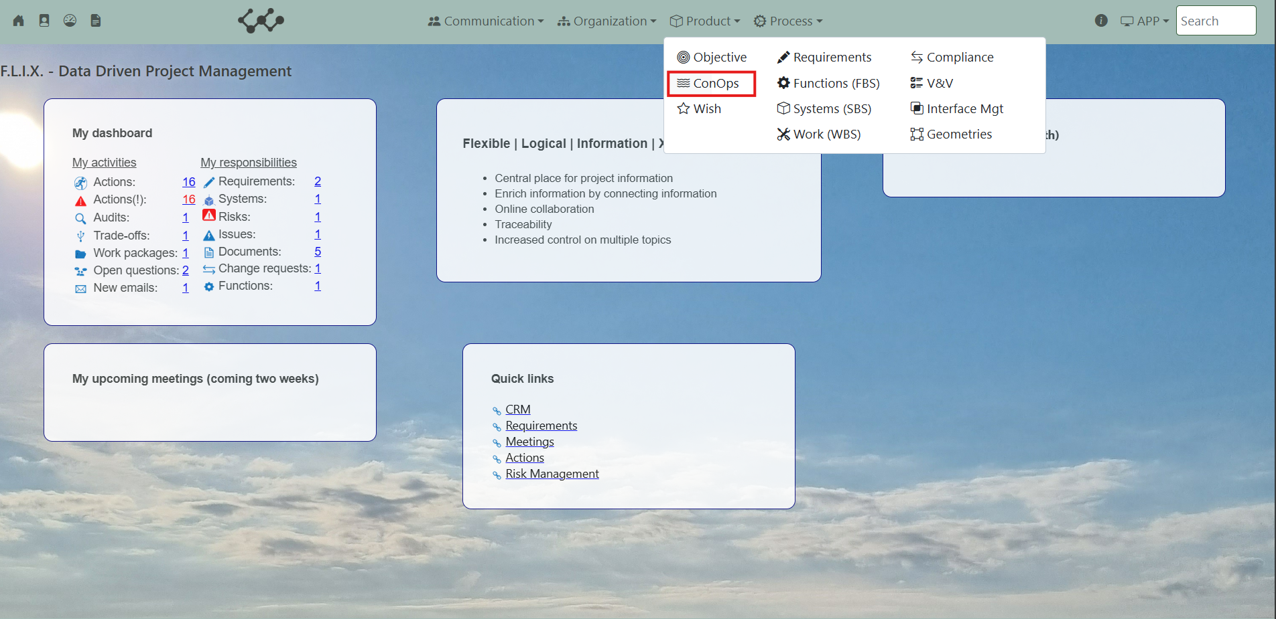

Click on Conops and you will see the following screen:

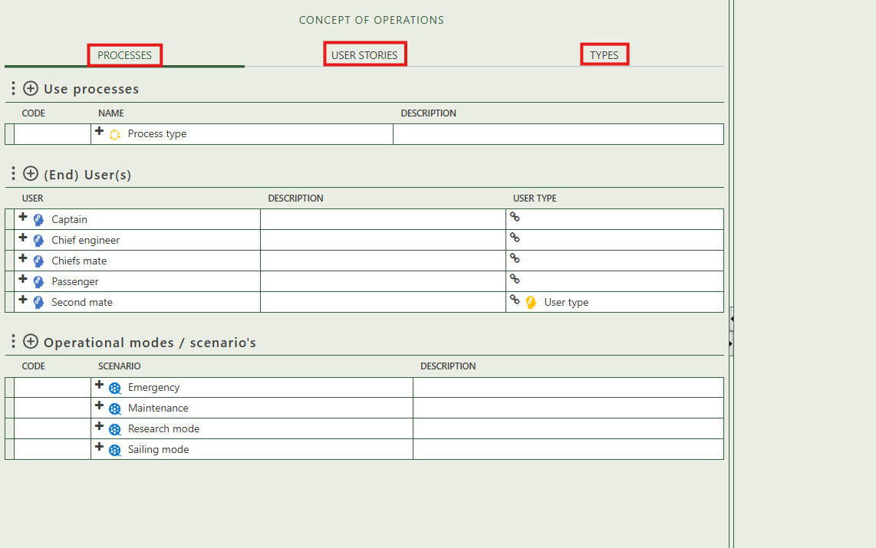

You will find three tabs in this module:

* Processes.
* User stories.
* Types.

## 2.1 Processes

This tab contains an overview of all the use processes, (end) users, and operational modes / scenario’s in this workspace. By pressing on the + signs above each table, you can create new instances.

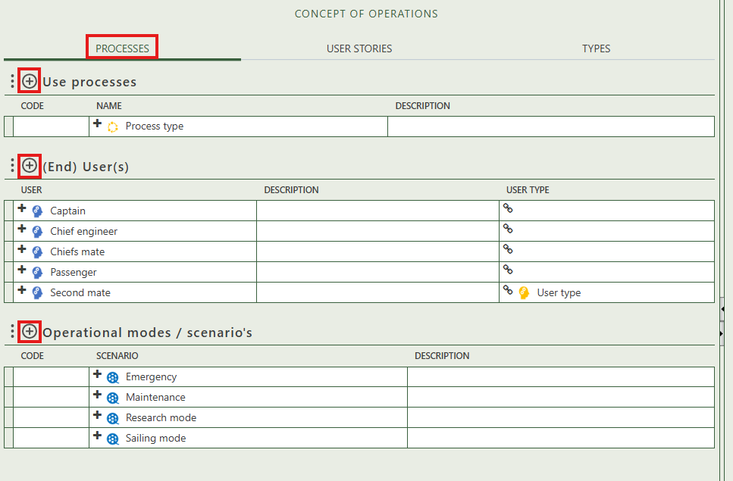

When you click on a specific instance, its full details will appear on the right side of the screen, where you can review and update the information.

Fill in the general information of the process type.

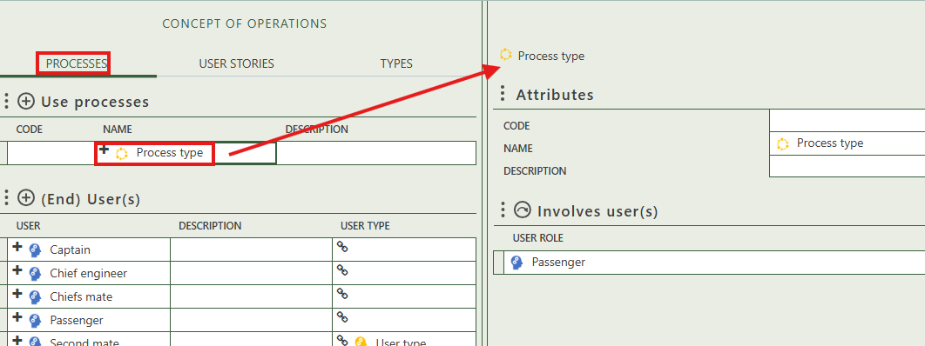

Select users that are involved in this process type.

Fill in the general information of the users.

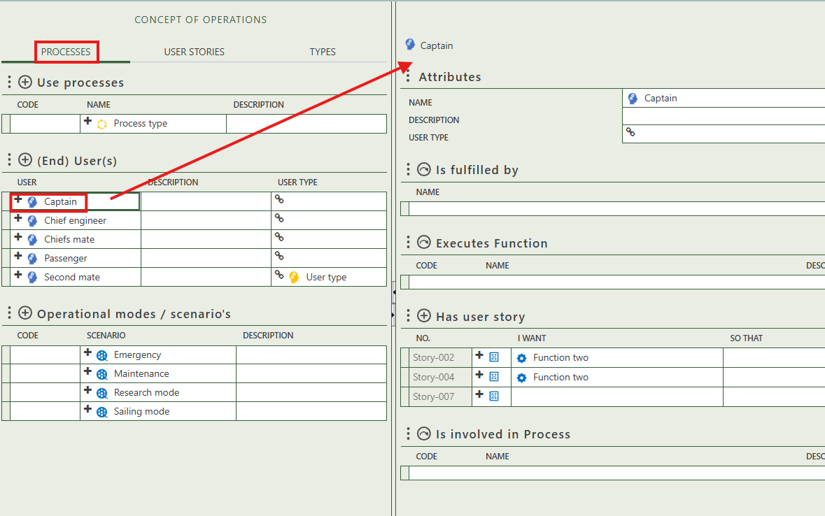

Allows you to select organizations & persons.

Allows you to select the functions (types) that this user executes.

Allows you to create user stories

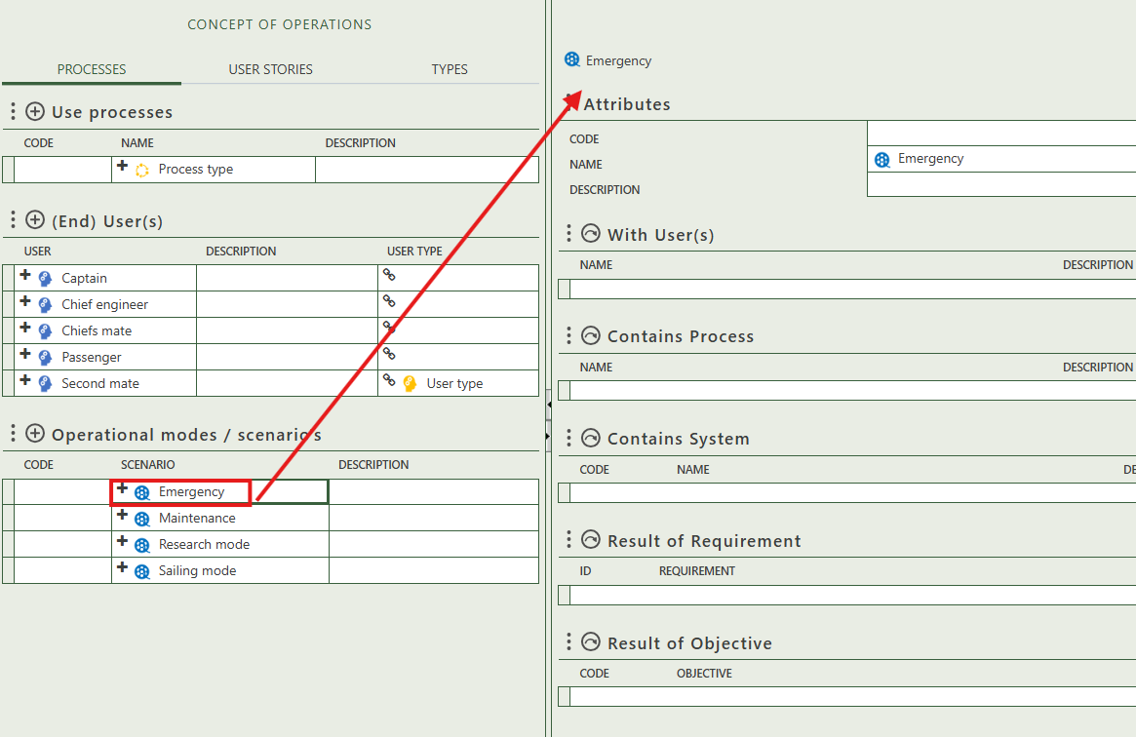

Allows you to select requirements of which this scenario is a result of.

Allows you to select objectives of which this scenario is a result of.

Allows you to select process(es) that are part of this scenario.

Allows you to select physical object(s) for this scenario.

Allows you to select user(s) that are part of this scenario.

Fill in the general information of the users.

Allows you to select processes that this person is involved in.

## 2.2 User stories

This tab provides an overview of all user stories types and allows you to create new ones. When you click on a specific user story, its full details will appear on the right side of the screen, where you can review and update the information.

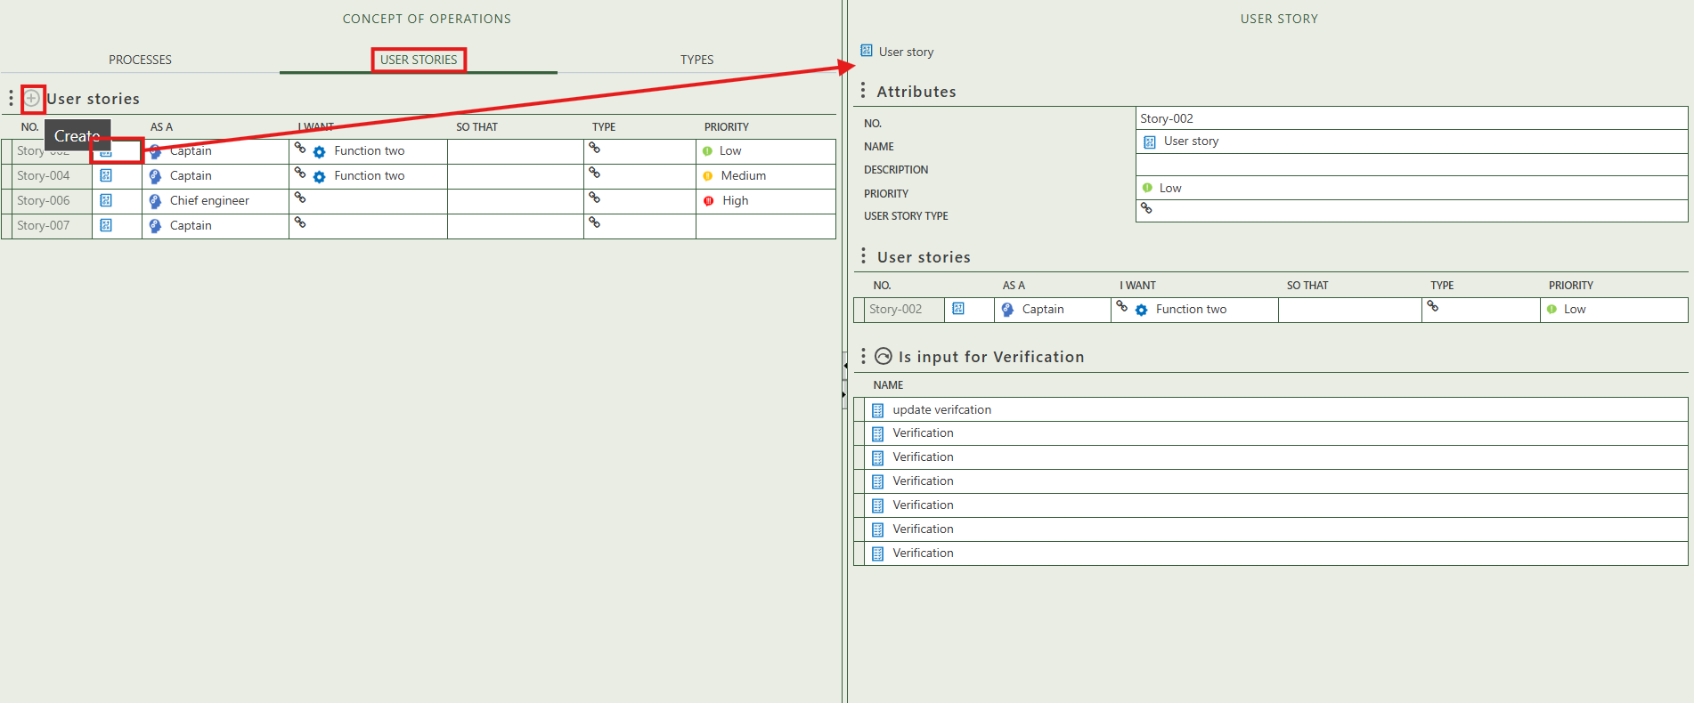

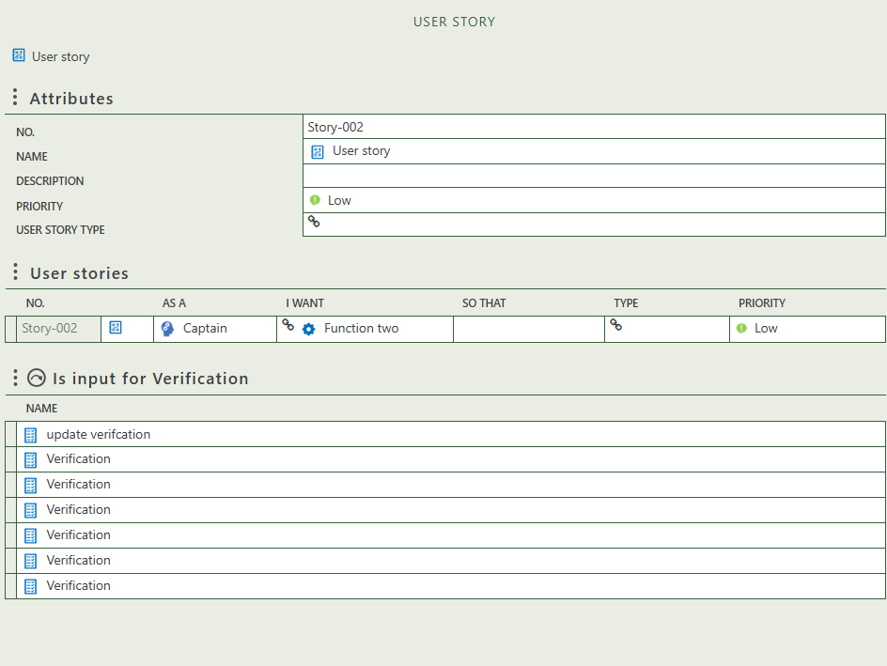

Fill in the general information of the user story.

Reflects the user story as shown in the table on the left part of the screen.

Allows you to select verification that have this user story as input.

The user and function are clickable. When you click on them, its full details will appear on the right side of the screen, where you can review and update the information.

## 2.3 Types

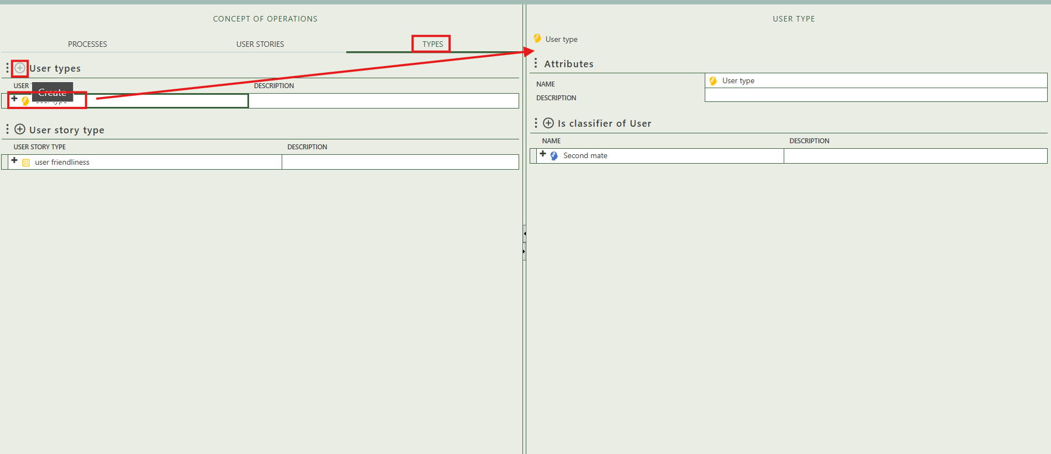This tab provides an overview of all user and user stories types and allows you to create new ones. When you click on a specific type, its full details will appear on the right side of the screen, where you can review and update the information.

