

Author: F.Bovendeert

Version: V1.0

Publication date: 25-07-2025

Work Instruction - Compliance

|  |  |  |  |  |
| --- | --- | --- | --- | --- |
| Work Instruction – Compliance | | | | Project: Master Template |
| Function | Doc No: | Doc sheet: | Doc Rev.: | Pages |
|  |  |  |  |  |
| Doc Class: | Created by: | Created on: | Changed by: | Changed Date: |
|  | Floris Bovendeert | 25-7-2025 |  |  |

In this document, you will find the basic work instructions for **Compliance.**

The document begins with general information about the module in Relatics, including an introduction, objective, and solution. Following this, the structure of the module as implemented in our master template is explained. The subchapters correspond to the tabs in Relatics. Whenever a relevant clickable element appears within a tab, its detail page is also described.

Content

1. General 3

1.1 Introduction 3

1.2 Objective 3

1.3 Solution 3

2. Module 4

2.1 Compliance relations between requirements 5

2.2Compliance single requirements 7

**Revision History**

|  |  |  |  |
| --- | --- | --- | --- |
| Revision | Date | By | Remarks |
|  |  |  |  |
|  |  |  |  |

# 1. General

## 1.1 Introduction

The Compliance Module enables comprehensive management and validation of project requirements. These requirements may originate from internal, class, or specific client needs. Compliance is not only about meeting single requirements but often involves verifying combinations of requirements across different sources. This module allows structured validation, ensuring alignment and consistency throughout the project lifecycle.

## 1.2 Objective

The objective of this module is to ensure full traceability, validation, and understanding of all compliance-related requirements. Projects often involve overlapping or conflicting requirements from different stakeholders. Without a structured system, it becomes difficult to track which requirements have been met, how combinations of requirements interact, or what trade-offs were made.

## 1.3 Solution

This module in Relatics supports a systematic compliance process. Users can register and validate individual requirements or logical combinations across internal, class, and client sources. This facilitates informed decision-making and ensures that no critical requirement is overlooked.

# 2. Module

Go to -> Product -> Compliance

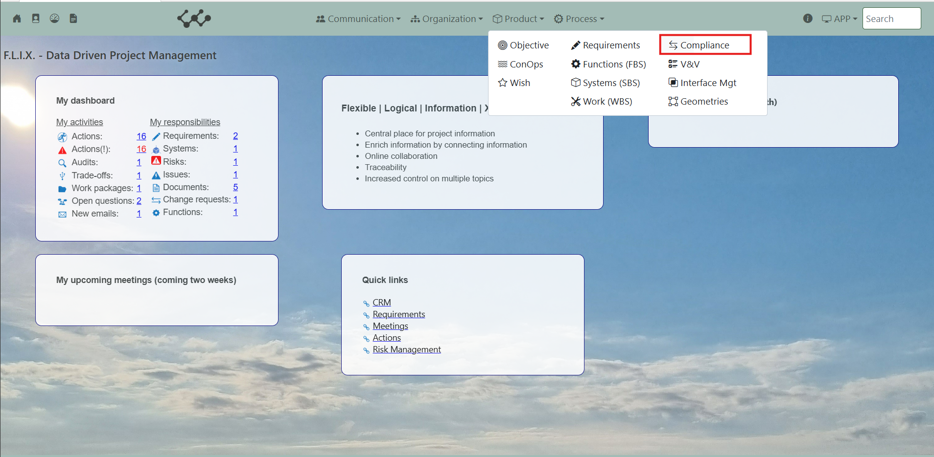

Click on Compliance and you will see the following screen:

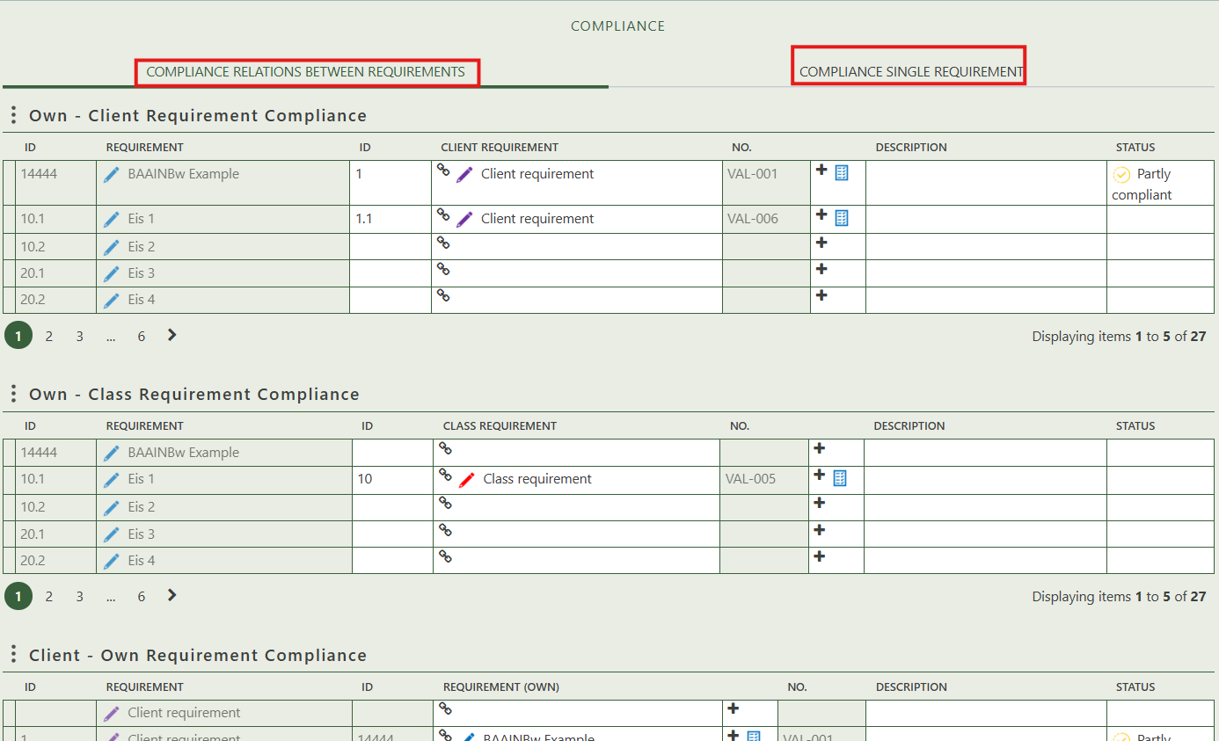

You will find two tabs in this module:

* Compliance relations between requirements.
* Compliance single requirement.

## 2.1 Compliance relations between requirements

This overview displays the compliance relationships between different types of requirements, enabling you to assess how they correspond to each other. The four tables show various combinations of requirement types and how these comply or link with each other:

**Own – Client Requirement Compliance**

Allows you to link an existing own (project) requirement to a client requirement. When this link is created, compliance is automatically established.

**Own – Class Requirement Compliance**

Allows you to link an existing own requirement to a class requirement. When linked, compliance is automatically established.

**Client – Own Requirement Compliance**

Shows the compliance from the client’s perspective by linking client requirements to own requirements. Creating these links automatically establishes compliance.

**Class – Own Requirements Compliance**

Shows the compliance from the class requirement perspective by linking class requirements to own requirements. When these connections are made, compliance is automatically established.

When you click on a specific compliance, its full details will appear on the right side of the screen, where you can review and update the information.

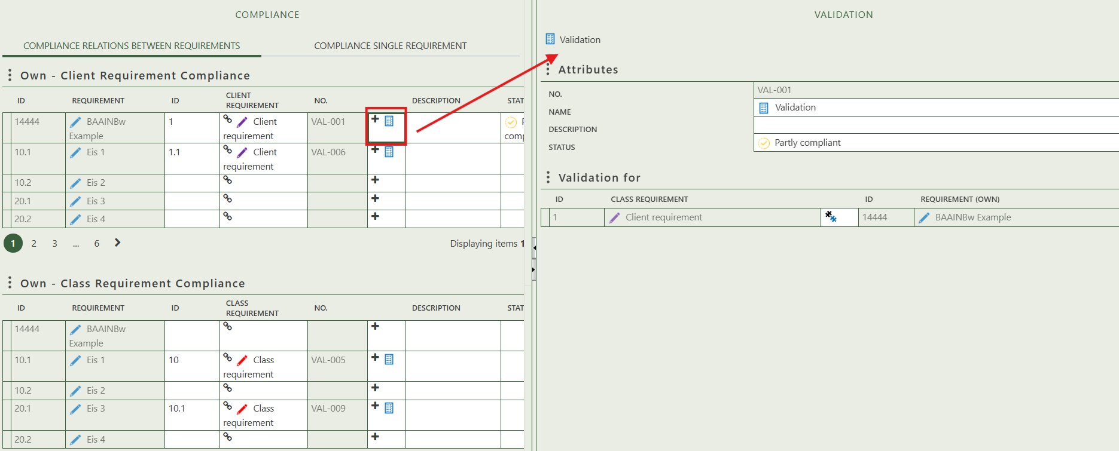

Fill in the general information of the validation.

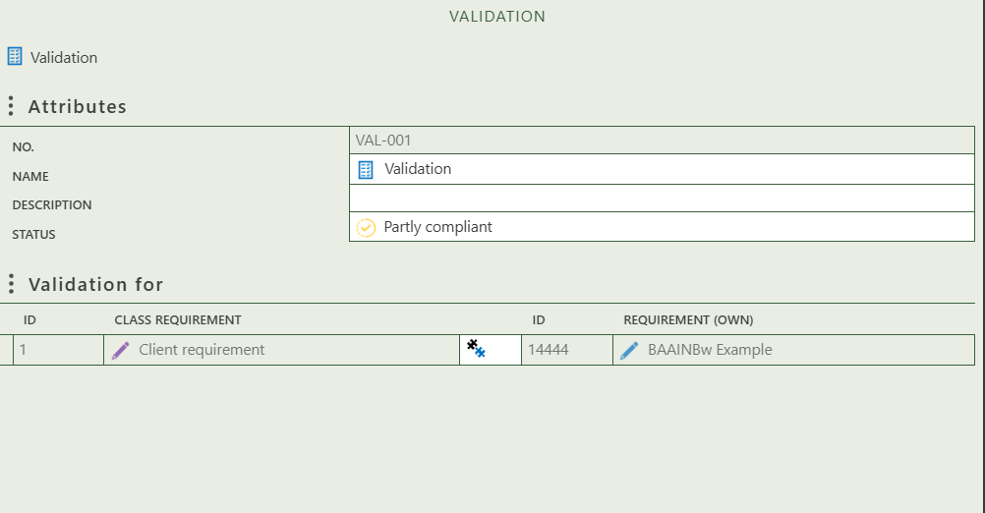

Shows what requirements are validated

## 2.2 Compliance single requirements

Allows you to create a requirement compliance for single requirements. Just press the + sign in the row of the requirement you want to validate.

