

Author: F.Bovendeert

Version: V1.0

Publication date: 25-07-2025

Work Instruction - Change

|  |  |  |  |  |
| --- | --- | --- | --- | --- |
| Work Instruction - Change | | | | Project: Master Template |
| Function | Doc No: | Doc sheet: | Doc Rev.: | Pages |
|  |  |  |  |  |
| Doc Class: | Created by: | Created on: | Changed by: | Changed Date: |
|  | Floris Bovendeert | 25-7-2025 |  |  |

In this document, you will find the basic work instructions for **Change.**

The document begins with general information about the module in Relatics, including an introduction, objective, and solution. Following this, the structure of the module as implemented in our master template is explained. The subchapters correspond to the tabs in Relatics. Whenever a relevant clickable element appears within a tab, its detail page is also described.

Content

1. General 3

1.1 Introduction 3

1.2 Objective 3

1.3 Solution 3

2. Module 4

2.1 Change requests 5

2.2Change log 8

2.3Types 8

3. Change log 9

**Revision History**

|  |  |  |  |
| --- | --- | --- | --- |
| Revision | Date | By | Remarks |
|  |  |  |  |
|  |  |  |  |

# 1. General

## 1.1 Introduction

In this module, you can manage all project-related changes. Changes are often triggered by undesired events, such as issues or risks that require a formal response. Relatics enables you to register the trigger, attach relevant documentation, define required actions, and assess the impact of the change in a clear and traceable manner.

## 1.2 Objective

The goal is to ensure structured decision-making and full traceability of project changes. In many projects, changes are handled informally, making it difficult to track why a decision was made, which requirements were affected, and who approved it. Without a centralized system, change management can become inconsistent and risky.

## 1.3 Solution

Relatics supports a consistent change management process—if used effectively. By registering changes in this module, documenting their cause, linking them to impacted subjects and requirements, selecting consequences, and capturing approvals, you create a clear and traceable record of all changes. This helps teams manage impact, ensure accountability, and maintain control over evolving project requirements.

# 2. Module

Go to -> Process -> Change Control-> Changes and Change log.

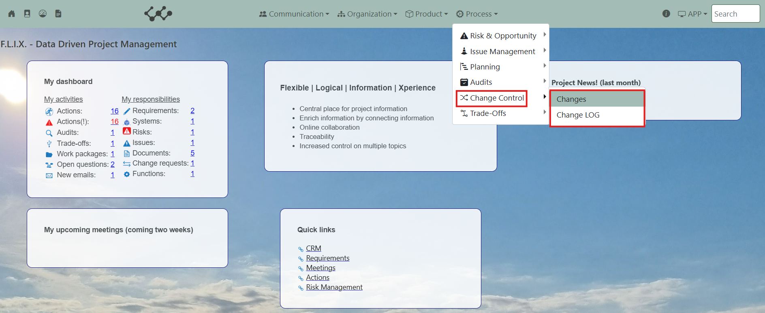

Click on Changes and you will see the following screen:

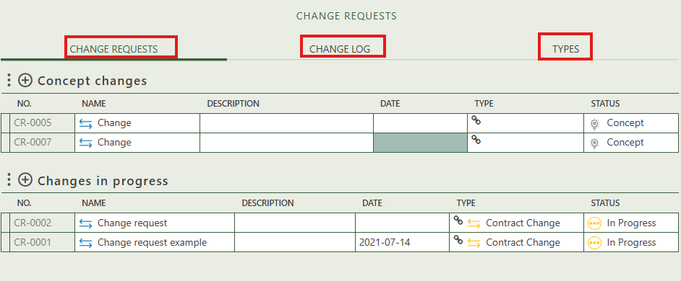

You will find three tabs in this module:

* Change requests.
* Change log .
* Types.

## 2.1 Change requests

This tab provides an overview of all the changes that have either the status ‘concept’ or ‘in progress’ within the workspace. You can create new entries by clicking the "+" icon above each table.

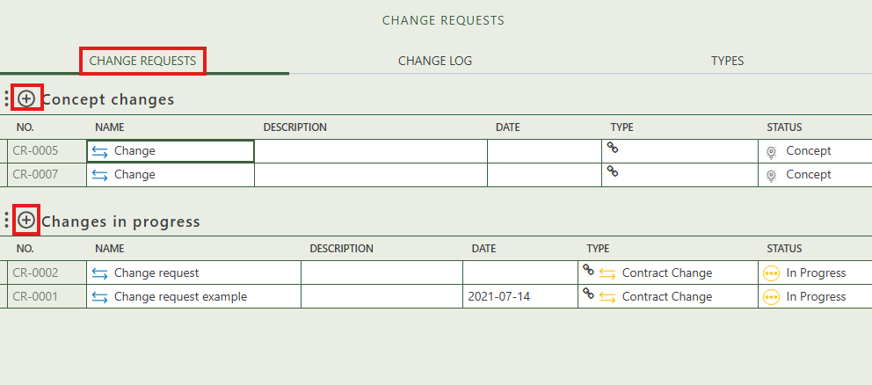

When you click on a specific change, its full details will appear on the right side of the screen, where you can review and update the information.

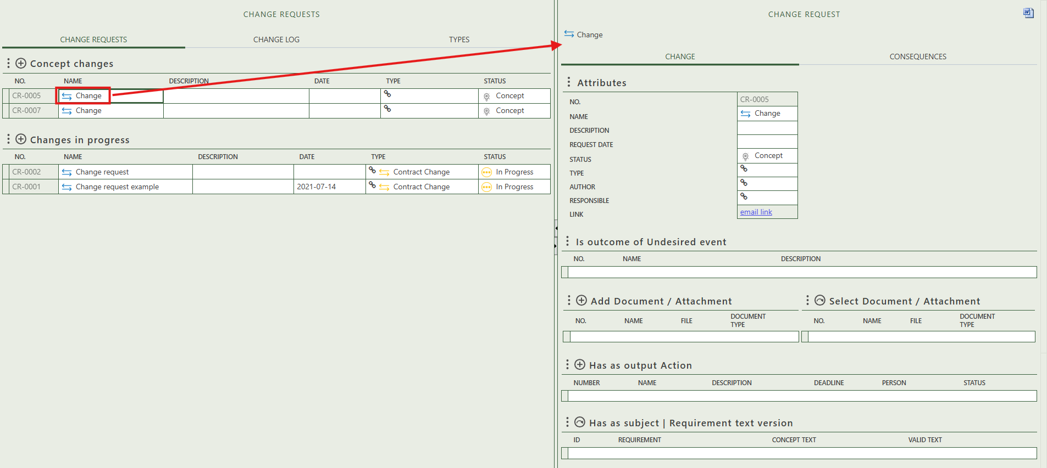

The option to generate a output report of the change request.

Fill in the general information of the specific change.

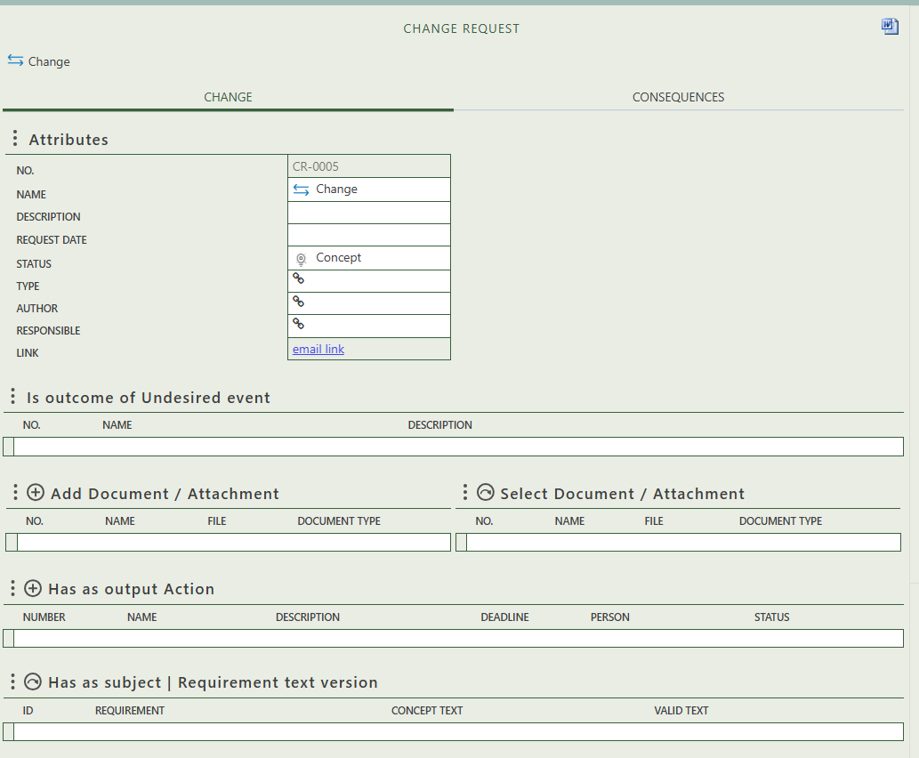

Shows the undesired event (issue or risk) that the change originates from.

Allows you to both create or select document / attachments.

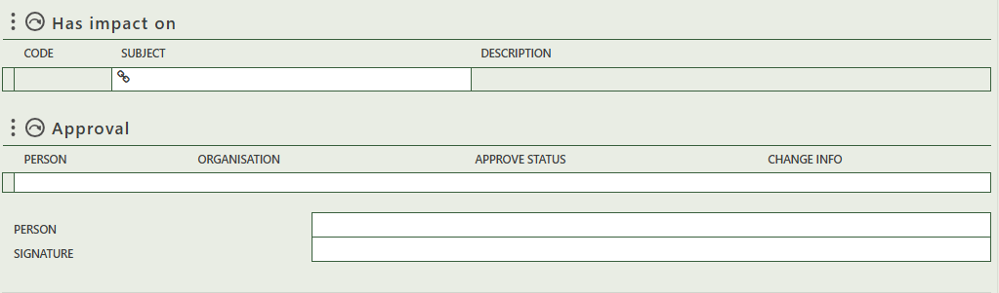

The selected approver(s) are automatically listed, and only need to provide their signature.

Select the person(s) that approve(s) the change. This can be multiple persons.

The option to select subject(s) (= activities, functions, goals, physical object or requirements) that the change have an impact on.

The option to select a specific version of a requirement text as the subject of the change.

Allows you to create action(s) as output of the change request.

On the second tab of the detail page, you can fill in the consequences of the specific change.

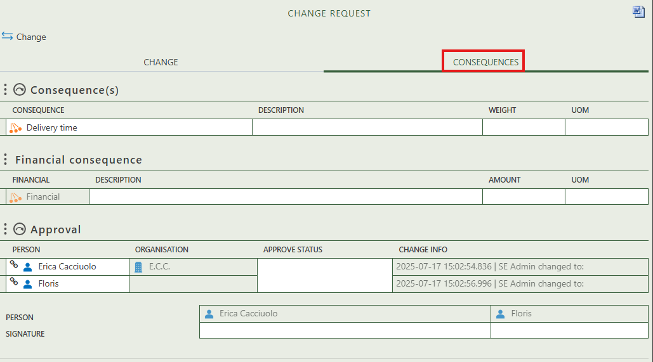

Select the consequence(s) that apply to the change. You can manage these option on the tab ‘types’.

Allows you to fill in the financial consequence of the change by filling in the description, amount and Unit Of Measure.

Are the same approvers you have selected on the previous tab

The selected approver(s) are automatically listed, and only need to provide their signature.

## 2.2 Change log

This tab displays a read-only Changes Overview table. As shown in the image, concept changes are not included here. Unlike the first tab, which only shows changes with the status Concept or In Progress, this view provides a complete summary of all finalized and ongoing changes.

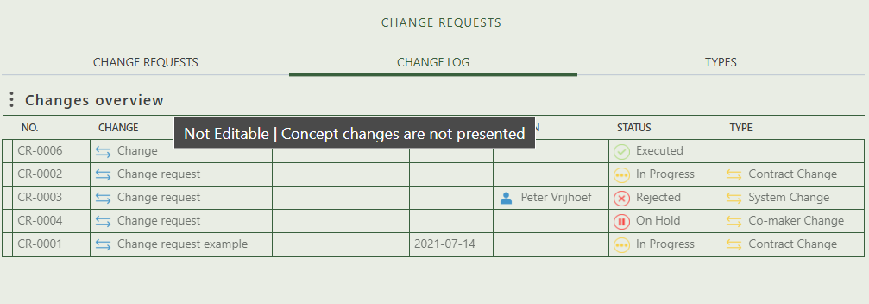

## 2.3 Types

This tab provides an overview of all change and consequence types and allows you to create new ones or edit existing ones.

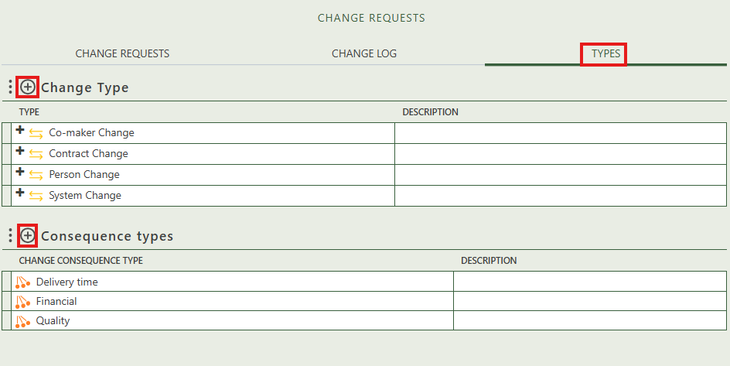

# 3. Change log

The Change LOG module in Relatics provides a clear overview of all registered changes within a project. It combines visual summaries, pivot analysis, and detailed listings to help teams monitor the progress, status, and type of each change. Below is a breakdown of the main components shown in the screenshot:

* **Change Chart** = A bar chart displays the number of changes grouped by type (e.g., System Change, Contract Change) and their current status (e.g., Executed, On Hold, Rejected). This offers a quick visual summary of how changes are distributed and progressing.
* **Change Pivot Table** = This pivot table organizes changes by type and status, allowing users to quickly see how many changes fall under each category.
* **Changes Overview Table** = A detailed table lists individual change records with information such as change number, title, date, responsible person, current status, and type.

