

Author: F.Bovendeert

Version: V1.0

Publication date: 25-07-2025

Work Instruction - Audit

|  |  |  |  |  |
| --- | --- | --- | --- | --- |
| Work Instruction - Audit | | | | Project: Master Template |
| Function | Doc No: | Doc sheet: | Doc Rev.: | Pages |
|  |  |  |  |  |
| Doc Class: | Created by: | Created on: | Changed by: | Changed Date: |
|  | Floris Bovendeert | 25-7-2025 |  |  |

In this document, you will find the basic work instructions for **Audit.**

The document begins with general information about the module in Relatics, including an introduction, objective, and solution. Following this, the structure of the module as implemented in our master template is explained. The subchapters correspond to the tabs in Relatics. Whenever a relevant clickable element appears within a tab, its detail page is also described.

Content

1. General 3

1.1 Introduction 3

1.2 Objective 3

1.3 Solution 3

2. Module 4

2.1 Audits 5

2.2Audit log 7

2.3 Audit types 7

3. Audit overview 8

**Revision History**

|  |  |  |  |
| --- | --- | --- | --- |
| Revision | Date | By | Remarks |
|  |  |  |  |
|  |  |  |  |

# 1. General

## 1.1 Introduction

In this module, you can manage all project-related audits. Audits are typically carried out at specific project milestones or phases to evaluate compliance, quality, or progress. Relatics enables you to register, plan, and document audits in a structured and transparent way—ensuring that findings and follow-up actions are clearly traceable throughout the project.

## 1.2 Objective

The goal is to ensure full traceability and clarity around all project audits. In many projects, audits are performed but not consistently documented or linked to project phases, which can lead to incomplete insights or lost lessons learned.

## 1.3 Solution

Relatics supports a structured audit process—if used consistently. By creating audits in this module, linking them to milestones or phases, and documenting the associated reports and outcomes, you create a reliable audit trail. This promotes transparency, continuous improvement, and accountability within your project team.

# 2. Module

Go to -> Process -> Audits -> Audits and Audits Overview

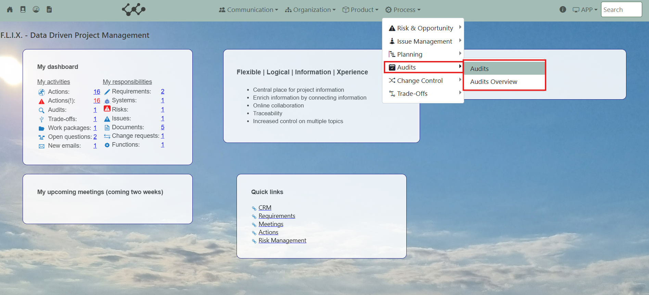

Click on Audits and you will see the following screen:

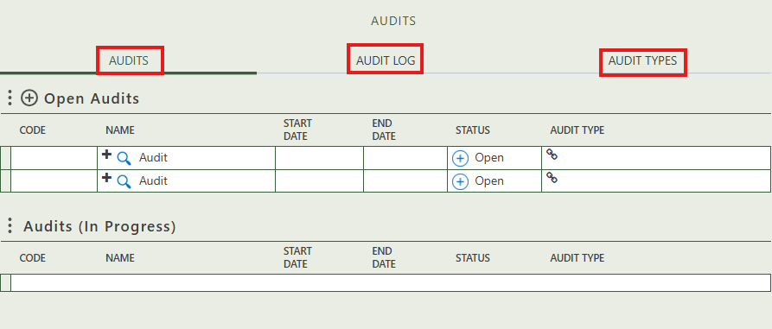

You will find three tabs in this module:

* Audits.
* Audit log.
* Audit types.

## 2.1 Audits

This tab contains an overview of all the audit in this workspace. By pressing on the + sign next to Open audits, you can create new audits. When the status of an audit changes to ‘in progress’, the audits moves to the second table.

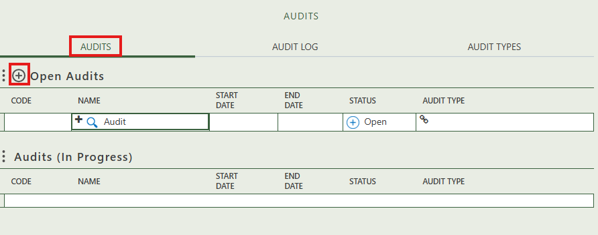

When you click on a specific audit, its full details will appear on the right side of the screen, where you can review and update the information.

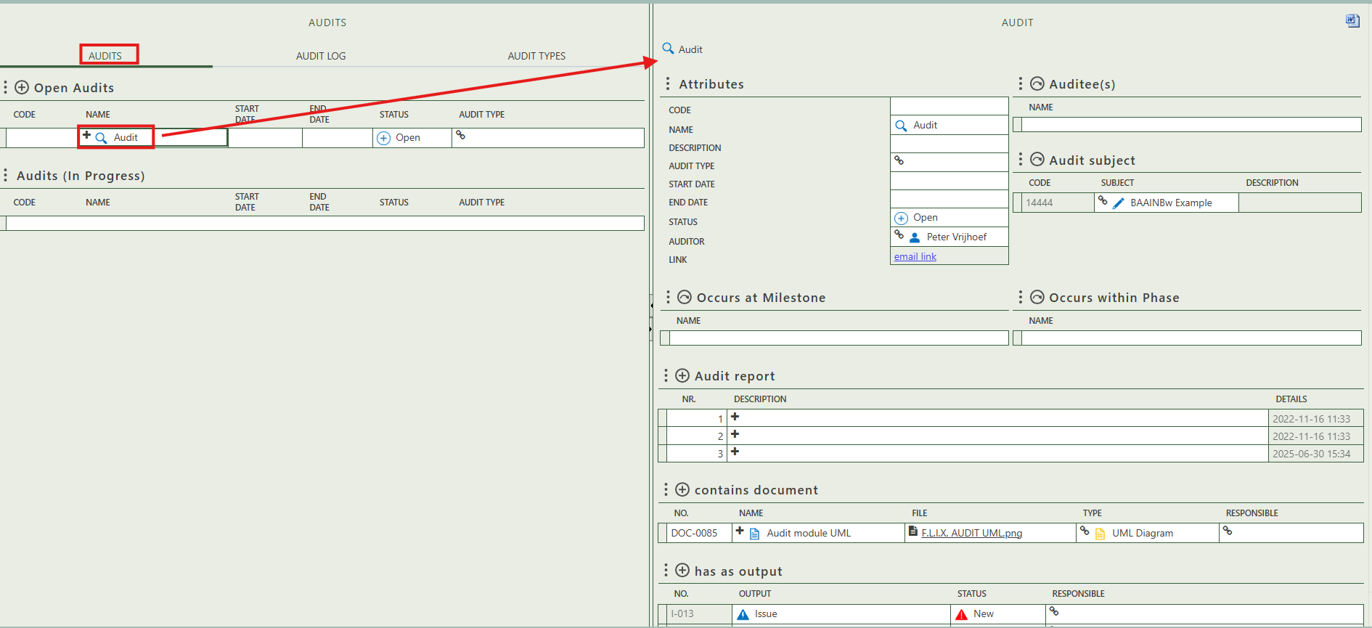

The option to get an audit output report.

Select the persons that are auditee(s).

Fill in the general information of the audit.

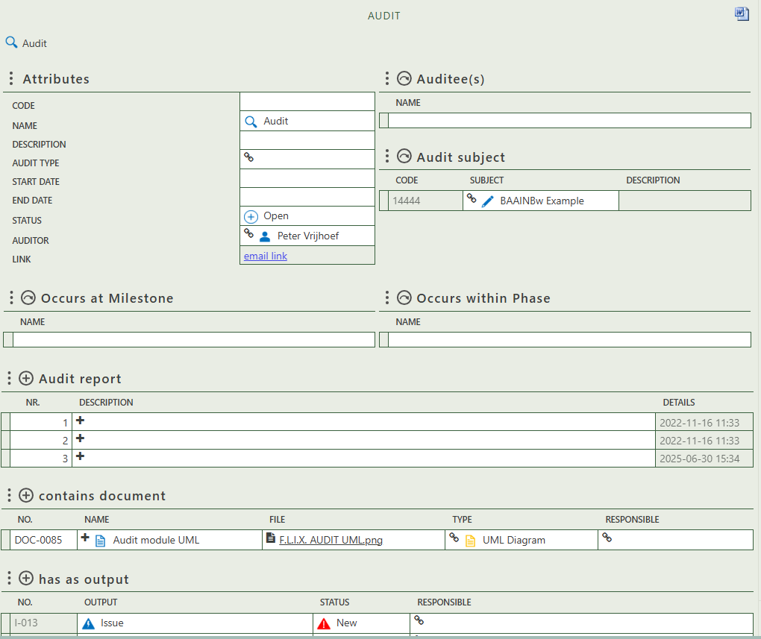

The option to get an audit output report.

Select the milestone at which the audit occurs.

Select the phase within the audit take place.

Allows you to create a general document.

Allows you to create output in the form of issues or risks.

Allows you to create audit report(s).

## 2.2 Audit log

This tab provides an overview of all audits with the status ‘Executed’ or ‘On hold’. It serves as a historical overview, showing audits that have been completed or are temporarily paused.

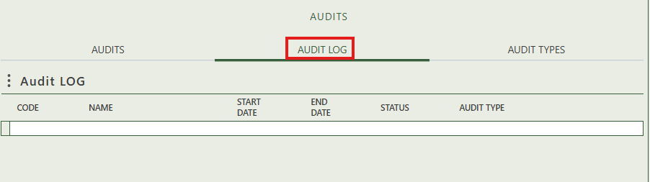

## 2.3 Audit types

This tab provides an overview of all audit types and allows you to create new ones. When you click on a specific audit type, its full details will appear on the right side of the screen, where you can review and update the information. You can also see which audits this type is used to classify.

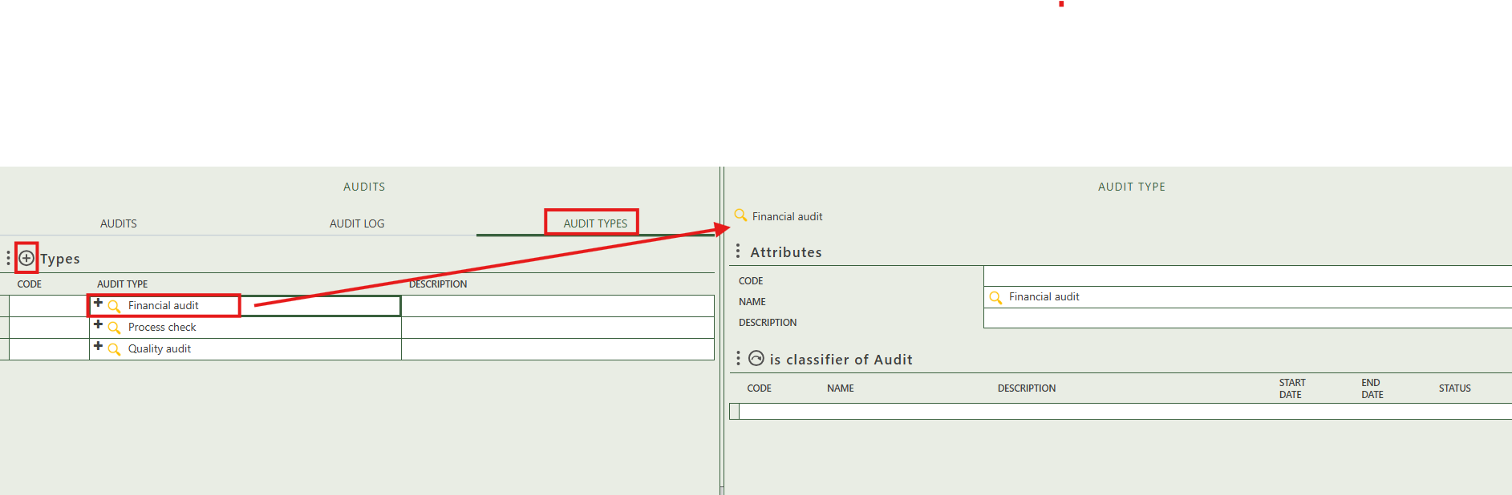

# 3. Audit overview

The audit Overview module provides a clear, centralized overview of all registered audits. It consists of:

* **Audit Chart**: Shows the amount of audits per audit type.
* **Audit LOG**: Is a general overview where the status of audits are either ‘Executed’ or ‘On hold’.

