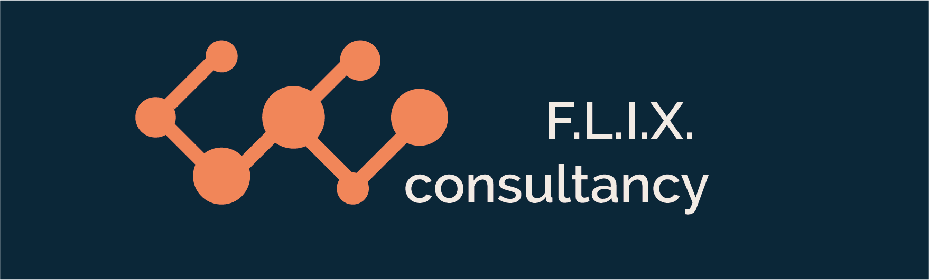

Author: F.Bovendeert

Version: V1.0

Publication date: **25**-07-2025

Work Instruction - Action

|  |  |  |  |  |
| --- | --- | --- | --- | --- |
| Work Instruction - Action | | | | Project: Master Template |
| Function | Doc No: | Doc sheet: | Doc Rev.: | Pages |
|  |  |  |  |  |
| Doc Class: | Created by: | Created on: | Changed by: | Changed Date: |
|  | Floris Bovendeert | 25-7-2025 |  |  |

In this document, you will find the basic work instructions for **Actions**.

The document begins with general information about the module in Relatics, including an introduction, objective, and solution. Following this, the structure of the module as implemented in our master template is explained. The subchapters correspond to the tabs in Relatics. Whenever a relevant clickable element appears within a tab, its detail page is also described.

Content

1. General 3

1.1 Introduction 3

1.2 Objective 3

1.3 Solution 3

2. Module 4

2.1 Actions overview 5

2.2 Actions with past deadlines 8

2.3 Actions updated last week 8

**Revision History**

|  |  |  |  |
| --- | --- | --- | --- |
| Revision | Date | By | Remarks |
|  |  |  |  |
|  |  |  |  |

# 1. General

## 1.1 Introduction

In this module, you can manage all project-related actions. While actions often originate from meetings and emails, Relatics allows you to register, assign, and track them in a structured and transparent way.

## 1.2 Objective

The goal is to ensure full traceability and follow-up of all project actions. In many projects, actions are only discussed verbally or written down in personal notes or emails. Over time, this can lead to miscommunication, duplication, or forgotten tasks. Imagine trying to find out who was responsible for an action agreed upon two years ago—without a central system, that’s nearly impossible.

## 1.3 Solution

Relatics reduces this problem—provided it is used correctly and consistently. By recording actions in this module, you create a shared overview of responsibilities, deadlines, and progress, helping your team stay aligned and accountable throughout the project.

# 2. Module

Go to -> Communication -> Actions

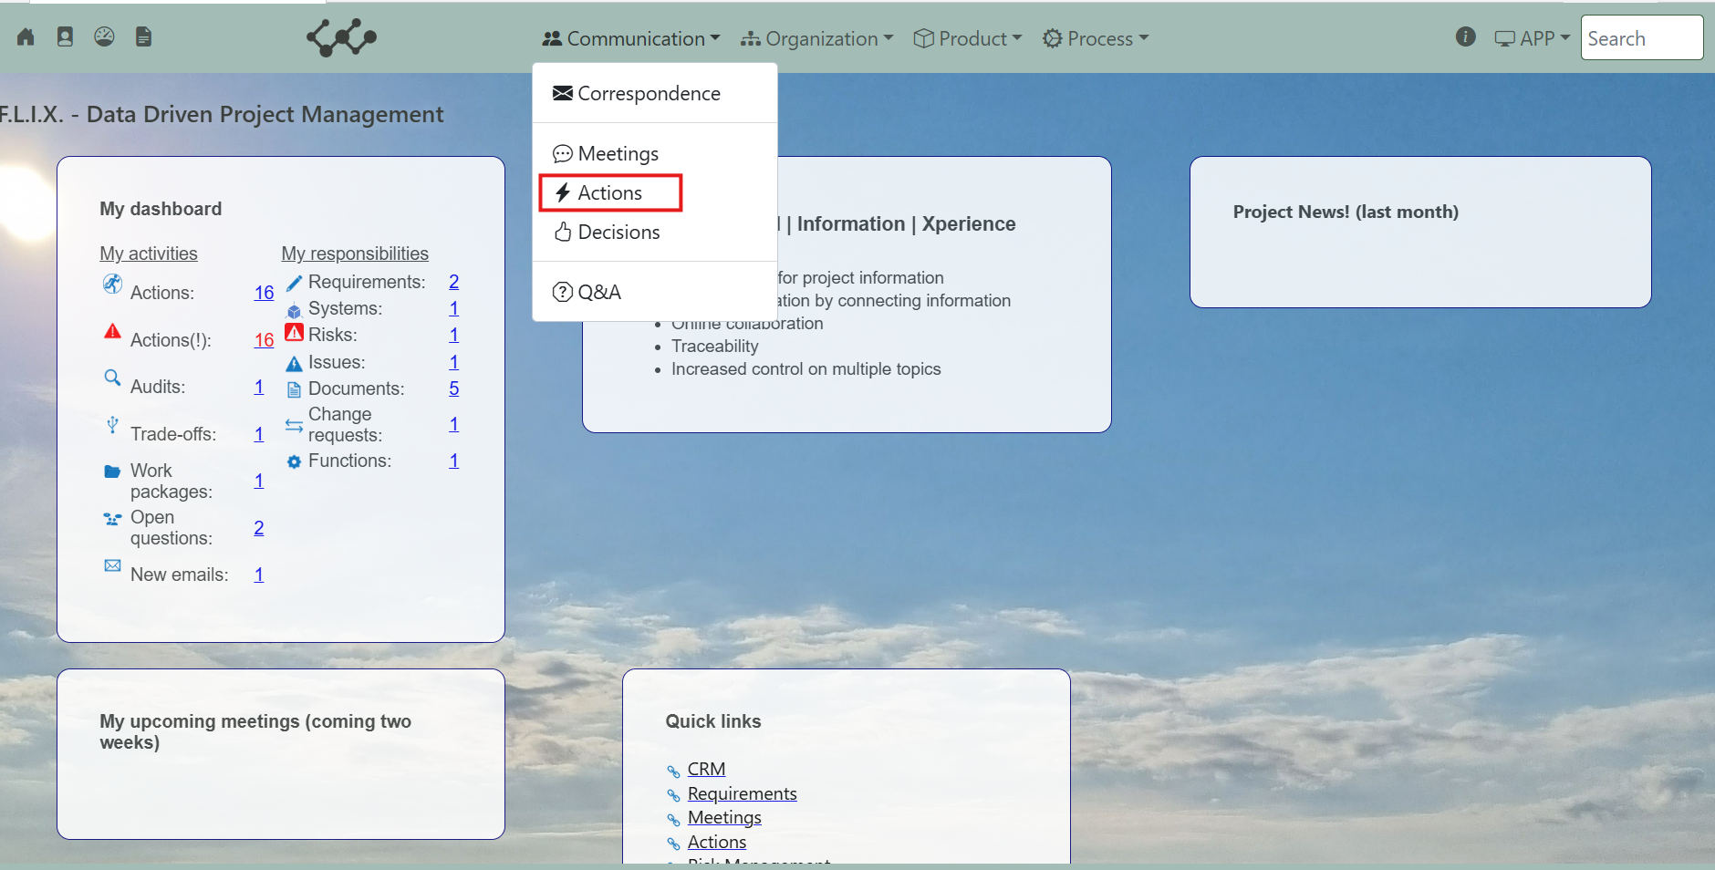

Click and you will see the following screen:

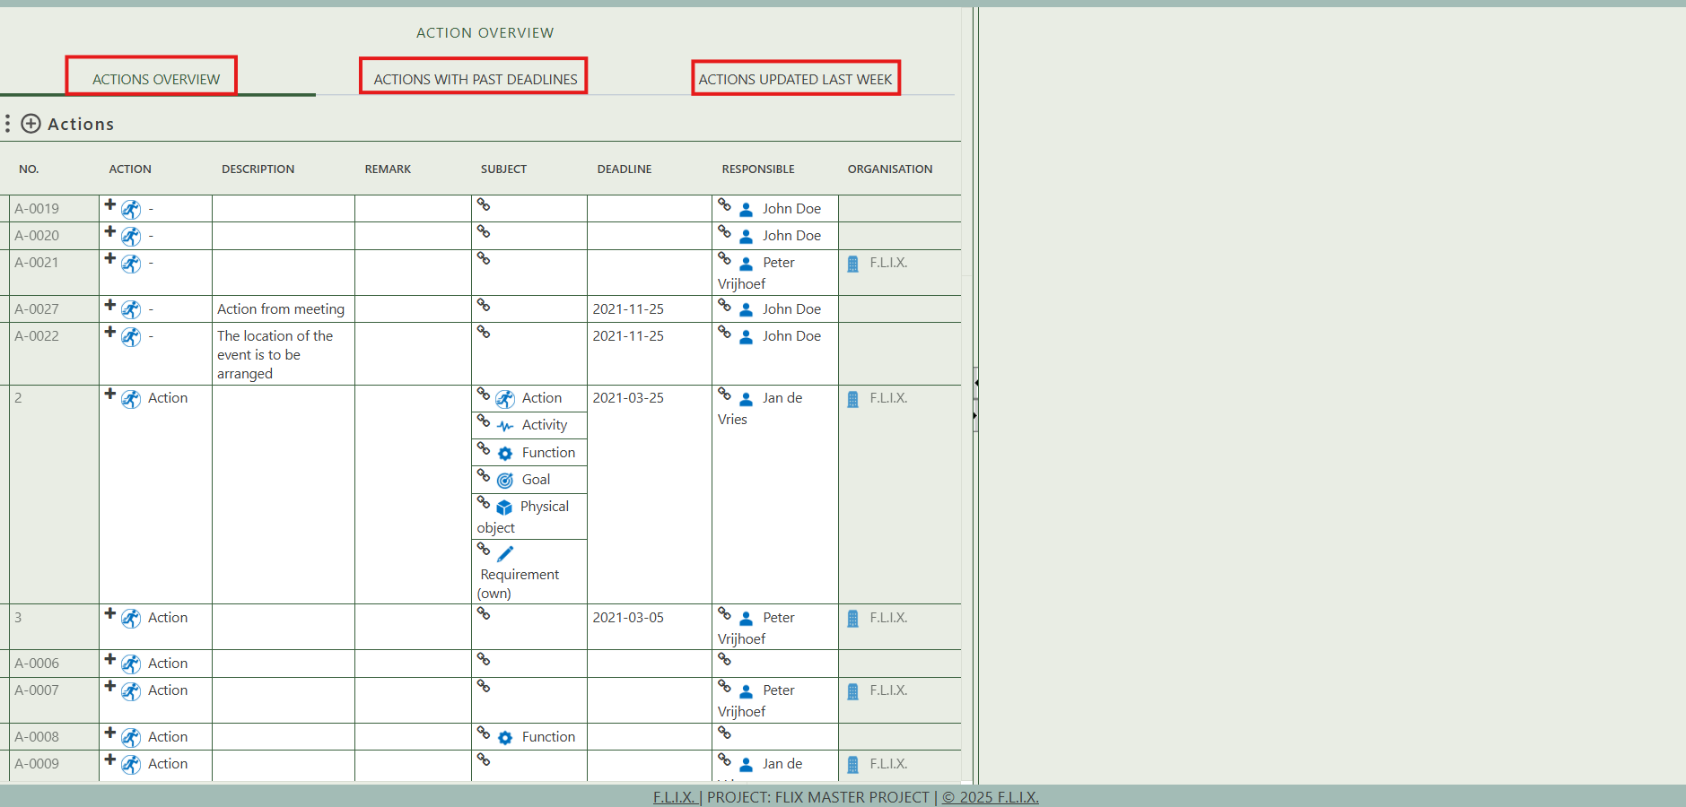

You will find three tabs in this module:

* Actions overview.
* Actions with past deadlines.
* Actions updated last week.

## 2.1 Actions overview

This tab contains an overview of all the actions that are created in this workspace.

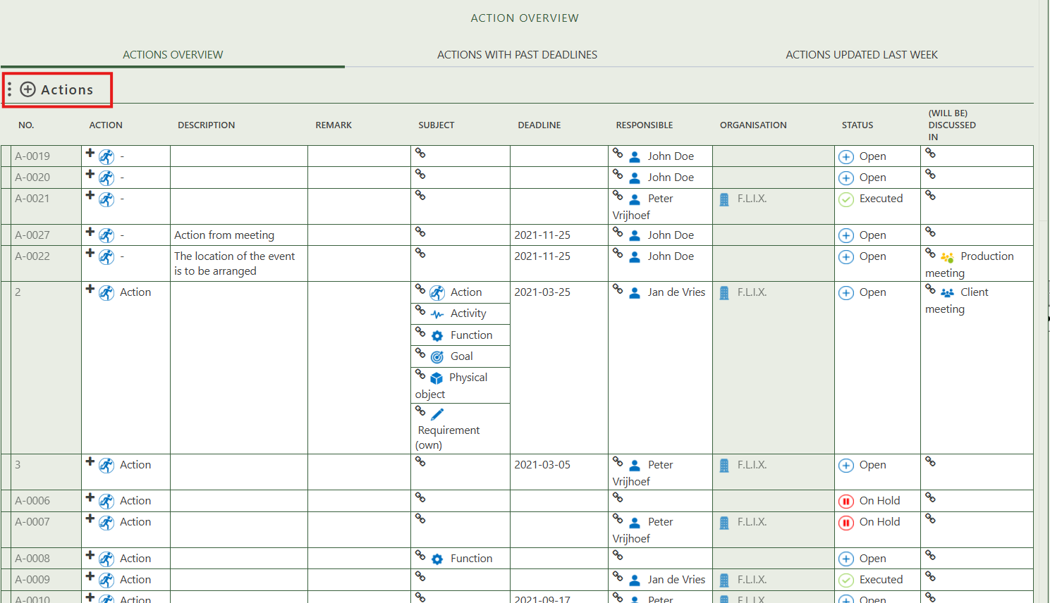

By pressing on the + sign next to actions, you can create new actions.

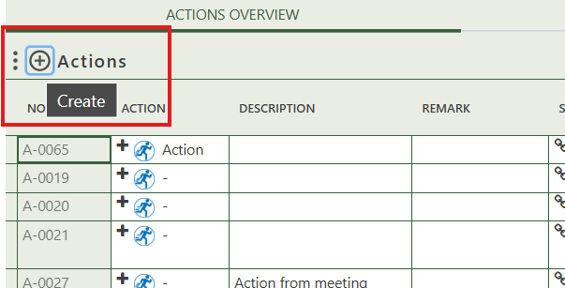

When you click on a specific action, its full details will appear on the right side of the screen, where you can review and update the information.

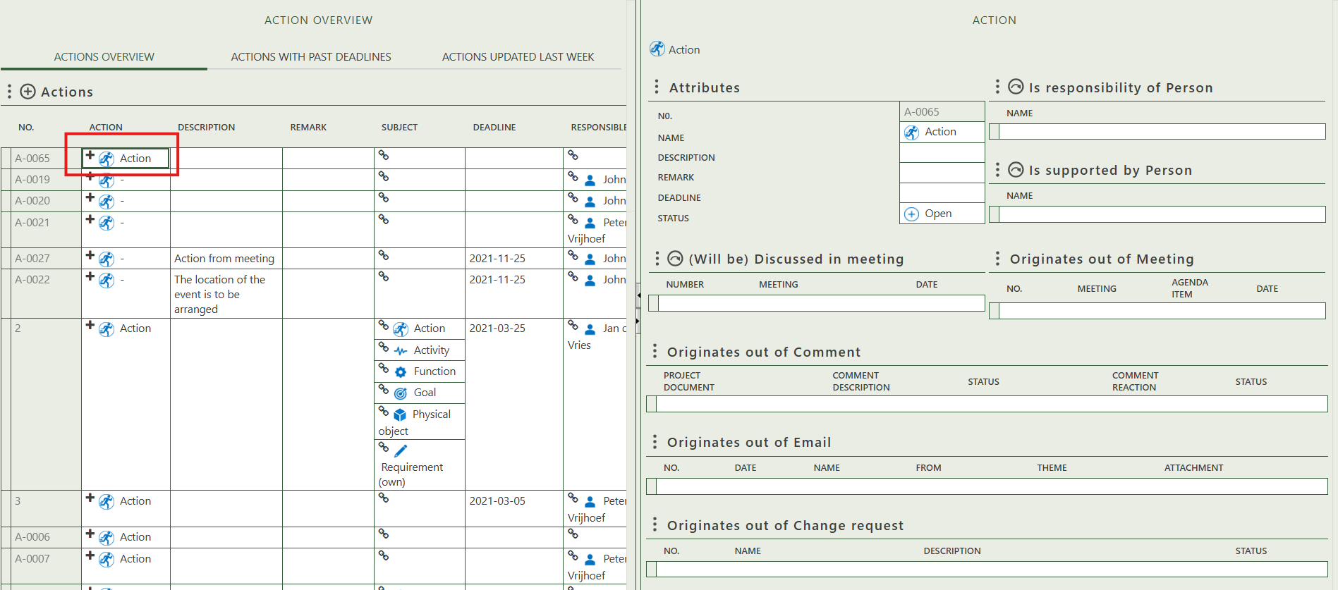

Fill in the general information of the specific action.

Select the person who is responsible for the action and who are supporting.

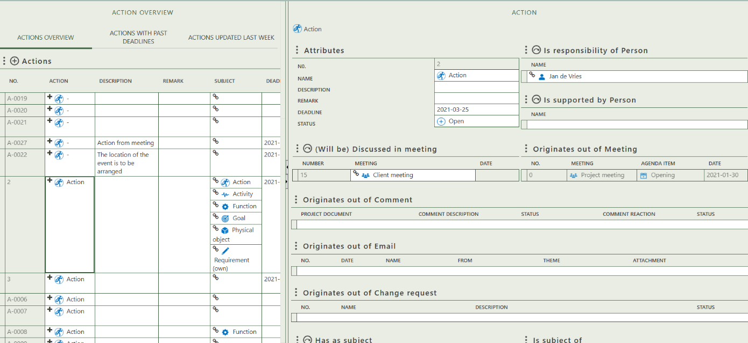

Select the meeting in which the action will be discussed.

Shows the meeting and agenda item from which the action originates.

Shows the comment, email, or change request from which the action originates.

Allows you to select a subject to which the action applies.

Shows where this action is the subject.

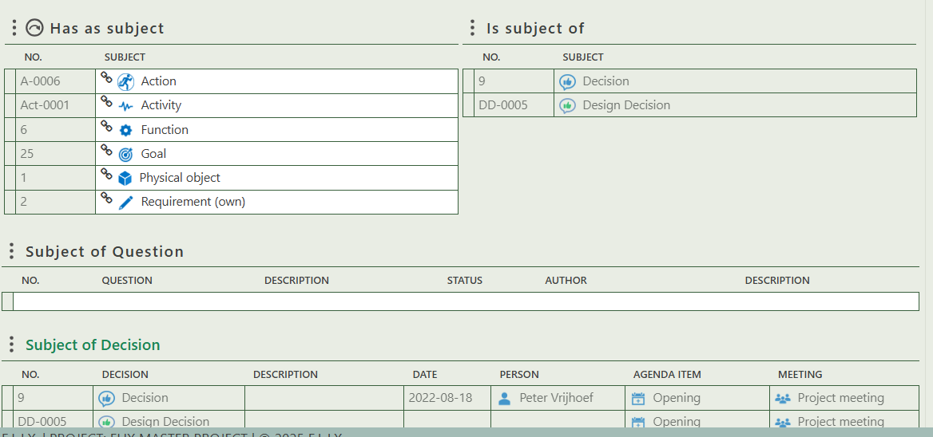

Displays the question of which this action is the subject.

Displays the decision of which this action is the subject.

## 2.2 Actions with past deadlines

This tab contains a single table that displays only actions with a past deadline.

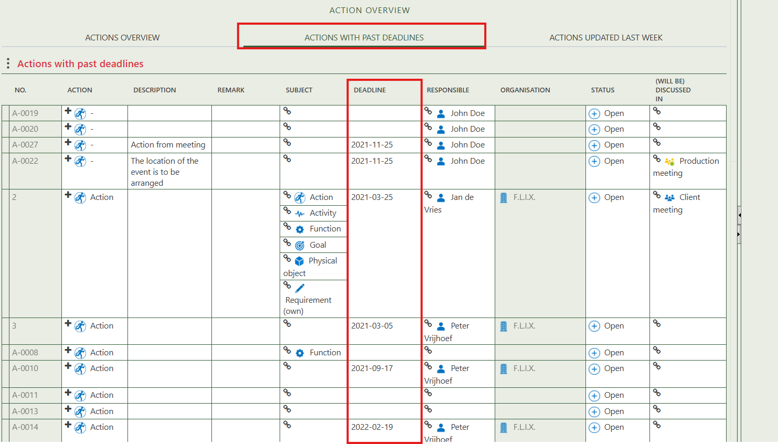

## 2.3 Actions updated last week

This tab displays multiple tables showing actions that have been updated within the last 7 days. As you can see, I created an action just a few minutes before taking this screenshot and is therefore shown on this tab.

